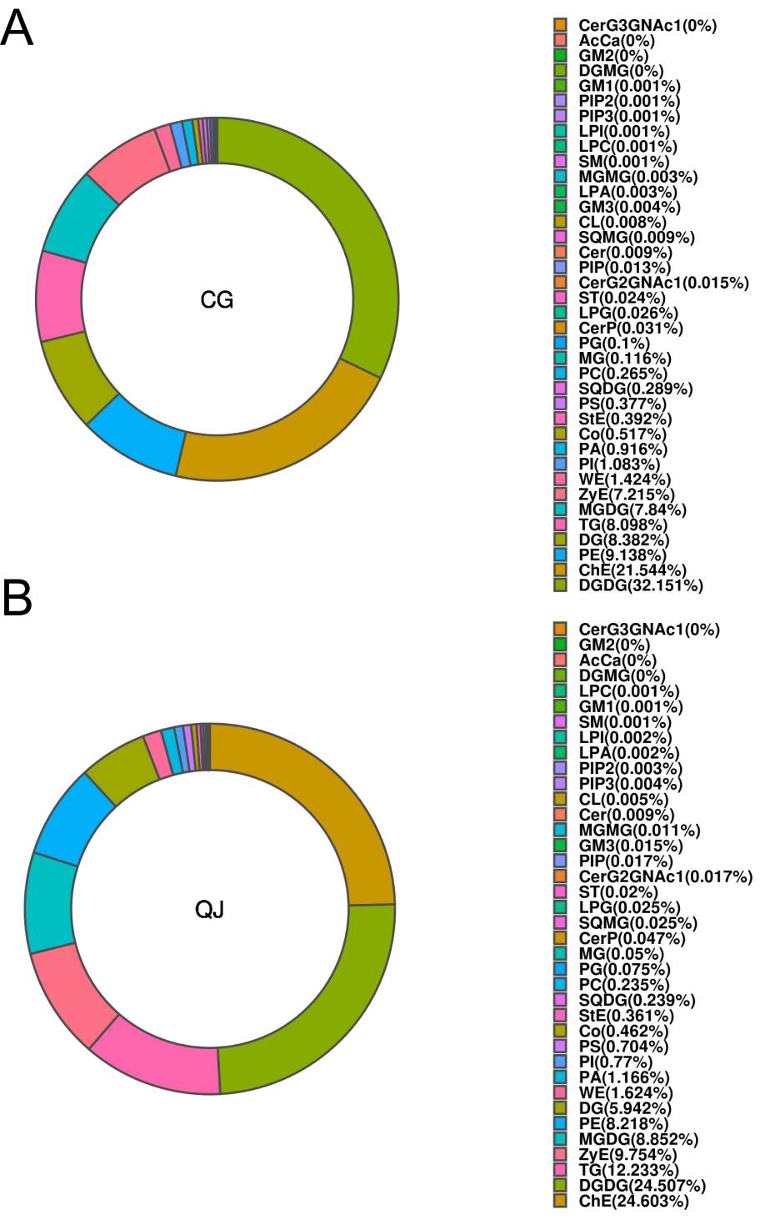

**Supplementary Figure 2.** Composition of lipid class (CG vs. QJ). The different lipid class are represented by different colours and the proportion of them is indicated by the size of the colour block area.