Walk/Jog/Run/Cycle
RESEARCH SURVEY
Prevalence, Types and Treatment of Skin Cancer in Surfers, Swimmers and Stand-Up Paddle Boarders:
Whole Body Screening with Artificial Intelligence

Participants are asked NOT TO put their name or any other identifying information on the survey

Clinic ID: ___________ ꙱ Self-referred ꙱ Referred by your GP
Age: _______ Height (cm): _______ Weight (kg): _______
Gender: ꙱ Male ꙱ Female
Smoking status: ꙱ Smoker ꙱ Non-smoker ꙱ Ex-smoker
Alcohol consumption: Number of standard drinks per week ________________

Walk/Jog/Run/Cycle Sun Exposure
Walk/Jog/Run/Cycle session (mins):
Walk/Jog/Run/Cycle hours per week: __Walk/Jog/Run/Cycle weeks per year: ______
Do you ever Walk/Jog/Run/Cycle during peak Sun (i.e., sun strongest from 10 am to 3pm):
꙱ Yes ꙱ No Estimated percent of swimming time during peak UV:______%

Walk/Jog/Run/Cycle season(s) (tick all that may apply): ꙱ Spring ꙱ Summer ꙱ Autumn ꙱ Winter

WORK/OCCUPATIONAL Sun exposure (leave blank if retired)
Hours per week: Weeks per year:
Do you ever complete these activities during peak ultra violet radiation (10 am to 3pm)
꙱ Yes ꙱ No
Estimated percent of WORK/Occupational time completed during peak UV:_____%

OTHER Recreational Sun exposure (Surfing, Swimming……..)
Other hours per week: Other weeks per year:
Do you ever complete these activities during peak ultra violet radiation (10 am to 3pm)
꙱ Yes ꙱ No
Estimated percent of OTHER time completed during peak UV:_____%

SKIN CANCER PREVENTION STRATEGIES
Which of the following sun protection strategies do you use on a regular basis? (tick all that may apply)
꙱ Cap ꙱ T-shirt
Do you wear sunscreen? ꙱ Yes ꙱ No Reapply sunscreen as directed? ꙱ Yes ꙱ No
Preferred Sunscreen (circle only 1) Banana Boat Bondi Sands Cancer Council
Hawaiian Tropic Le Tan Neutrogena Nivea Surf Life Saving Cole/Woolworths Other____________
Preferred Sunscreen strength (circle only 1) ꙱ 0 (oil) ꙱ 8+ ꙱ 15+ ꙱ 30+ ꙱ 50+ ꙱100+
Do you use Zinc ? ꙱ Yes ꙱ No Re apply Zinc as directed? ꙱ Yes ꙱ No
Do you use SPF lip balm? ꙱ Yes ꙱ No Re apply lip balm as directed? ꙱ Yes ꙱ No
Do you conduct self/partner exams for suspicious moles on a regular basis? ꙱ Yes ꙱ No
Do you have any suspicious moles of concern? ꙱ Yes ꙱ No
How long ago was your last skin check for skin cancer or suspicious moles?
꙱ Never ꙱ < 6 months ꙱ 1 year ꙱ 2 years ꙱ 3 years ꙱ 4 years ꙱ 5 years ꙱ 5 years+
Who performed your last skin check?
꙱ Skin cancer doctor ꙱ GP ꙱ Dermatologist ꙱ Plastic Surgeon
Do you place any significance on who is doing the skin check?
꙱ Yes ꙱ No
Fitzpatrick Skin Type (please circle correct response for each)
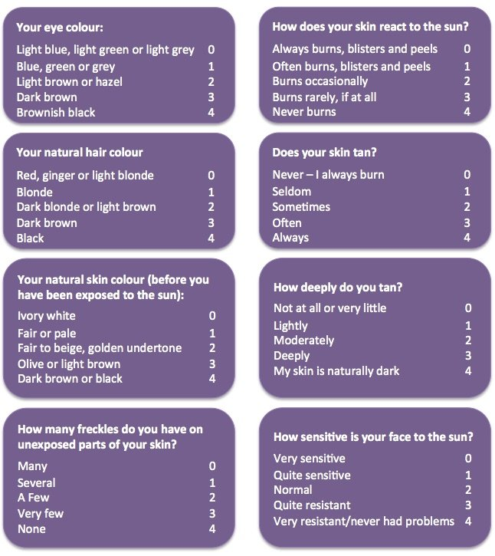
Skin Cancer Risk and History
TOTAL completed by Researcher
0 – 6 points Type 1
7 – 13 points Type 2
14 – 20 points Type 3
21 – 27 points Type 4
28 – 34 points Type 5
35 – 36 points Type 6

Total points = __________
Family history of skin cancer? ꙱ Yes ꙱ No
Blistering sunburns as child (18 years or younger)? ꙱ Yes ꙱ No
Ever used a solarium/tanning bed? ꙱ Yes ꙱ No
Number of sunburns previous 12 months:
꙱ 0 ꙱ 1 ꙱ 2 ꙱ 3 ꙱ 4 ꙱ 5 ꙱ 6 ꙱ 7 ꙱ 8 ꙱ 9 ꙱ 10 ꙱ 11 ꙱ >12
Do you have any skin lesions of concern? ꙱ Yes ꙱ No
Do you have a history of skin cancer? ꙱ Yes ꙱ No
If yes, tick body part, then tick the relevant type of skin cancer (if known):
꙱ Scalp Type: ꙱ Basal cell ꙱ Squamous cell ꙱ Melanoma ꙱ Unsure
꙱ Nose Type: ꙱ Basal cell ꙱ Squamous cell ꙱ Melanoma ꙱ Unsure
꙱ Face Type: ꙱ Basal cell ꙱ Squamous cell ꙱ Melanoma ꙱ Unsure
꙱ Lip Type: ꙱ Basal cell ꙱ Squamous cell ꙱ Melanoma ꙱ Unsure
꙱ Ear Type: ꙱ Basal cell ꙱ Squamous cell ꙱ Melanoma ꙱ Unsure
꙱ Neck Type: ꙱ Basal cell ꙱ Squamous cell ꙱ Melanoma ꙱ Unsure
꙱ Shoulder Type: ꙱ Basal cell ꙱ Squamous cell ꙱ Melanoma ꙱ Unsure
꙱ Chest Type: ꙱ Basal cell ꙱ Squamous cell ꙱ Melanoma ꙱ Unsure
꙱ Arm Type: ꙱ Basal cell ꙱ Squamous cell ꙱ Melanoma ꙱ Unsure
꙱ Back Type: ꙱ Basal cell ꙱ Squamous cell ꙱ Melanoma ꙱ Unsure
꙱ Hand Type: ꙱ Basal cell ꙱ Squamous cell ꙱ Melanoma ꙱ Unsure
꙱ Upper leg Type: ꙱ Basal cell ꙱ Squamous cell ꙱ Melanoma ꙱ Unsure
꙱ Lower leg Type: ꙱ Basal cell ꙱ Squamous cell ꙱ Melanoma ꙱ Unsure
꙱ Foot Type: ꙱ Basal cell ꙱ Squamous cell ꙱ Melanoma ꙱ Unsure
Thank you for completing our survey
If you would like a copy of the results of our findings from the study, please ensure you write your email address on the informed consent form.
NOTE: Please do not include your name or any other identifying information on this form.

TO BE COMPLETED BY YOUR DOCTOR/SURGEON
Actinic/solar keratosis diagnosed:
꙱ Top of head ꙱ Face ꙱ Lip ꙱ Nose ꙱ Ear ꙱ Neck ꙱ Shoulder

꙱ Chest ꙱ Arm ꙱ Back ꙱ Hand ꙱ Upper leg ꙱ Lower leg

꙱ Foot ꙱ Other: ______________________________________________________

BCC diagnosed: VEXIA Artificial Intelligence Score __________
꙱ Top of head ꙱ Face ꙱ Lip ꙱ Nose ꙱ Ear ꙱ Neck ꙱ Shoulder
꙱ Chest ꙱ Arm ꙱ Back ꙱ Hand ꙱ Upper leg ꙱ Lower leg

꙱ Foot ꙱ Other: ______________________________________________________

SCC (in situ/IEC) diagnosed: VEXIA Artificial Intelligence Score __________
꙱ Top of head ꙱ Face ꙱ Lip ꙱ Nose ꙱ Ear ꙱ Neck ꙱ Shoulder
꙱ Chest ꙱ Arm ꙱ Back ꙱ Hand ꙱ Upper leg ꙱ Lower leg

꙱ Foot ꙱ Other: ______________________________________________________

SCC diagnosed: VEXIA Artificial Intelligence Score __________
꙱ Top of head ꙱ Face ꙱ Lip ꙱ Nose ꙱ Ear ꙱ Neck ꙱ Shoulder

꙱ Chest ꙱ Arm ꙱ Back ꙱ Hand ꙱ Upper leg ꙱ Lower leg

꙱ Foot ꙱ Other: ______________________________________________________

Melanoma diagnosed: VEXIA Artificial Intelligence Score __________
꙱ Top of head ꙱ Face ꙱ Lip ꙱ Nose ꙱ Ear ꙱ Neck ꙱ Shoulder

꙱ Chest ꙱ Arm ꙱ Back ꙱ Hand ꙱ Upper leg ꙱ Lower leg

꙱ Foot ꙱ Other: ______________________________________________________

Treatment required: ꙱ Yes ꙱ No: wait and watch
Treatment performed: ꙱ Cryotherapy ꙱ Topical therapy ꙱ Curettage & cautery
꙱ Excision + direct closure ꙱ Excision + flap repair ꙱ Excision + graft
꙱ Local anaesthetic ꙱ General anaesthetic
꙱ Radiotherapy required ꙱ Sentinel node biopsy
Pathology Results:
Punch Biopsy: ꙱ Confirmed + ꙱ Confirmed -
Shave Biopsy: ꙱ Confirmed + ꙱ Confirmed -
Excision: ꙱ Confirmed + ꙱ Confirmed -

