The novel role of LDHA/LDHB in the prognostic value and tumor-immune infiltration in clear cell renal cell carcinoma

Jie Chen¹, Fei Wu^{2,3}, Yehua Cao⁴, Yuanxin Xing⁵, Qingyong Liu^{3*}, Zuohui Zhao^{6*}

¹ Department of Urology, Jinan Central Hospital, Cheeloo College of Medicine, Shandong University, Jinan, Shandong, China
² Department of Urology, Shandong Provincial Hospital Affiliated to Shandong First Medical University, Shandong First Medical University &Shandong Academy of Medical Sciences, Jinan, Shandong, China.
³ Department of Urology, The First Affiliated Hospital of Shandong First Medical University & Shandong Provincial Qianfoshan Hospital, Jinan, Shandong, China
⁴ Department of Gastroenterology, Jinan Central Hospital, Cheeloo College of Medicine, Shandong University, Jinan, Shandong, China
⁵ Central Laboratory, Jinan Central Hospital, Cheeloo College of Medicine, Shandong University, Jinan, Shandong, China
⁶ Department of Pediatric Surgery, The First Affiliated Hospital of Shandong First Medical University & Shandong Provincial Qianfoshan Hospital, Jinan, Shandong, China

Corresponding Author:
Qingyong Liu¹
Jingshi Road, No. 16766, Jinan, Shandong, 250014, China
Email address: lqylbc@163.com
Zuohui Zhao²
Email address: zhaozuohui@126.com, zhaozuohui@sdhospital.com.cn

Supplementary dataset file 2: Original full-length gel/blot bands

The original full-length gel/blot bands | The marked full-length gel/blot bands
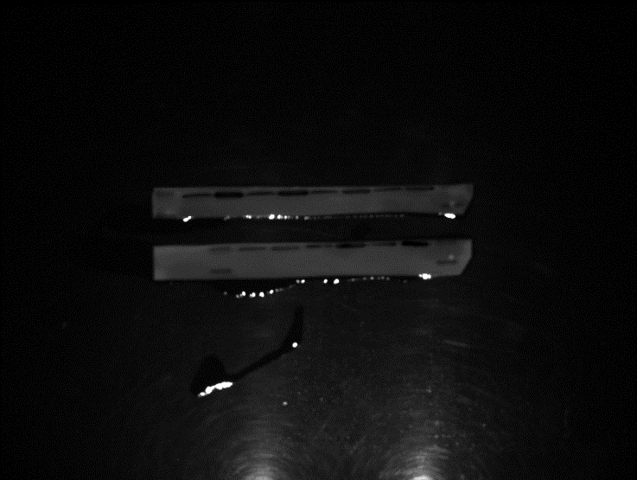 | 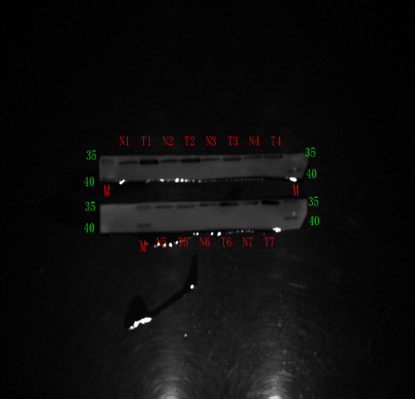

- The original full-length gel/blot bands of LDHA in 7 pairs of ccRCC and adjacent tissues.

The original full-length gel/blot bands | The marked full-length gel/blot bands
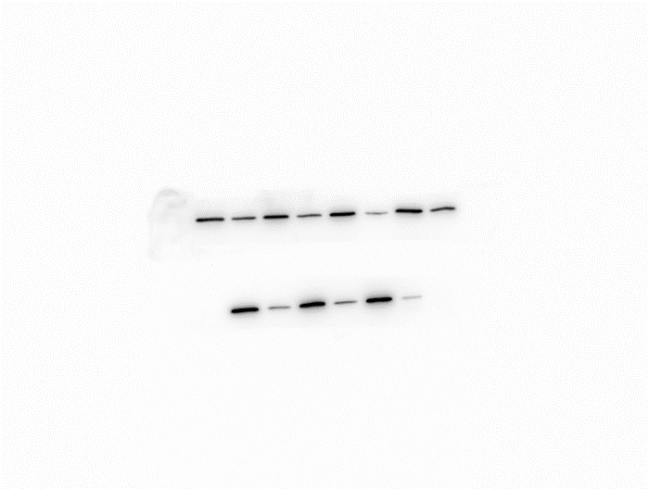 | 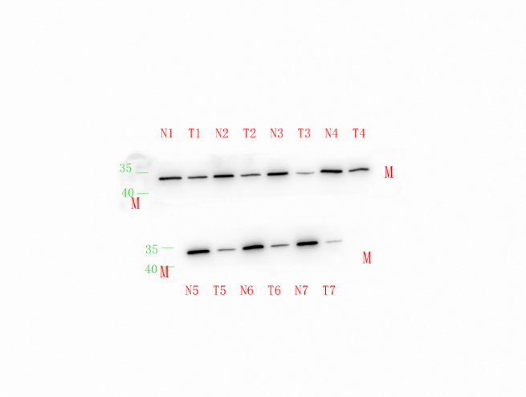

- The original full-length gel/blot bands of LDHB in 7 pairs of ccRCC and adjacent tissues.

The original full-length gel/blot bands | The marked full-length gel/blot bands
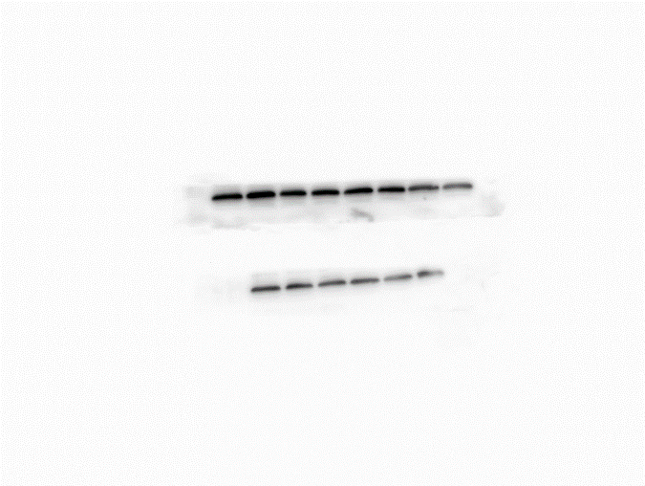 | 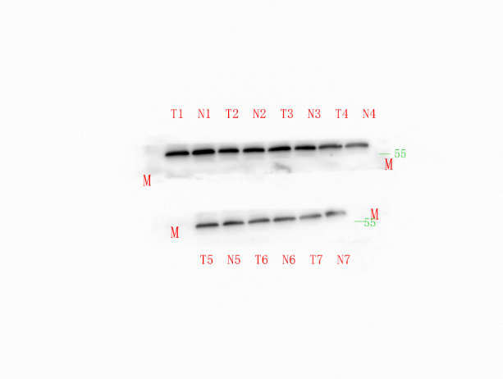

- The original full-length gel/blot bands of Tubulin in 7 pairs of ccRCC and adjacent tissues.

