Supplementary Table 3. Molecular docking results of the first six compounds targeting the core protein S100A1 binding.
Protein | Compound | Structure | Vina(kcal·mol⁻¹) | RMSD | DS(LibDockScore) | Hydrogen bond interaction | Hydrophobic interaction
S100A1  (5K89) | ZINC000049841054 | 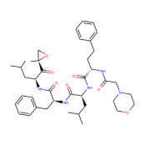 | -5.9 | 1.621 | 155.257 | CYS:86,THR:83 | LEU:12,PHE:45,LEU:37,LEU:38,LEU:42,ALA:8
S100A1  (5K89) | ZINC000085537014 | 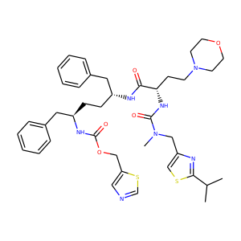 | -5.8 | 1.758 | 155.157 | PHE:45,GLN:39,SER:43 | ALA:85,PHE:45,LEU:82,VAL:79,LEU:42,ALA:8,LEU:37,CYS:86
S100A1  (5K89) | ZINC000003941496 | 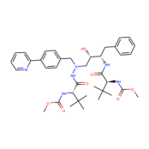 | -6.3 | 1.228 | 152.984 | SER:43,GLN:39,THR:40,THR:83 | LEU:46,CYS:86,ALA:85,LEU:82,LEU:42,TYR:75,LEU:78,LEU:37,VAL:79
S100A1  (5K89) | ZINC000003944422 | 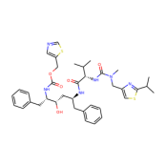 | -5.6 | 1.918 | 151.549 | ASP:47 | LEU:46,CYS:86,ALA:85,LEU:82,VAL:79
S100A1  (5K89) | ZINC000026985532 (Butanediamide) | 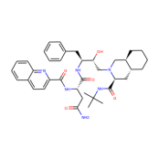 | -7.9 | 2.219 | 144.975 | THR:83 | VA:79,LEU:37,LEU:42
S100A1  (5K89) | ZINC000049783788 | 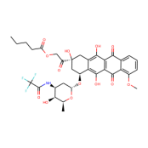 | -6.2 | 2.777 | 143.821 | CYS:86 | LEU:12,VAL:15,VAL:79,LEU:82,PHE:90

