Supplementary Table 4. Molecular docking results of the first six compounds targeting the core protein RASSF8 binding.
Domain | Compound | Structure | Vina(kcal·mol⁻¹) | RMSD | DS(LibDockScore) | Hydrogen bond interaction | Hydrophobic interaction
RASSF8  (2CS4) | ZINC000028232750 | 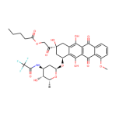 | -5.8 | 2.398 | 146.405 | ARG:86,ARG:85,LEU:84 | TYR:47,ASP:15,TRP:13
RASSF8  (2CS4) | ZINC000003830635 | 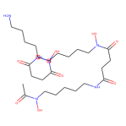 | -3.9 | 2.751 | 145.626 | GLY:16,ASP:15,LEU:84,TRP:13,TYR:47,ARG:86,SER:90 | -
RASSF8  (2CS4) | ZINC000095564694 | 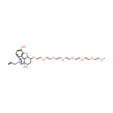 | -4.6 | 2.216 | 139.8 | LYS:52,TRP:13,GLY:16,ARG:85,LEU:84,ASP:15,ILE:20,LEU:37,GLU:57 | -
RASSF8  (2CS4) | ZINC000085537014 | 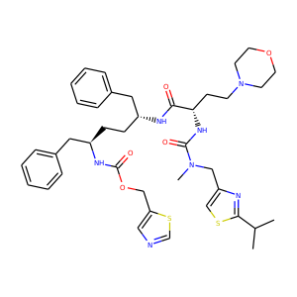 | -5.4 | 2.353 | 139.564 | ARG:85,ASP:15 | ARG:86ILE:83,TRP:13,VAL:14,LEU:84
RASSF8  (2CS4) | ZINC000036701290 | 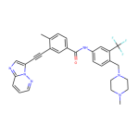 | -6.9 | 1.066 | 137.788 | TRP:13,ARG:43,ARG:86,ARG:85 | LYS:52,ILE:83,LEU:84,VAL:14,ASP:15,TYR:47,ILE:41
RASSF8  (2CS4) | ZINC000072267023 | 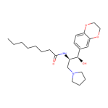 | -4.5 | 1.386 | 137.324 | THR:87,TYR:47 | ARG:46,ILE:35,ALA:38,VAL:34,PRO:62,CYS:30,LEU:49

