Paper 2: Supplementary Material

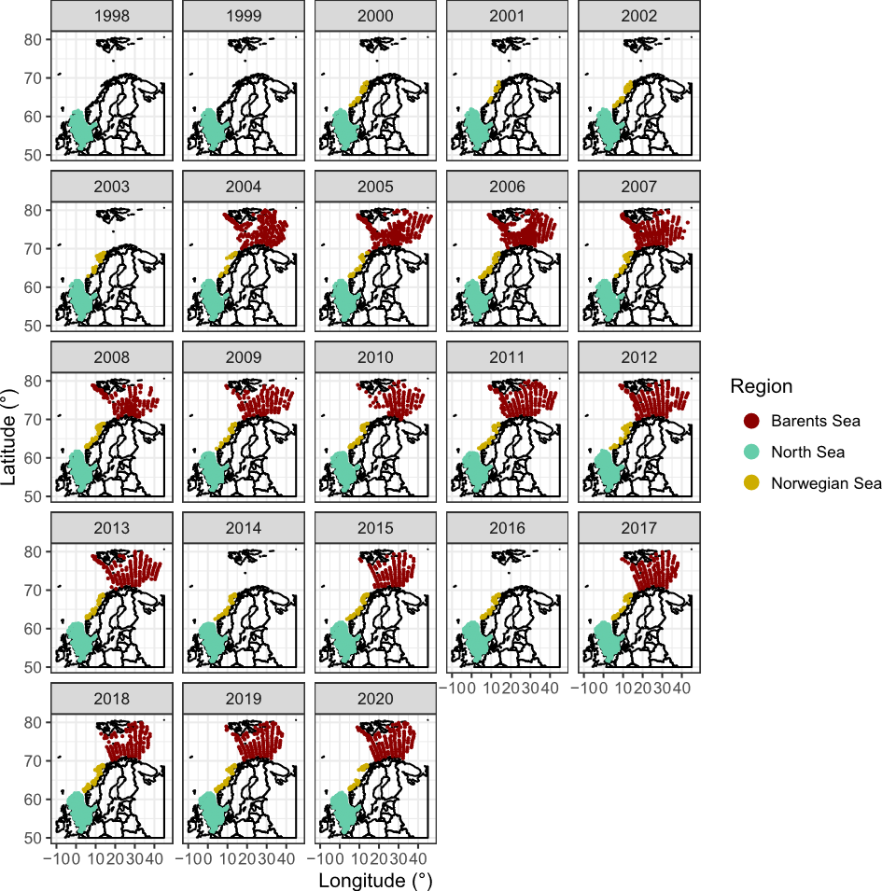
Figure S1. Spatiotemporal distribution of surveys in each region.

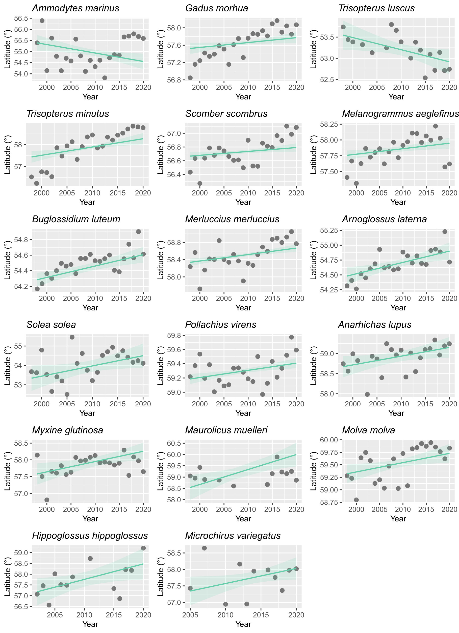
Figure S2. Significant shifts in species mean latitude across time in the North Sea

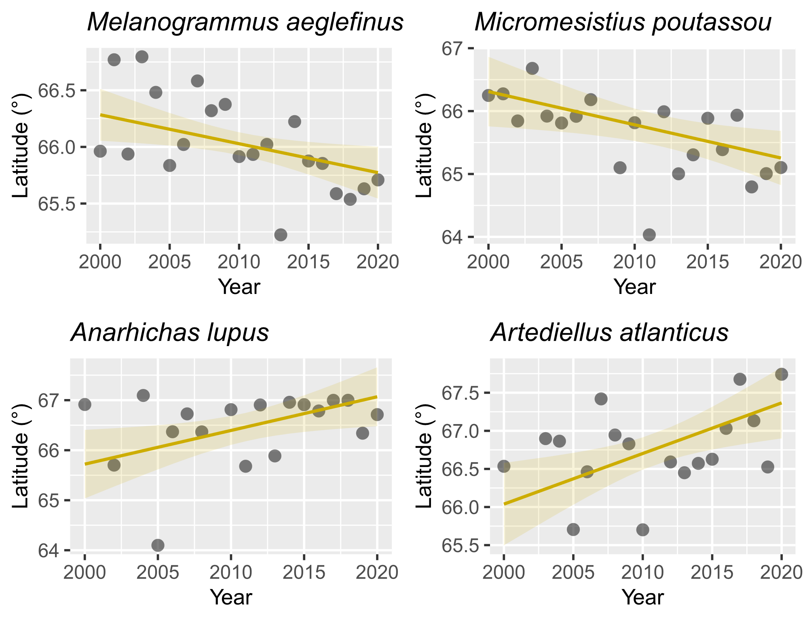

Figure S3. Significant shifts in species mean latitude across time in the Norwegian Sea

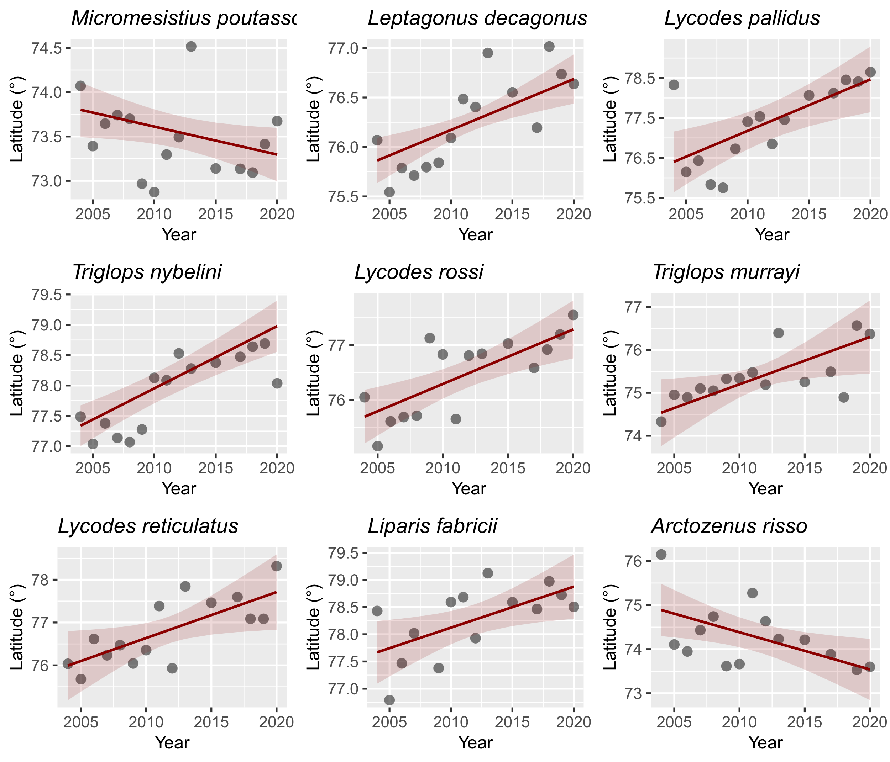
Figure S4. Significant shifts in species mean latitude across time in the Barents Sea

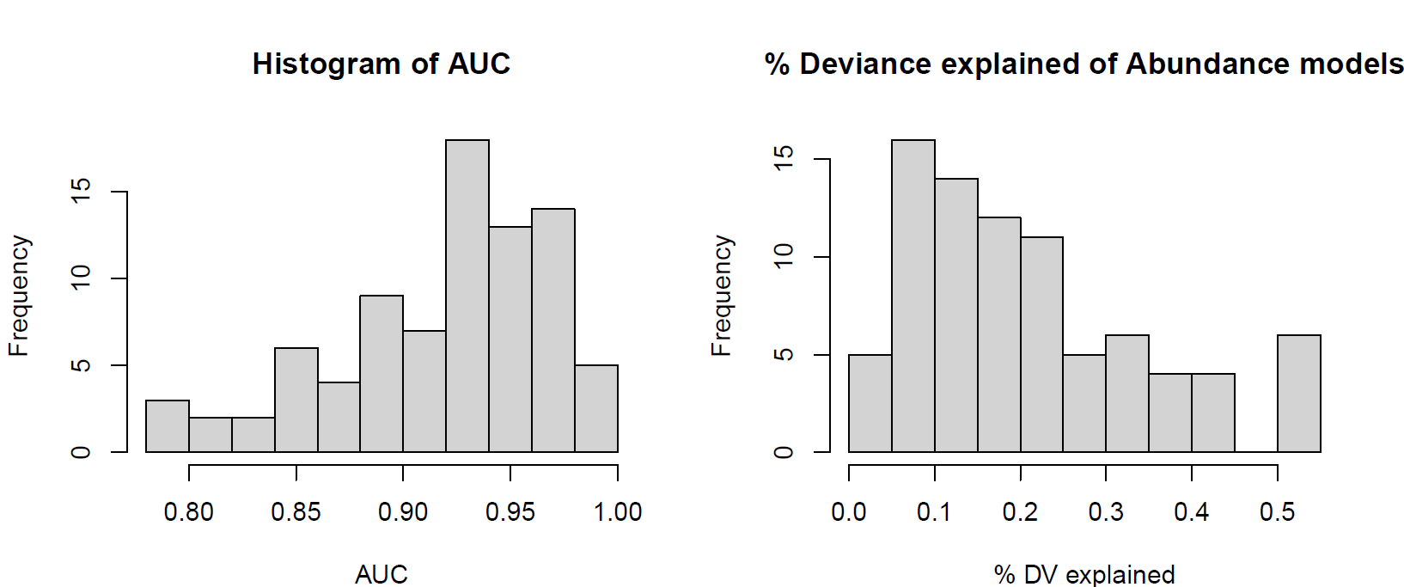
Figure S5. Histogram of all models AUC (step 1 of the two-step models, presence absence GAM binomial models) and %DV explained (Abundance log(Biomass) GAM models).

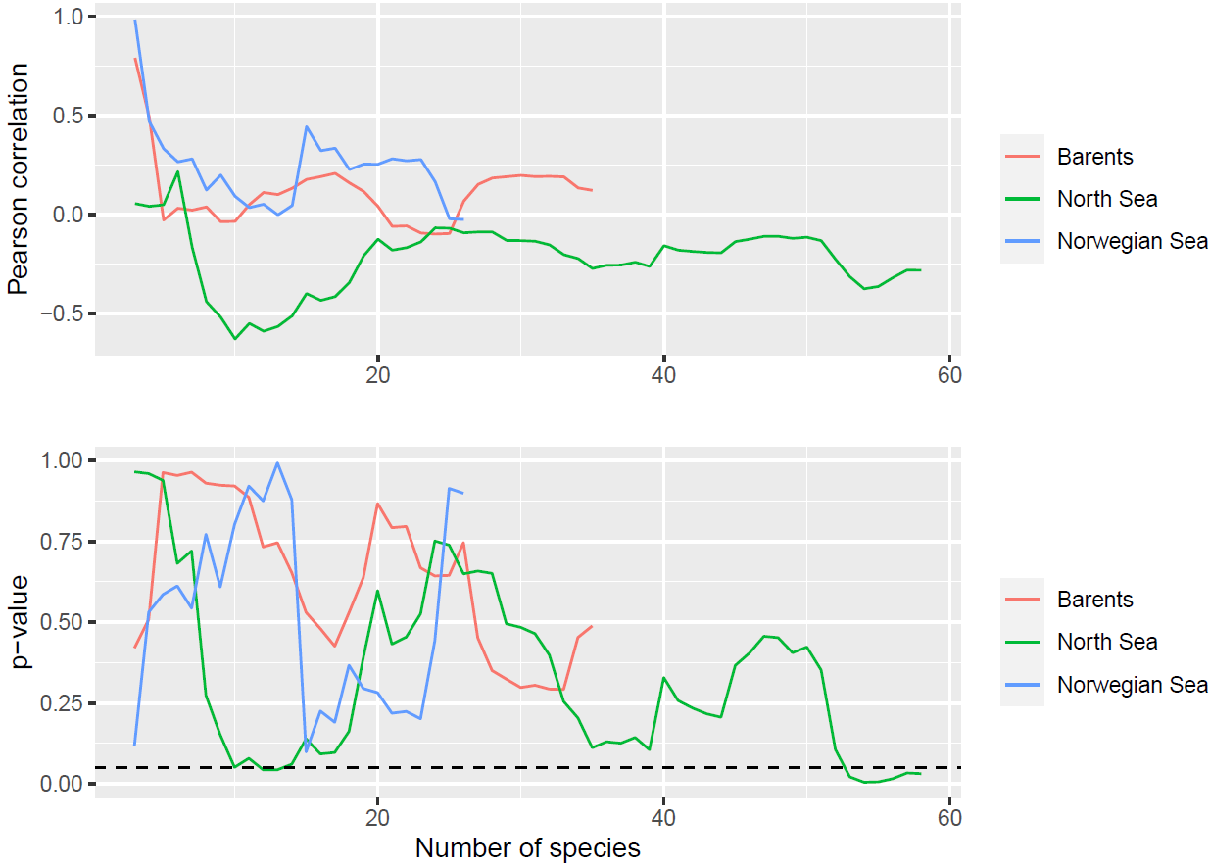
Figure S6. Correlation test results between species latitudinal geographic shifts and species latitudinal thermal envelope shifts at each study area, as the number of species included increases, from best sampled to worst sampled species.

SUPPLEMENTARY TABLES

Table S1. Number of sites from which each species geographic shifts and shifts in thermal envelope were calculated in the 10 least to most species in the surveys.
Index | Species | Region | Hauls
1 | Brosme brosme | North Sea | 73
2 | Clupea harengus | Norwegian Sea | 80
3 | Microchirus variegatus | North Sea | 83
4 | Pollachius pollachius | North Sea | 93
5 | Merluccius merluccius | Norwegian Sea | 98
6 | Hippoglossus hippoglossus | North Sea | 103
7 | Lycodes esmarkii | Barents Sea | 114
8 | Trisopterus minutus | Norwegian Sea | 118
9 | Trachinus draco | North Sea | 120
10 | Lophius piscatorius | Norwegian Sea | 122
… | … | … | …
110 | Gadus morhua | North Sea | 4113
111 | Scomber scombrus | North Sea | 4221
112 | Melanogrammus aeglefinus | North Sea | 4626
113 | Hippoglossoides platessoides | North Sea | 4664
114 | Eutrigla gurnardus | North Sea | 4815
115 | Pleuronectes platessa | North Sea | 4944
116 | Clupea harengus | North Sea | 5080
117 | Microstomus kitt | North Sea | 5097
118 | Limanda limanda | North Sea | 5512
119 | Merlangius merlangus | North Sea | 6229

Table S2. Effect of species number of records in species latitudinal shift and absolute latitudinal shift in each region, using weighted generalised least squared regression.

Study area | Predicted variable | Estimate | r² | P
Barents Sea | Absolute shift rate | -3 x 10 -3 | 0.17 | < 0.05
Norwegian Sea | Absolute shift rate | -1 x 10 -2 | 0.36 | < 0.05
North Sea | Absolute shift rate | -7 x 10-4 | 0.26 | < 0.05
Barents Sea | Shift rate | -4 x 10 -3 | 0.10 | < 0.05
Norwegian Sea | Shift rate | 6 x 10 -3 | 0.001 | 0.9
North Sea | Shift rate | 2 x 10 -4 | 0.006 | 0.5

