Supporting Information for

Body size and trophic level increase with latitude and decrease in the deep-sea and Antarctica for marine fish species

Table S1. Comparison of species number between FishBase and this study

Fish group |  | FishBase |  | This Study
 |  | Species number |  | Species number |  | %
All fish |  | 15195 |  | 5619 |  | 37
With body size records |  | 13894 |  | 5619 |  | 40
With trophic level records |  | 15194 |  | 5619 |  | 37
In traits group
Maximum body size (cm) | FishBase |  |  |  | This Study
 | Species number |  | % of all records |  | Species number |  | % of 5619 species |  | % of FishBase species
< 30 | 8644 |  | 62 |  | 2743 |  | 49 |  | 32
30 - 100 | 4402 |  | 32 |  | 2260 |  | 40 |  | 51
> 100 | 848 |  | 6 |  | 616 |  | 11 |  | 73
Trophic level
< 2.20 | 468 |  | 3 |  | 242 |  | 4 |  | 52
2.20 - 2.80 | 621 |  | 4 |  | 286 |  | 5 |  | 46
2.81 - 3.70 | 10203 |  | 67 |  | 3234 |  | 58 |  | 32
> 3.7 | 3902 |  | 26 |  | 1857 |  | 33 |  | 48

Table S2. Number of species for groups of three body sizes and four trophic levels in the 5-degree latitude band in the whole water column.

Latitude (°) | All fish | Maximum body size (cm) |  |  |  | Trophic level
 |  | < 30 | 30 - 100 | > 100 |  | < 2.20 | 2.21 -2.80 | 2.81 - 3.70 | > 3.70
-75 | 72 | 39 | 32 | 1 |  | 0 | 1 | 58 | 13
-70 | 95 | 52 | 40 | 3 |  | 0 | 1 | 72 | 22
-65 | 120 | 63 | 52 | 5 |  | 0 | 1 | 94 | 25
-60 | 177 | 81 | 74 | 22 |  | 2 | 3 | 118 | 54
-55 | 265 | 95 | 110 | 60 |  | 2 | 4 | 143 | 116
-50 | 396 | 152 | 151 | 93 |  | 5 | 7 | 209 | 175
-45 | 581 | 212 | 234 | 135 |  | 10 | 13 | 301 | 257
-40 | 828 | 298 | 342 | 188 |  | 15 | 25 | 402 | 386
-35 | 1462 | 550 | 634 | 278 |  | 45 | 66 | 740 | 611
-30 | 1997 | 845 | 831 | 321 |  | 100 | 111 | 1035 | 751
-25 | 2543 | 1197 | 988 | 358 |  | 155 | 158 | 1325 | 905
-20 | 2777 | 1343 | 1063 | 371 |  | 156 | 167 | 1470 | 984
-15 | 2914 | 1418 | 1119 | 377 |  | 173 | 172 | 1543 | 1026
-10 | 3090 | 1549 | 1159 | 382 |  | 181 | 188 | 1655 | 1066
-5 | 3147 | 1572 | 1188 | 387 |  | 183 | 180 | 1690 | 1094
0 | 3188 | 1590 | 1206 | 392 |  | 187 | 188 | 1706 | 1107
5 | 3299 | 1661 | 1248 | 390 |  | 192 | 189 | 1781 | 1137
10 | 3461 | 1743 | 1323 | 395 |  | 196 | 189 | 1894 | 1182
15 | 3480 | 1722 | 1353 | 405 |  | 197 | 193 | 1895 | 1195
20 | 3532 | 1721 | 1393 | 418 |  | 196 | 187 | 1946 | 1203
25 | 3533 | 1664 | 1438 | 431 |  | 180 | 181 | 1940 | 1232
30 | 3397 | 1551 | 1426 | 420 |  | 171 | 158 | 1865 | 1203
35 | 2341 | 931 | 1021 | 389 |  | 66 | 81 | 1281 | 913
40 | 1656 | 610 | 716 | 330 |  | 33 | 40 | 907 | 676
45 | 1291 | 478 | 552 | 261 |  | 18 | 29 | 726 | 518
50 | 897 | 325 | 394 | 178 |  | 4 | 17 | 522 | 354
55 | 750 | 268 | 334 | 148 |  | 1 | 12 | 452 | 285
60 | 633 | 222 | 277 | 134 |  | 1 | 11 | 367 | 254
65 | 434 | 147 | 190 | 97 |  | 0 | 5 | 253 | 176
70 | 216 | 67 | 82 | 67 |  | 0 | 1 | 123 | 92
75 | 113 | 37 | 43 | 33 |  | 0 | 1 | 66 | 46

Table S3. Number of species for groups of three body sizes and four trophic levels in the 5-degree latitude band in the surface zone (0 – 200 m).

Latitude (°) | All fish | Maximum body size (cm) |  |  |  | Trophic level
 |  | < 30 | 30 - 100 | > 100 |  | < 2.20 | 2.21 -2.80 | 2.81 - 3.70 | > 3.70
-75 | 8 | 4 | 4 | 0 |  | 0 | 0 | 7 | 1
-70 | 13 | 6 | 7 | 0 |  | 0 | 0 | 9 | 4
-65 | 16 | 7 | 9 | 0 |  | 0 | 0 | 12 | 4
-60 | 24 | 11 | 10 | 3 |  | 1 | 2 | 13 | 8
-55 | 59 | 17 | 29 | 13 |  | 1 | 3 | 27 | 28
-50 | 112 | 34 | 50 | 28 |  | 4 | 6 | 55 | 47
-45 | 231 | 72 | 104 | 55 |  | 9 | 12 | 116 | 94
-40 | 402 | 125 | 181 | 96 |  | 14 | 25 | 186 | 177
-35 | 908 | 314 | 430 | 164 |  | 44 | 66 | 462 | 336
-30 | 1406 | 589 | 614 | 203 |  | 99 | 111 | 745 | 451
-25 | 1931 | 922 | 768 | 241 |  | 154 | 158 | 1032 | 587
-20 | 2129 | 1042 | 830 | 257 |  | 155 | 167 | 1152 | 655
-15 | 2264 | 1110 | 883 | 271 |  | 172 | 172 | 1217 | 703
-10 | 2419 | 1221 | 921 | 277 |  | 180 | 188 | 1313 | 738
-5 | 2467 | 1237 | 945 | 285 |  | 183 | 180 | 1341 | 763
0 | 2511 | 1254 | 965 | 292 |  | 187 | 188 | 1357 | 779
5 | 2595 | 1308 | 995 | 292 |  | 192 | 189 | 1413 | 801
10 | 2714 | 1376 | 1044 | 294 |  | 196 | 189 | 1502 | 827
15 | 2715 | 1350 | 1068 | 297 |  | 197 | 192 | 1495 | 831
20 | 2719 | 1323 | 1095 | 301 |  | 196 | 186 | 1511 | 826
25 | 2679 | 1263 | 1111 | 305 |  | 180 | 180 | 1484 | 835
30 | 2517 | 1149 | 1080 | 288 |  | 171 | 156 | 1400 | 790
35 | 1527 | 576 | 702 | 249 |  | 66 | 80 | 842 | 539
40 | 952 | 313 | 436 | 203 |  | 33 | 39 | 514 | 366
45 | 711 | 248 | 318 | 145 |  | 18 | 28 | 398 | 267
50 | 423 | 151 | 192 | 80 |  | 4 | 16 | 256 | 147
55 | 345 | 127 | 155 | 63 |  | 1 | 11 | 217 | 116
60 | 292 | 108 | 132 | 52 |  | 1 | 11 | 179 | 101
65 | 176 | 63 | 80 | 33 |  | 0 | 5 | 107 | 64
70 | 98 | 34 | 41 | 23 |  | 0 | 1 | 63 | 34
75 | 48 | 17 | 21 | 10 |  | 0 | 1 | 30 | 17

Table S4. Number of species for groups of three body sizes and four trophic levels in the 5-degree latitude band in the middle zone (201 – 1000 m).

Latitude (°) | All fish | Maximum body size (cm) |  |  |  | Trophic level
 |  | < 30 | 30 - 100 | > 100 |  | < 2.20 | 2.21 -2.80 | 2.81 - 3.70 | > 3.70
-75 | 50 | 28 | 21 | 1 |  | 0 | 1 | 40 | 9
-70 | 61 | 36 | 22 | 3 |  | 0 | 1 | 47 | 13
-65 | 74 | 40 | 30 | 4 |  | 0 | 1 | 59 | 14
-60 | 97 | 41 | 44 | 12 |  | 1 | 1 | 63 | 32
-55 | 135 | 40 | 59 | 36 |  | 1 | 1 | 64 | 69
-50 | 193 | 72 | 70 | 51 |  | 1 | 1 | 92 | 99
-45 | 246 | 88 | 94 | 64 |  | 1 | 1 | 117 | 127
-40 | 303 | 115 | 115 | 73 |  | 1 | 0 | 143 | 159
-35 | 403 | 163 | 146 | 94 |  | 1 | 0 | 189 | 213
-30 | 441 | 183 | 160 | 98 |  | 1 | 0 | 204 | 236
-25 | 460 | 203 | 162 | 95 |  | 1 | 0 | 208 | 251
-20 | 482 | 219 | 171 | 92 |  | 1 | 0 | 224 | 257
-15 | 487 | 229 | 173 | 85 |  | 1 | 0 | 234 | 252
-10 | 502 | 246 | 173 | 83 |  | 1 | 0 | 243 | 258
-5 | 507 | 252 | 173 | 82 |  | 0 | 0 | 245 | 262
0 | 501 | 254 | 167 | 80 |  | 0 | 0 | 245 | 256
5 | 525 | 269 | 176 | 80 |  | 0 | 0 | 262 | 263
10 | 558 | 283 | 193 | 82 |  | 0 | 0 | 281 | 277
15 | 571 | 288 | 196 | 87 |  | 0 | 1 | 286 | 284
20 | 606 | 307 | 204 | 95 |  | 0 | 1 | 309 | 296
25 | 638 | 305 | 231 | 102 |  | 0 | 1 | 325 | 312
30 | 666 | 308 | 252 | 106 |  | 0 | 2 | 337 | 327
35 | 607 | 269 | 225 | 113 |  | 0 | 1 | 317 | 289
40 | 525 | 223 | 198 | 104 |  | 0 | 1 | 284 | 240
45 | 425 | 171 | 161 | 93 |  | 0 | 1 | 235 | 189
50 | 340 | 130 | 134 | 76 |  | 0 | 1 | 189 | 150
55 | 288 | 102 | 122 | 64 |  | 0 | 1 | 166 | 121
60 | 253 | 82 | 108 | 63 |  | 0 | 0 | 141 | 112
65 | 187 | 57 | 81 | 49 |  | 0 | 0 | 108 | 79
70 | 97 | 27 | 34 | 36 |  | 0 | 0 | 53 | 44
75 | 56 | 15 | 21 | 20 |  | 0 | 0 | 31 | 25

Table S5. Number of species for groups of three body sizes and four trophic levels in the 5-degree latitude band in the deep zone (1001 – 6000 m).

Latitude (°) | All fish | Maximum body size (cm) |  |  |  | Trophic level
 |  | < 30 | 30 - 100 | > 100 |  | < 2.20 | 2.21 -2.80 | 2.81 - 3.70 | > 3.70
-75 | 14 | 7 | 7 | 0 |  | 0 | 0 | 11 | 3
-70 | 21 | 10 | 11 | 0 |  | 0 | 0 | 16 | 5
-65 | 30 | 16 | 13 | 1 |  | 0 | 0 | 23 | 7
-60 | 56 | 29 | 20 | 7 |  | 0 | 0 | 42 | 14
-55 | 71 | 38 | 22 | 11 |  | 0 | 0 | 52 | 19
-50 | 91 | 46 | 31 | 14 |  | 0 | 0 | 62 | 29
-45 | 104 | 52 | 36 | 16 |  | 0 | 0 | 68 | 36
-40 | 123 | 58 | 46 | 19 |  | 0 | 0 | 73 | 50
-35 | 151 | 73 | 58 | 20 |  | 0 | 0 | 89 | 62
-30 | 150 | 73 | 57 | 20 |  | 0 | 0 | 86 | 64
-25 | 152 | 72 | 58 | 22 |  | 0 | 0 | 85 | 67
-20 | 166 | 82 | 62 | 22 |  | 0 | 0 | 94 | 72
-15 | 163 | 79 | 63 | 21 |  | 0 | 0 | 92 | 71
-10 | 169 | 82 | 65 | 22 |  | 0 | 0 | 99 | 70
-5 | 173 | 83 | 70 | 20 |  | 0 | 0 | 104 | 69
0 | 176 | 82 | 74 | 20 |  | 0 | 0 | 104 | 72
5 | 179 | 84 | 77 | 18 |  | 0 | 0 | 106 | 73
10 | 189 | 84 | 86 | 19 |  | 0 | 0 | 111 | 78
15 | 194 | 84 | 89 | 21 |  | 0 | 0 | 114 | 80
20 | 207 | 91 | 94 | 22 |  | 0 | 0 | 126 | 81
25 | 216 | 96 | 96 | 24 |  | 0 | 0 | 131 | 85
30 | 214 | 94 | 94 | 26 |  | 0 | 0 | 128 | 86
35 | 207 | 86 | 94 | 27 |  | 0 | 0 | 122 | 85
40 | 179 | 74 | 82 | 23 |  | 0 | 0 | 109 | 70
45 | 155 | 59 | 73 | 23 |  | 0 | 0 | 93 | 62
50 | 134 | 44 | 68 | 22 |  | 0 | 0 | 77 | 57
55 | 117 | 39 | 57 | 21 |  | 0 | 0 | 69 | 48
60 | 88 | 32 | 37 | 19 |  | 0 | 0 | 47 | 41
65 | 71 | 27 | 29 | 15 |  | 0 | 0 | 38 | 33
70 | 21 | 6 | 7 | 8 |  | 0 | 0 | 7 | 14
75 | 9 | 5 | 1 | 3 |  | 0 | 0 | 5 | 4

Table S6. Number of species for all fish, three body sizes and four trophic levels along 100 m depth bands.

Depth band (m) | All fish | Maximum body size (cm) |  |  | Trophic level
 |  | < 30 | 30 -100 | > 100 |  | < 2.20 | 2.21 -2.80 | 2.81 - 3.70 | > 3.70
0 - 100 | 4224 | 2104 | 1666 | 454 |  | 241 | 285 | 2443 | 1255
101 - 200 | 1153 | 428 | 525 | 200 |  | 3 | 13 | 597 | 540
201 - 300 | 904 | 386 | 358 | 160 |  | 1 | 4 | 477 | 422
301 - 400 | 736 | 344 | 277 | 115 |  | 1 | 2 | 392 | 341
401 - 500 | 636 | 294 | 233 | 109 |  | 1 | 1 | 332 | 302
501 - 600 | 517 | 247 | 187 | 83 |  | 1 | 1 | 273 | 242
601 - 700 | 444 | 219 | 164 | 61 |  | 0 | 0 | 253 | 191
701 - 800 | 401 | 192 | 155 | 54 |  | 0 | 0 | 240 | 161
801 - 900 | 360 | 170 | 143 | 47 |  | 0 | 0 | 226 | 134
901 - 1000 | 278 | 125 | 114 | 39 |  | 0 | 0 | 166 | 112
1001 - 1100 | 242 | 107 | 99 | 36 |  | 0 | 0 | 141 | 101
1101 - 1200 | 206 | 87 | 88 | 31 |  | 0 | 0 | 115 | 91
1201 - 1300 | 163 | 70 | 69 | 24 |  | 0 | 0 | 90 | 73
1301 - 1400 | 131 | 59 | 54 | 18 |  | 0 | 0 | 74 | 57
1401 - 1500 | 138 | 75 | 48 | 15 |  | 0 | 0 | 79 | 59
1501 - 1600 | 129 | 72 | 46 | 11 |  | 0 | 0 | 74 | 55
1601 - 1700 | 112 | 63 | 41 | 8 |  | 0 | 0 | 66 | 46
1701 - 1800 | 100 | 54 | 38 | 8 |  | 0 | 0 | 56 | 44
1801 - 1900 | 92 | 49 | 36 | 7 |  | 0 | 0 | 54 | 38
1901 - 2000 | 82 | 44 | 33 | 5 |  | 0 | 0 | 47 | 35
2001 - 2100 | 77 | 43 | 28 | 6 |  | 0 | 0 | 47 | 30
2101 - 2200 | 63 | 39 | 20 | 4 |  | 0 | 0 | 40 | 23
2201 - 2300 | 59 | 37 | 18 | 4 |  | 0 | 0 | 36 | 23
2301 - 2400 | 36 | 17 | 16 | 3 |  | 0 | 0 | 26 | 10
2401 - 2500 | 32 | 15 | 14 | 3 |  | 0 | 0 | 23 | 9
2501 - 2600 | 23 | 12 | 9 | 2 |  | 0 | 0 | 16 | 7
2601 - 2700 | 13 | 6 | 6 | 1 |  | 0 | 0 | 10 | 3
2701 - 2800 | 14 | 6 | 7 | 1 |  | 0 | 0 | 11 | 3
2801 - 2900 | 15 | 5 | 9 | 1 |  | 0 | 0 | 12 | 3
2901 - 3000 | 14 | 4 | 9 | 1 |  | 0 | 0 | 11 | 3
3001 - 3100 | 14 | 4 | 9 | 1 |  | 0 | 0 | 12 | 2
3101 - 3200 | 12 | 3 | 9 | 0 |  | 0 | 0 | 11 | 1
3201 - 3300 | 10 | 2 | 8 | 0 |  | 0 | 0 | 9 | 1
3301 - 3400 | 8 | 2 | 6 | 0 |  | 0 | 0 | 7 | 1
3401 - 3500 | 6 | 2 | 4 | 0 |  | 0 | 0 | 5 | 1

Table S7. Mean and standard error (± SE) of maximum body size (cm) and trophic level for all fish in 5-degree latitude bands.

 | Maximum body size (cm) |  |  |  |  |  |  |  |  | Trophic level
Latitude (°) | Whole water column |  | 0 - 200 m |  | 201 - 1000 m |  | 1000 - 6000 m |  |  | Whole water column |  | 0 - 200 m |  | 201 - 1000 m |  | 1000 - 6000 m
 | Mean | Standard error | Mean | Standard error | Mean | Standard error | Mean | Standard error | Mean |  | Standard error | Mean | Standard error | Mean | Standard error | Mean | Standard error
-75 | 33.6 | 3.2 | 26.5 | 9.4 | 32.6 | 4.1 | 35.2 | 6.2 | 3.4 |  | 0.0 | 3.4 | 0.6 | 3.4 | 0.0 | 3.5 | 0.1
-70 | 35.5 | 3.1 | 33.4 | 9.3 | 33.0 | 3.9 | 37.6 | 5.9 | 3.5 |  | 0.0 | 3.6 | 1.2 | 3.5 | 0.0 | 3.5 | 0.1
-65 | 39.7 | 4.0 | 31.8 | 8.0 | 38.9 | 5.4 | 39.9 | 7.6 | 3.5 |  | 0.0 | 3.6 | 1.1 | 3.5 | 0.0 | 3.5 | 0.1
-60 | 66.4 | 10.4 | 138.4 | 28.3 | 73.3 | 17.3 | 47.9 | 6.9 | 3.6 |  | 0.0 | 3.5 | 0.4 | 3.6 | 0.0 | 3.5 | 0.0
-55 | 87.5 | 8.6 | 151.4 | 19.7 | 98.2 | 14.0 | 50.0 | 6.4 | 3.7 |  | 0.0 | 3.7 | 0.2 | 3.7 | 0.0 | 3.6 | 0.0
-50 | 89.9 | 8.2 | 228.9 | 21.6 | 89.9 | 10.6 | 52.2 | 7.1 | 3.7 |  | 0.0 | 3.6 | 0.3 | 3.8 | 0.0 | 3.6 | 0.0
-45 | 86.0 | 6.0 | 173.5 | 11.4 | 88.4 | 8.8 | 52.1 | 6.4 | 3.7 |  | 0.0 | 3.6 | 0.3 | 3.8 | 0.0 | 3.6 | 0.0
-40 | 83.2 | 4.6 | 150.5 | 7.5 | 81.3 | 7.3 | 52.5 | 5.6 | 3.7 |  | 0.0 | 3.6 | 0.0 | 3.8 | 0.0 | 3.7 | 0.0
-35 | 73.8 | 3.0 | 120.6 | 4.0 | 78.9 | 5.8 | 49.5 | 4.7 | 3.6 |  | 0.0 | 3.5 | 0.1 | 3.8 | 0.0 | 3.7 | 0.0
-30 | 65.1 | 2.3 | 103.4 | 2.8 | 75.0 | 5.4 | 48.7 | 4.6 | 3.5 |  | 0.0 | 3.4 | -0.1 | 3.8 | 0.0 | 3.7 | 0.0
-25 | 58.8 | 1.9 | 93.0 | 2.1 | 71.6 | 5.2 | 50.3 | 4.7 | 3.5 |  | 0.0 | 3.4 | -0.2 | 3.8 | 0.0 | 3.7 | 0.0
-20 | 56.8 | 1.8 | 91.0 | 2.0 | 68.7 | 5.0 | 47.9 | 4.3 | 3.5 |  | 0.0 | 3.4 | -0.2 | 3.8 | 0.0 | 3.7 | 0.0
-15 | 56.2 | 1.7 | 90.2 | 1.9 | 66.6 | 4.9 | 48.0 | 4.4 | 3.5 |  | 0.0 | 3.4 | -0.2 | 3.7 | 0.0 | 3.7 | 0.0
-10 | 54.7 | 1.6 | 88.2 | 1.8 | 64.9 | 4.8 | 48.2 | 4.3 | 3.5 |  | 0.0 | 3.4 | -0.2 | 3.7 | 0.0 | 3.7 | 0.0
-5 | 54.7 | 1.6 | 87.8 | 1.8 | 64.2 | 4.7 | 45.8 | 3.9 | 3.5 |  | 0.0 | 3.4 | -0.2 | 3.7 | 0.0 | 3.7 | 0.0
0 | 54.6 | 1.6 | 87.3 | 1.7 | 63.8 | 4.8 | 46.3 | 3.9 | 3.5 |  | 0.0 | 3.4 | -0.2 | 3.7 | 0.0 | 3.7 | 0.0
5 | 53.7 | 1.5 | 85.9 | 1.7 | 62.2 | 4.6 | 45.4 | 3.7 | 3.5 |  | 0.0 | 3.4 | -0.2 | 3.7 | 0.0 | 3.7 | 0.0
10 | 53.0 | 1.5 | 84.5 | 1.6 | 61.4 | 4.3 | 46.5 | 3.6 | 3.5 |  | 0.0 | 3.4 | -0.2 | 3.7 | 0.0 | 3.7 | 0.0
15 | 53.7 | 1.5 | 85.0 | 1.6 | 62.0 | 4.3 | 47.7 | 3.5 | 3.5 |  | 0.0 | 3.4 | -0.2 | 3.7 | 0.0 | 3.7 | 0.0
20 | 54.1 | 1.4 | 84.8 | 1.6 | 61.2 | 4.1 | 47.3 | 3.4 | 3.5 |  | 0.0 | 3.4 | -0.2 | 3.7 | 0.0 | 3.7 | 0.0
25 | 55.1 | 1.4 | 85.1 | 1.6 | 62.3 | 3.9 | 47.6 | 3.3 | 3.5 |  | 0.0 | 3.4 | -0.2 | 3.7 | 0.0 | 3.7 | 0.0
30 | 56.2 | 1.5 | 86.6 | 1.7 | 62.7 | 3.7 | 48.7 | 3.4 | 3.5 |  | 0.0 | 3.4 | -0.2 | 3.7 | 0.0 | 3.7 | 0.0
35 | 66.0 | 2.0 | 100.1 | 2.6 | 67.9 | 4.2 | 50.6 | 3.5 | 3.6 |  | 0.0 | 3.5 | 0.2 | 3.7 | 0.0 | 3.7 | 0.0
40 | 74.8 | 2.7 | 120.1 | 3.9 | 72.0 | 4.8 | 51.5 | 3.9 | 3.6 |  | 0.0 | 3.6 | 0.3 | 3.7 | 0.0 | 3.7 | 0.0
45 | 76.5 | 3.3 | 128.9 | 4.8 | 77.0 | 5.7 | 55.0 | 4.4 | 3.6 |  | 0.0 | 3.6 | 0.4 | 3.7 | 0.0 | 3.7 | 0.0
50 | 76.2 | 4.2 | 142.4 | 6.9 | 79.3 | 6.7 | 59.6 | 5.0 | 3.6 |  | 0.0 | 3.6 | 0.6 | 3.7 | 0.0 | 3.7 | 0.0
55 | 76.8 | 4.8 | 152.2 | 8.2 | 79.5 | 7.4 | 61.1 | 5.5 | 3.6 |  | 0.0 | 3.6 | 0.6 | 3.7 | 0.0 | 3.7 | 0.0
60 | 75.9 | 4.5 | 104.6 | 6.1 | 84.7 | 8.3 | 64.5 | 7.0 | 3.7 |  | 0.0 | 3.6 | 0.6 | 3.7 | 0.0 | 3.7 | 0.0
65 | 82.0 | 6.0 | 113.2 | 8.5 | 94.4 | 10.9 | 64.0 | 8.2 | 3.7 |  | 0.0 | 3.6 | 0.7 | 3.7 | 0.0 | 3.7 | 0.1
70 | 98.6 | 10.4 | 123.7 | 12.5 | 117.8 | 19.1 | 79.8 | 13.5 | 3.7 |  | 0.0 | 3.7 | 1.0 | 3.7 | 0.0 | 3.9 | 0.1
75 | 97.2 | 16.4 | 90.1 | 13.0 | 128.7 | 30.6 | 57.6 | 23.0 | 3.7 |  | 0.0 | 3.7 | 0.7 | 3.7 | 0.1 | 3.9 | 0.2

Table S8. Mean and standard error (± SE) of maximum body size (cm) and trophic level for all fish along 100 m depth bands

Depth band (m) | Maximum body size (cm) |  | Trophic level
 | Mean | SE | Mean | SE
0 - 100 | 50.6 | 1.2 | 3.4 | 0.0
101 - 200 | 69.0 | 2.8 | 3.7 | 0.0
201 - 300 | 66.9 | 3.3 | 3.7 | 0.0
301 - 400 | 60.0 | 3.5 | 3.7 | 0.0
401 - 500 | 62.0 | 3.9 | 3.7 | 0.0
501 - 600 | 59.6 | 4.4 | 3.7 | 0.0
601 - 700 | 55.7 | 4.8 | 3.7 | 0.0
701 - 800 | 55.0 | 4.9 | 3.7 | 0.0
801 - 900 | 55.6 | 5.4 | 3.7 | 0.0
901 - 1000 | 52.8 | 3.8 | 3.7 | 0.0
1001 - 1100 | 50.7 | 3.4 | 3.7 | 0.0
1101 - 1200 | 52.1 | 3.8 | 3.7 | 0.0
1201 - 1300 | 48.8 | 3.4 | 3.7 | 0.0
1301 - 1400 | 46.8 | 3.6 | 3.7 | 0.0
1401 - 1500 | 42.1 | 3.3 | 3.7 | 0.0
1501 - 1600 | 40.7 | 3.4 | 3.7 | 0.0
1601 - 1700 | 39.3 | 3.4 | 3.7 | 0.0
1701 - 1800 | 40.7 | 3.6 | 3.7 | 0.0
1801 - 1900 | 41.1 | 3.8 | 3.7 | 0.0
1901 - 2000 | 39.3 | 3.5 | 3.7 | 0.1
2001 - 2100 | 40.9 | 3.9 | 3.7 | 0.1
2101 - 2200 | 35.2 | 3.9 | 3.6 | 0.1
2201 - 2300 | 35.2 | 4.2 | 3.7 | 0.1
2301 - 2400 | 42.2 | 5.7 | 3.5 | 0.1
2401 - 2500 | 39.9 | 6.1 | 3.5 | 0.1
2501 - 2600 | 40.1 | 7.0 | 3.6 | 0.1
2601 - 2700 | 40.8 | 9.6 | 3.5 | 0.1
2701 - 2800 | 43.4 | 9.0 | 3.5 | 0.1
2801 - 2900 | 45.3 | 8.0 | 3.5 | 0.1
2901 - 3000 | 48.0 | 8.1 | 3.5 | 0.1
3001 - 3100 | 49.5 | 8.1 | 3.5 | 0.1
3101 - 3200 | 42.8 | 5.0 | 3.4 | 0.1
3201 - 3300 | 43.9 | 4.9 | 3.4 | 0.1
3301 - 3400 | 41.2 | 4.6 | 3.4 | 0.1
3401 - 3500 | 39.6 | 6.0 | 3.3 | 0.1

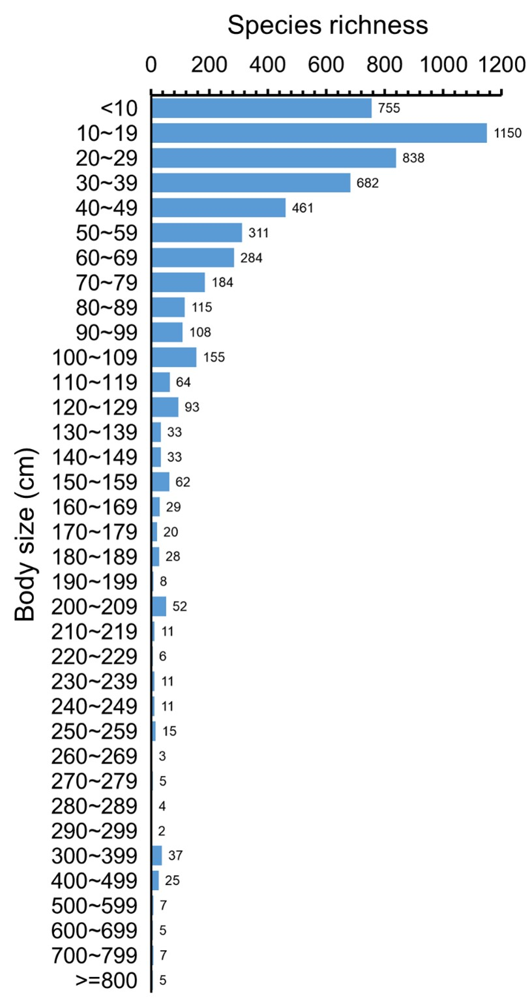

Figure S1. Number of species of marine fish in different body size groups.

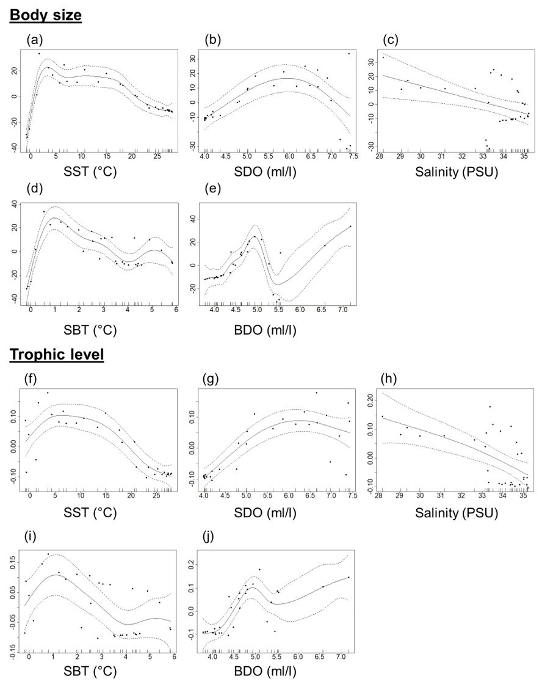
Figure S2: The smoothed GAM (solid lines) for (a – e) mean body size and (f – j) mean trophic level of all fish against sea surface temperature (SST), dissolved oxygen (SDO), salinity, and sea bottom temperature (SBT) and dissolved oxygen (BDO) in 5-degree latitude bands. The dashed lines indicate the 95% confidence intervals. The black dots and tick marks on the x-axis are observed data points. The y-axis represents the spline function. PSU is practical salinity units.

