Job billowing-tree-605c
This output file was generated at:
2022-Feb-09 17:22:27 PST
This document is not permanent. It will automatically be removed from the server in seven (7) days. Please save or print it for your records. If images are missing, try reloading; this sometimes happens under heavy server load.

Single file archive including this page, all images, all clumpp files: download. [.tar.gz]

L(K)
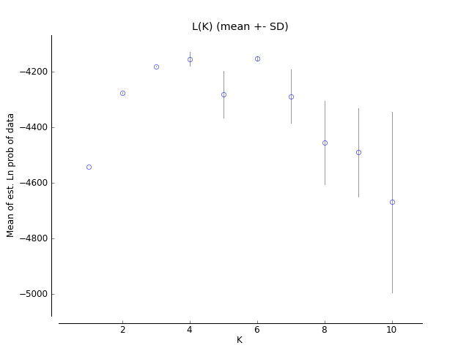
L(K): pdf eps

Clumpp files
K = 1 Clumpp indfile K = 1 Clumpp popfile
K = 2 Clumpp indfile K = 2 Clumpp popfile
K = 3 Clumpp indfile K = 3 Clumpp popfile
K = 4 Clumpp indfile K = 4 Clumpp popfile
K = 5 Clumpp indfile K = 5 Clumpp popfile
K = 6 Clumpp indfile K = 6 Clumpp popfile
K = 7 Clumpp indfile K = 7 Clumpp popfile
K = 8 Clumpp indfile K = 8 Clumpp popfile
K = 9 Clumpp indfile K = 9 Clumpp popfile
K = 10 Clumpp indfile K = 10 Clumpp popfile

Evanno method
*Evanno et al., 2005. Molecular Ecology 14, 2611 - 2620. How are we calculating this? Look at the FAQ.
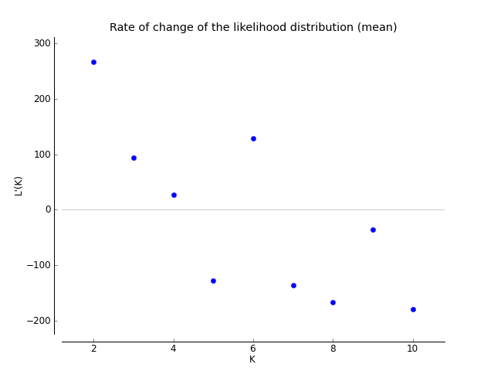
L'(K): pdf eps

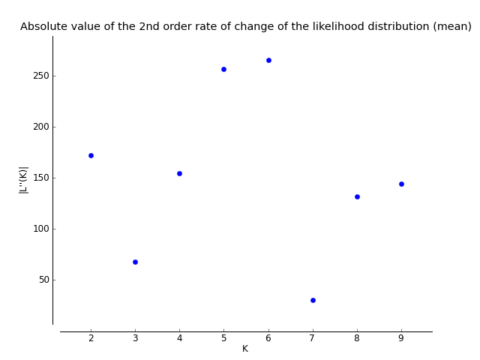
|L''(K)|: pdf eps

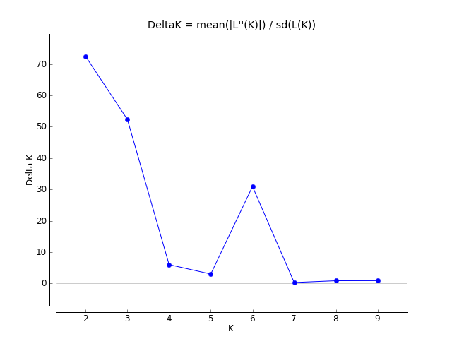
Delta K: pdf eps

The Evanno table output is also available as a tab-delimited text file (for use with Excel) here.
K | Reps | Mean LnP(K) | Stdev LnP(K) | Ln'(K) | |Ln''(K)| | Delta K
1 | 10 | -4541.760000 | 0.374759 | — | — | —
2 | 10 | -4275.130000 | 2.378165 | 266.630000 | 172.190000 | 72.404577
3 | 10 | -4180.690000 | 1.292242 | 94.440000 | 67.630000 | 52.335406
4 | 10 | -4153.880000 | 25.659947 | 26.810000 | 154.210000 | 6.009755
5 | 10 | -4281.280000 | 85.135380 | -127.400000 | 256.380000 | 3.011439
6 | 10 | -4152.300000 | 8.575935 | 128.980000 | 265.340000 | 30.940065
7 | 10 | -4288.660000 | 95.747401 | -136.360000 | 30.310000 | 0.316562
8 | 10 | -4455.330000 | 149.375731 | -166.670000 | 131.520000 | 0.880464
9 | 10 | -4490.480000 | 160.259497 | -35.150000 | 144.200000 | 0.899791
10 | 10 | -4669.830000 | 325.799605 | -179.350000 | — | —

