Table S1: List of mammals carnivorous species and and their threat status. IUCN represents the global threat status and MMA the national threat status (From Brazil). Subtitles: LC (Least Concern); NT (Near Threatened); VU (Vulnerable); EN (Endangered); DD (Deficient Data). *Species with some threatened status.
Species | IUCN | MMA
Canidae
Atelocynus microtis* | NT | VU
Cerdocyon thous | LC | LC
Speothos venaticus* | NT | VU
Felidae
Herpailurus yagouaroundi* | LC | VU
Leopardus pardalis | LC | LC
Leopardus tigrinus* | VU | EM
Leopardus wiedii* | NT | VU
Panthera onca* | NT | VU
Puma concolor | LC | LC
Procyonidae
Bassaricyon alleni | LC | LC
Nasua nasua | LC | LC
Potos flavus | LC | LC
Procyon cancrivorus | LC | LC
Mustelidae
Eira barbara | LC | LC
Galictis vittata | LC | LC
Mustela africana | LC | DD

Table S2: Information about online database Gbif (Global Biodiversity Information Facility). From left to right: carnivorous species, date of access to occurrence records for each species and DOI electronic address.
Species | Access date | DOI
A. microtis | 11 July 2020 | https://doi.org/10.15468/dl.m5fcqx
B.alleni | 11 July 2020 | https://www.gbif.org/occurrence/download/0019456-200613084148143
C. thous | 11 July 2020 | https://www.gbif.org/occurrence/download/0019480-200613084148143
E. barbara | 17 July 2020 | https://www.gbif.org/occurrence/download/0023158-200613084148143
G. vittata | 13 July 2020 | https://www.gbif.org/occurrence/download/0020826-200613084148143
H. yagouaroundi | 16 July 2020 | https://www.gbif.org/occurrence/download/0023074-200613084148143
L. pardalis | 13 July 2020 | https://www.gbif.org/occurrence/download/0020859-200613084148143
L. tigrinus | 13 July 2020 | https://www.gbif.org/occurrence/download/0020653-200613084148143
L. wiedii | 15 July 2020 | https://www.gbif.org/occurrence/download/0022520-200613084148143
M. africana | 13 July 2020 | https://www.gbif.org/occurrence/download/0020732-200613084148143
N. nasua | 22 July 2020 | https://www.gbif.org/occurrence/download/0026273-200613084148143
P. cancrivorus | 15 July 2020 | https://www.gbif.org/occurrence/download/0022441-200613084148143
P. concolor | 21 July 2020 | https://www.gbif.org/occurrence/download/0026106-200613084148143
P. flavus | 23 July 2020 | https://www.gbif.org/occurrence/download/0027288-200613084148143
P. onca | 18 July 2020 | https://www.gbif.org/occurrence/download/0024444-200613084148143
S. venaticus | 12 July 2020 | https://www.gbif.org/occurrence/download/0019955-200613084148143

Table S3: Results of Principal Component Analysis (PCA). The six axes selected from the PCA that explained at least 95% of the original variance.
PCA Axes | Variance - Principal Component | Cumulative Variance
PC1 | 0.54622 | 0.54622
PC2 | 0.20108 | 0.7473
PC3 | 0.09501 | 0.84231
PC4 | 0.05651 | 0.89882
PC5 | 0.04112 | 0.93994
PC6 | 0.02827 | 0.96821

Table S4: SDMs processing results. The number of occurrences after cleaning is denominated as Unique occurrences. The table also shows the predictive performance of the models, which were evaluated by the Jaccard Index and AUC. The THR (Jaccard) value corresponds to the threshold values per species after the ensemble and before the overlap of the vegetation cover model.
Species | Unique ocurrences | Jaccard Index | AUC | THR (Jaccard) | True Positive Rate | True Negative Rate
Atelocynus microtus | 281 | 0.931 | 0.988 | 0.535 | 0.987 | 0.981
Bassaricyon alleni | 58 | 0.859 | 0.968 | 0.449 | 1 | 0.921
Cerdocyon thous | 4051 | 0.969 | 0.997 | 0.699 | 0.991 | 0.992
Eira barbara | 2264 | 0.955 | 0.995 | 0.693 | 0.985 | 0.994
Galictis vittata | 312 | 0.978 | 0.997 | 0.626 | 0.995 | 0.995
Herpailurus yagouaroundi | 2030 | 0.955 | 0.995 | 0.424 | 0.989 | 0.981
Leopardus pardalis | 2970 | 0.959 | 0.996 | 0.760 | 0.986 | 0.996
Leopardus tigrinus | 413 | 0.970 | 0.996 | 0.453 | 1 | 0.989
Leopardus wiedii | 1480 | 0.948 | 0.996 | 0.713 | 0.988 | 0.992
Mustela africana | 14 | 0.888 | 0.916 | 0.865 | 1 | 0.833
Nasua nasua | 2247 | 0.937 | 0.993 | 0.253 | 0.992 | 0.956
Panthera onca | 2492 | 0.957 | 0.996 | 0.729 | 0.985 | 0.994
Potos flavus | 1050 | 0.967 | 0.997 | 0.503 | 0.994 | 0.990
Procyon cancrivorus | 2285 | 0.961 | 0.996 | 0.634 | 0.994 | 0.987
Puma concolor | 4652 | 0.962 | 0.997 | 0.769 | 0.981 | 0.997
Speothos venaticus | 434 | 0.969 | 0.997 | 0.639 | 0.988 | 0.994

Table S5. Algorithm performance and threshold. Performance of the five algorithms used for model building (Maxent - MXS, Support Vector Machine - SPV, Random Forest - RF, General Linear Model and Gaussian Model - GAU). The table contains the Jaccard Index values of each algorithm by species (THR). It also includes the values of True Positive Rate (TPR) and True Negative Rate (TNR) per algorithm and species.
Species | Algorithm | THR | THR VALUE | TPR | TNR
A. microtis | MXS | Jaccard | 0.598 | 0.774 | 0.995
A. microtis | SVM | Jaccard | 0.588 | 0.993 | 0.963
A. microtis | RDF | Jaccard | 0.646 | 1 | 1
A. microtis | GLM | Jaccard | 0.999 | 1 | 1
A. microtis | GAU | Jaccard | 0.668 | 0.981 | 0.969
B. alleni | MXS | Jaccard | 0.965 | 0.450 | 0.999
B. alleni | SVM | Jaccard | 0.315 | 1 | 0.843
B. alleni | RDF | Jaccard | 0.678 | 1 | 1
B. alleni | GLM | Jaccard | 0.999 | 1 | 1
B. alleni | GAU | Jaccard | 0.578 | 1 | 0.921
C. thous | MXS | Jaccard | 0.406 | 0.866 | 0.991
C. thous | SVM | Jaccard | 0.699 | 0.992 | 0.987
C. thous | RDF | Jaccard | 0.529 | 1 | 0.999
C. thous | GLM | Jaccard | 0.576 | 0.991 | 0.979
C. thous | GAU | Jaccard | 0.597 | 0.991 | 0.986
E. barbara | MXS | Jaccard | 0.488 | 0.850 | 0.994
E. barbara | SVM | Jaccard | 0.458 | 0.992 | 0.973
E. barbara | RDF | Jaccard | 0.578 | 1 | 0.999
E. barbara | GLM | Jaccard | 0.522 | 0.992 | 0.973
E. barbara | GAU | Jaccard | 0.572 | 0.992 | 0.973
G. vittata | MXS | Jaccard | 0.686 | 0.786 | 0.998
G. vittata | SVM | Jaccard | 0.909 | 0.995 | 0.990
G. vittata | RDF | Jaccard | 0.738 | 1 | 1
G. vittata | GLM | Jaccard | 0.999 | 1 | 1
G. vittata | GAU | Jaccard | 0.692 | 0.995 | 0.985
H. yagouaroundi | MXS | Jaccard | 0.340 | 0.835 | 0.991
H. yagouaroundi | SVM | Jaccard | 0.472 | 0.989 | 0.974
H. yagouaroundi | RDF | Jaccard | 0.519 | 0.999 | 0.997
H. yagouaroundi | GLM | Jaccard | 0.466 | 0.987 | 0.968
H. yagouaroundi | GAU | Jaccard | 0.602 | 0.984 | 0.979
L. pardalis | MXS | Jaccard | 0.357 | 0.829 | 0.990
L. pardalis | SVM | Jaccard | 0.573 | 0.991 | 0.970
L. pardalis | RDF | Jaccard | 0.560 | 1 | 1
L. pardalis | GLM | Jaccard | 0.483 | 0.989 | 0.969
L. pardalis | GAU | Jaccard | 0.595 | 0.990 | 0.973
L. tigrinus | MXS | Jaccard | 0.647 | 0.725 | 0.997
L. tigrinus | SVM | Jaccard | 0.554 | 1 | 0.983
L. tigrinus | RDF | Jaccard | 0.633 | 1 | 1
L. tigrinus | GLM | Jaccard | 0.999 | 1 | 1
L. tigrinus | GAU | Jaccard | 0.458 | 1 | 0.979
L. wiedii | MXS | Jaccard | 0.462 | 0.778 | 0.993
L. wiedii | SVM | Jaccard | 0.386 | 0.997 | 0.964
L. wiedii | RDF | Jaccard | 0.566 | 1 | 0.998
L. wiedii | GLM | Jaccard | 0.677 | 0.987 | 0.982
L. wiedii | GAU | Jaccard | 0.631 | 0.988 | 0.977
M. africana | MXS | Jaccard | 0.857 | 0.333 | 0.988
M. africana | SVM | Jaccard | 0.750 | 1 | 1
M. africana | RDF | Jaccard | 0.865 | 1 | 1
M. africana | GLM | Jaccard | 0 | 0 | 0
M. africana | GAU | Jaccard | 0.647 | 1 | 1
N. nasua | MXS | Jaccard | 0.709 | 0.768 | 0.996
N. nasua | SVM | Jaccard | 0.154 | 0.998 | 0.952
N. nasua | RDF | Jaccard | 0.526 | 1 | 0.999
N. nasua | GLM | Jaccard | 0.426 | 0.990 | 0.958
N. nasua | GAU | Jaccard | 0.461 | 0.994 | 0.953
P. onca | MXS | Jaccard | 0.371 | 0.838 | 0.988
P. onca | SVM | Jaccard | 0.560 | 0.989 | 0.978
P. onca | RDF | Jaccard | 0.485 | 0.998 | 0.999
P. onca | GLM | Jaccard | 0.585 | 0.987 | 0.975
P. onca | GAU | Jaccard | 0.590 | 0.989 | 0.979
P. flavus | MXS | Jaccard | 0.245 | 0.895 | 0.996
P. flavus | SVM | Jaccard | 0.623 | 0.993 | 0.979
P. flavus | RDF | Jaccard | 0.590 | 1 | 1
P. flavus | GLM | Jaccard | 0.498 | 0.998 | 0.994
P. flavus | GAU | Jaccard | 0.692 | 0.987 | 0.987
P. cancrivorus | MXS | Jaccard | 0.481 | 0.793 | 0.993
P. cancrivorus | SVM | Jaccard | 0.268 | 0.997 | 0.969
P. cancrivorus | RDF | Jaccard | 0.528 | 0.999 | 0.999
P. cancrivorus | GLM | Jaccard | 0.555 | 0.988 | 0.976
P. cancrivorus | GAU | Jaccard | 0.549 | 0.996 | 0.972
P. concolor | MXS | Jaccard | 0.561 | 0.798 | 0.984
P. concolor | SVM | Jaccard | 0.501 | 0.990 | 0.977
P. concolor | RDF | Jaccard | 0.473 | 0.999 | 0.998
P. concolor | GLM | Jaccard | 0.357 | 0.993 | 0.954
P. concolor | GAU | Jaccard | 0.635 | 0.985 | 0.973
S. venaticus | MXS | Jaccard | 0.574 | 0.764 | 0.996
S. venaticus | SVM | Jaccard | 0.904 | 0.982 | 0.994
S. venaticus | RDF | Jaccard | 0.525 | 1 | 1
S. venaticus | GLM | Jaccard | 0.999 | 1 | 1
S. venaticus | GAU | Jaccard | 0.775 | 0.982 | 0.991

Figure S1
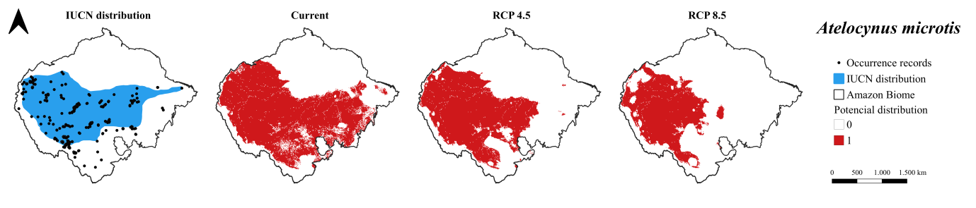
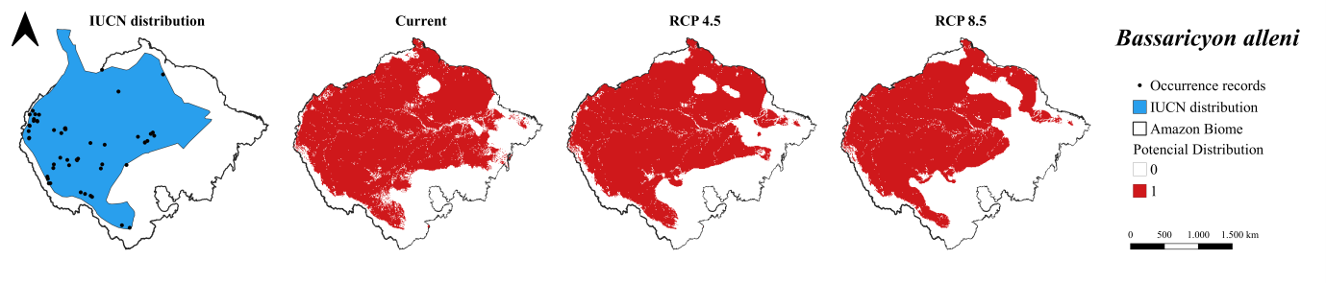
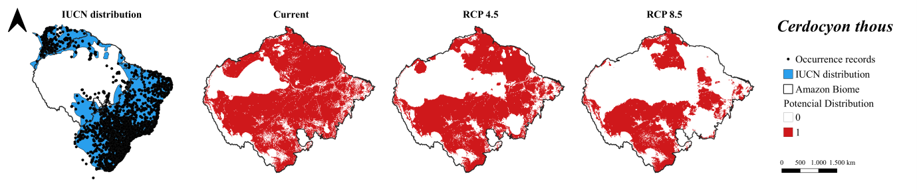
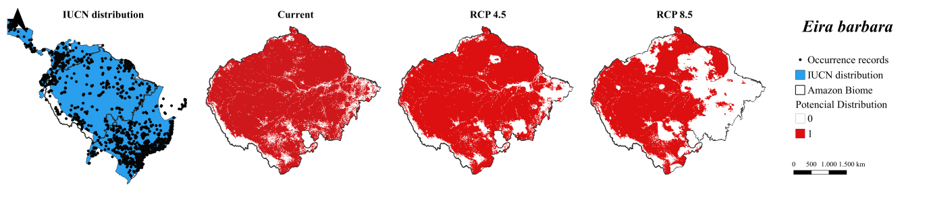
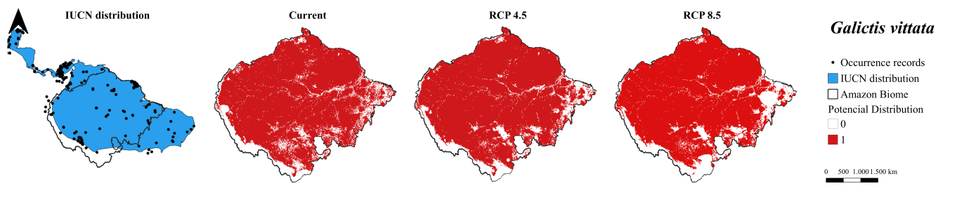

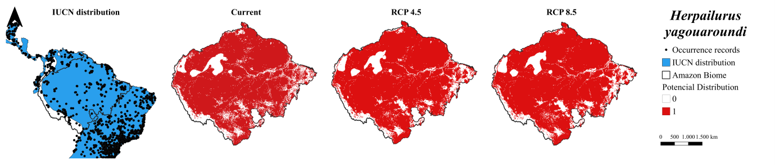
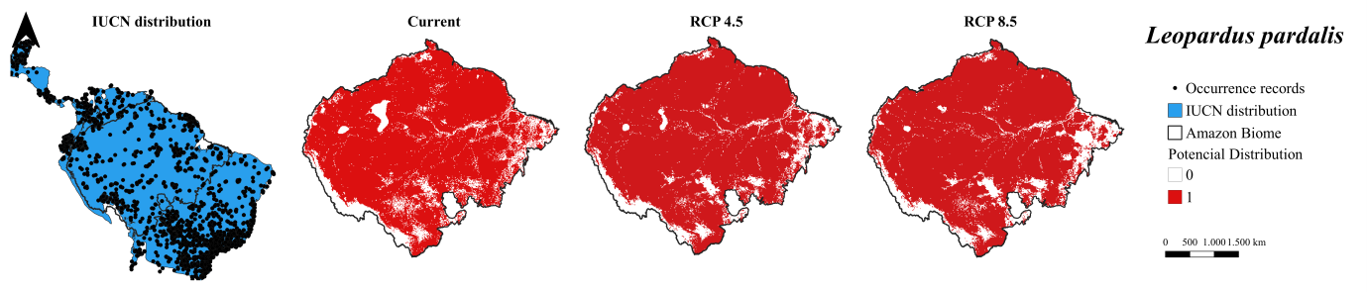

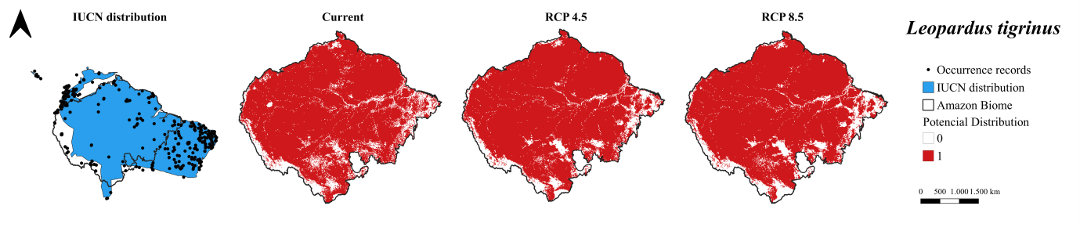
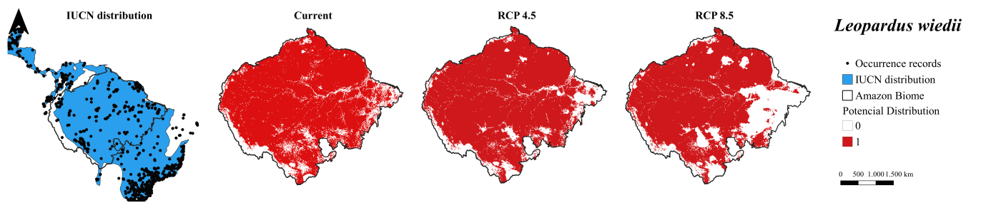
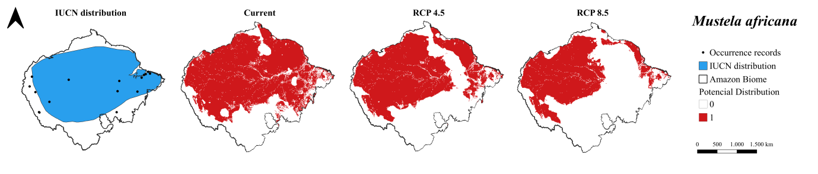
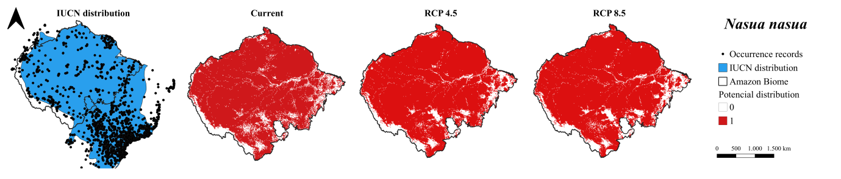
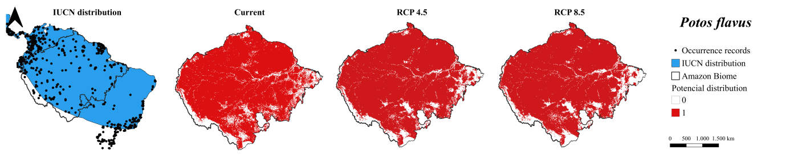
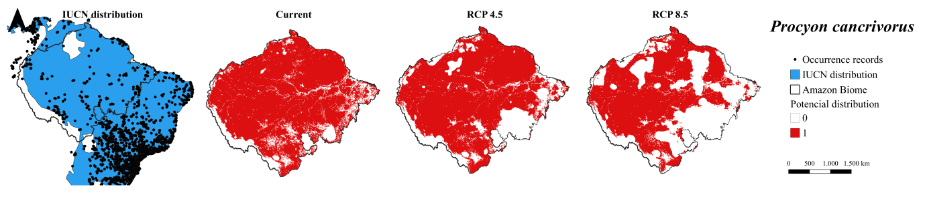
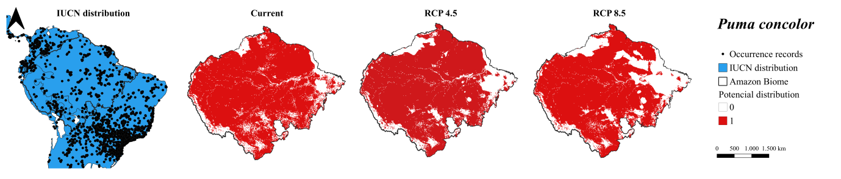
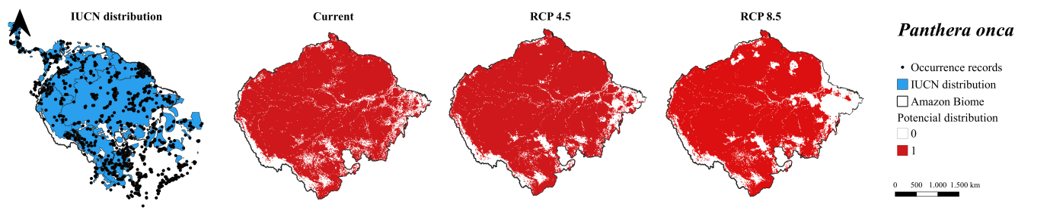
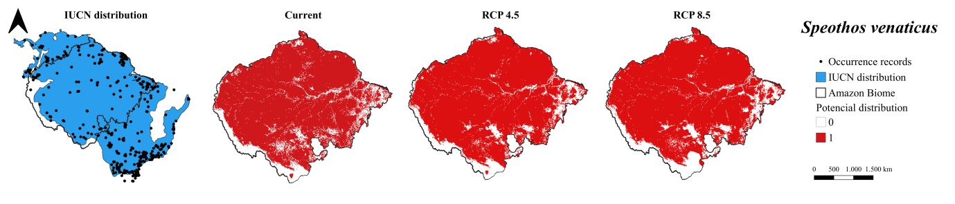
Figure S1: Suitability models for carnivorous mammals of the Amazon Biome on all climate scenarios. Black lines and white area: Amazon Biome. From left to right: geographical distribution of carnivore species according to IUCN; potential distribution for the current-time, potential distribution in RCP 4.5 and potential distribution in RCP 8.5. All the models presented above are the result of overlapping the vegetation cover models to the consensus SDMs of each species.

Table S6: Measurement of the spatial dynamics of carnivores. Area represents the total suitability area of the species. Negative values of Lost/Gain Area represent the loss of suitable area of the species, and positive values represent gain of suitable area (km² and percentage). The species are stable if they present negative and positive values below 5%.
Area (km²) | Current | RCP 45 | RCP 85 |  | Lost/Gain Area
 |  | Total | Total |  | RCP 45 (km²) | RCP 85 (km²) | RCP 45 (%) | RCP 85 (%)
A. microtis | 3978658.2 | 2943452.82 | 2019241.89 |  | -1035205.38 | -1959416.31 | -26.02 | -49.25
B. alleni | 5186569.23 | 4927296.48 | 4306156.11 |  | -259272.75 | -880413.12 | -5.00 | -16.97
C. thous | 5158284.93 | 4253958.72 | 2790717.6 |  | -904326.21 | -2367567.33 | -17.53 | -45.90
E. barbara | 6327369.33 | 6198804.33 | 4470205.05 |  | -128565 | -1857164.28 | -2.03 | -29.35
G. vittata | 6215946.33 | 6330712.02 | 6110608.74 |  | 114765.69 | -105337.59 | 1.85 | -1.69
H. yagouaroundi | 6054554.4 | 6178919.61 | 6101352.06 |  | 124365.21 | 46797.66 | 2.05 | 0.77
L. pardalis | 6226574.37 | 6407851.02 | 6308427.42 |  | 181276.65 | 81853.05 | 2.91 | 1.31
L. tigrinus | 6346139.82 | 6453791.58 | 6357024.99 |  | 107651.76 | 10885.17 | 1.70 | 0.17
L. wiedii | 6279543.15 | 6276714.72 | 5408815.26 |  | -2828.43 | -870727.89 | -0.05 | -13.87
M. africana | 4978722.48 | 4161734.76 | 2998821.48 |  | -816987.72 | -1979901 | -16.41 | -39.77
N. nasua | 6342025.74 | 6461419.77 | 6370310.04 |  | 119394.03 | 28284.3 | 1.88 | 0.45
P. flavus | 6311170.14 | 6413079.33 | 6295313.79 |  | 101909.19 | -15856.35 | 1.61 | -0.25
P. cancrivorus | 6174462.69 | 5711542.98 | 4391608.98 |  | -462919.71 | -1782853.71 | -7.50 | -28.87
P. onça | 6332683.35 | 6422764.56 | 6056440.02 |  | 90081.21 | -276243.33 | 1.42 | -4.36
P. concolor | 6143092.83 | 6015042.09 | 5474983.38 |  | -128050.74 | -668109.45 | -2.08 | -10.88
S. venaticus | 6245259.15 | 6358824.9 | 6216889.14 |  | 113565.75 | -28370.01 | 1.82 | -0.45

Figure S2
Figure S2: Climatic suitability models for carnivorous mammals of the Amazon Biome on all climate scenarios. Black line and white area: Amazon Biome. From left to right: climatic suitability for the current-time, climatic suitability in RCP 4.5 and climatic suitability in RCP 8.5. The minimum climate suitability values for each species correspond to the THR (Jaccard) cited in Table S4. All the models presented above are the result of overlapping the vegetation cover models to the consensus SDMs of each species.

Table S7: Results of GAP analysis. Target for protected rating is 0.1 (10%). All species are protected. IPA: Integral Protected Areas; SUA: Sustainable Use Areas; and IL: Indigenous Lands.
Current | IPA | IPA+SUA | IPA+SUA+IL
Species | Target achieved | Target achieved | Target achieved
A. microtis | 1.315 | 3.299 | 6.648
B. alleni | 1.787 | 4.133 | 7.043
C. thous | 1.531 | 3.700 | 6.364
E. barbara | 1.572 | 3.730 | 6.625
G. vittata | 1.587 | 3.745 | 6.624
H. yagouaroundi | 1.585 | 3.782 | 6.558
L. pardalis | 1.580 | 3.753 | 6.605
L. tigrinus | 1.569 | 3.728 | 6.620
L. wiedii | 1.579 | 3.720 | 6.612
M. africana | 1.697 | 3.958 | 6.831
N. nasua | 1.570 | 3.738 | 6.631
P. flavus | 1.577 | 3.729 | 6.615
P. cancrivorus | 1.589 | 3.777 | 6.650
P. onca | 1.571 | 3.720 | 6.621
P. concolor | 1.572 | 3.681 | 6.597
S. venaticus | 1.590 | 3.748 | 6.629
RCP 4.5 | IPA | IPA+SUA | IPA+SUA+IL
Species | Target achieved | Target achieved | Target achieved
A. microtis | 1.392 | 3.385 | 6.900
B. alleni | 1.791 | 4.061 | 7.007
C. thous | 1.533 | 3.620 | 6.298
E. barbara | 1.603 | 3.630 | 6.693
G. vittata | 1.582 | 3.585 | 6.625
H. yagouaroundi | 1.574 | 3.632 | 6.560
L. pardalis | 1.560 | 3.580 | 6.621
L. tigrinus | 1.559 | 3.578 | 6.614
L. wiedii | 1.589 | 3.589 | 6.637
M. africana | 1.710 | 3.793 | 6.871
N. nasua | 1.558 | 3.581 | 6.628
P. flavus | 1.568 | 3.570 | 6.602
P. cancrivorus | 1.642 | 3.790 | 6.722
P. onca | 1.565 | 3.568 | 6.627
P. concolor | 1.562 | 3.572 | 6.615
S. venaticus | 1.579 | 3.592 | 6.625
RCP 8.5 | IPA | IPA+SUA | IPA+SUA+IL
Species | Target achieved | Target achieved | Target achieved
A. microtis | 1.307 | 3.364 | 6.840
B. alleni | 1.780 | 4.072 | 7.069
C. thous | 1.509 | 3.780 | 6.715
E. barbara | 1.778 | 3.995 | 7.021
G. vittata | 1.635 | 3.748 | 6.749
H. yagouaroundi | 1.593 | 3.738 | 6.601
L. pardalis | 1.592 | 3.705 | 6.689
L. tigrinus | 1.583 | 3.682 | 6.654
L. wiedii | 1.680 | 3.847 | 6.784
M. africana | 1.730 | 3.829 | 7.127
N. nasua | 1.580 | 3.694 | 6.670
P. flavus | 1.595 | 3.689 | 6.664
P. cancrivorus | 1.602 | 3.873 | 6.805
P. onca | 1.602 | 3.711 | 6.751
P. concolor | 1.520 | 3.591 | 6.653
S. venaticus | 1.613 | 3.724 | 6.692

Figure S3: Results of Null Model. In all climate scenarios, PAs did not reach different values expected by chance (p < 0.05). Minimum and maximums values of p for all PAs. The minimum p-value was 0.05 and the maximum p-value was 1.

