Supplemental Materials

Detailed analyses results from threshold investigations
All analyses were performed in R with the following results forming the basis of threshold conclusions relating to Question 4 (For the last three elements of the flow chart, what are the thresholds that need to be met for VME designation?).

Supplemental Figure 1. Boxplots of YMN (Yes, Maybe, No) for Taxa per m² and additional taxa.
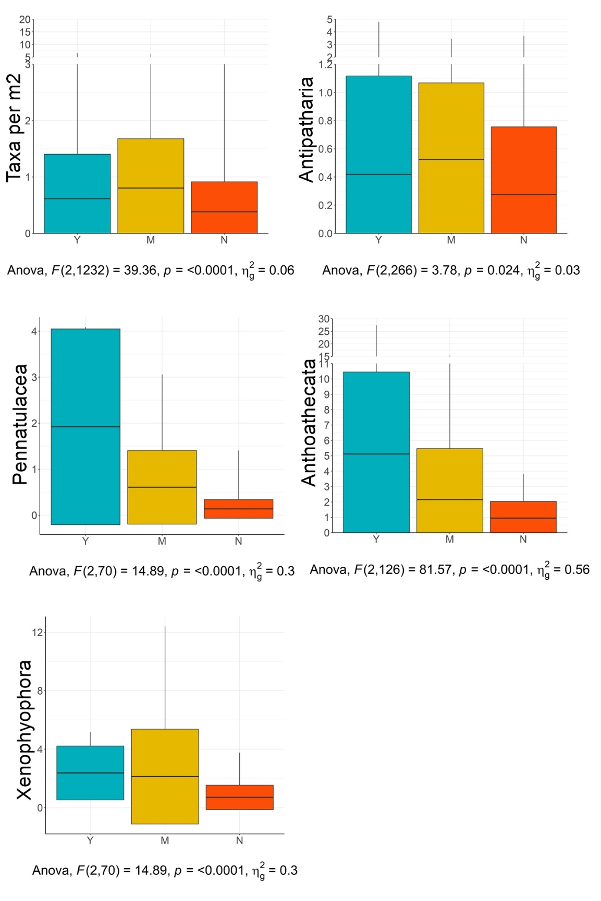

Supplemental Table 2. Summary statistics for YMN (Yes, Maybe, No) decisions per category discussed in the text in Question 4 across all images with >1m² area.
 | VME_YMN | mean | sd | n | min | max
 | <fctr> | <dbl> | <dbl> | <int> | <dbl> | <dbl>
Overall Density | Y | 6.00 | 11.47 | 293 | 0.17 | 125.32
 | M | 5.81 | 11.65 | 290 | 0.10 | 116.13
 | N | 2.32 | 8.57 | 652 | 0.03 | 184.72
Total Taxa | Y | 3.93 | 1.62 | 293 | 1.00 | 9.00
 | M | 3.61 | 1.69 | 290 | 1.00 | 9.00
 | N | 2.16 | 1.24 | 652 | 1.00 | 8.00
Taxa per m2 | Y | 0.61 | 0.79 | 293 | 0.05 | 6.53
 | M | 0.80 | 0.88 | 290 | 0.05 | 6.17
 | N | 0.38 | 0.53 | 652 | 0.02 | 4.59
Scleractinia | Y | 3.59 | 9.32 | 73 | 0.07 | 53.83
 | M | 1.25 | 2.12 | 99 | 0.07 | 12.72
 | N | 0.48 | 2.18 | 141 | 0.04 | 25.40
Alcyonacea | Y | 1.47 | 2.71 | 224 | 0.02 | 22.17
 | M | 0.80 | 2.29 | 150 | 0.05 | 18.31
 | N | 0.29 | 1.15 | 168 | 0.03 | 14.73
Pennatulacea | Y | 1.92 | 2.13 | 4 | 0.09 | 4.09
 | M | 0.60 | 0.80 | 26 | 0.05 | 3.06
 | N | 0.14 | 0.20 | 43 | 0.03 | 1.41
Antipatharia | Y | 0.42 | 0.70 | 97 | 0.02 | 4.78
 | M | 0.52 | 0.55 | 91 | 0.03 | 3.44
 | N | 0.28 | 0.48 | 81 | 0.03 | 3.68
Porifera | Y | 1.29 | 3.72 | 177 | 0.05 | 43.64
 | M | 1.48 | 2.21 | 158 | 0.03 | 11.87
 | N | 0.58 | 0.92 | 201 | 0.02 | 6.02
Xenophyopora | Y | 2.37 | 1.84 | 7 | 0.52 | 5.18
 | M | 2.13 | 3.24 | 38 | 0.07 | 12.40
 | N | 0.70 | 0.83 | 34 | 0.06 | 3.76
Anthoathecata | Y | 5.11 | 5.34 | 48 | 0.20 | 27.33
 | M | 2.15 | 3.31 | 29 | 0.07 | 15.34
 | N | 0.95 | 1.08 | 24 | 0.07 | 3.82

Supplemental Table 3. Anova (stats::aov) results tables for YMN (Yes, Maybe, No) decisions per category discussed in the Question 4 across all images with >1m² area.
Significance codes: 0 ‘***’ 0.001 ‘**’ 0.01 ‘*’ 0.05 ‘.’ 0.1 ‘ ’ 1

 |  | Df | SumSq | MeanSq | Fvalue | Pr(>F)
Overall Density | data.cln$VME_YMN | 2 | 3968 | 1984 | 19.48 | 4.71E-09 | ***
 | Residuals | 1232 | 125509 | 101.9
 | ---
 |  | Df | SumSq | MeanSq | Fvalue | Pr(>F)
Total Taxa | data.cln$VME_YMN | 2 | 813.2 | 406.6 | 193.3 | <2e-16 | ***
 | Residuals | 1232 | 2591.9 | 2.1
 | ---
 |  | Df | SumSq | MeanSq | Fvalue | Pr(>F)
Taxa per m2 | data.cln$VME_YMN | 2 | 37.7 | 18.827 | 39.36 | <2e-16 | ***
 | Residuals | 1232 | 589.3 | 0.478
 | ---
 |  | Df | SumSq | MeanSq | Fvalue | Pr(>F)
Scleractinia | data.sc$VME_YMN | 2 | 471 | 235.52 | 9.923 | 6.65E-05 | ***
 | Residuals | 310 | 7357 | 23.73
 | ---
 |  | Df | SumSq | MeanSq | Fvalue | Pr(>F)
Alcyonacea | data.oc$VME_YMN | 2 | 135.5 | 67.77 | 13.85 | 1.36E-06 | ***
 | Residuals | 539 | 2637.4 | 4.89
 | ---
 |  | Df | SumSq | MeanSq | Fvalue | Pr(>F)
Pennatulacea | data.pn$VME_YMN | 2 | 13.33 | 6.666 | 14.89 | 4.10E-06 | ***
 | Residuals | 70 | 31.34 | 0.448
 | ---
 |  | Df | SumSq | MeanSq | Fvalue | Pr(>F)
Antipatharia | data.an$VME_YMN | 2 | 2.61 | 1.3073 | 3.777 | 0.0241 | *
 | Residuals | 266 | 92.08 | 0.3462
 | ---
 |  | Df | SumSq | MeanSq | Fvalue | Pr(>F)
Porifera | data.sp$VME_YMN | 2 | 82 | 41.1 | 6.496 | 0.00163 | **
 | Residuals | 533 | 3372 | 6.33
 | ---
 |  | Df | SumSq | MeanSq | Fvalue | Pr(>F)
Xenophyopora | data.xe$VME_YMN | 2 | 41.7 | 20.825 | 3.663 | 0.0303 | *
 | Residuals | 76 | 432.1 | 5.685
 | ---
 |  | Df | SumSq | MeanSq | Fvalue | Pr(>F)
Anthoathecata | data.st$VME_YMN | 2 | 329 | 164.52 | 9.64 | 0.000151 | ***
 | Residuals | 98 | 1672 | 17.07
 | ---

Supplemental Table 4. Tukey HSD (rstatix::tukey_hsd) results tables for YMN (Yes, Maybe, No) decisions per category discussed in Question 4 across all images with >1m² area.
Significance codes: 0 ‘***’ 0.001 ‘**’ 0.01 ‘*’ 0.05 ‘.’ 0.1 ‘ ’ 1

 |  |  | term | group1 | group2 | null.value | estimate | conf.low | conf.high | p.adj | p.adj.signif
Overall Density |  |  | <chr> | <chr> | <chr> | <dbl> | <dbl> | <dbl> | <dbl> | <dbl> | <chr>
 | 1 |  | data.cln$VME_YMN | Y | M | 0 | -0.19107 | -2.1529 | 1.770758 | 9.72E-01 | ns
 | 2 |  | data.cln$VME_YMN | Y | N | 0 | -3.68319 | -5.34897 | -2.01741 | 7.42E-07 | ****
 | 3 |  | data.cln$VME_YMN | M | N | 0 | -3.49212 | -5.16384 | -1.82041 | 3.22E-06 | ****
 |  |  | term | group1 | group2 | null.value | estimate | conf.low | conf.high | p.adj | p.adj.signif
Total Taxa |  |  | <chr> | <chr> | <chr> | <dbl> | <dbl> | <dbl> | <dbl> | <dbl> | <chr>
 | 1 |  | data.cln$VME_YMN | Y | M | 0 | -0.31798 | -0.59991 | -0.03606 | 0.0224 | *
 | 2 |  | data.cln$VME_YMN | Y | N | 0 | -1.76882 | -2.0082 | -1.52944 | 0 | ****
 | 3 |  | data.cln$VME_YMN | M | N | 0 | -1.45084 | -1.69107 | -1.2106 | 0 | ****
 |  |  | term | group1 | group2 | null.value | estimate | conf.low | conf.high | p.adj | p.adj.signif
Taxa per m2 |  |  | <chr> | <chr> | <chr> | <dbl> | <dbl> | <dbl> | <dbl> | <dbl> | <chr>
 | 1 |  | data.cln$VME_YMN | Y | M | 0 | 0.18972 | 0.055295 | 0.324146 | 2.74E-03 | **
 | 2 |  | data.cln$VME_YMN | Y | N | 0 | -0.23012 | -0.34426 | -0.11598 | 7.44E-06 | ****
 | 3 |  | data.cln$VME_YMN | M | N | 0 | -0.41984 | -0.53438 | -0.30529 | 0.00E+00 | ****
 |  |  | term | group1 | group2 | null.value | estimate | conf.low | conf.high | p.adj | p.adj.signif
Scleractinia |  |  | <chr> | <chr> | <chr> | <dbl> | <dbl> | <dbl> | <dbl> | <dbl> | <chr>
 | 1 |  | data.sc$VME_YMN | Y | M | 0 | -2.34693 | -4.11688 | -0.57698 | 5.55E-03 | **
 | 2 |  | data.sc$VME_YMN | Y | N | 0 | -3.10933 | -4.76362 | -1.45504 | 3.95E-05 | ****
 | 3 |  | data.sc$VME_YMN | M | N | 0 | -0.7624 | -2.26677 | 0.741966 | 4.58E-01 | ns
 |  |  | term | group1 | group2 | null.value | estimate | conf.low | conf.high | p.adj | p.adj.signif
Alcyonacea |  |  | <chr> | <chr> | <chr> | <dbl> | <dbl> | <dbl> | <dbl> | <dbl> | <chr>
 | 1 |  | data.oc$VME_YMN | Y | M | 0 | -0.67199 | -1.22048 | -0.1235 | 1.15E-02 | *
 | 2 |  | data.oc$VME_YMN | Y | N | 0 | -1.17468 | -1.70528 | -0.64408 | 8.35E-07 | ****
 | 3 |  | data.oc$VME_YMN | M | N | 0 | -0.50269 | -1.08669 | 0.081317 | 1.08E-01 | ns
 |  |  | term | group1 | group2 | null.value | estimate | conf.low | conf.high | p.adj | p.adj.signif
Pennatulacea |  |  | <chr> | <chr> | <chr> | <dbl> | <dbl> | <dbl> | <dbl> | <dbl> | <chr>
 | 1 |  | data.pn$VME_YMN | Y | M | 0 | -1.31567 | -2.1762 | -0.45514 | 1.39E-03 | **
 | 2 |  | data.pn$VME_YMN | Y | N | 0 | -1.78433 | -2.62187 | -0.94678 | 8.20E-06 | ****
 | 3 |  | data.pn$VME_YMN | M | N | 0 | -0.46866 | -0.8667 | -0.07062 | 1.70E-02 | *
 |  |  | term | group1 | group2 | null.value | estimate | conf.low | conf.high | p.adj | p.adj.signif
Antipatharia |  |  | <chr> | <chr> | <chr> | <dbl> | <dbl> | <dbl> | <dbl> | <dbl> | <chr>
 | 1 |  | data.an$VME_YMN | Y | M | 0 | 0.10457 | -0.0978 | 0.306944 | 0.444 | ns
 | 2 |  | data.an$VME_YMN | Y | N | 0 | -0.14204 | -0.35076 | 0.066676 | 0.246 | ns
 | 3 |  | data.an$VME_YMN | M | N | 0 | -0.24661 | -0.45844 | -0.03479 | 0.0178 | *
 |  |  | term | group1 | group2 | null.value | estimate | conf.low | conf.high | p.adj | p.adj.signif
Porifera |  |  | <chr> | <chr> | <chr> | <dbl> | <dbl> | <dbl> | <dbl> | <dbl> | <chr>
 | 1 |  | data.sp$VME_YMN | Y | M | 0 | 0.180476 | -0.46657 | 0.827519 | 0.789 | ns
 | 2 |  | data.sp$VME_YMN | Y | N | 0 | -0.7103 | -1.31968 | -0.10092 | 0.0175 | *
 | 3 |  | data.sp$VME_YMN | M | N | 0 | -0.89077 | -1.51933 | -0.26221 | 0.00266 | **
 |  |  | term | group1 | group2 | null.value | estimate | conf.low | conf.high | p.adj | p.adj.signif
Xenophyopora |  |  | <chr> | <chr> | <chr> | <dbl> | <dbl> | <dbl> | <dbl> | <dbl> | <chr>
 | 1 |  | data.xe$VME_YMN | Y | M | 0 | -0.24458 | -2.58898 | 2.099825 | 0.966 | ns
 | 2 |  | data.xe$VME_YMN | Y | N | 0 | -1.66678 | -4.03253 | 0.69898 | 0.218 | ns
 | 3 |  | data.xe$VME_YMN | M | N | 0 | -1.4222 | -2.76775 | -0.07664 | 0.0359 | *
 |  |  | term | group1 | group2 | null.value | estimate | conf.low | conf.high | p.adj | p.adj.signif
Anthoathecata |  |  | <chr> | <chr> | <chr> | <dbl> | <dbl> | <dbl> | <dbl> | <dbl> | <chr>
 | 1 |  | data.st$VME_YMN | Y | M | 0 | -2.96021 | -5.27243 | -0.64799 | 0.00829 | **
 | 2 |  | data.st$VME_YMN | Y | N | 0 | -4.16854 | -6.62632 | -1.71076 | 0.000315 | ***
 | 3 |  | data.st$VME_YMN | M | N | 0 | -1.20833 | -3.92125 | 1.504589 | 0.541 | ns

