Supplementary Figures and Tables

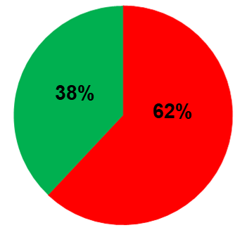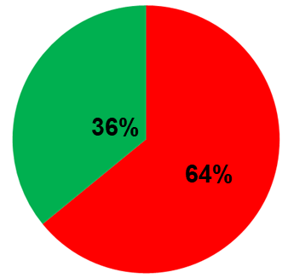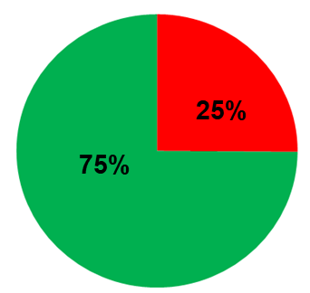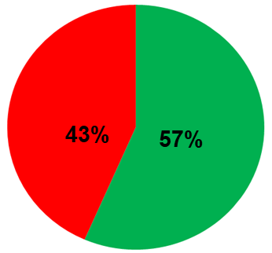
d)
c)
b)
a)

Upregulation
Downregulation

Supplementary Figure 1: Transcriptome Profile of each sample: Total % of DE genes upregulated and downreglated in each tumor sample (A) P1: EPH_1, (B)P2: EPH_2, (C) P3:TNBC, (D) P4: EP
a)
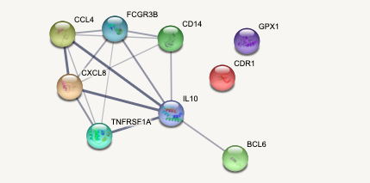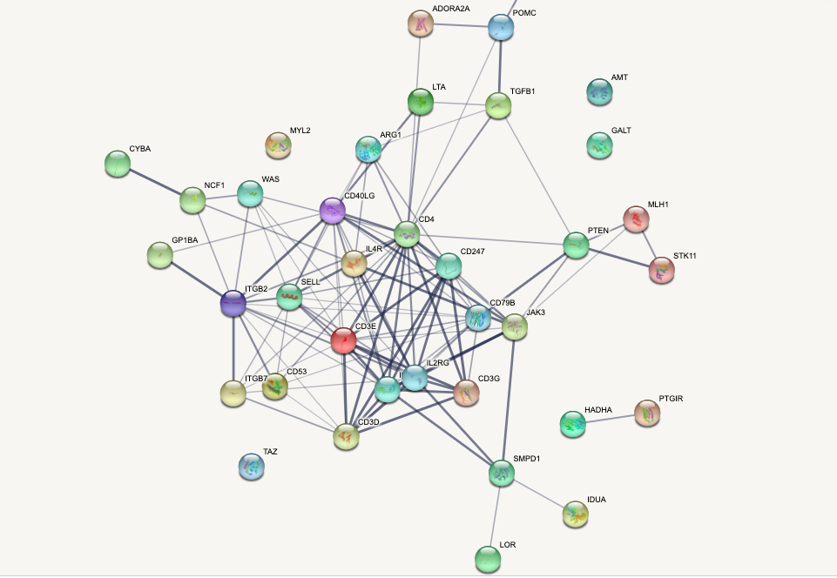
b)

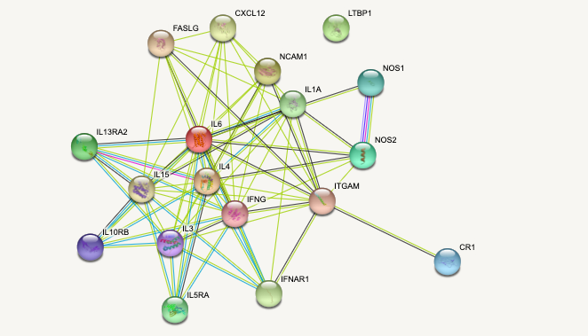
d)
c)
Supplementary Figure 2: STRING networks generated from gene lists from the WGCNA modules. a) EPH subtype, b) Estrogen positive subtype, c) Hmod subtype, d) TNBC subtype

Gene | Mutation Type | Amino acid change | Number of Patients
TLR10 | missense | p.Asn241His | 2
C7 | missense | p.Ser389Thr | 2
BTK | missense | p.Glu24Gly | 1
CARD8 | missense | p.Phe102Ile | 2
Supplementary Table 1a: List of genes and mutational burden in Immune system pathway and cytokine signaling pathway enriched in EPH subtype

Gene | Mutation Type | Amino acid change | Number of Patients
IL4R | missense | p.Ile75Val | 2
Supplementary Table 1b: List of genes and mutational burden in T cell mediated immunity enriched in
Estrogen positive subtype

Gene | Mutation Type | Amino acid change | Number of Patients
CCL4 | misense | p.Ser80Thr | 1
FCGR3B | misense | p.Asn101Ser | 3
GPX1 | misense | p.Pro200Leu | 1
IFNAR1 | misense | p.Val168Leu | 2
Supplementary Table 1c: List of genes and mutational burden in Type II Immune response enriched in
Hmod subtype

Gene | Mutation Type | Amino acid change | Number of Patients
C8A | misense | p.Ala36Glu | 1
C8A | misense | p.Arg59Gln | 1
C8A | misense | p.Gln93Lys | 2
CR1 | misense | p.Asn1990Ser | 1
CR1 | misense | p.His1658Arg | 1
CR1 | misense | p.Ile1813Thr | 1
CR1 | misense | p.Ile2065Val | 1
CR1 | misense | p.Pro2277Arg | 1
CR1 | misense | p.Thr1858Ala | 1
CR1 | misense | p.Thr1858Met | 2
CR1 | misense | p.Thr2060Ser | 3
NCAM1 | misense | p.Phe7Leu | 3
NOS1 | misense | p.Pro853Ser | 2
NOS2 | misense | p.Arg1018Ser | 1
NOS2 | misense | p.Ser608Leu | 1
CR1 | misense | p.His1768Tyr | 1
CR1 | misense | p.Thr2419Ala | 3
IL5RA | misense | p.Ile129Val | 3
ITGAM | misense | p.Ala859Val | 1
ITGAM | misense | p.Pro1147Ser | 1
LTBP1 | misense | p.Val1378Ala | 3
Supplementary Table 1d: List of genes and mutational burden in Interleukin and Interferon pathway
enriched in TNBC subtype

