|  |  |  |  |  |
| --- | --- | --- | --- | --- |
|  | | N | Mean | Standard deviation |
|
| paCO2 | IPPV | 87 | 45,7345 | 11,89617 |
| SV 20mbar | 87 | 48,9437 | 19,38394 |
| CCSV 40mbar | 62 | 51,2887 | 23,51004 |
| Overall | 236 | 48,3767 | 18,37681 |
| paO2 | IPPV | 87 | 155,7092 | 48,90125 |
| SV 20 | 87 | 143,6092 | 54,76911 |
| CCSV 40 | 62 | 186,9548 | 129,95608 |
| Overall | 236 | 159,4572 | 81,57443 |

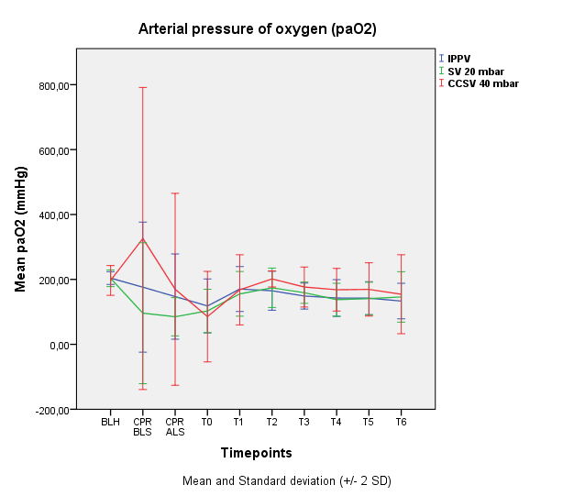

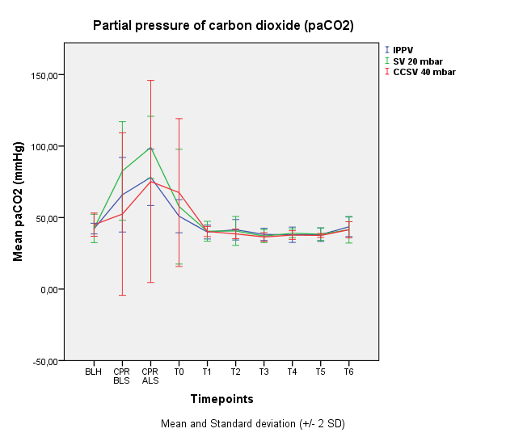

The BGAs showed a trend towards lower PaO2 and higher PaCO2 in the SV 20 group during basic life support, especially when compared to the CCSV 40 group. However, variance was very high, which is why no statistical significance was reached.