Figure S1. In vitro antimicrobial activity of potentially probiotic lactic acid bacteria strains against different pathogens.

Salmonella typhimurium ATCC 14028 (A) | Staphylococcus aureus ATCC 25923 (B) | Escherichia coli ATCC 25922 (C)
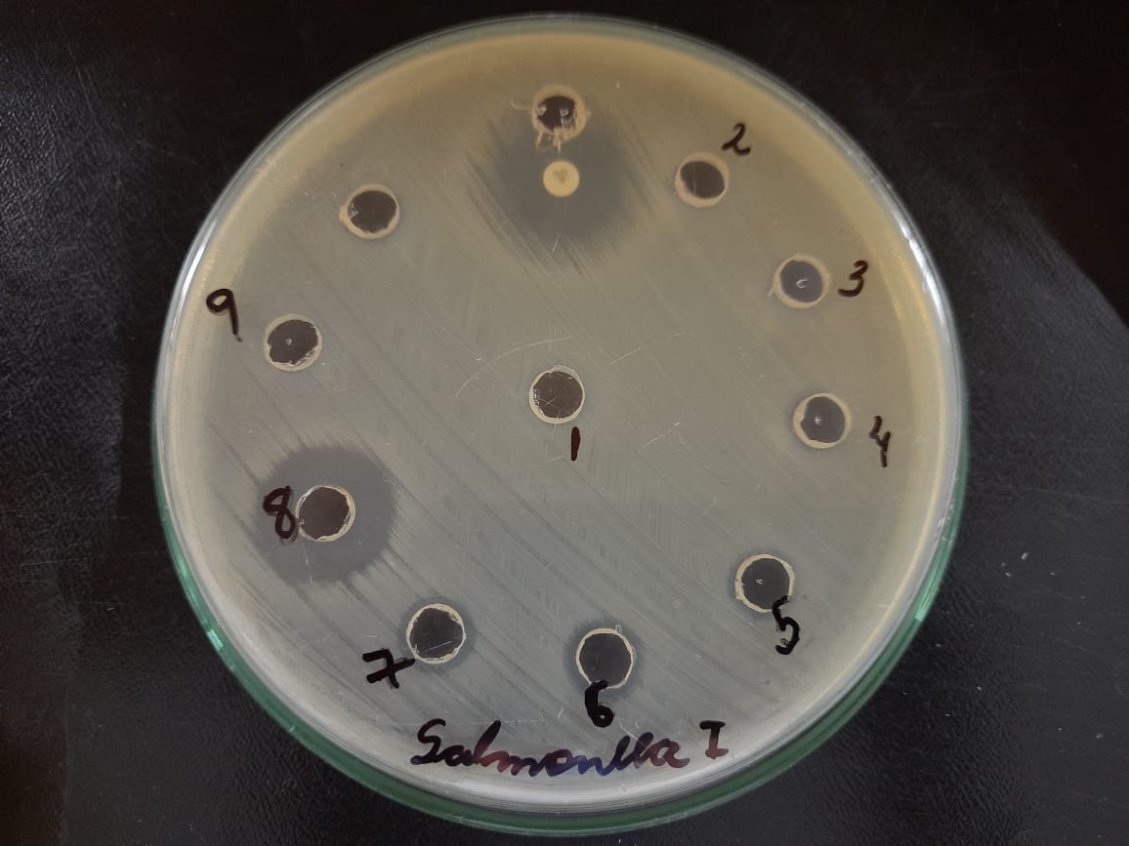  I)  10  11 | 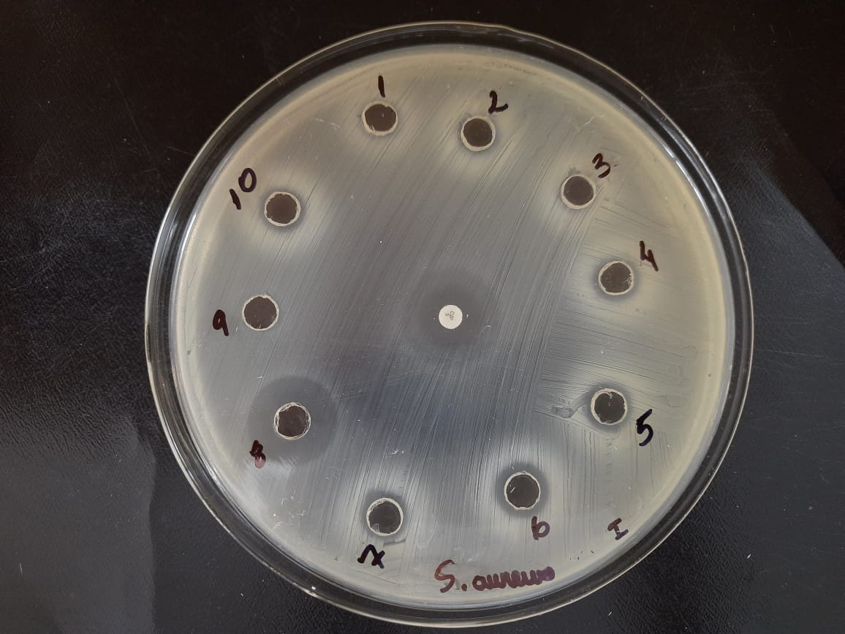  III)  11 | 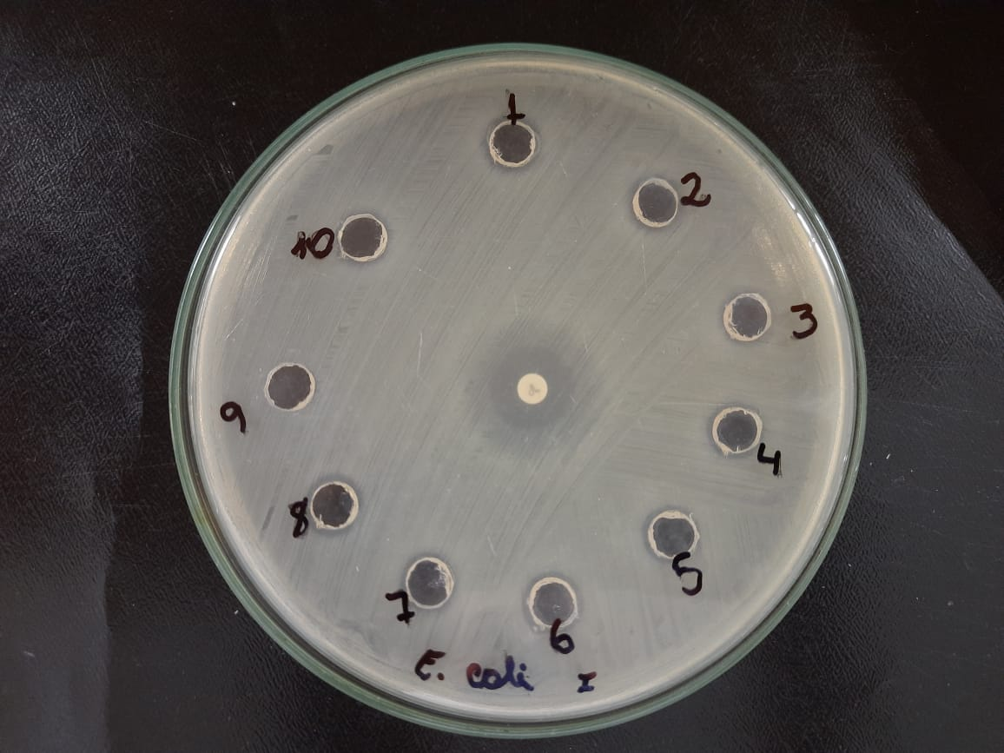  V)  11
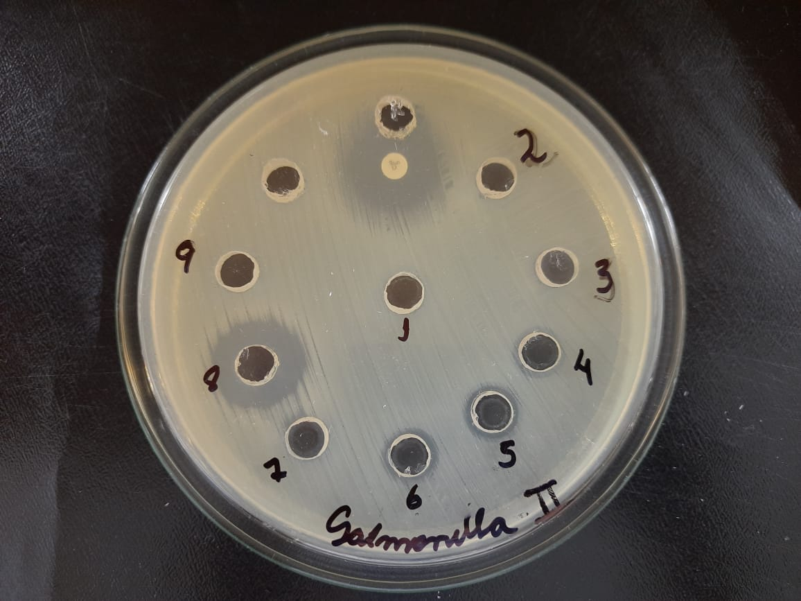  II)  11  10 | 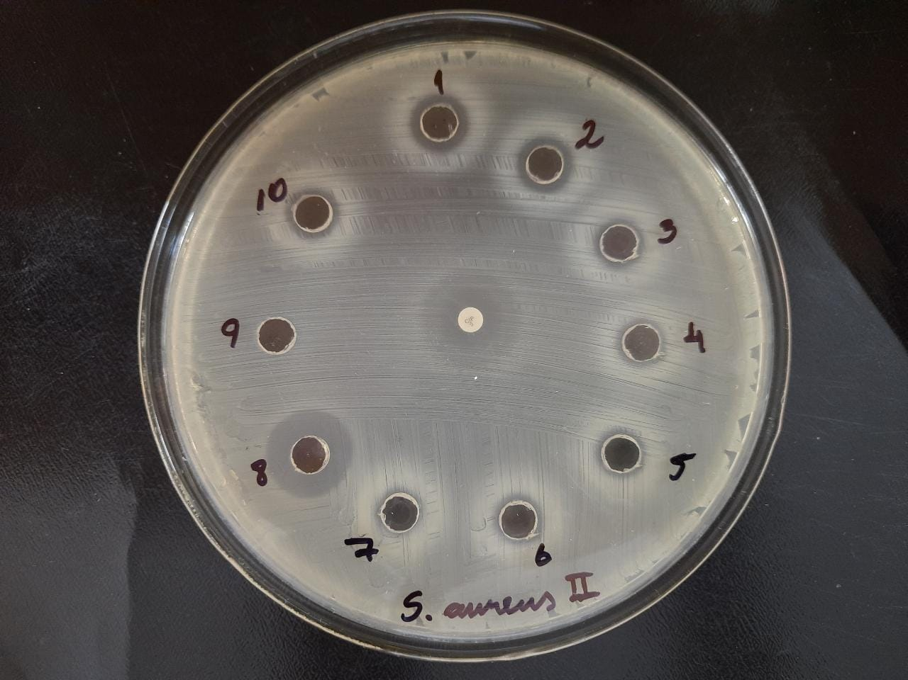  IV)  11 | 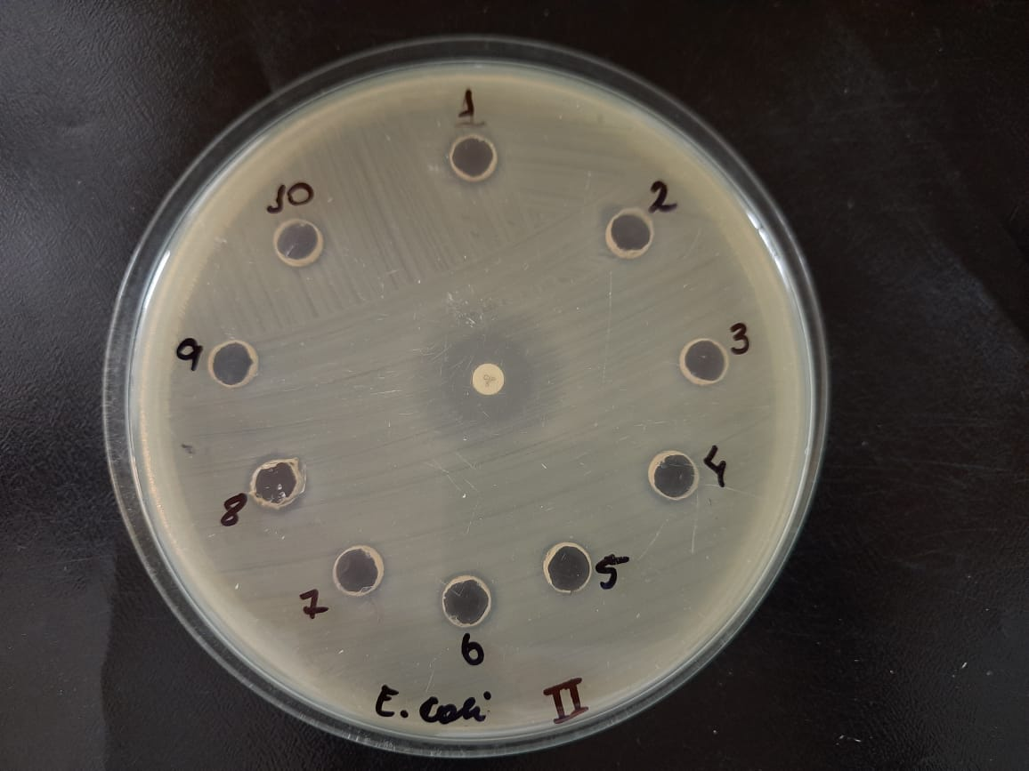  VI)  11
Columns: A - Salmonella typhimurium ATCC 14028 (I and II); B - Staphylococcus aureus ATCC 25923 (III and IV); C - Escherichia coli ATCC 25922 (V and VI). Wells: Lactiplantibacillus plantarum CNPC001 (1 and 10); Lactiplantibacillus plantarum CNPC002 (2); Lactiplantibacillus plantarum CNPC003 (3); Lactiplantibacillus plantarum CNPC004 (4); Limosilactobacillus mucosae CNPC007 (5); Lactiplantibacillus plantarum CNPC020 (6); Lacticaseibacillus rhamnosus EM1107 (7); Positive control (liquid) with 5 μg ciprofloxacin in solution (8); Negative control (9). Disc: Positive control with 5 μg ciprofloxacin (11).

