Areas of spatial overlap between common bottlenose dolphin, recreational boating, and small-scale fishery: management insights from modelling exercises

La Manna Gabriella^{1,2,3}, Ronchetti Fabio³, Perretti Francesco³, Ceccherelli Giulia¹

¹ Università di Sassari, Dipartimento di Scienze Chimiche, Fisiche, Matematiche e Naturali, Sassari, Italy
² National Biodiversity Future Center, Palermo, Italy
³ MareTerra Onlus, Environmental Research and Conservation, Sassari, Italy

Supplementary materials

Suppl. Mat. 1. Correlation matrix of the Pearson correlation coefficients (r) between the environmental predictors in the spring (a), summer (b) and (c) the whole period (spr-sum).
a) spring | Aspect | Boats | Depth | Distance to coast | Distance to harbour | Fishnets | Traps | Chla | Seabed Habitat | Slope | SSTm | SSTr
Aspect |  | -0.13 | 0.09 | -0.07 | 0.07 | 0.14 | -0.02 | 0.00 | 0.02 | 0.08 | 0.11 | 0.16
Boats | -0.13 |  | 0.62 | -0.60 | -0.45 | 0.62 | 0.53 | 0.16 | 0.16 | 0.35 | -0.30 | 0.18
Depth | 0.09 | 0.62 |  | -0.84 | -0.55 | 0.62 | 0.46 | 0.83 | 0.26 | 0.19 | -0.22 | 0.26
Distance to coast | -0.07 | -0.60 | -0.84 |  | 0.34 | -0.52 | -0.35 | -0.46 | -0.18 | -0.31 | -0.08 | 0.06
Distance to harbour | 0.07 | -0.45 | -0.55 | 0.34 |  | -0.45 | -0.76 | -0.48 | -0.20 | 0.08 | 0.77 | -0.28
Fishnets | 0.14 | 0.62 | 0.62 | -0.52 | -0.45 |  | 0.83 | 0.22 | 0.44 | 0.16 | -0.22 | 0.31
Traps | -0.02 | 0.53 | 0.46 | -0.35 | -0.76 | 0.83 |  | 0.32 | 0.21 | 0.21 | -0.65 | 0.11
Chla | 0.00 | 0.16 | 0.83 | -0.46 | -0.48 | 0.22 | 0.32 |  | 0.18 | -0.01 | -0.24 | 0.03
Seabed habitat | 0.02 | 0.16 | 0.26 | -0.18 | -0.20 | 0.44 | 0.21 | 0.18 |  | -0.04 | -0.05 | 0.16
Slope | 0.08 | 0.35 | 0.19 | -0.31 | 0.08 | 0.16 | 0.21 | -0.01 | -0.04 |  | 0.13 | -0.12
SSTm | 0.11 | -0.30 | -0.22 | -0.08 | 0.77 | -0.22 | -0.65 | -0.24 | -0.05 | 0.13 |  | -0.24
SSTr | 0.16 | 0.18 | 0.26 | 0.06 | -0.28 | 0.31 | 0.11 | 0.03 | 0.16 | -0.12 | -0.24
b) summer | Aspect | Boats | Depth | Distance to coast | Distance to harbour | Fishnets | Traps | Chla | Seabed Habitat | Slope | SSTm | SSTr
Aspect |  | -0.18 | 0.09 | -0.07 | 0.07 | 0.07 | 0.02 | 0.00 | 0.02 | 0.08 | -0.03 | 0.07
Boats | -0.18 |  | 0.54 | -0.56 | -0.43 | 0.73 | 0.59 | 0.10 | 0.14 | 0.29 | -0.32 | 0.38
Depth | 0.09 | 0.54 |  | -0.84 | -0.55 | 0.46 | 0.44 | 0.86 | 0.26 | 0.19 | -0.44 | 0.32
Distance to coast | -0.07 | -0.56 | -0.84 |  | 0.34 | -0.46 | -0.46 | -0.50 | -0.18 | -0.31 | 0.05 | -0.67
Distance to harbour | 0.07 | -0.43 | -0.55 | 0.34 |  | -0.37 | -0.59 | -0.49 | -0.20 | 0.08 | 0.77 | -0.09
Fishnets | 0.07 | 0.73 | 0.46 | -0.46 | -0.37 |  | 0.84 | -0.05 | 0.19 | 0.22 | -0.34 | 0.34
Traps | 0.02 | 0.59 | 0.44 | -0.46 | -0.59 | 0.84 |  | 0.20 | 0.18 | 0.28 | -0.37 | 0.43
Chla | 0.00 | 0.10 | 0.86 | -0.50 | -0.49 | -0.05 | 0.20 |  | 0.24 | -0.02 | -0.32 | 0.06
Seabed habitat | 0.02 | 0.14 | 0.26 | -0.18 | -0.20 | 0.19 | 0.18 | 0.24 |  | -0.04 | -0.18 | -0.05
Slope | 0.08 | 0.29 | 0.19 | -0.31 | 0.08 | 0.22 | 0.28 | -0.02 | -0.04 |  | 0.13 | 0.27
SSTm | -0.03 | -0.32 | -0.44 | 0.05 | 0.77 | -0.34 | -0.37 | -0.32 | -0.18 | 0.13 |  | 0.28
SSTr | 0.07 | 0.38 | 0.32 | -0.67 | -0.09 | 0.34 | 0.43 | 0.06 | -0.05 | 0.27 | 0.28
c) spr-sum | Aspect | Boats | Depth | Distance to coast | Distance to harbour | Fishnets | Traps | Chla | Seabed Habitat | Slope | SSTm | SSTr
Aspect |  | -0.16 | 0.09 | -0.07 | 0.07 | 0.13 | -0.01 | 0.00 | 0.02 | 0.08 | 0.00 | 0.20
Boats | -0.16 |  | 0.58 | -0.58 | -0.45 | 0.75 | 0.61 | 0.11 | 0.15 | 0.28 | -0.35 | 0.35
Depth | 0.09 | 0.58 |  | -0.84 | -0.55 | 0.57 | 0.44 | 0.85 | 0.26 | 0.19 | -0.40 | 0.41
Distance to coast | -0.07 | -0.58 | -0.84 |  | 0.34 | -0.53 | -0.41 | -0.48 | -0.18 | -0.31 | 0.02 | -0.22
Distance to harbour | 0.07 | -0.45 | -0.55 | 0.34 |  | -0.44 | -0.69 | -0.49 | -0.20 | 0.08 | 0.79 | -0.33
Fishnets | 0.13 | 0.75 | 0.57 | -0.53 | -0.44 |  | 0.87 | 0.07 | 0.31 | 0.20 | -0.37 | 0.49
Traps | -0.01 | 0.61 | 0.44 | -0.41 | -0.69 | 0.57 |  | 0.25 | 0.16 | 0.27 | -0.49 | 0.11
Chla | 0.00 | 0.11 | 0.65 | -0.48 | -0.49 | 0.07 | 0.25 |  | 0.21 | -0.02 | -0.32 | 0.04
Seabed habitat | 0.02 | 0.15 | 0.26 | -0.18 | -0.20 | 0.31 | 0.16 | 0.21 |  | -0.04 | -0.15 | 0.15
Slope | 0.08 | 0.28 | 0.19 | -0.31 | 0.08 | 0.20 | 0.27 | -0.02 | -0.04 |  | 0.14 | -0.01
SSTm | 0.00 | -0.35 | -0.40 | 0.02 | 0.79 | -0.37 | -0.49 | -0.32 | -0.15 | 0.14 |  | -0.54
SSTr | 0.20 | 0.35 | 0.41 | -0.22 | -0.33 | 0.49 | 0.11 | 0.04 | 0.15 | -0.01 | -0.54

Suppl. Mat. 2. Raster of the environmental variables used to model the likelihood of boat, fishing net, and dolphin presence (whole period): aspect; seafloor slope (degree); water depth (m); distance to the harbor (m); seabed habitat type; mean sea surface temperature (SSTm) and difference between the maximum and the minimum sea surface temperature (SSTr), averaged over the whole sampling period (spr-sum). Aspect was coded as follows: flat (0); N (1); NW (2); E (3); SE (4); S (5); SW (6); W (7); NE (8). Seabed habitat type was coded as follows: 1 = Mediterranean infralittoral rock (MB15); 2 = Coralligenous biocenosis (MC151); 3 = Mediterranean infralittoral coarse sediment (MB35); 4 = Mediterranean infralittoral sand (MB55); 5 = Biocenosis of Mediterranean muddy detritic bottoms (MC451); 6 = Mediterranean circalittoral coarse sediment (MC35); 7 = Biocenosis of Mediterranean open-sea detritic bottoms on shelf-edge (MD451); 8 = Biocenosis of Posidonia oceanica (MB252); 9= Facies of dead "mattes" of Posidonia oceanica without much epiflora (MB2523).

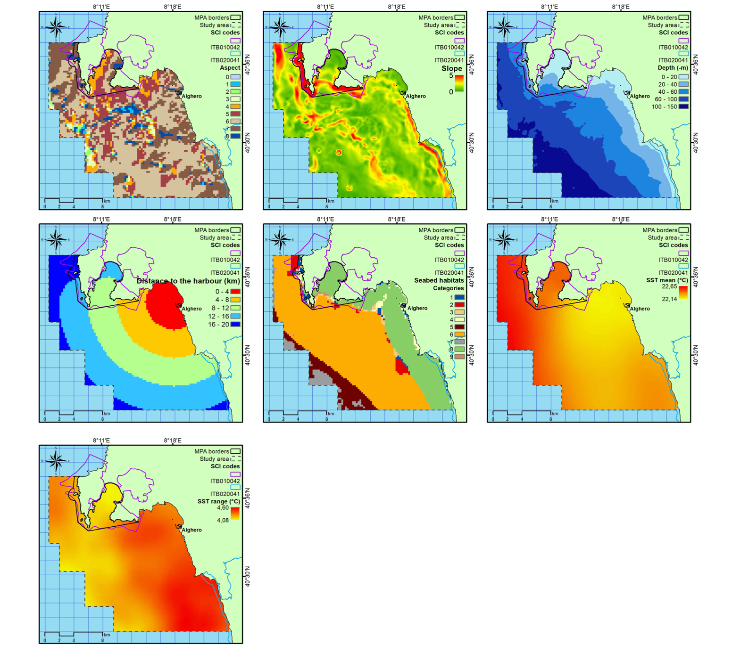

Suppl. Mat. 2. Effect of depth and aspect on the likelihood of boat presence (cloglog output) in spring (A), summer (B) and spr-sum (C).

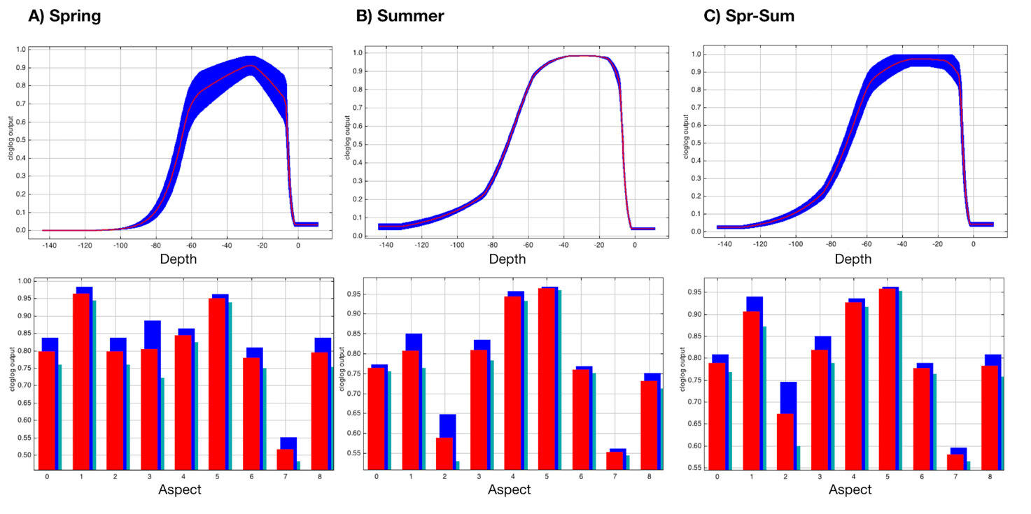

Suppl. Mat. 3. Effect of SSTm, SSTr, seabed habitat, distance to harbor and depth on the likelihood of fishing net presence (cloglog output) in spring (A), summer (B) and spr-sum (C).

