Table 1: Mantel-Haenszel bounds result for lifetime test to know HIV status
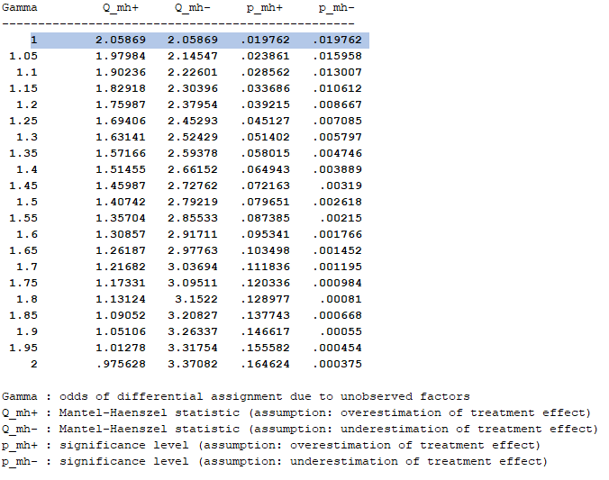

Table 2: Mantel-Haenszel bounds result for the outcome finding HIV positives

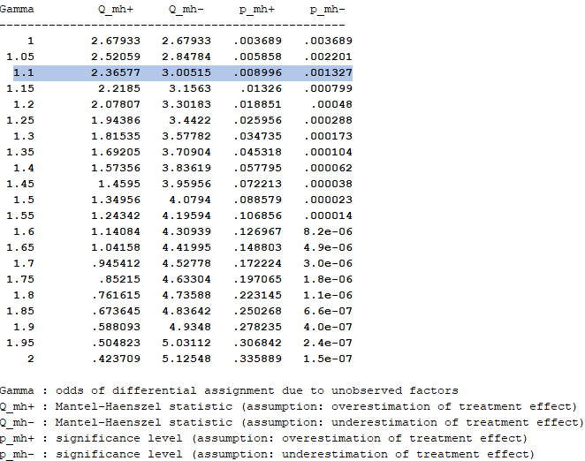

Table 3: Mantel-Haenszel bounds result for aware of their HIV positive status

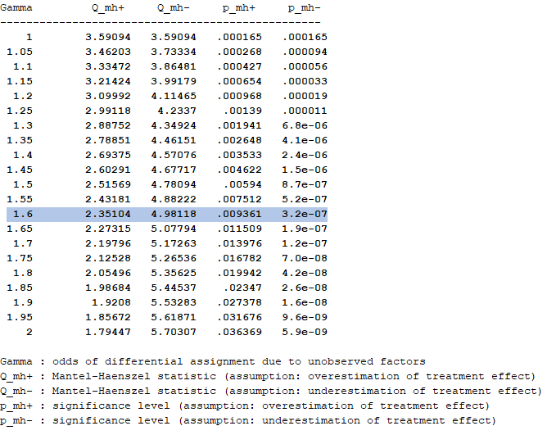

Table 4: Mantel-Haenszel bounds result for consistent condom use

