Figure S1 Lineages through time (LTT) plot from an ultrametric tree. Outgroups, including Riccardia and Lobatiriccardia, were removed before the species delimitation.
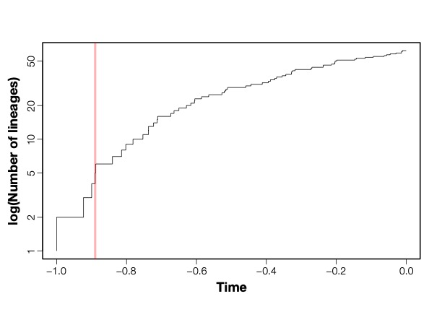
Red line showed the threshold from the “single” method of the GMYC analysis

