Figure S2 Morphological difference among genetic clades of GMYC with single threshold within Aneura species from Thailand. Quantitative characters were recognized by non-parametric Wilcoxon Rank Sum and Signed Rank Tests, while the qualitative characters were recognized by Pearson's Chi-squared test.

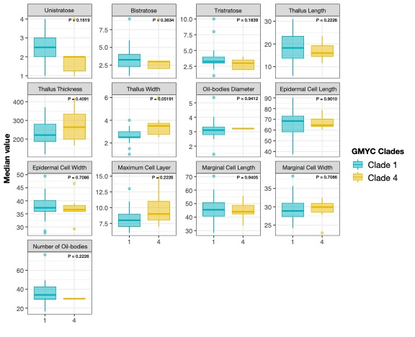
R boxplot continuous characters with p-value
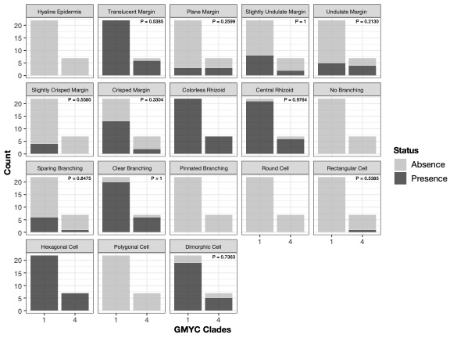
R barplot discrete characters with p-value

