**Fig 2 B**

The photo below corresponds to Figure 2B. The position indicated by the red line in the figure is the electrophoresis band of the qPCR product of circMSH3 in this article.

tagged photo

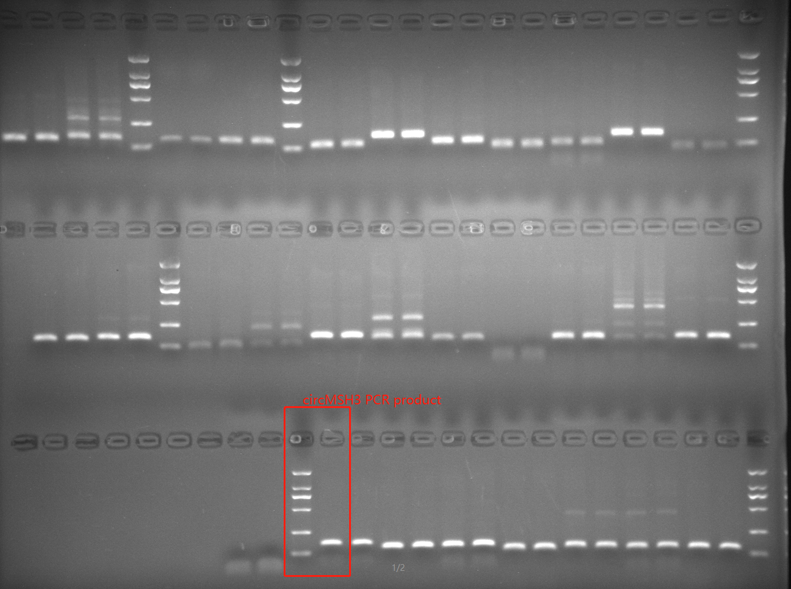

raw photo

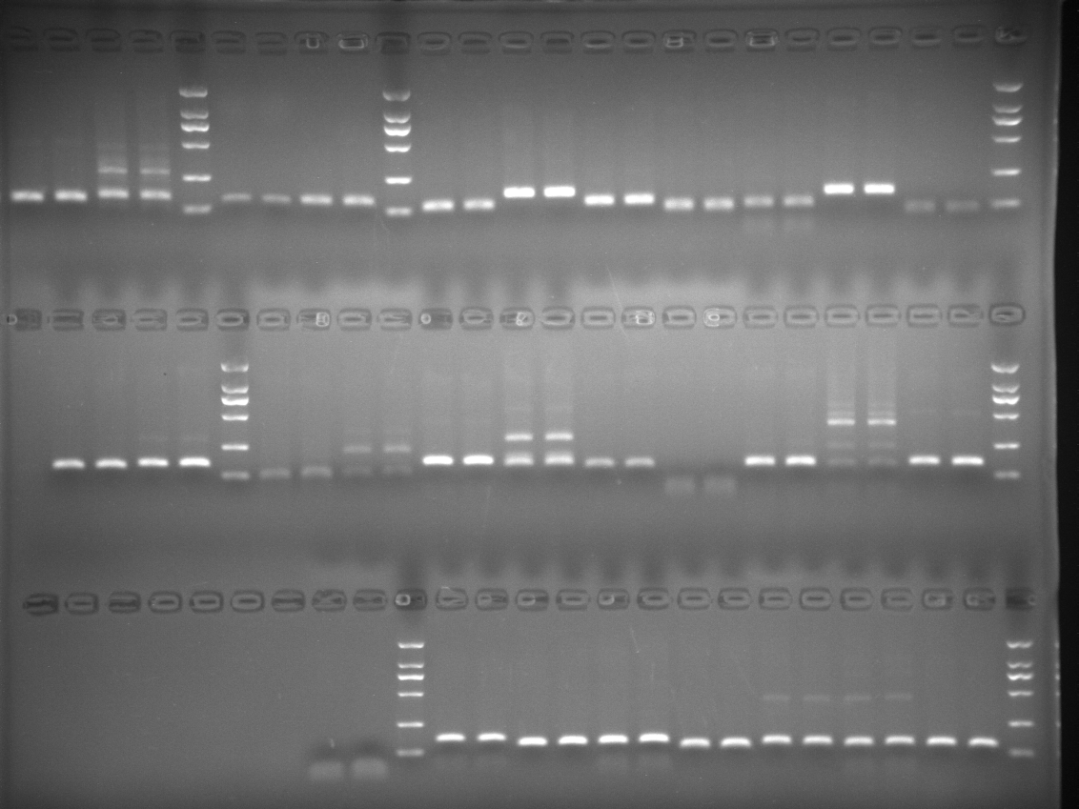

**Fig 4 C**

The photo below corresponds to the WB original film photo and marker in Figure 4c

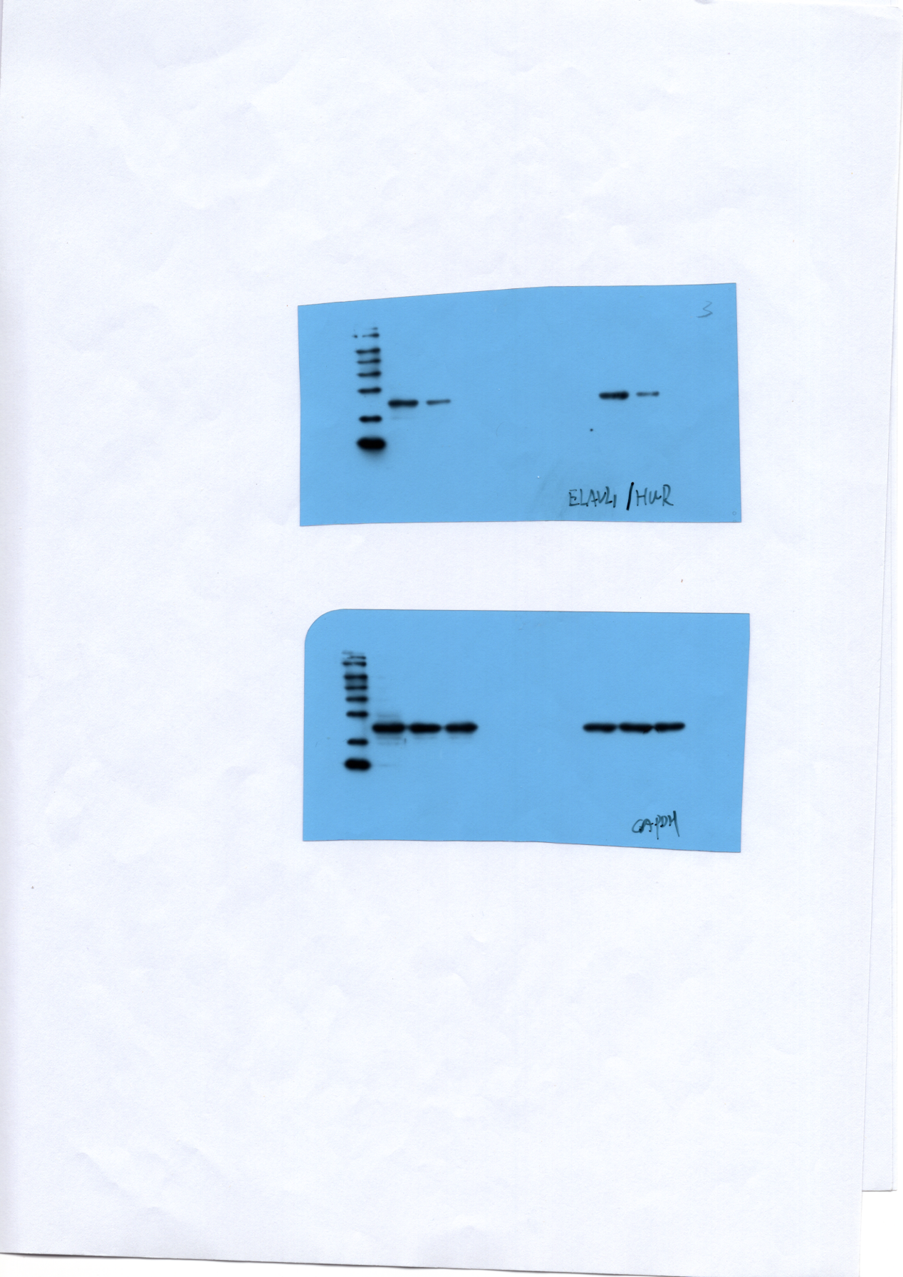

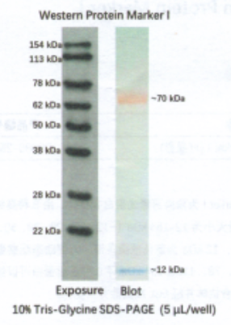

整理-HUR