**Fig 4 C**

The photo below corresponds to the WB original film photo and marker in Figure 4c

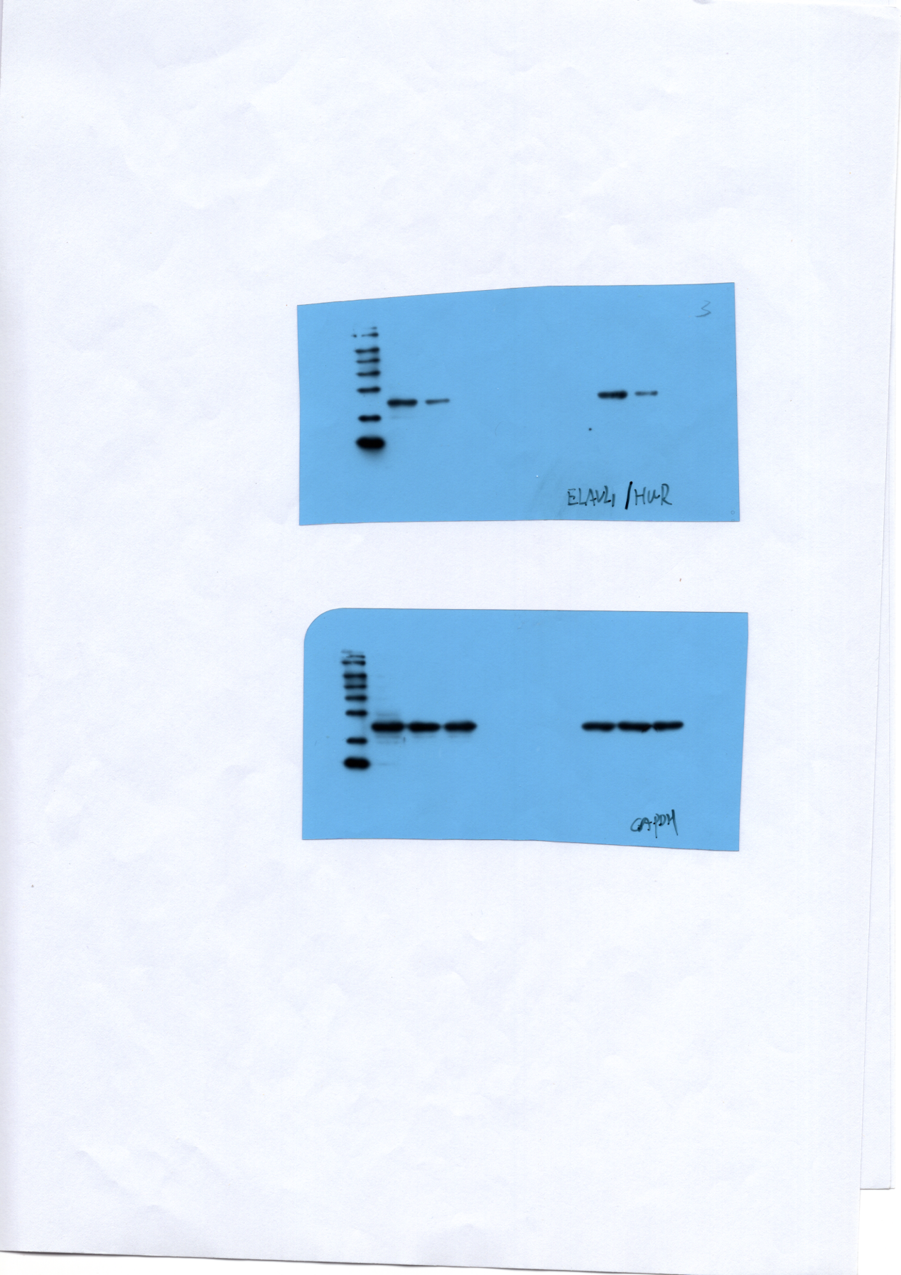

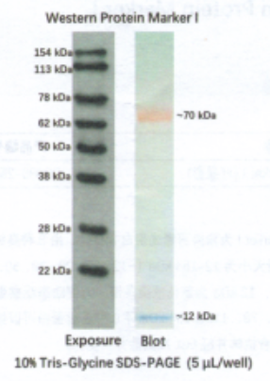

Below is the cropped image

整理-HUR