Original Image for Fig 1B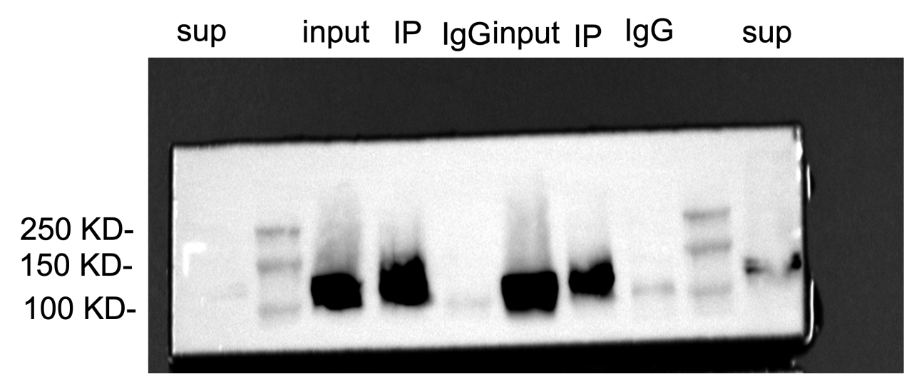

Ctrl_1 Ctrl_2 OE_1 OE_2