**Supplemental information 3**

**Supplementary table 1. Microsatellite multilocus profile for the ten single sequence repeat (SSR) markers developed by [1] and [2]**

|  |  |  |  |  |  |  |  |  |  |  |  |
| --- | --- | --- | --- | --- | --- | --- | --- | --- | --- | --- | --- |
| **Identity** | **Isolate** | **PC61** | **PC371** | **PC3221** | **Pc71** | **Pc201** | **Pc4402** | **Pc1172** | **Pc10072** | **Pc191** | **Pc121** |
| ***P. citricarpa*** | **LSVM359** | 126 | 147 | 152 | 171 | 204 | 266 | 178 | 155 | 160 | 182 |
| ***P. citricarpa*** | **LSVM1101** | 129 | 147 | 152 | 183 | 204 | 266 | 178 | 155 | 160 | 182 |
| ***P. citricarpa*** | **LSVM1123** | 118 | 147 | 152 | 183 | 204 | 266 | 178 | 155 | 160 | 182 |
| ***P. citricarpa*** | **LSVM1499** | 126 | 147 | 152 | 183 | 204 | 266 | 178 | 155 | 160 | 182 |
| ***P. citricarpa*\*** | **CBS141350** | 118 | 147 | 152 | 171 | 204 | Missing | 178 | 158 | 157 | 182 |
| ***P. paracitricarpa*\*** | **CBS141357** | 135 | 144 | 160 | 177 | 200 | 266 | 178 | 160 | 160 | 173 |
| ***P. paracitricarpa*\*** | **CBS141358** | 135 | 144 | 160 | 177 | 200 | 269 | 178 | 158 | 160 | 173 |
| ***P. paracitricarpa*\*** | **ZJUCC20093** | 135 | 144 | 160 | 177 | 200 | 269 | 178 | 158 | 160 | 173 |
| ***P. paracitricarpa*** | **GIHF303** | 141 | 144 | 160 | 177 | 200 | 269 | 178 | 158 | 157 | 173 |
| ***P. paracitricarpa*** | **LSVM1238** | 135 | 144 | 160 | 177 | 194 | 266 | 149 | 158 | 157 | 190 |

[1] N-Y Wang et al., Phytopathology® 106 (11), 1300 (2016).

[2] E Carstens et al., Phytopathology 107 (6), 758 (2017).

* According to V Guarnaccia et al., Studies in Mycology 87, 161 (2017).

**Supplementary figure 1. Minimum spanning network (MSN)**. **The minimum spanning network was constructed based on pairwise allele shared distance. Computed distances are indicated alongside the edges of the MSN.**

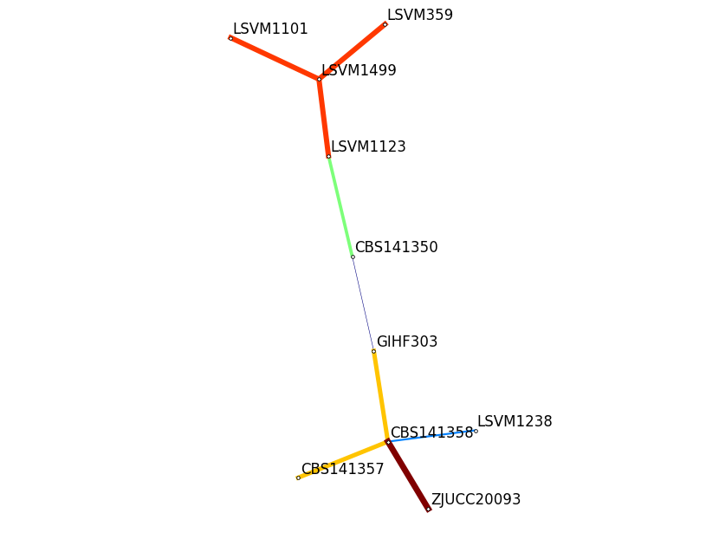

0.67

0.20

0.20

0.50

0.0

0.22

0.10

0.10

0.10

*Phyllosticta citricarpa*

*Phyllosticta paracitricarpa*