***Litsea glaucescens* Kuthpossesses bactericidal activity against *Listeria monocytogenes*.**

Carlos David Gress-Antonio1, Nallely Rivero-Perez1, Silvia Marquina Bahena2, Laura Alvarez2, Adrian Zaragoza-Bastida1, Víctor Manuel Martínez-Juarez1, Carolina G. Sosa-Gutiérrez1, Juan Ocampo-López1, Armando Zepeda-Bastida1, Deyanira Ojeda-Ramírez1

1 Área Académica de Medicina Veterinaria y Zootecnia, Universidad Autónoma del Estado de Hidalgo, Tulancingo de Bravo, Hidalgo,

2 Centro de Investigaciones Químicas, Universidad Autónoma del Estado de Morelos, Cuernavaca, Morelos, México

Corresponding Author:

Deyanira Ojeda-Ramírez1

Avenida Universidad Km1, Ex-hacienda de Aquetzalpa, Tulancingo. Hidalgo, 43600, Mexico.

Email address: [dojeda@uaeh.edu.mx](mailto:dojeda@uaeh.edu.mx)

Content

Figure S1. **.**1H NMR (500 MHz, DMSO-d6) of 5,7-dihydroxy flavanone (Pinocembrin, **1**).

Figure S2. **.**1H NMR (500 MHz, DMSO-d6 + D2O) of 5,7-dihydroxy flavanone (Pinocembrin, **1**).

Figure S3. **.**1H NMR (500 MHz, CDCl3-CD3OD) of 5,7-dihydroxy flavanone (Pinocembrin, **1**).

Figure S4. **.**13C NMR (125 MHz, CDCl3-CD3OD) of 5,7-dihydroxy flavanone (Pinocembrin, **1**).

Figure S5. COSY (500 MHz, CDCl3-CD3OD) of 5,7-dihydroxy flavanone (Pinocembrin, **1**).

Figure S6. HSQC (500 MHz, CDCl3-CD3OD) of 5,7-dihydroxy flavanone (Pinocembrin, **1**).

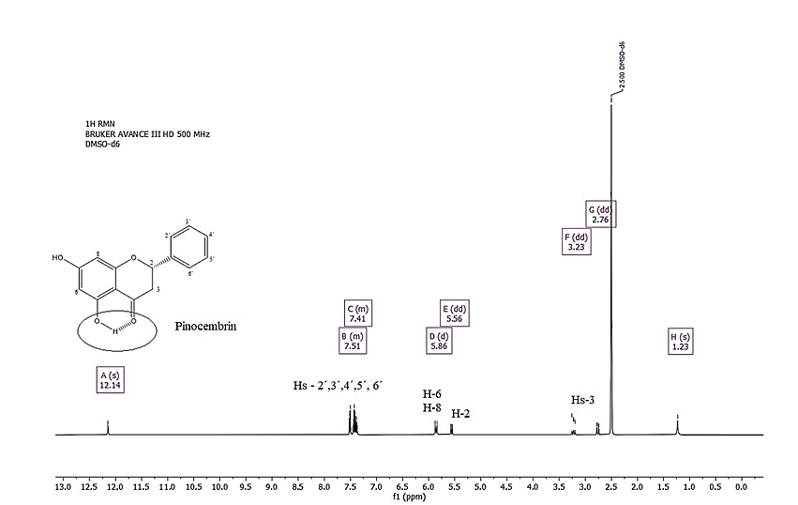

Figure S1. **.**1H NMR (500 MHz, DMSO-d6) of 5,7-dihydroxy flavanone (Pinocembrin, **1**).

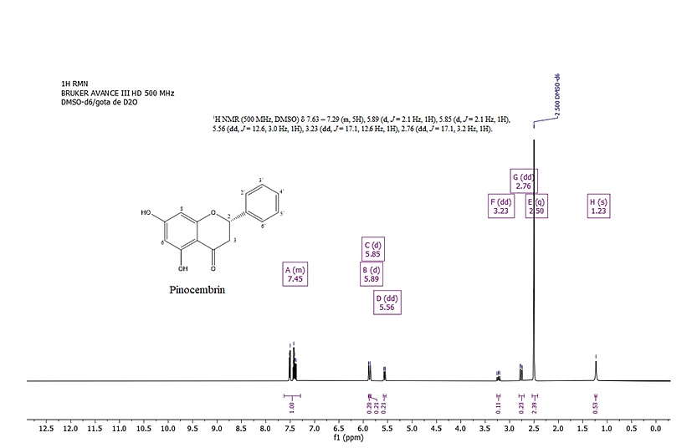

Figure S2. **.**1H NMR (500 MHz, DMSO-d6 + D2O) of 5,7-dihydroxy flavanone (Pinocembrin, **1**).

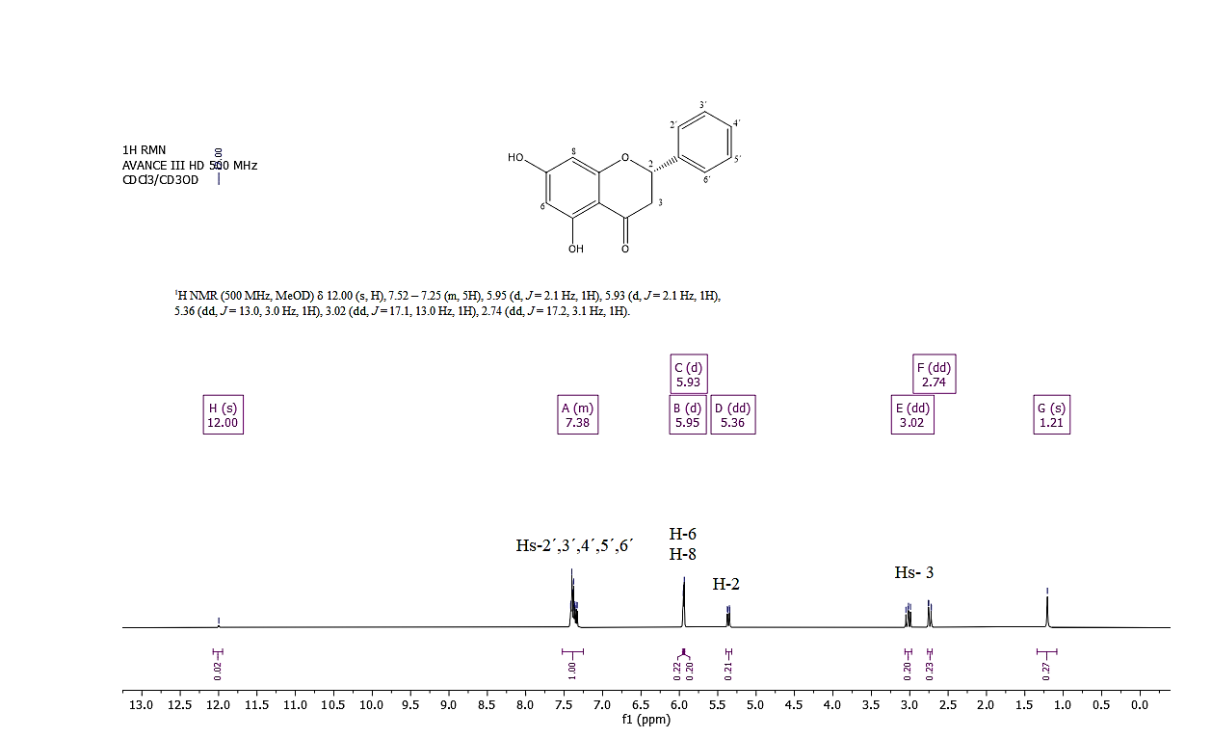

Figure S3. **.**1H NMR (500 MHz, CDCl3-CD3OD) of 5,7-dihydroxy flavanone (Pinocembrin, **1**).

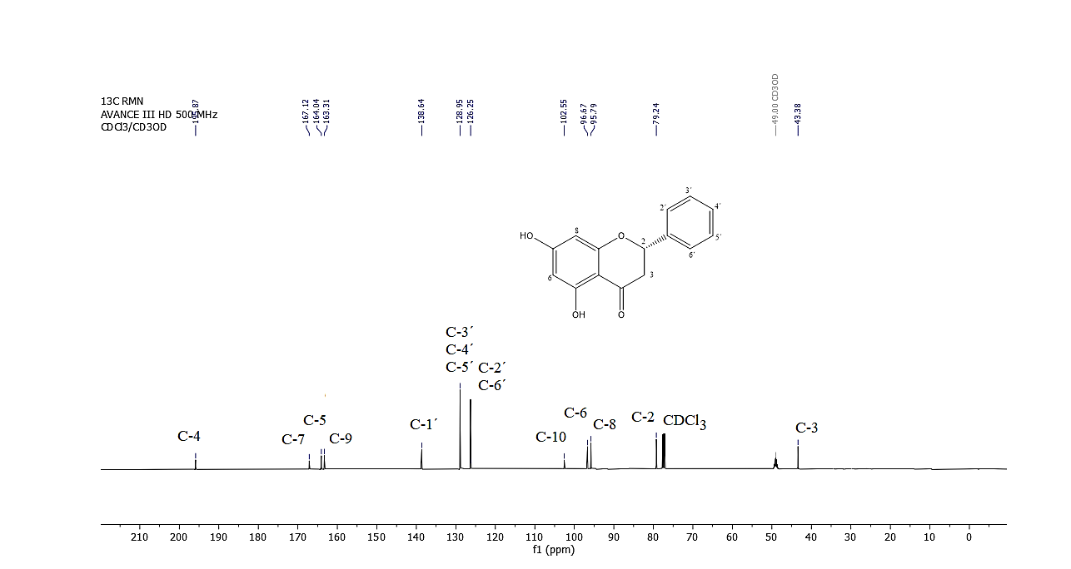

Figure S4. **.**13C NMR (125 MHz, CDCl3-CD3OD) of 5,7-dihydroxy flavanone (Pinocembrin, **1**).

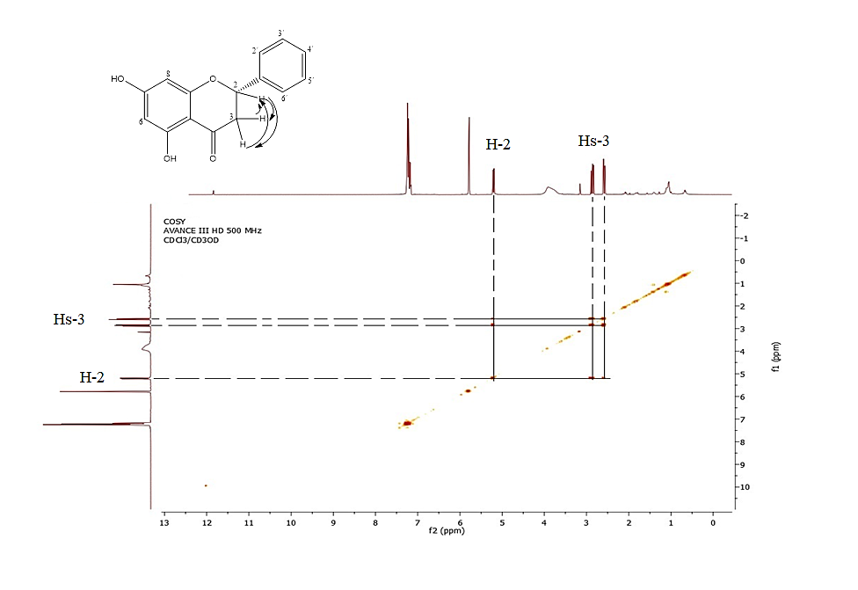

Figure S5. COSY (500 MHz, CDCl3-CD3OD) of 5,7-dihydroxy flavanone (Pinocembrin, **1**).

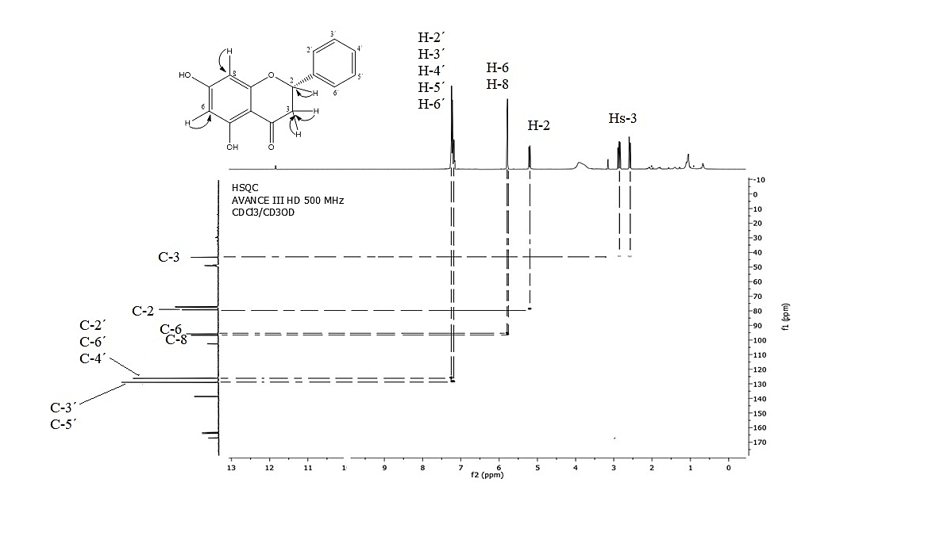

Figure S5. HSQC (500 MHz, CDCl3-CD3OD) of 5,7-dihydroxy flavanone (Pinocembrin, **1**).