SUPPLEMENTARY MATERIAL
Table S1. Sites from Morelia city and surrounding areas where firefly populations have been reported in the last decades.
Urban zone | Firefly population status | Year of observation | Latitude (°N) | Longitude (°W) | Elevation (m asl) | Vegetated spaces category | Terrain slope | Associated waterbodies | Source
Extra-urban | Extant | 2021 | 19.5397 | -101.2393 | 2213 | Meadows | Steep slope | None | Naturalista, 2021
Extra-urban | Extant | 2022 | 19.5397 | -101.2485 | 2153 | Woods | Steep slope | Permanent river | Entomological sampling 2021-2022
Extra-urban | Extant | 2021 | 19.5739 | -101.1237 | 2362 | Hills | Steep slope | Temporal river | Naturalista, 2021
Extra-urban | Extant | 2021 | 19.6012 | -101.3489 | 2384 | Cultivated land | Hillside | None | Naturalista, 2021
Extra-urban | Extant | 2020 | 19.6427 | -101.1377 | 2108 | Hills | Foothill | Temporal river | Naturalista, 2021
Extra-urban | Extant | 2021 | 19.6651 | -101.1414 | 2123 | Hills | Foothill | Permanent river | Naturalista, 2021
Extra-urban | Possible extant | 1963 | 19.6833 | -101.1167 | 1962 | Hills | Hillside | None | GBIF, 2022
Peri-urban | Extant | 2022 | 19.6248 | -101.2447 | 2013 | Woods | Hillside | Permanent lake | Entomological sampling 2021-2022
Peri-urban | Extant | 2022 | 19.6339 | -101.2866 | 1999 | Meadows | Flat plains | Permanent creek | Entomological sampling 2021-2022
Peri-urban | Extant | 2022 | 19.6428 | -101.2662 | 1898 | Wetland | Flat plains | Permanent wetland | Entomological sampling 2021-2022
Peri-urban | Extant | 2020 | 19.6434 | -101.2182 | 2024 | Residential area | Foothill | Temporal river | Naturalista, 2021
Peri-urban | Extant | 2021 | 19.6447 | -101.274 | 1889 | Wetland | Flat plains | Permanent wetland | Naturalista, 2021
Peri-urban | Extant | 2022 | 19.6479 | -101.224 | 1983 | Meadows | Flat plains | Permanent lake | Entomological sampling 2021-2022
Peri-urban | Extant | 2022 | 19.6483 | -101.1983 | 2045 | Meadows | Foothill | Temporal creek | Entomological sampling 2021-2022
Peri-urban | Extant | 2020 | 19.6490 | -101.1575 | 2113 | Cultivated land | Flat plains | None | Naturalista, 2021
Peri-urban | Extant | 2016 | 19.6505 | -101.2278 | 1971 | Roads | Flat plains | Permanent lake | Naturalista, 2021
Peri-urban | Extant | 2019 | 19.6506 | -101.2226 | 1963 | Public garden | Flat plains | Permanent lake | Naturalista, 2021
Peri-urban | Extant | 2019 | 19.6629 | -101.2258 | 1914 | Vacant lots | Flat plains | Temporal river | Naturalista, 2021
Peri-urban | Extant | 2022 | 19.6645 | -101.2109 | 1930 | Meadows | Flat plains | Permanent channel | Entomological sampling 2021-2022
Peri-urban | Extant | 2021 | 19.6663 | -101.2082 | 1981 | Roads | Flat plains | Permanent channel | Naturalista, 2021
Peri-urban | Extant | 2021 | 19.6829 | -101.2474 | 1891 | Vacant lots | Flat plains | Permanent channel | Naturalista, 2021
Peri-urban | Extant | 2022 | 19.6853 | -101.3168 | 1980 | Public garden | Flat plains | None | Entomological sampling 2021-2022
Peri-urban | Possible extant | 1972 | 19.6883 | -101.3047 | 1962 | Vacant lots | Flat plains | Permanent pond | GBIF, 2022
Peri-urban | Possible extant | 1988 | 19.6997 | -101.1167 | 2051 | Vacant lots | Foothill | Temporal creek | Naturalista, 2021
Peri-urban; extinction zone | Extinct | 1950s | 19.7433 | -101.2073 | 1904 | Public garden | Flat plains | None | Interviews, 2022
Urban core | Extant | 2018 | 19.6731 | -101.2001 | 1966 | Backyard | Hillside | Permanent river | Naturalista, 2021
Urban core | Extant | 2021 | 19.674 | -101.211 | 1937 | Vacant lots | Flat plains | None | Entomological sampling 2021-2022
Urban core | Extant | 2021 | 19.6764 | -101.2057 | 1944 | Cultivated land | Flat plains | Permanent river | Entomological sampling 2021-2022
Urban core | Extant | 2022 | 19.6826 | -101.2066 | 1904 | Public garden | Foothill | Permanent channel | Entomological sampling 2021-2022
Urban core | Extant | 2022 | 19.6893 | -101.2499 | 1898 | Meadows | Flat plains | Permanent channel | Entomological sampling 2021-2022
Urban core | Extant | 2022 | 19.6926 | -101.208 | 1921 | Public garden | Flat plains | None | Entomological sampling 2021-2022
Urban core | Extant | 2019 | 19.6964 | -101.2333 | 1886 | Meadows | Flat plains | Permanent wetland and channels | Naturalista, 2021
Urban core | Extant | 2022 | 19.6964 | -101.2349 | 1898 | Wetland | Flat plains | Permanent wetland | Entomological sampling 2021-2022
Urban core; extinction zone | Extinct | 1980s | 19.6683 | -101.2262 | 1889 | Residential area | Flat plains | None | Interviews, 2022
Urban core; extinction zone | Extinct | 1980s | 19.6858 | -101.1995 | 1906 | Residential area | Flat plains | None | Interviews, 2022
Urban core; extinction zone | Extinct | 1950s | 19.6917 | -101.1855 | 1907 | Residential area | Flat plains | Permanent river | Interviews, 2022
Urban core; extinction zone | Extinct | 1980s | 19.6933 | -101.2054 | 1908 | Residential area | Flat plains | None | Interviews, 2022

Table S2. Variables and categories were evaluated to determine the current habitat of the firefly populations from Morelia city.
- Geographic location and elevation
- Habitat suitability variables
  - Landscape class: urban land use classification in 2021, based on MacGregor-Fors (2011):
    - Commercial
    - Conservation
    - green area
    - residential
    - industrial
  - Type of vegetated space: forests or woods, shrubs, meadows, cultivated land, green urban spaces (e.g., backyards or domestic gardens, parks, open grass, sport areas, public gardens), vacant lots, corridors (e.g., median strips, along rivers, or between residential areas), conservation areas, hills.
  - Habitat size: limited to the area within a 500-m radius circular buffer (0.79 km²)
  - Percentage of suitable habitat: estimated green area within a ratio of 500-m radius circular buffer (0.79 km²).
      - highly vegetated (67–100% vegetated area)
      - moderately vegetated (34–66% vegetated area)
      - sparsely vegetated (0–33% vegetated area)
  - Watercourses:
    - Type: temporary or permanent lake, creek, river, pond, channel, and wetland.
    - Distance from firefly population (m)
    - Size: width
  - Terrain slope (FAO categorization):
    - very gentle slopes (0-4% slope gradient)
    - gentle slopes (>4-8%)
    - moderate slopes (>8-16%)
    - steep to extremely steep slopes (>16%)
- Disturbance factors
  - Urbanization degree (following MacGregor-Fors 2010, 2011)
    - Urban-core or intra-urban spaces
    - Peri-urban
    - Extra-urban
    - Extinction zone
  - Percentage of urban surfaces within a ratio of 500-m radius circular buffer (0.79 km²)
    - sparsely developed (0–33% built cover)
    - moderately developed (34–66% built cover)
    - highly developed (67–100% built cover)
  - Radiance values. Based on the database of Earth Observation Group (2021).

Table S3. Updated species list of fireflies (Coleoptera, Lampyridae) for Michoacán, México. Based on Pérez-Hernández et al. (2022), Zaragoza-Caballero et al. (2023), and this study. ** New records for Michoacán.
Lampyridae from Michoacán
Aspisoma aegrota (Gorham, 1880)
Aspisoma depictum (Gorham, 1880)
Aspisomoides bilineatum (Gorham, 1880)
Bicellonycha amoena (Gorham, 1880)
Cratomorphus halffteri Zaragoza-Caballero, 2012**
Photinus acutiformis Zaragoza-Caballero & Cifuentes-Ruíz, 2023**
Photinus advenus Olivier, 1907
Photinus aliciae Zaragoza-Caballero, 2000
Photinus aliciarodriguezae Zaragoza-Caballero & López-Pérez, 2023
Photinus anisodrilus Zaragoza-Caballero, 2007**
Photinus apahtzii Zaragoza-Caballero & López-Pérez, 2023
Photinus ater Gorham, 1881
Photinus barrerae Zaragoza-Caballero & Rodríguez-Mirón, 2023
Photinus brailovskyi Zaragoza-Caballero, 2017
Photinus chanantzkua Zaragoza-Caballero & Domínguez-León, 2023
Photinus chipirietetsi Zaragoza-Caballero & Vega-Badillo, 2023**
Photinus extensus Gorham, 1881**
Photinus guillermodeltoroi Zaragoza-Caballero & Rodríguez-Mirón, 2023**
Photinus intermedius Zaragoza-Caballero, 1995
Photinus leobonillai Zaragoza-Caballero & Domínguez-León 2023
Photinus marthae Zaragoza-Caballero & Cifuentes-Ruiz, 2023
Photinus ortegae Zaragoza-Caballero & Rodríguez-Mirón, 2023
Photinus parvusater Zaragoza-Caballero, 1995
Photinus ca. pyralis (Linnaeus, 1767) (under P. pyralis in Zaragoza-Caballero et al. 2023)
Photinus vegai Zaragoza-Caballero & Cifuentes-Ruíz, 2020**
Photinus vulgatus Olivier, 1907
Photinus zuritai Zaragoza-Caballero & Cifuentes-Ruiz, 2023**
Photinus ca. brailovskyi Zaragoza-Caballero, 2017
Photinus sp. 2 **
Photinus sp. 3**
Photuris fulvipes (Blanchard, 1846)**
Photuris lugubris Gorham, 1881**
Photuris group versicolor (Fabricius, 1798)
Photuris sp.
Pleotomus emmiltos Zaragoza-Caballero, 2002**
Pleotomus pallens LeConte, 1866
Pyractomena striatella Gorham, 1880**
Pyractomena sp.
Pyropyga minuta (LeConte, 1851)
Pyropyga alticola Green, 1961**
Pyropyga nigricans (Say, 1823)

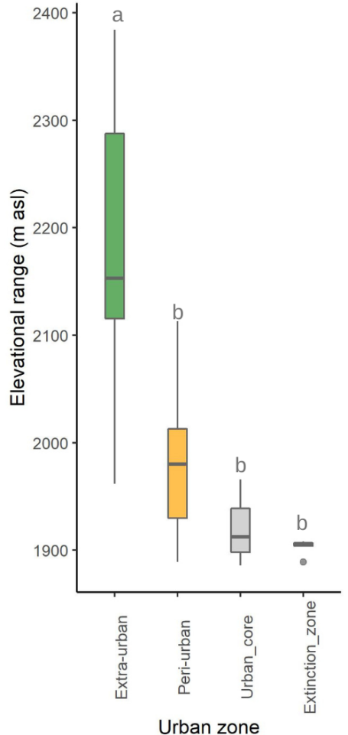
Figure S1. Elevational range among sites where firefly populations have been recorded from different zones in Morelia city, Michoacán, Mexico.

