## Discovering the diversity of tadpoles in the mid-north Brazil: morphological and molecular identification, and characterization of the habitat

Patrícia dos Santos Sousa1, Carlos Augusto Silva de Azevêdo1, Maria Claudene Barros1,Elmary da Costa Fraga1, Thaís B. Guedes2,3

1Centro de Estudos Superiores de Caxias, Universidade Estadual do Maranhão, 65604-380, Caxias, MA, Brazil

2Departamento de Biologia Animal, Instituto de Biologia, Universidade Estadual de Campinas, 13083-862, Campinas, SP, Brazil

3Gothenburg Global Biodiversity Center, University of Gothenburg, Department of Biological and Environmental Sciences, Box 461, SE-405-30, Göteborg, Sweden

Corresponding author: Thaís B. Guedes. Address: Rua Monteiro Lobato, 255, Cidade Universitária, 13083-862, Campinas, SP, Brazil. E-mail: thaisbguedes@yahoo.com.br

Supporting information

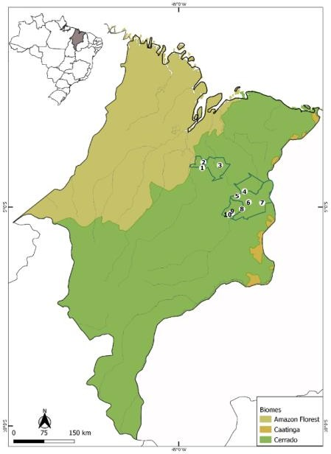

**Appendix S2.** View of the study area in the eastern Maranhão, mid-north region of Brazil. (A) Map of Maranhão highlighting the location of the sampling areas in the following municipalities: São Mateus do Maranhão (1 and 2), Coroatá (3), Aldeias Altas (4), Caxias (5, 6, 7, 8), and São João do Sóter (9, 10). Municipal and biome limits follow (IBGE, 2019).