Outliers can be detected using visualization, implementing mathematical formulas on the dataset, or using the statistical approach, we used Scatter plot and Mahalanobis Distance using python

Scatter plot for PM2.5 pollutant
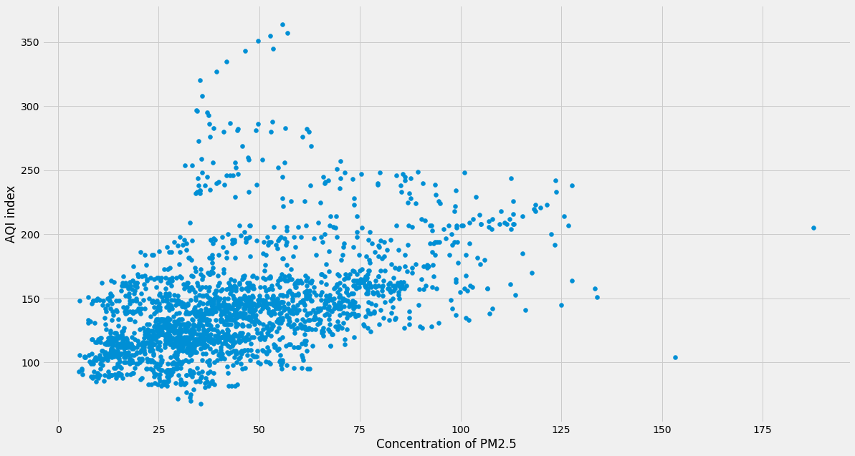
Figure 1: scatter plot for pm2.5

Scatter plot for PM10
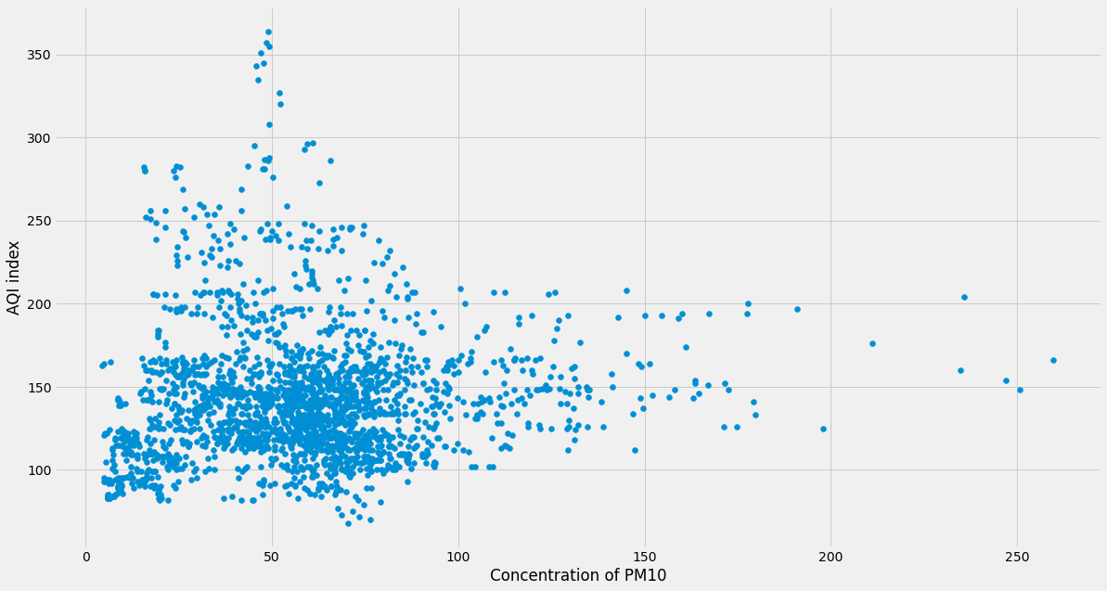
Figure 2: scatter plot for PM10

Scatter plot for NO2 pollutant
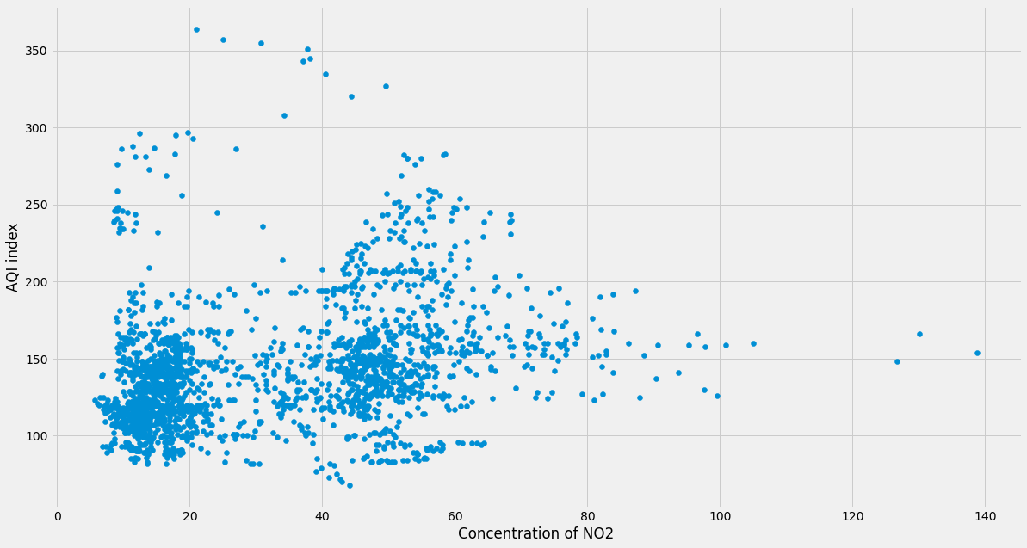
Figure 3: scatter plot for NO2

Scatter plot for O3 pollutant
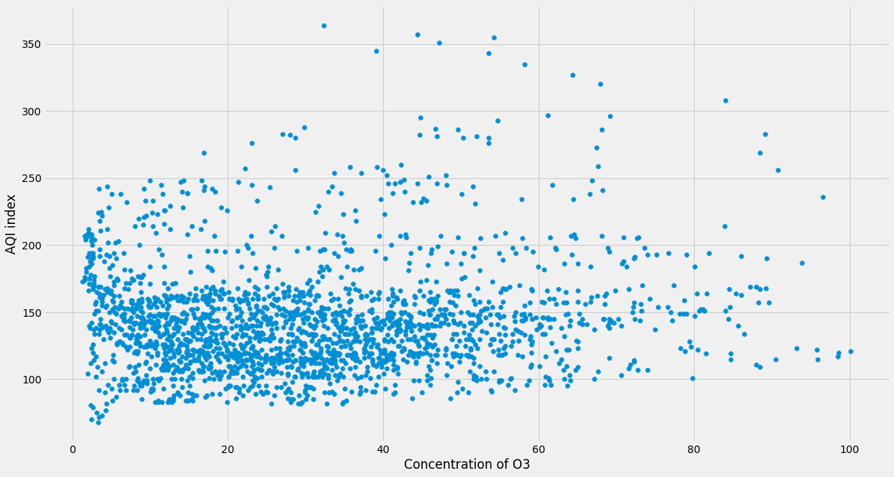
Figure 4: scatter plot for O3

Mahalanobis Distance for PM2.5
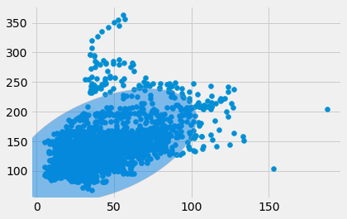
Figure 5: Mahalanobis Distance for PM2.5
Figure 5 shows the Mahalanobis Distance for PM2.5, the points stay outside the ellipse detected as outliers, this ellipse represents the area that wraps non-outlier values according to Mahalanobis Distance.

Mahalanobis Distance for PM10
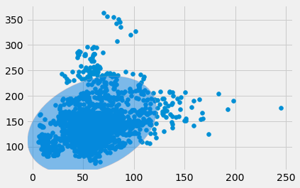
Figure 6: Mahalanobis Distance for PM10
Figure 6 shows the Mahalanobis Distance for PM10, the points stay outside the ellipse detected as outliers, this ellipse represents the area that wraps non-outlier values according to Mahalanobis Distance.

Mahalanobis Distance for NO2
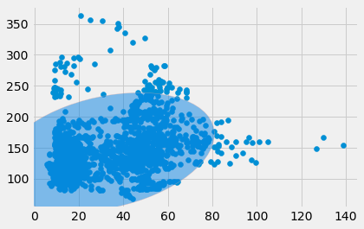
Figure 7: Mahalanobis Distance for NO2
Figure 7 shows the Mahalanobis Distance for NO2, the points stay outside the ellipse detected as outliers, this ellipse represents the area that wraps non-outlier values according to Mahalanobis Distance.

Mahalanobis Distance for O3
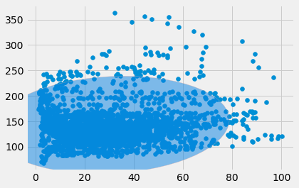
Figure 8: Mahalanobis Distance for O3
Figure 8 shows the Mahalanobis Distance for O3, the points stay outside the ellipse detected as outliers, this ellipse represents the area that wraps non-outlier values according to Mahalanobis Distance.

