Supplemental Files



Figure S1: 1H NMR spectrum of (*E,E*)-*N*-Isobutyl -2,4-octadienamide



Figure S2: 13C NMR spectrum of (*E,E*)-*N*-Isobutyl -2,4-octadienamide

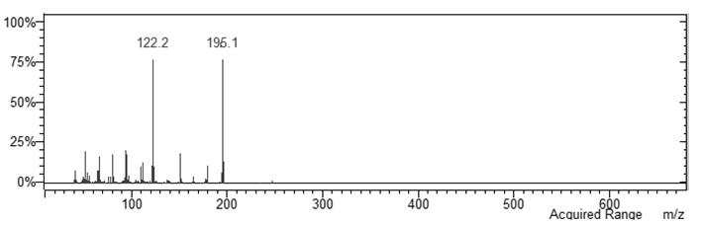

Figure S3: Mass spectrum of (*E,E*)-*N*-Isobutyl -2,4-octadienamide



Figure S4: IR spectrum of (*E,E*)-*N*-Isobutyl -2,4-octadienamide

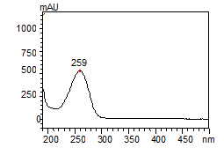

Figure S5: UV spectrum of (*E,E*)-*N*-Isobutyl -2,4-octadienamide



Figure S6: 1H NMR spectrum of (*E,E*)-*N*-Isobutyl -2,4-decadienamide

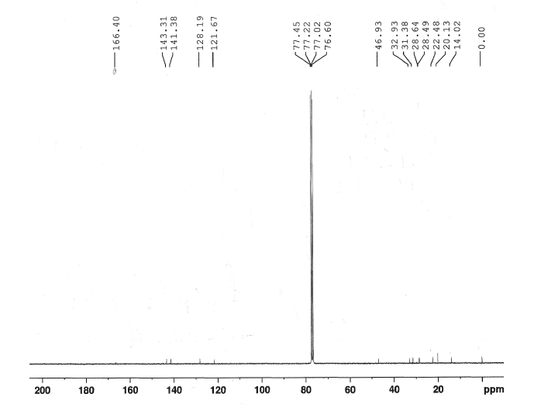

Figure S7: 13C NMR spectrum of (*E,E*)-*N*-Isobutyl -2,4-decadienamide

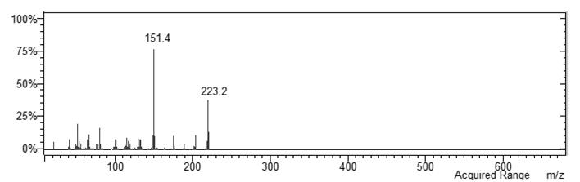

Figure S8: Mass spectrum of (*E,E*)-*N*-Isobutyl -2,4-decadienamide

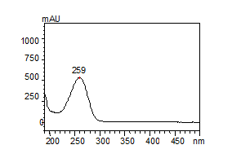

Figure S9: UV spectrum of (*E,E*)-*N*-Isobutyl -2,4-decadienamide