**C6**

Con 40B 80B 250T

250T

+40B

250T

+80B

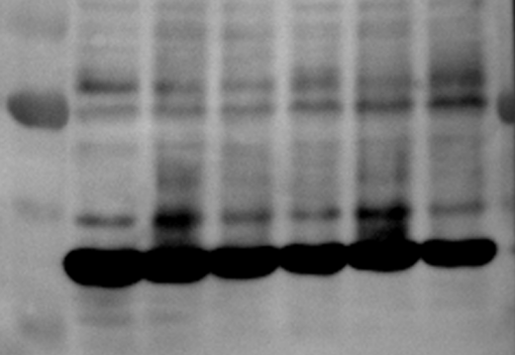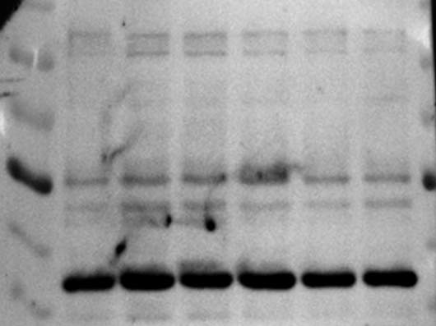

**Repeat 1**

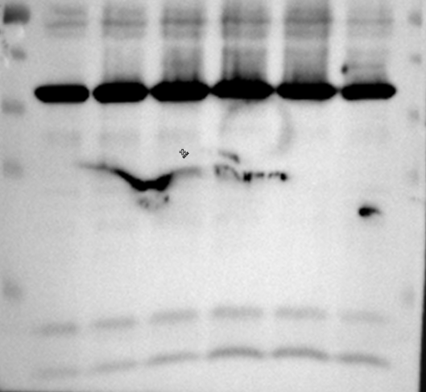

HIF-1α 120kDa

GAPDH 36kDa

GAPDH 36kDa

Beclin 1 52kDa

LC3Ⅰ 16kDa

LC3Ⅱ 14kDa

40

35

130

70

100

40

55

35

55

LC3Ⅱ

LC3Ⅰ

Beclin 1

GAPDH

HIF-1αα

GAPDH

15

35

40

25

GAPDH

**Repeat 2**

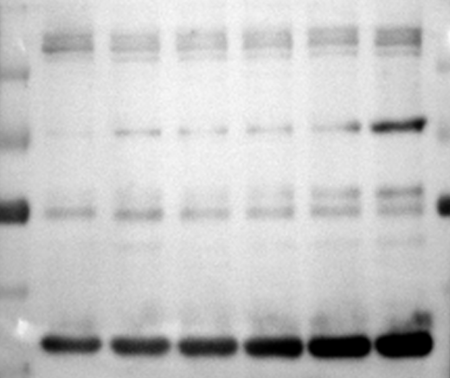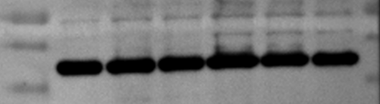

**Repeat 3**

130

70

100

40

55

35

Con 40B 80B 250T

250T

+80B

250T

+40B

Con 40B 80B 250T

250T

+80B

250T

+40B

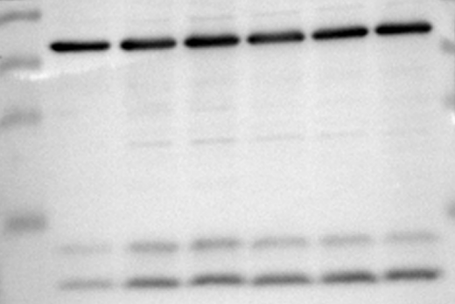

70

40

55

35

15

55

35

40

25

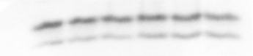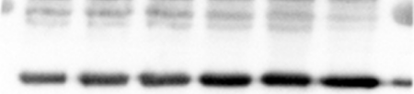

130

55

Beclin 1

GAPDH

HIF-1αα

LC3Ⅱ

LC3Ⅰ

GAPDH

GAPDH 36kDa

35

40

100

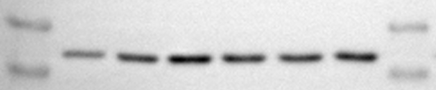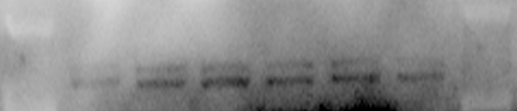

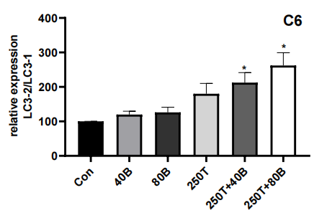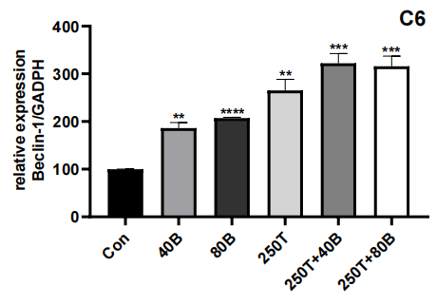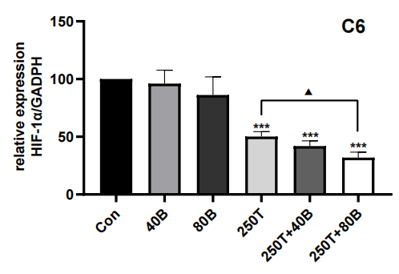

**U251**

GAPDH 36kDa

HIF-1α 120kDa

Beclin 1 52kDa

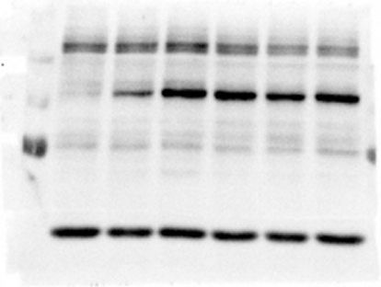

Con 40B 80B 200T

200T

+80B

200T

+40B

130

70

100

40

55

**Repeat 1**

GAPDH 36kDa

55

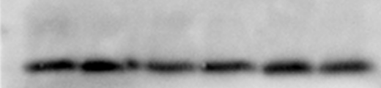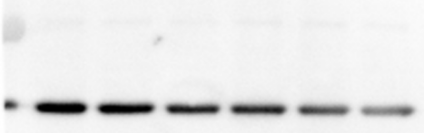

LC3Ⅱ 16kDa 16kDa

LC3Ⅰ 14kDa

15

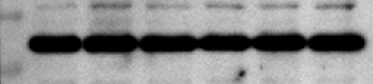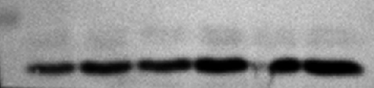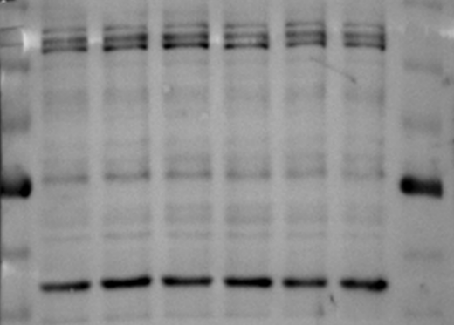

40

35

130

70

100

40

55

35

55

Beclin 1

GAPDH

HIF-1αα

GAPDH

Con 40B 80B 200T

200T

+80B

200T

+40B

**Repeat 2**

LC3Ⅱ

LC3Ⅰ

15

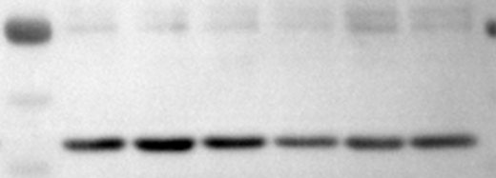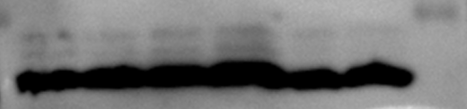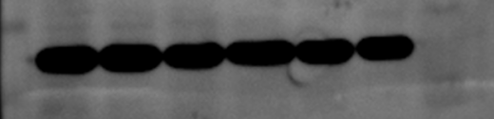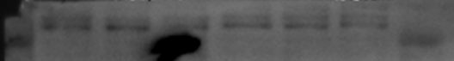

Con 40B 80B 200T

200T

+80B

200T

+40B

130

100

40

55

35

40

35

LC3Ⅱ

LC3Ⅰ

15

Beclin 1

GAPDH

HIF-1αα

GAPDH

**Repeat 3**

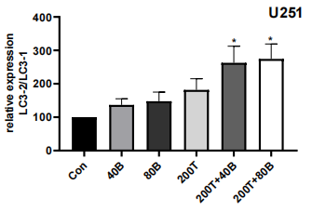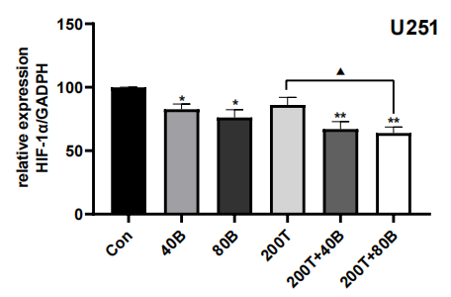

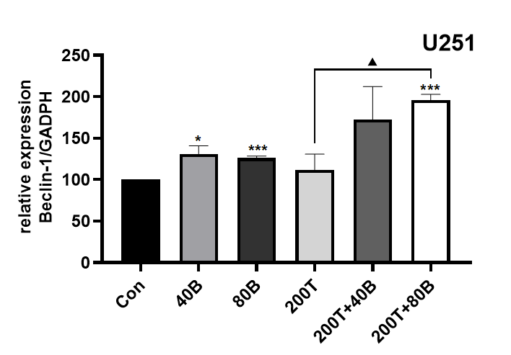

130

HIF-1α 120kDa

100

Con CQ 40B

CQ+40B

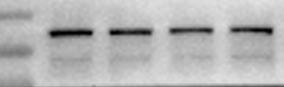

**Repeat 1**

40

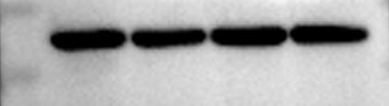

GAPDH 37kDa

35

130

100

40

35

GAPDH

HIF-1αα

**Repeat 2**

Con CQ 40B

CQ+40B

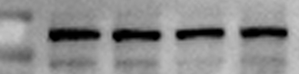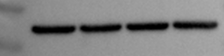

**Repeat 3**

130

100

HIF-1αα



GAPDH

35

40

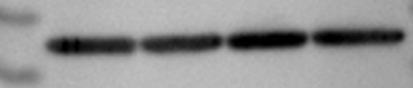

Con CQ 40B

CQ+40B

**U251**

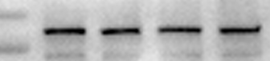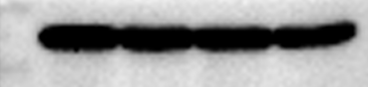

Con CQ 40B

CQ+40B

**Repeat 4**

40

GAPDH 37kDa

35

100

130

HIF-1α 120kDa

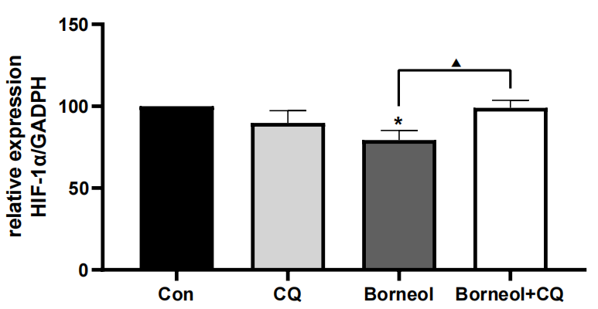

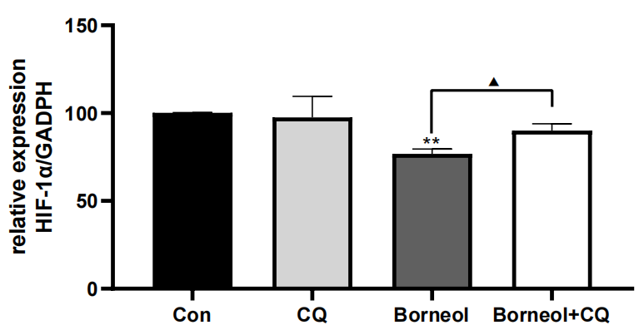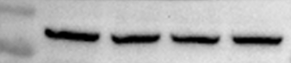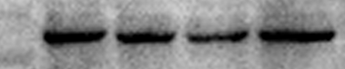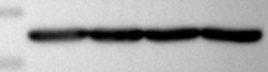

**Repeat 3**

130

100

HIF-1αα

GAPDH

35

40

Con CQ 40B

CQ+40B

130

100

40

35

GAPDH

HIF-1αα

**Repeat 2**

Con CQ 40B

CQ+40B

**Repeat 1**



40

GAPDH 37kDa

35

130

HIF-1α 120kDa

100

**C6**

Con CQ 40B

CQ+40B