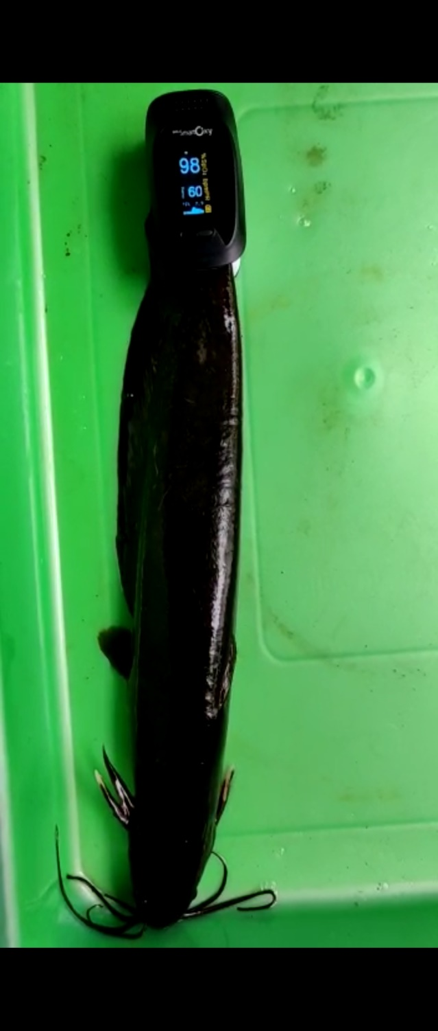

**Supplemnetary Fig. 1.** Mesurement of O2 saturation level in the fish *H. fossilis* under hypoxia tsress.

A pulse oximeter was used to measure the oxygen stauration in the fish. The readings were recorded at regular intervals of 0, 3, 6, 12 and 18 hours in the respective groups and were computed.