Supplementary Material

Melanella martarum sp. nov. (Gastropoda: Eulimidae): the first parasitic deep-sea snail reported for the Salas & Gomez Ridge.

Leonardo Santos de Souza¹, Cynthia M. Asorey^{2,3}, Javier Sellanes^{2,3}

¹ Departamento de Zoologia - Instituto de Biociências, Universidade Federal do Rio Grande do Sul (UFRGS), Brazil.
² Centro de Ecología y Manejo Sustentable de Islas Oceánicas (ESMOI), Departamento de Biología Marina, Universidad Católica del Norte, Coquimbo, Chile.
³Sala de Colecciones Biológicas, Universidad Católica del Norte, Coquimbo, Chile.

Corresponding Author:
Cynthia M. Asorey
Larrondo 1281, Coquimbo, 1781421, Chile
Email address: cynthia.asorey@ucn.cl

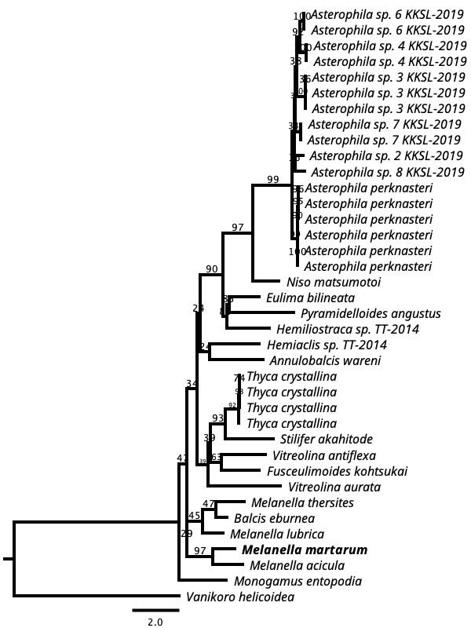
Fig S1: RaxML inferred phylogenetic reconstruction based on 630-bp alignment of partial COI sequences of Eulimidae (bootstrap = 1,000). Bootstrap values obtained are shown in each node. Vanikoro helicoidea (Vanikoridae) was used as outgroup.
Table S1: Species used in RaxML inferred phylogenetic reconstruction based on 630-bp alignment of partial COI sequences of Eulimidae with GenBank accession numbers and the authors of each one. Accession numbers of newly obtained sequences are given in bold.
Family Species |  | COI
Eulimidae | Hemiaclis sp. TT-2014 | AB930465
 | Hemiliostraca sp. TT-2014 | AB930466
 | Melanella acicula | AB930464
 | Monogamus entopodia | AB930458
 | Niso matsumotoi | AB930469
 | Pyramidelloides angustus | AB930470
 | Stilifer akahitode | AB930461
 | Thyca crystallina | AB930460
 | Vitreolina aurata | AB930457
 | Asterophila perknasteri | MN224306
 | Asterophila perknasteri | MN224310
 | Asterophila sp 4 KKSL-2019 | MN224348
 | Asterophila perknasteri 3 | MN224362
 | Fusceulimoides kohtsukai | LC726231.1
 | Melanella martarum sp. nov. | OP577852
 | Annulobalcis wareni | JF717841.1
 | Asterophila perknasteri | MN224312.1
 | Asterophila perknasteri | MN224315.1
 | Asterophila perknasteri | MN224316.1
 | Asterophila perknasteri | MN224362
 | Asterophila sp. 2 KKSL-2019 | MN224340.1
 | Asterophila sp. 3 KKSL-2019 | MN224319.
 | Asterophila sp. 3 KKSL-2019 | MN224324.1
 | Asterophila sp. 3 KKSL-2019 | MN224325.1
 | Asterophila sp. 4 KKSL-2019 | MN224347
 | Asterophila sp. 6 KKSL-2019 | MN224311.1
 | Asterophila sp. 6 KKSL-2019 | MN224341.1
 | Asterophila sp. 7 KKSL-2019 | MN224307.1
 | Asterophila sp. 7 KKSL-2019 | MN224336.1
 | Asterophila sp. 8 KKSL-2019 | MN224333.1
 | Balcis eburnea | AF120636
 | Eulima bilineata | MG934894
 | Fusceulimoides kohtsukai | LC726231.1
 | Hemiaclis sp. TT-2014 | AB930465
 | Hemiliostraca sp. TT-2014 | AB930466
 | Melanella acicula | AB930464
 | Melanella lubrica | MG935328.1
 | Melanella thersites | KF644012
 | Monogamus entopodia | AB930458
 | Niso matsumotoi | AB930469
 | Pyramidelloides angustus | AB930470
 | Stilifer akahitode | AB930461
 | Thyca crystallina | AB930460
 | Thyca crystallina | FJ386279.1
 | Thyca crystallina | FJ386280.1
 | Thyca crystallina | FJ386281.1
 | Vanikoro helicoidea | AB930487
 | Vitreolina antiflexa | MT920177
 | Vitreolina aurata | AB930457
Vanikoridae | Vanikoro helicoidea | AB930487

