Supplemental material
The destructive subterranean termite Reticulitermes flavipes (Blattodea: Rhinotermitidae) can colonize arid territories
Table S1. Meteorological stations for each zone, their coordinates and distance from the areas with Reticulitermes flavipes.
Meteorological stations | Zone | Latitude | Longitude | Distance from the focus (km)
GC102 | Lanzarote | 29.0036111 | -13.6458333 | 5.4
LZ01 | Lanzarote | 29.0005556 | -13.5580556 | 6.4
LZ airport | Lanzarote | 28.9519444 | -13.6002778 | 2.3
TF105 | North Tenerife | 28.5128145 | -16.3878427 | 0.7
TF106 | North Tenerife | 28.5280556 | -16.3869444 | 0
TF108 | North Tenerife | 28.5247222 | -16.3700000 | 1.5
TF109 | North Tenerife | 28.5063125 | -16.3892082 | 0.1
TF02 | South Tenerife | 28.2300000 | -16.8341667 | 0.7
TF13 | South Tenerife | 28.0406000 | -16.6532300 | 8.8

Table S2. The area occupied by R. flavipes each year in the northeast of Tenerife.
Locality | Main focus | Distal focus 1 | Distal focus 2 | Distal focus 3 | Distal focus 4
Area (m²)/year | Tacoronte-La Laguna | La Barranquera | Los Collazos | Garimba | Los Naranjeros
2010 | 89,900 | - | - | - | -
2015 | 107,116 | - | - | - | -
2017 | 120,909 | - | - | - | -
2018 | 949,614 | - | - | - | -
2019 | 1,061,021 | - | - | - | -
2020 | 2,599,891 | 19,322 | 3,005 | 11,693 | 5,285
2021 | 3,416,966 | 63,136 | - | 26,834 | 6,628
2022 | 3,669,703 | 63,474 | - | 29,643 | -

Table S3. The area occupied by R. flavipes each year in Lanzarote and the south of Tenerife.
Locality | Lanzarote | Southern focus 1 | Southern focus 2
Area (m²)/year | Güíme | Los Cristianos | Puerto Santiago
2018 | - | 15 | -
2019 | - | 15 | -
2020 | 10,942 | 8,233 | 13,748
2021 | 11,678 | 9,143 | 18,306
2022 | 21,377 | 37,043 | 19,972

Table S4. Expansion of R. flavipes in each of its populations in the north-east of Tenerife. Maximum, minimum, and mean linear distance of advance by R. flavipes between 2010-2022. The main direction of their advance is also indicated.
Linear expansion (m)/year |  | Main focus | Distal focus 1 | Distal focus 3 | Distal focus 4
 |  | Tacoronte-La Laguna | La Barranquera | Garimba | Los Naranjeros
2010-2015 | Min. | 5.44 | - | - | -
 | Max. | 183.25 | - | - | -
 | Mean | 79.5 | - | - | -
 | Main direction | South | - | - | -
2015-2017 | Min. | 6.29 | - | - | -
 | Max. | 133.66 | - | - | -
 | Mean | 63.87 | - | - | -
 | Main direction | West | - | - | -
2017-2018 | Min. | 5.09 | - | - | -
 | Max. | 866.5 | - | - | -
 | Mean | 407.13 | - | - | -
 | Main direction | East | - | - | -
2018-2019 | Min. | 5.04 | - | - | -
 | Max. | 140.21 | - | - | -
 | Mean | 53.34 | - | - | -
 | Main direction | Northwest | - | - | -
2019-2020 | Min. | 5.53 | - | - | -
 | Max. | 1046.97 | - | - | -
 | Mean | 434.08 | - | - | -
 | Main direction | East | - | - | -
2020-2021 | Min. | 5.06 | 5 | 5.94 | 7.05
 | Max. | 1027.13 | 332.83 | 122.4 | 25.61
 | Mean | 258.49 | 152.82 | 53.65 | 18.61
 | Main direction | North | Northwest | North | West
2021-2022 | Min. | 5.02 | - | 5.08 | -
 | Max. | 169.31 | - | 38.3 | -
 | Mean | 39.25 | - | 23.76 | -
 | Main direction | Southeast | - | Northeast | -

Table S5. Expansion of R. flavipes in each population in Lanzarote and the south of Tenerife. Maximum, minimum, and mean linear distance of advance by R. flavipes between 2020-2022. In addition, the main direction of advance is indicated.
Linear expansion (m)/year |  | Lanzarote | Southern focus 1 | Southern focus 2
 |  | Güíme | Los Cristianos | Puerto Santiago
2020-2021 | Min. | 6.37 | 6.00 | 5.43
 | Max. | 16.08 | 15.44 | 46.96
 | Mean | 10.64 | 12.09 | 20.19
 | main direction | South | South | East
2021-2022 | Min. | 6.04 | 5.11 | 5.37
 | Max. | 59.03 | 414.87 | 24.11
 | Mean | 31.63 | 213.91 | 12.62
 | main direction | East | North | Northeast

Table S6. Pairwise comparisons of climatic variables between the three zones. NT: North Tenerife; ST: South Tenerife; LZ: Lanzarote.
Pairwise comparisons
Mean Temperature
 | Estimate | SE | p
NT-LZ | -2.25381 | 0.26191 | < 1x10⁻⁵
NT-ST | 2.32967 | 0.29555 | < 1x10⁻⁵
ST-LZ | 0.07586 | 0.31259 | 0.968
Max. Temperature
NT-LZ | -2.0939 | 0.4181 | < 1x10⁻⁵
NT-ST | 2.4381 | 0.4719 | < 1x10⁻⁵
ST-LZ | 0.3442 | 0.4991 | 0.769
Min. Temperature
NT-LZ | -2.3236 | 0.2998 | < 1x10⁻⁴
NT-ST | 1.7661 | 0.3383 | < 1x10⁻⁴
ST-LZ | -0.5575 | 0.3578 | 0.263
Mean Humidity
NT-LZ | -0.06164 | 0.73277 | 0.996
NT-ST | -4.37508 | 0.82554 | < 1x10⁻⁶
ST-LZ | -4.43673 | 0.82554 | < 1x10⁻⁶
Precipitation
NT-LZ | 22.031 | 2.681 | < 1x10⁻⁴
NT-ST | -25.793 | 3.026 | < 1x10⁻⁴
ST-LZ | -3.762 | 3.200 | 0.466

Table S7. Differences in climatic variables between the three zones in each season. NT: North Tenerife; ST: South Tenerife; LZ: Lanzarote.

Zones/Seasons
SPRING
 | χ² | df | p | Mean ± SE NT | Mean ± SE ST | Mean ± SE LZ
Mean Temperature | 94.621 | 2 | 2.2x10⁻¹⁶ | 16.5 ± 0.195 | 19.0 ± 0.276 | 19.1 ± 0.228
Max. Temperature | 16.393 | 2 | 2.7x10⁻⁴ | 24.6 ± 0.489 | 27.2 ± 0.691 | 27.4 ± 0.571
Min. Temperature | 44.662 | 2 | 2.00x10⁻¹⁰ | 11.3 ± 0.254 | 13.2 ± 0.359 | 13.7 ± 0.297
Mean Humidity | 22.453 | 2 | 1.33x10⁻⁵ | 71.6 ± 0.650 | 66.3 ± 0.931 | 68.9 ± 0.769
Precipitation | 102.3 | 2 | 2.2x10⁻¹⁶ | 33.56 ± 2.09 | 4.71 ± 2.96 | 5.32 ± 2.44
SUMMER
Mean Temperature | 95.321 | 2 | 2.2x10⁻¹⁶ | 20.4 ± 0.198 | 22.9 ±0.280 | 23.0 ± 0.229
Max. Temperature | 20.724 | 2 | 3.16x10⁻⁵ | 28.7 ± 0.485 | 31.1 ± 0.686 | 32.0 ± 0.560
Min. Temperature | 74.725 | 2 | 2.2x10⁻¹⁶ | 15.4 ± 0.236 | 17.3 ± 0.334 | 18.4 ± 0.272
Mean Humidity | 7.4007 | 2 | 0.02471 | 74.2 ± 0.760 | 70.8 ± 1.075 | 72.2 ± 0.878
Precipitation | 37.981 | 2 | 5.65x10⁻⁹ | 11.93 ± 1.27 | 1.96 ± 1.79 | 1.15 ± 1.46
AUTUMN
Mean Temperature | 54.128 | 2 | 1.76x10⁻¹² | 20.1 ± 0.220 | 22.3 ± 0.311 | 22.2 ± 0.254
Max. Temperature | 10.351 | 2 | 0.005654 | 28.5 ± 0.439 | 30.5 ± 0.621 | 30.3 ± 0.507
Min. Temperature | 25.442 | 2 | 2.98x10⁻⁶ | 14.8 ± 0.284 | 16.5 ± 0.402 | 16.8 ± 0.328
Mean Humidity | 3.7961 | 2 | 0.1499 | 70.1 ± 0.983 | 67.4 ± 1.390 | 70.8 ± 1.148
Precipitation | 15.861 | 2 | 3.5x10⁻⁴ | 42.9 ± 5.42 | 10.2 ± 7.66 | 17.2 ± 6.26
WINTER
Mean Temperature | 48.341 | 2 | 3.18x10⁻¹¹ | 15.9 ± 0.193 | 18.1 ± 0.272 | 17.3 ± 0.228
Max. Temperature | 22.878 | 2 | 1.07x10⁻⁵ | 23.6 ± 0.339 | 26.3 ± 0.480 | 24.0 ± 0.401
Min. Temperature | 20.92 | 2 | 2.86x10⁻⁵ | 10.5 ± 0.246 | 11.9 ± 0.348 | 12.0 ± 0.291
Mean Humidity | 32.787 | 2 | 7.59x10⁻⁸ | 64.2 ± 0.963 | 58.1 ± 1.362 | 38.3 ± 1.138
Precipitation | 48.964 | 2 | 2.33x10⁻¹¹ | 40.32 ± 2.90 | 8.66 ± 4.10 | 17.12 ± 3.43

Table S8. Pairwise comparisons of climatic variables between the three zones in each season. NT: North Tenerife; ST: South Tenerife; LZ: Lanzarote.
Pairwise comparisons Zones/Season
SPRING
Mean Temperature
 | Estimate | SE | p
NT-LZ | -2.58591 | 0.29980 | < 1x10⁻⁵
NT-ST | 2.50167 | 0.33775 | < 1x10⁻⁵
ST-LZ | -0.08425 | 0.35764 | 0.97
Max. Temperature
NT-LZ | -2.7195 | 0.7514 | 0.00106
NT-ST | 2.5745 | 0.8963 | 0.00659
ST-LZ | -0.1450 | 0.8465 | 0.98562
Min. Temperature
NT-LZ | -2.4649 | 0.3904 | < 1x10⁻⁴
NT-ST | 1.9353 | 0.4398 | < 1x10⁻⁴
ST-LZ | -0.5296 | 0.4657 | 0.49
Mean Humidity
NT-LZ | 2.652 | 1.012 | 0.0235
NT-ST | -5.293 | 1.140 | <0.001
ST-LZ | -2.641 | 1.207 | 0.0726
Precipitation
NT-LZ | 28.2354 | 3.2180 | < 1x10⁻⁶
NT-ST | -28.8508 | 3.6254 | < 1x10⁻⁶
ST-LZ | -0.6155 | 3.8389 | 0.986
SUMMER
Mean Temperature
NT-LZ | -2.6635 | 0.3025 | < 1x10⁻⁵
NT-ST | 2.4818 | 0.3430 | < 1x10⁻⁵
ST-LZ | -0.1817 | 0.3616 | 0.87
Max. Temperature
NT-LZ | -3.2316 | 0.7409 | <0.001
NT-ST | 2.3990 | 0.8401 | 0.012
ST-LZ | -0.8326 | 0.8855 | 0.613
Min. Temperature
NT-LZ | -3.0558 | 0.3603 | <0.001
NT-ST | 1.9423 | 0.4086 | <0.001
ST-LZ | -1.1134 | 0.4307 | 0.0263
Mean Humidity
NT-LZ | 1.976 | 1.161 | 0.2035
NT-ST | -3.435 | 1.317 | 0.0244
ST-LZ | -1.459 | 1.388 | 0.5431
Precipitation
NT-LZ | 10.786 | 1.936 | < 1x10⁻⁵
NT-ST | -9.974 | 2.195 | 1.46x10⁻⁵
ST-LZ | 0.812 | 2.314 | 0.934
AUTUMN
Mean Temperature
NT-LZ | -2.172949 | 0.336419 | < 1x10⁻⁷
NT-ST | 2.175333 | 0.381463 | < 1x10⁻⁷
ST-LZ | 0.002384 | 0.402097 | 1
Max. Temperature
NT-LZ | -1.7868 | 0.6705 | 0.0209
NT-ST | 2.0343 | 0.7602 | 0.0202
ST-LZ | 0.2476 | 0.8013 | 0.9485
Min. Temperature
NT-LZ | -2.0207 | 0.4341 | <0.001
NT-ST | 1.7517 | 0.4922 | 0.00108
ST-LZ | -0.2690 | 0.5189 | 0.86174
Mean Humidity
NT-LZ | -0.7121 | 1.5116 | 0.884
NT-ST | -2.6825 | 1.7029 | 0.143
ST-LZ | -3.3946 | 1.8032 | 0.255
Precipitation
NT-LZ | 25.702 | 8.278 | 0.00523
NT-ST | -32.689 | 9.386 | 0.00134
ST-LZ | -6.987 | 9.894 | 0.75886
WINTER
Mean Temperature
NT-LZ | -1.4225 | 0.2982 | <0.001
NT-ST | 2.1598 | 0.3337 | <0.001
ST-LZ | 0.7374 | 0.3550 | 0.094
Max. Temperature
NT-LZ | -0.4163 | 0.5249 | 0.706231
NT-ST | 2.7447 | 0.5874 | < 1x10⁻⁴
ST-LZ | 2.3284 | 0.6250 | 0.000571
Min. Temperature
NT-LZ | -1.5730 | 0.3810 | <0.001
NT-ST | 1.4352 | 0.4264 | 0.00223
ST-LZ | -0.1379 | 0.4536 | 0.95012
Mean Humidity
NT-LZ | -4.072 | 1.491 | 0.0172
NT-ST | -6.091 | 1.669 | <0.001
ST-LZ | -10.163 | 1.775 | <0.001
Precipitation
NT-LZ | 23.198 | 4.488 | < 1x10⁻⁴
NT-ST | -31.660 | 5.022 | < 1x10⁻⁴
NT-LZ | -8.461 | 5.343 | 0.251

Figures
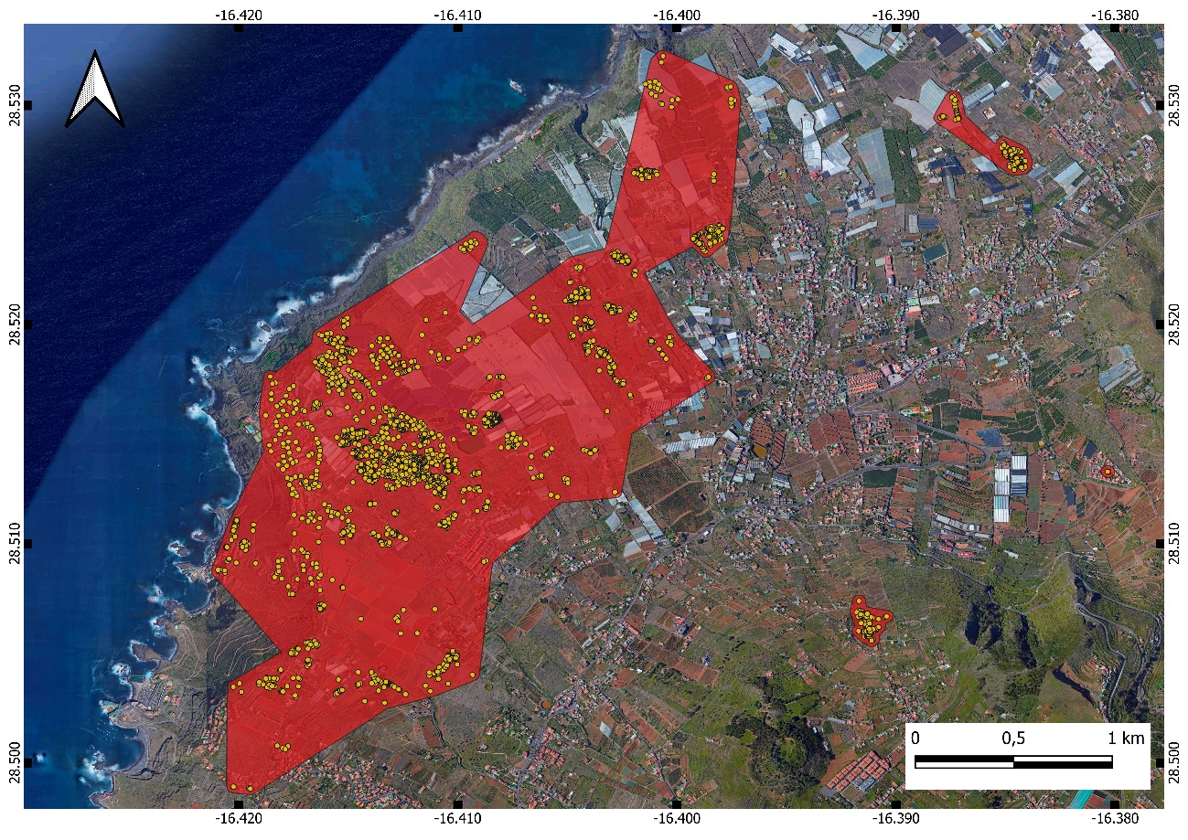
Figure S1. Detailed map with R. flavipes distribution (yellow dots and red area) in the main focus on Tenerife. Map credit: Gobierno de Canarias.
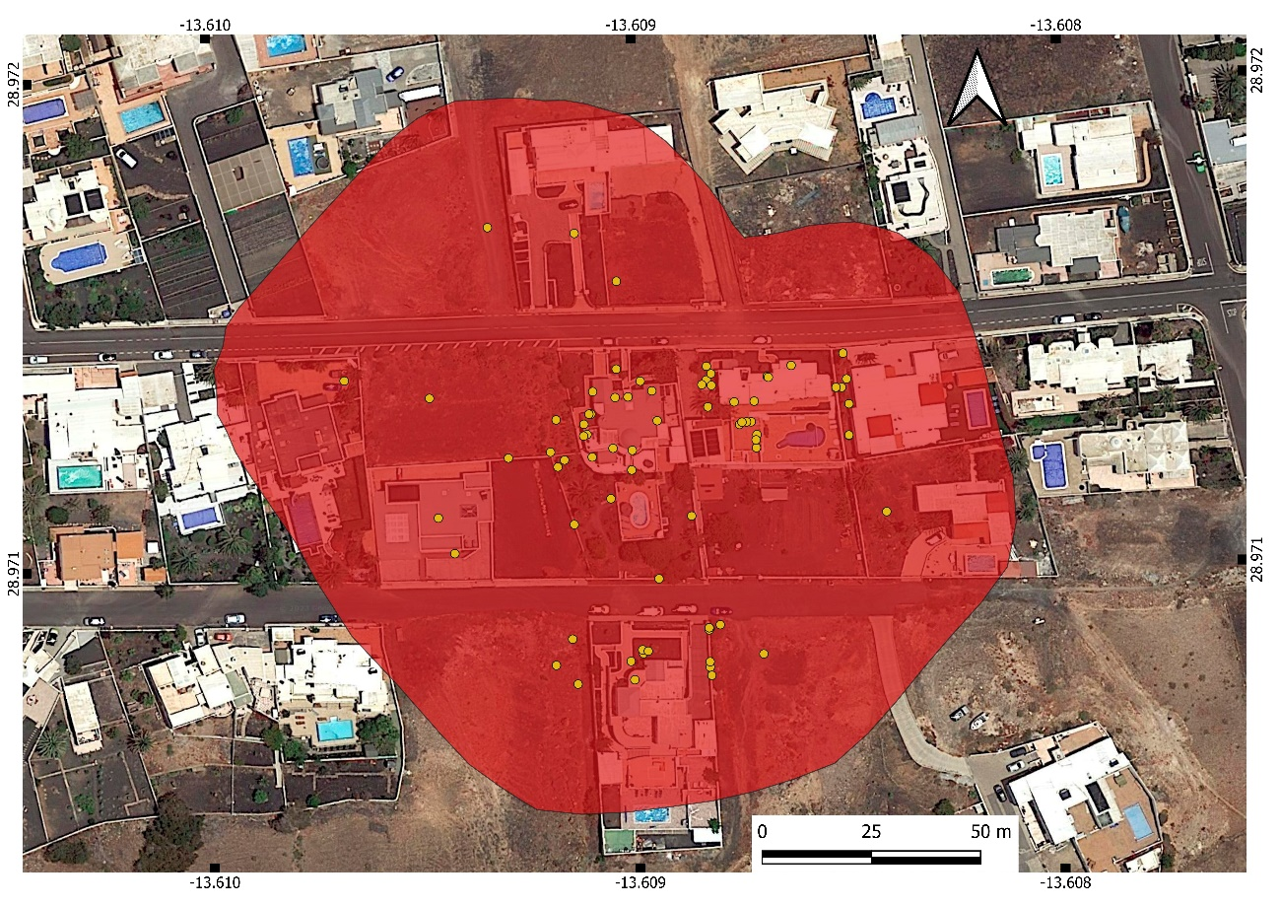
Figure S2. Detailed map with R. flavipes distribution (yellow dots and red area) in Lanzarote. Map credit: Gobierno de Canarias.

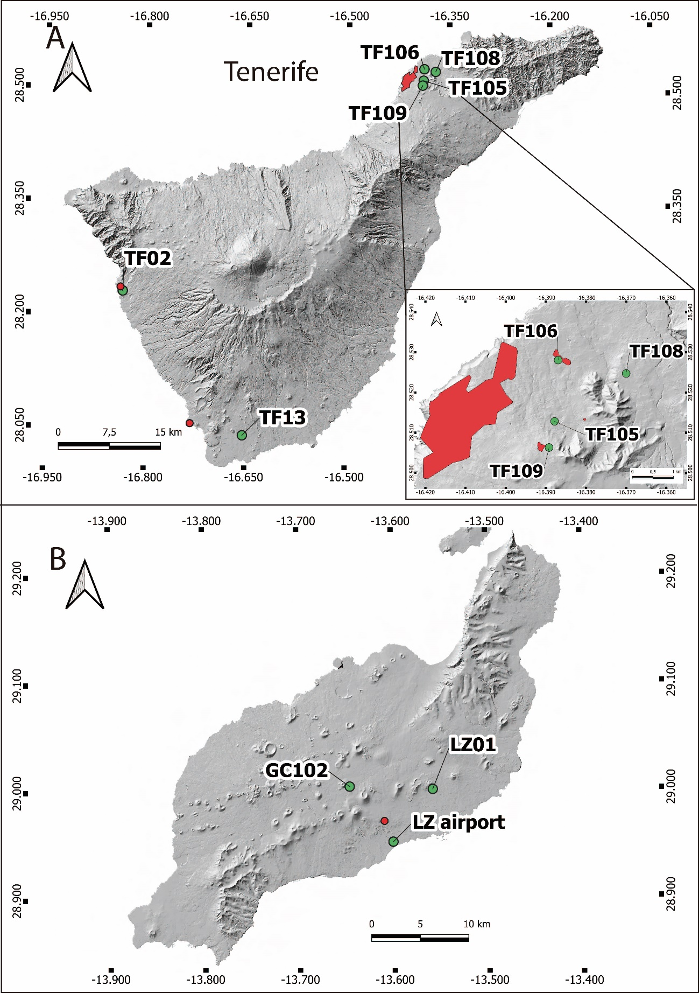
Figure S3. Map with R. flavipes distribution (red dots and area) on Tenerife (A) and Lanzarote (B), and the location of the meteorological stations used (green points). Map credit: Gobierno de Canarias.

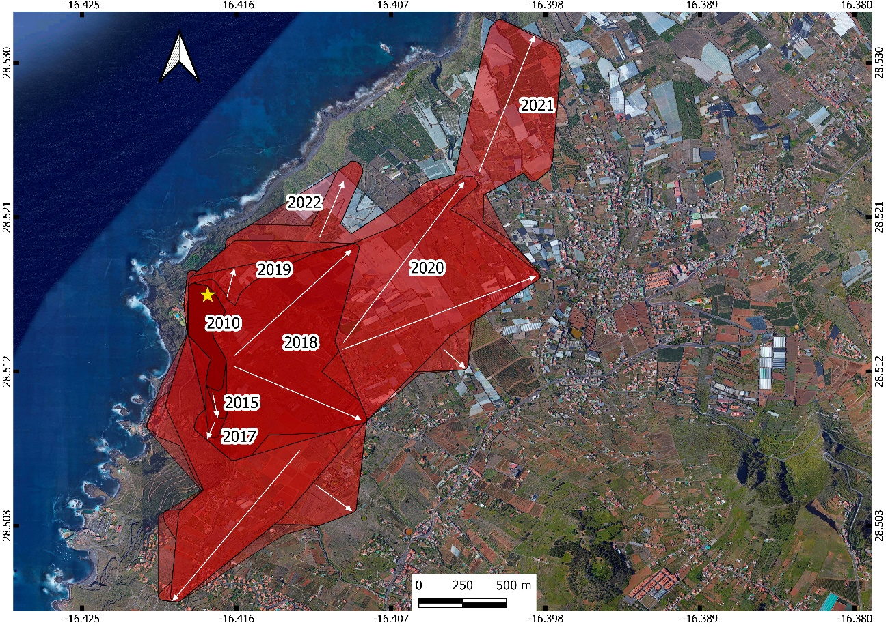
Figure S4. Map with R. flavipes annual distribution in the main focus of Tenerife from 2009 to 2022. The areas are represented by a scale of red, from deepest to lightest. White arrows represent the main fronts of progress in each year. A star indicates the first point where R. flavipes was detected. Map credit: Gobierno de Canarias.
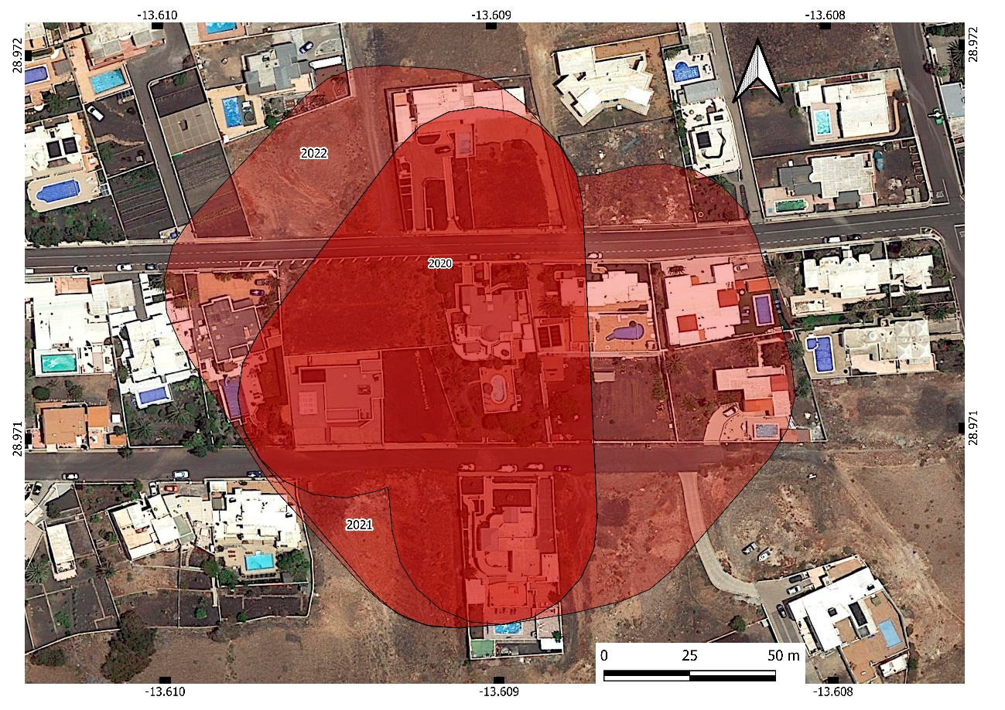
Figure S5. Map with R. flavipes annual distribution in the Lanzarote focus from 2020 to 2022. The areas are represented by a scale of red, from deepest to lightest. Map credit: Gobierno de Canarias.

..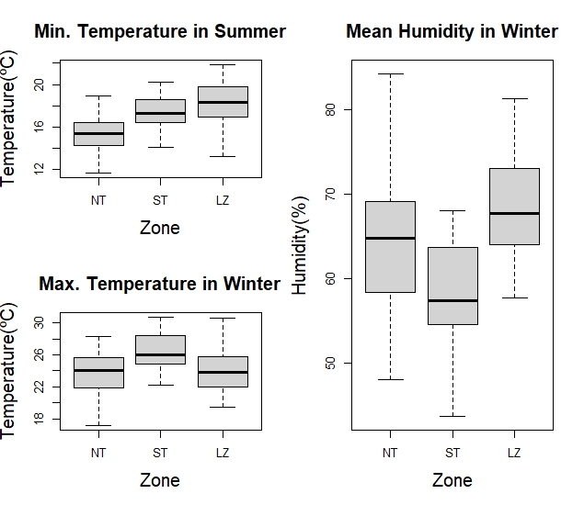
Figure S6. Differences between South Tenerife and Lanzarote in Minimum Temperature in summer and Maximum Temperature and Mean Humidity in winter. The boxes comprise 50% of the data, the black horizontal lines represent the median, and the whiskers extend to the last value within 1.5 times the interquartile range. Abbreviations: NT, North Tenerife; ST, South Tenerife; and LZ, Lanzarote.

,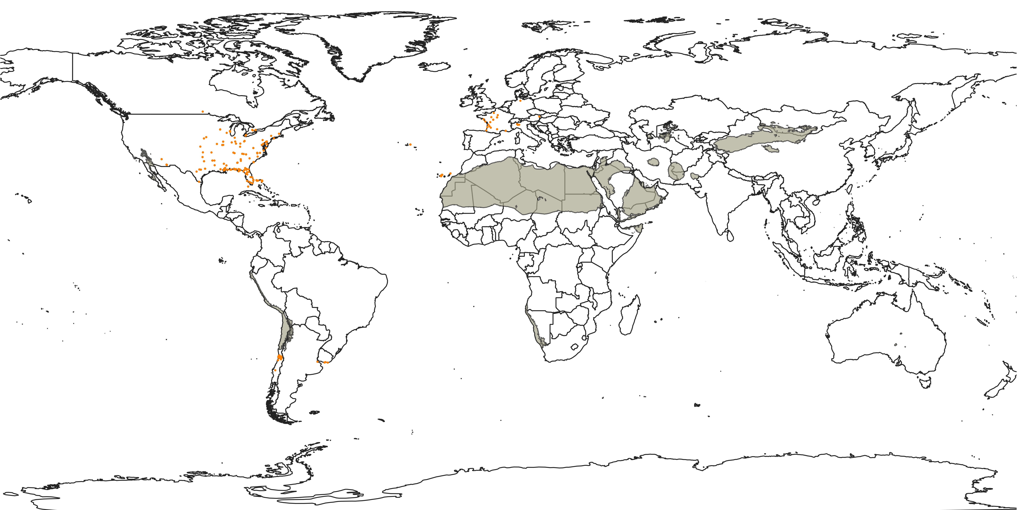Figure S7. World map representing the zones with less annual rainfall than Lanzarote and with a suitable mean temperature for the establishment of Reticulitermes flavipes (grey) and the worldwide distribution of this species (orange dots). Map data © EuroGeographics for the administrative boundaries.

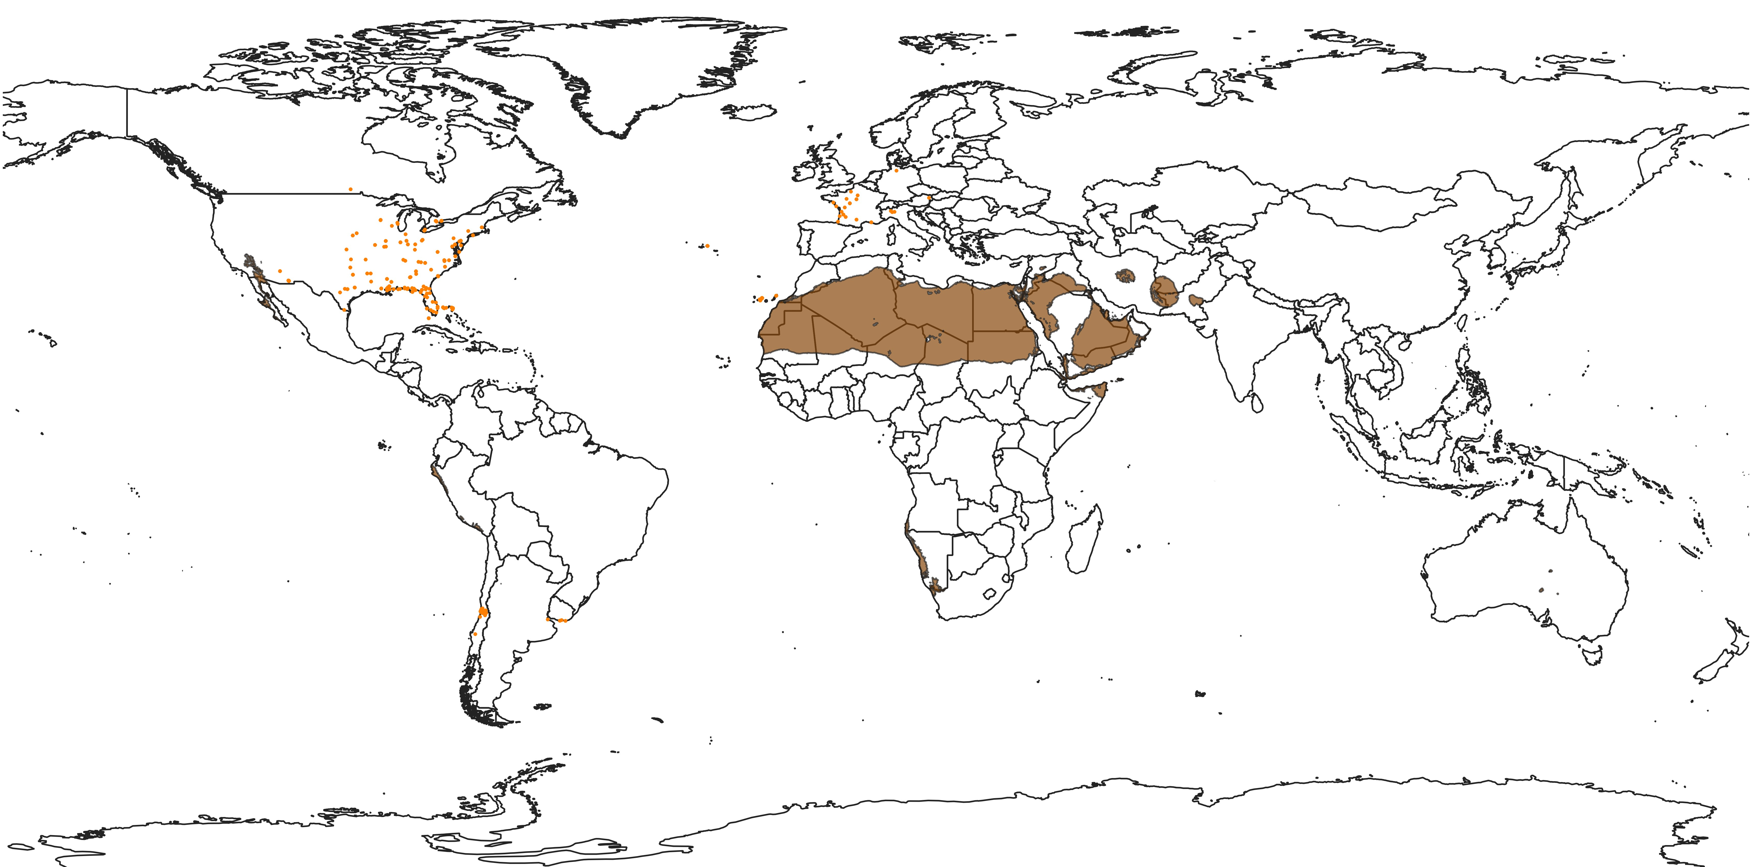
Figure S8. World map representing the zones with less annual rainfall and higher mean temperature than Lanzarote (brown) and the worldwide distribution of this species (orange dots). Map data © EuroGeographics for the administrative boundaries.

