Table S1 Propolis extracts used in screening for anti-Acanthamoeba activity

Propolis from City | Coordinate
No. 1 Tabriz city | 38.0962° N, 46.2738° E
No. 2 South Khorasam province | 32.5176° N, 59.1042° E
No. 3 Pranshahr city | 36.6950° N, 45.1446°E
No. 4 Mashhad city | 36.2605° N, 59.6168° E
No. 5 Sarab city | 37.9429° N, 47.5384° E
No. 6 Sardasht county | 36.1584° N, 45.4760° E
No. 7 Boroujen city | 31.9798° N, 51.2946° E
No. 8 Neyshabor city | 36.2141° N, 58.7961° E
No. 9 Tehran city | 35.6892° N, 51.3890° E
No. 10 Kermanshah city | 34.3277° N, 47.0778° E

Table S2 Eye drops composition

Eye drops solution (ESD) | Composition
EDS-1 | Chloramphenicol 5 mg/mL
EDS-2 | Neomycin sulfate 2 mg/mL  Gramicidin 0.025 mg/mL  Polymyxin B 5000 units
EDS-3 | Antazoline HCI 0.5 mg/mL  Tetrahydrozoline HCl 0.4 mg/mL  Benzalkonium chloride 0.15 mg/mL
EDS-4 | Levofloxacin 5 mg/mL

Table S3 Screening of anti-Acanthamoeba activity from plant and Propolis extracts
Plant name/Propolis | Percentage of viable cells at 1 mg/mL
 | Trophozoites | Cysts
No. 1 Tabriz city | 0 | 38.46 ± 7.69
No. 2 South Khorasam province | 32.85 ± 8.92 | 79.48 ± 4.44
No. 3 Pranshahr city | 0 | 74.35 ± 4.44
No. 4 Mashhad city | 11.76 ± 5.09 | 87.17 ± 4.44
No. 5 Sarab city | 0 | 82.05 ± 4.44
No. 6 Sardasht county | 70.58 ± 8.82 | 46.15 ± 5.38
No. 7 Boroujen city | 44.28 ± 2.47 | 51.28 ± 4.44
No. 8 Neyshabor city | 79.41 ± 0 | 64.10 ± 8.88
No. 9 Tehran city | 70.58 ± 8.82 | 79.48 ± 9.35
No. 10 Kermanshah city | 0 | 5.12 ± 8.88
Eye drop solution | Percentage of viable cells at 100%
 | Trophozoites | Cysts
EDS 1 | 0 | 23.08 ± 6.88
EDS 2 | 2.86 ± 4.42 | 13.08 ± 13.71
EDS 3 | 8.57 ± 0 | 7.69 ± 0
EDS 4 | 25.71 ± 0 | 43.59 ± 10.51

Table S4 Minimal inhibitory concentration (MIC) of active extract, eye drops and chlorhexidine against Acanthamoeba triangularis WU19001 trophozoites and cysts.

Anti-Acanthamoeba agent | MIC (mg/mL)
 | Trophozoites | Cysts
No. 1 Propolis-Tabriz city | 0.256 | > 1
No. 3 Propolis-Pranshahr city | 0.128 | > 1
No. 5 Propolis-Sarab city | 0.128 | > 1
No. 10 Propolis-Kermanshah city | 0.256 | 1
EDS-1  - Chloramphenicol | 100%  5 | > 100%  > 5
EDS-2  - Neomycin Sulfate  - Gramicidin  - Polymyxin B | 100%  2  0.025  5000 units | > 100%  > 2  > 0.025  > 5000 units
EDS-3  - Antazoline HCI 0.5  - Tetrahydrozoline HCl 0.4  - Benzalkonium Chloride 0.15 | 100%  0.5  0.4  0.15 | 100%  0.5  0.4  0.15
EDS-4  - Levofloxacin | > 100  > 5 | > 100  > 5
Chlorhexidine | 0.008 | 0.032

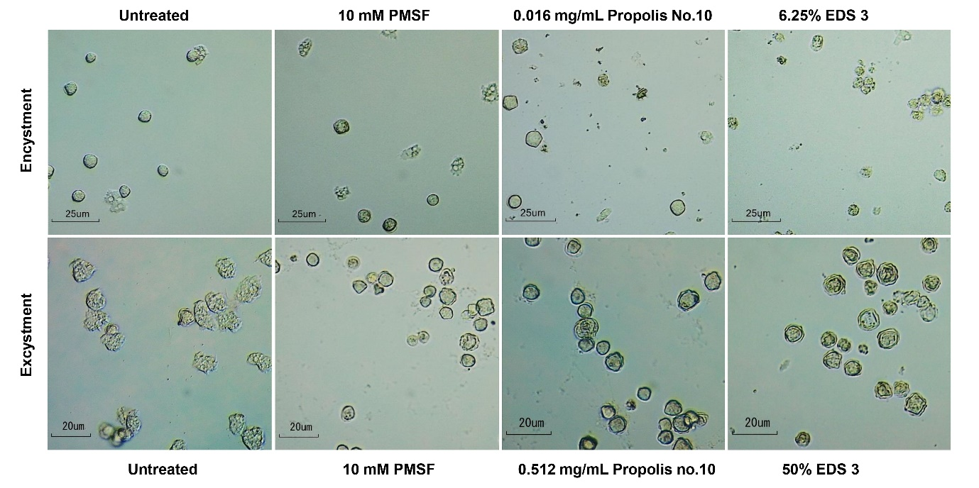
Fig. S1 Encystment and excystment of A. triangularis in PYG and Neff’s medium with and without propolis extract No. 10 and eye drops EDS 3. Magnification = 40x

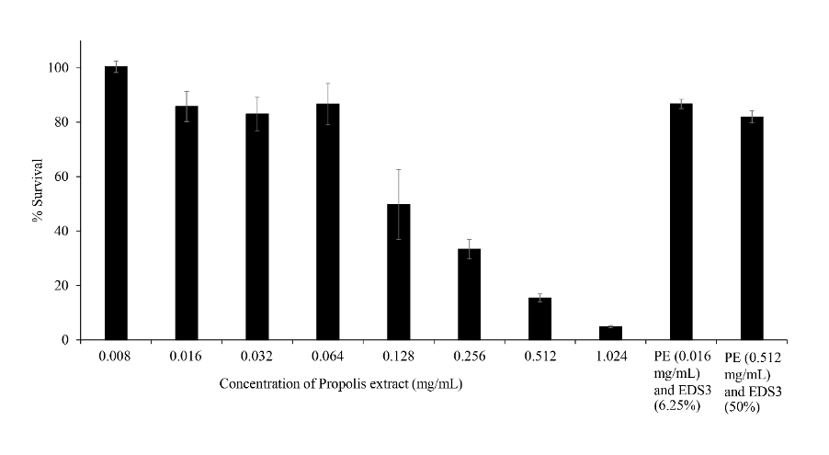
Fig. S2 Toxicity of various concentrations of Propolis extract and combination sets.

