Supplementary Table 1 Analysis of interactions between water salinity and purple nonsulfur bacteria on pH_{water}.
Factors |  | Water salinity (A) (‰) |  |  |  | Mean
 |  | 0 | 2 | 3 | 4
PNSB (B) (1.812 x 10⁵ CFU g⁻¹ dry soil) | NAPNSB | 3.74±0.07^{d} | 3.75±0.04^{d} | 3.73±0.11^{d} | 3.81±0.02^{bcd} | 3.75±0.06^{B}
 | EPS18 | 3.81±0.04^{bcd} | 3.81±0.08^{bcd} | 4.04±0.12^{ab} | 4.05±0.12^{ab} | 3.92±0.09^{A}
 | EPS37 | 3.77±0.05^{cd} | 4.14±0.57ª | 4.05±0.15^{ab} | 3.86±0.05^{bcd} | 3.95±0.21^{A}
 | EPS54 | 3.70±0.07^{d} | 3.75±0.06^{d} | 4.02±0.17^{abc} | 3.90±0.05^{a-d} | 3.83±0.09^{AB}
 | MTPNSB | 3.87±0.08^{bcd} | 3.91±0.01^{a-d} | 3.85±0.07^{bcd} | 3.90±0.10^{a-d} | 3.88±0.06^{A}
Mean |  | 3.77±0.06^{B} | 3.87±0.15^{AB} | 3.93±0.12^{A} | 3.90±0.07^{A}
F (A) |  |  |  |  |  | *
F (B) |  |  |  |  |  | *
F (A x B) |  |  |  |  |  | *
CV (%) |  |  |  |  |  | 3.88
Note: NAPNSB: No application of purple non-sulfur bacteria, EPS18: application of EPS18 strain; EPS37: application of EPS37 strain; EPS54: application of EPS54 strain; MTPNSB: application of the mixture of strains EPS18, EPS37 and EPS54. The identical lowercase letters indicate insignificant differences between numbers in the same pool, while the identical uppercase letters indicate insignificant differences between numbers in the same column or row (P < 0.05).

Supplementary Table 2 Analysis of interactions between water salinity and purple nonsulfur bacteria on pH_{KCl}.
Factors |  | Water salinity (A) (‰) |  |  |  | Mean
 |  | 0 | 2 | 3 | 4
PNSB (B) (1.812 x 10⁵ CFU g⁻¹ dry soil) | NAPNSB | 3.34±0.05^{ab} | 3.32±0.03^{abc} | 3.35±0.08^{ab} | 3.34±0.08^{ab} | 3.33±0.06
 | EPS18 | 3.29±0.07^{bc} | 3.30±0.13^{bc} | 3.34±0.12^{ab} | 3.38±0.12^{ab} | 3.30±0.11
 | EPS37 | 3.20±0.02^{cd} | 3.45±0.17ª | 3.32±0.02^{abc} | 3.25±0.04^{bcd} | 3.30±0.06
 | EPS54 | 3.24±0.03^{bcd} | 3.15±0.09^{d} | 3.36±0.06^{ab} | 3.36±0.04^{ab} | 3.27±0.06
 | MTPNSB | 3.30±0.01^{bc} | 3.28±0.07^{bc} | 3.27±0.04^{bcd} | 3.29±0.08^{bc} | 3.28±0.05
Mean |  | 3.27±0.04 | 3.29±0.10 | 3.32±0.06 | 3.32±0.07
F (A) |  |  |  |  |  | ns
F (B) |  |  |  |  |  | ns
F (A x B) |  |  |  |  |  | *
CV (%) |  |  |  |  |  | 2.46
Note: NAPNSB: No application of purple non-sulfur bacteria, EPS18: application of EPS18 strain; EPS37: application of EPS37 strain; EPS54: application of EPS54 strain; MTPNSB: application of the mixture of strains EPS18, EPS37 and EPS54. The identical lowercase letters indicate insignificant differences between numbers in the same pool, while the identical uppercase letters indicate insignificant differences between numbers in the same column or row (P < 0.05).

Supplementary Table 3 Analysis of interactions between water salinity and purple nonsulfur bacteria on Na content in soil.
Factors |  | Water salinity (A) (‰) |  |  |  | Mean
 |  | 0 | 2 | 3 | 4
PNSB (B) (1.812 x 10⁵ CFU g⁻¹ dry soil) | NAPNSB | 1.020±0.067^{b} | 1.158±0.024ª | 1.250±0.062ª | 1.150±0.083ª | 1.144±0.059^{A}
 | EPS18 | 0.948±0.053^{bcd} | 0.720±0.088^{gh} | 0.815±0.133^{d-g} | 0.868±0.010^{c-f} | 0.837±0.071^{AB}
 | EPS37 | 0.753±0.101^{fgh} | 0.843±0.051^{d-g} | 0.985±0.087^{bc} | 0.923±0.099^{b-e} | 0.875±0.084^{B}
 | EPS54 | 0.810±0.090^{efg} | 0.885±0.110^{c-f} | 0.908±0.125^{b-e} | 0.985±0.075^{bc} | 0.896±0.100^{B}
 | MTPNSB | 0.643±0.010^{h} | 0.800±0.051^{efg} | 0.885±0.096^{c-f} | 0.858±0.085^{c-f} | 0.796±0.060^{C}
Mean |  | 0.835±0.064^{B} | 0.881±0.065^{B} | 0.968±0.101^{A} | 0.956±0.070^{A}
F (A) |  |  |  |  |  | *
F (B) |  |  |  |  |  | *
F (A x B) |  |  |  |  |  | *
CV (%) |  |  |  |  |  | 9.16
Note: NAPNSB: No application of purple non-sulfur bacteria, EPS18: application of EPS18 strain; EPS37: application of EPS37 strain; EPS54: application of EPS54 strain; MTPNSB: application of the mixture of strains EPS18, EPS37 and EPS54. The identical lowercase letters indicate insignificant differences between numbers in the same pool, while the identical uppercase letters indicate insignificant differences between numbers in the same column or row (P < 0.05).

Supplementary Table 4 Analysis of interactions between water salinity and purple nonsulfur bacteria on dry biomass of stem and leaves.
Factors |  | Water salinity (A) (‰) |  |  |  | Mean
 |  | 0 | 2 | 3 | 4
PNSB (B) (1.812 x 10⁵ CFU g⁻¹ dry soil) | NAPNSB | 23.4±1.04^{fgh} | 23.4±1.13^{fgh} | 23.3±2.36^{f-i} | 19.9±2.04^{j} | 22.5±1.64^{C}
 | EPS18 | 26.4±0.48^{cde} | 23.4±0.73^{fgh} | 20.8±0.24^{ij} | 20.9±2.04^{hij} | 22.8±0.88^{C}
 | EPS37 | 24.0±0.57^{efg} | 24.4±1.43^{efg} | 23.3±1.02^{f-i} | 24.4±1.43^{efg} | 24.0±1.12^{B}
 | EPS54 | 29.1±1.73^{b} | 25.4±1.73^{def} | 22.0±2.48^{g-j} | 22.0±0.90^{g-j} | 24.6±1.71^{B}
 | MTPNSB | 31.9±1.89ª | 28.7±1.99^{bc} | 27.2±2.41^{bcd} | 24.2±1.10^{efg} | 28.0±1.85^{A}
Mean |  | 27.0±1.14^{A} | 25.0±1.40^{B} | 23.3±1.71^{C} | 22.2±1.50^{D}
F (A) |  |  |  |  |  | *
F (B) |  |  |  |  |  | *
F (A x B) |  |  |  |  |  | *
CV (%) |  |  |  |  |  | 6.54
Note: NAPNSB: No application of purple non-sulfur bacteria, EPS18: application of EPS18 strain; EPS37: application of EPS37 strain; EPS54: application of EPS54 strain; MTPNSB: application of the mixture of strains EPS18, EPS37 and EPS54. The identical lowercase letters indicate insignificant differences between numbers in the same pool, while the identical uppercase letters indicate insignificant differences between numbers in the same column or row (P < 0.05).

Supplementary Table 5 Analysis of interactions between water salinity and purple nonsulfur bacteria on dry biomass of grain.
Factors |  | Water salinity (A) (‰) |  |  |  | Mean
 |  | 0 | 2 | 3 | 4
PNSB (B) (1.812 x 10⁵ CFU g⁻¹ dry soil) | NAPNSB | 14.3±0.36^{gh} | 11.9±0.17^{i} | 11.4±0.92^{ij} | 10.5±0.34^{j} | 12.0±0.45^{C}
 | EPS18 | 16.6±0.59de | 15.6±0.77^{ef} | 14.4±1.09^{fgh} | 14.7±0.53^{fgh} | 15.3±0.74^{B}
 | EPS37 | 18.2±0.65^{ab} | 16.5±0.34de | 14.6±0.33^{fgh} | 13.6±0.85^{h} | 15.7±0.54^{B}
 | EPS54 | 17.8±1.22^{bc} | 16.5±0.41de | 16.3±1.36de | 14.9±1.28^{fg} | 16.3±1.07^{A}
 | MTPNSB | 19.1±0.77ª | 17.0±0.47^{cd} | 15.5±0.61^{efg} | 14.4±0.49^{fgh} | 16.5±0.59^{A}
Mean |  | 17.2±0.72^{A} | 15.5±0.43^{B} | 14.4±0.86^{C} | 13.6±0.70^{D}
F (A) |  |  |  |  |  | *
F (B) |  |  |  |  |  | *
F (A x B) |  |  |  |  |  | *
CV (%) |  |  |  |  |  | 2.36
Note: NAPNSB: No application of purple non-sulfur bacteria, EPS18: application of EPS18 strain; EPS37: application of EPS37 strain; EPS54: application of EPS54 strain; MTPNSB: application of the mixture of strains EPS18, EPS37 and EPS54. The identical lowercase letters indicate insignificant differences between numbers in the same pool, while the identical uppercase letters indicate insignificant differences between numbers in the same column or row (P < 0.05).

Supplementary Table 6 Analysis of interactions between water salinity and purple nonsulfur bacteria on total K uptake.
Factors |  | Water salinity (A) (‰) |  |  |  | Mean
 |  | 0 | 2 | 3 | 4
PNSB (B) (1.812 x 10⁵ CFU g⁻¹ dry soil) | NAPNSB | 322.2±18.1^{i} | 345.5±37.6^{hi} | 316.8±73.4^{i} | 303.9±31.5^{i} | 322.1±40.1^{D}
 | EPS18 | 543.0±17.4^{c} | 458.5±29.1^{def} | 444.6±9.2^{d-g} | 382.0±44.3^{gh} | 457.0±25.0^{BC}
 | EPS37 | 406.3±30.5^{fg} | 468.1±53.5^{def} | 423.1±21.4^{d-g} | 479.9±36.3^{d} | 444.3±35.4^{C}
 | EPS54 | 625.5±53.5^{b} | 471.1±58.9de | 409.3±24.2^{efg} | 416.5±34.7^{d-g} | 480.6±42.8^{B}
 | MTPNSB | 693.0±56.0ª | 552.2±10.2^{c} | 562.4±45.7^{c} | 390.0±22.4^{gh} | 549.4±33.6^{A}
Mean |  | 518.0±35.1^{A} | 459.1±37.8^{B} | 459.1±37.8^{B} | 394.5±33.8^{D}
F (A) |  |  |  |  |  | *
F (B) |  |  |  |  |  | *
F (A x B) |  |  |  |  |  | *
CV (%) |  |  |  |  |  | 8.54
Note: NAPNSB: No application of purple non-sulfur bacteria, EPS18: application of EPS18 strain; EPS37: application of EPS37 strain; EPS54: application of EPS54 strain; MTPNSB: application of the mixture of strains EPS18, EPS37 and EPS54. The identical lowercase letters indicate insignificant differences between numbers in the same pool, while the identical uppercase letters indicate insignificant differences between numbers in the same column or row (P < 0.05).

Supplementary Table 7 Analysis of interactions between water salinity and purple nonsulfur bacteria on total Na uptake.
Factors |  | Water salinity (A) (‰) |  |  |  | Mean
 |  | 0 | 2 | 3 | 4
PNSB (B) (1.812 x 10⁵ CFU g⁻¹ dry soil) | NAPNSB | 131.5±8.7^{c-f} | 155.5±22.5^{ab} | 159.3±16.4ª | 142.5±19.9^{a-d} | 147.2±16.9^{A}
 | EPS18 | 107.1±9.1^{fg} | 99.9±15.7^{g} | 112.2±6.8^{efg} | 124.7±16.5^{c-f} | 111.0±12.0^{C}
 | EPS37 | 113.2±8.6^{efg} | 120.9±11.9^{d-g} | 122.1±9.2^{d-g} | 156.0±8.8^{ab} | 128.1±9.6^{B}
 | EPS54 | 130.2±15.4^{c-f} | 148.4±17.4^{abc} | 130.9±16.0^{c-f} | 133.2±7.8^{b-e} | 135.7±14.2^{B}
 | MTPNSB | 130.2±23.0^{c-f} | 120.7±20.6^{d-g} | 125.3±7.1^{c-f} | 127.9±10.0^{c-f} | 126.0±15.2^{B}
Mean |  | 122.4±13.0^{B} | 129.1±17.6^{AB} | 130.0±11.1^{AB} | 136.8±12.6^{A}
F (A) |  |  |  |  |  | *
F (B) |  |  |  |  |  | *
F (A x B) |  |  |  |  |  | *
CV (%) |  |  |  |  |  | 11.4
Note: NAPNSB: No application of purple non-sulfur bacteria, EPS18: application of EPS18 strain; EPS37: application of EPS37 strain; EPS54: application of EPS54 strain; MTPNSB: application of the mixture of strains EPS18, EPS37 and EPS54. The identical lowercase letters indicate insignificant differences between numbers in the same pool, while the identical uppercase letters indicate insignificant differences between numbers in the same column or row (P < 0.05).

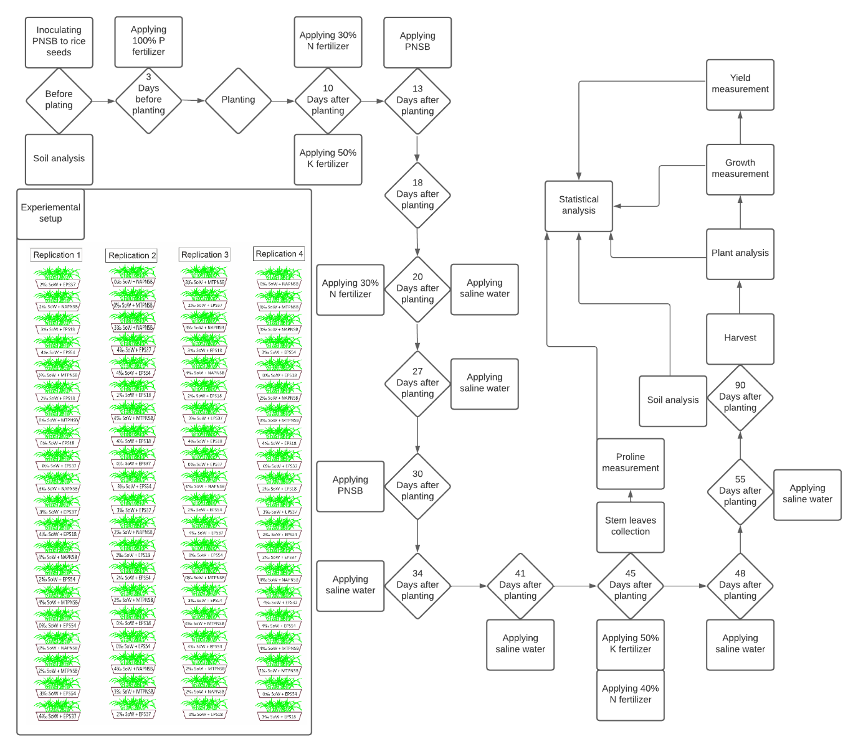
Supplementary Figure 1 Research procedure.

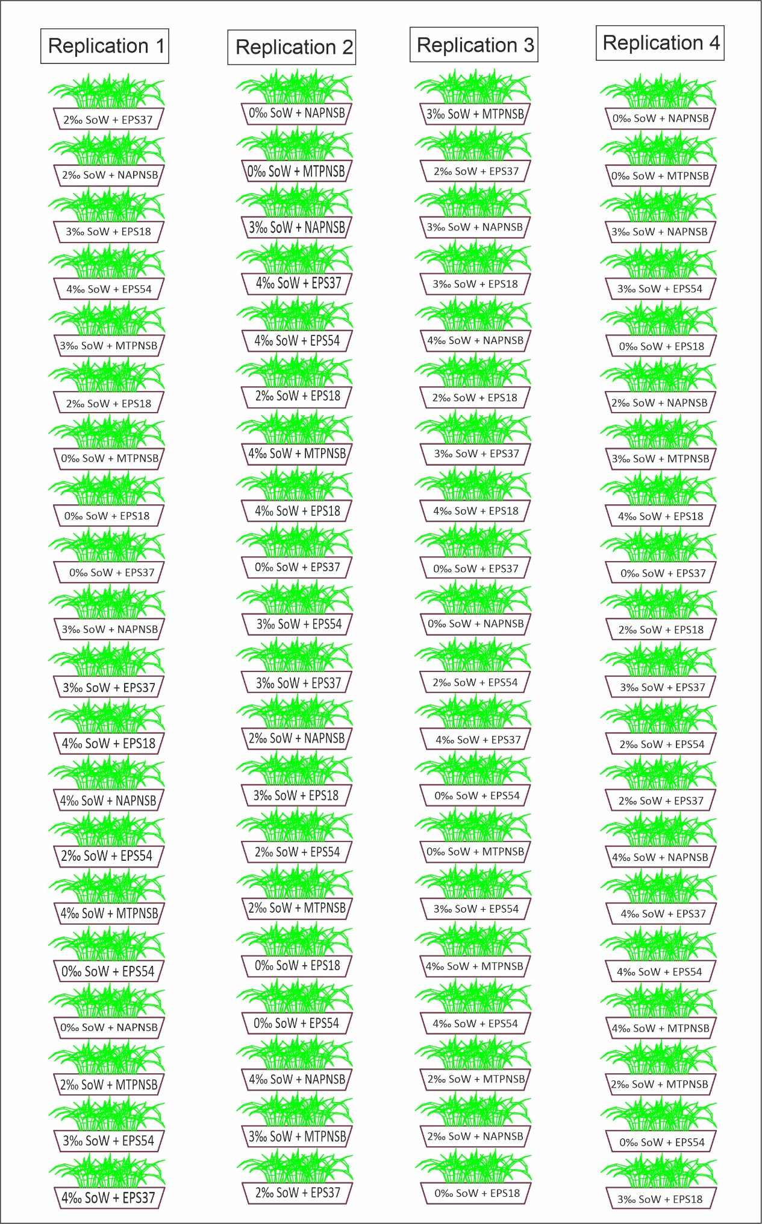
Supplementary Figure 2 Diagram of experimental design.

