EXPERIMENTAL DESIGN
Definition of experimental and control groups
Control group: untrimming stolon nodes of bermudagrass.
Experimental group: trimming stolon nodes of bermudagrass.
Number within each group
Nodal sample was taken after 0, 1, 3, 6, 12, and 24 h upon trimming treatment.
Intact:0 h. Trimming:1, 3, 6, 12, 24 h. Three replicates per treatment.
From each of the first four nodes of bermudagrass stolons was taken after 24 h of trimming treatment.
Intact:1st, 2nd, 3rd, 4nd; Trimming: 1st, 2nd, 3rd ,4nd. ( Materials and Methods, Trimming treatment in manuscripts .)
SAMPLE
Description
Volume/mass of sample processed
When bermudagrass produces more stolons, stolon nodes as test samples were selected.
0.1g nodal was taken.
Processing procedure
Freeze samples in liquid nitrogen immediately after taken and stored at -80 ℃, then one day later RNA was extracted by grinding process.
NUCLEIC ACID EXTRACTION
Procedure and/or instrumentation
Total RNA was extracted using the Plant RNA Kit (Vazyme Biotech Co., Ltd).
Details of DNase or RNase treatment
The pipette tips and tubes were RNase-free.
Nucleic acid quantification
RNA concentration and quality were measured using a NanoDrop microspectrophotometer (Eppendorf).
Purity (A260/A280): A260/A280>1.9
RNA integrity method/instrument
RNA electrophoresis
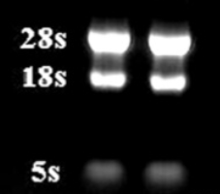
REVERSE TRANSCRIPTION
RNA was reverse transcribed to obtain cDNA with HiScript II 1st Strand cDNA Synthesis Kit (Vazyme Biotech Co., Ltd).
RNase-free ddH₂O | 7µL
4 x gDNA wiper Mix | 4µL
RNA | 5µL
Pipette gun blowing and mixing.42 ℃ 2 min.
5 x HiScript III qRT SuperMix | 4µL
First Step Reaction Solution | 16µL
Pipette gun blowing and mixing.
37 ℃ | 15 min
85 ℃ | 5 sec
Storage conditions of cDNA
cDNA is stored at -4 ℃.
qPCR TARGET INFORMATION
Sequence accession number
BRC1(Gene ID: 821386 NC_003074.8).
LOG1(Gene ID: 817376 NC_003071.7).
IPT1 (Gene ID: 843175 NC_003070.9).
SPS (Gene ID: 832150 NC_003076.8).
Amplicon length(100-150bp).
qPCR OLIGONUCLEOTIDES
qPCR oligonucleotides: the primer sequences are in Supplemental Data S1.
qPCR PROTOCOL
cDNA was employed as a template for qRT-PCR (Thermo, America) to detect gene expression using SYBR qPCR Master Mix (Vazyme Biotech Co., Ltd).
2 x Taq Pro universal SYBR qPCR Master Mix |  |  | 10 µL
Primer(F) |  |  | 0.5 µL
Primer(R) |  |  | 0.5 µL
Template DNA/cDNA |  |  | 2 µL
ddH₂O |  |  | 7 µL
Amplification Protocol
cycle step | temperature | time |  | cycle number
predegeneration | 95 ℃ | 5 min |  | 1
denaturation | 95 ℃ | 10 sec |  | 40
annealing | 60 ℃ | 30 sec |  | 40
Manufacturer of plates/tubes and catalog number
Yeasen Biotechnology(shanghai).
CAT:83555ES03 LOT:MO2022120836
qPCR VALIDATION
Specificity (gel, sequence, melt, or digest)
The dissolution curve is single peaked.
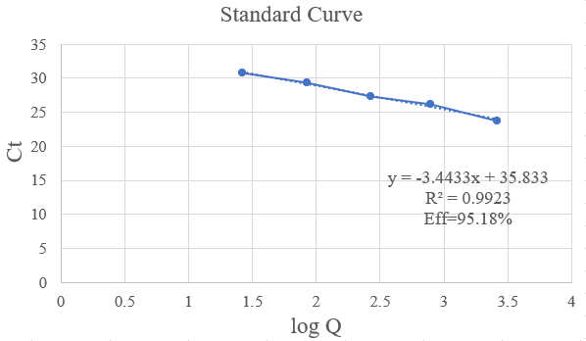
DATA ANALYSIS
qPCR analysis program was offered by Thermo, America. The technique was repeated three times for each sample.
qPCR dates are in raw date, significance by t-test(P<0.05), SPSS16.0.

