Supplemental material for: Exotic and native plants play equally important roles in supporting and structuring plant-hummingbird networks within urban green spaces
Figure 1SA

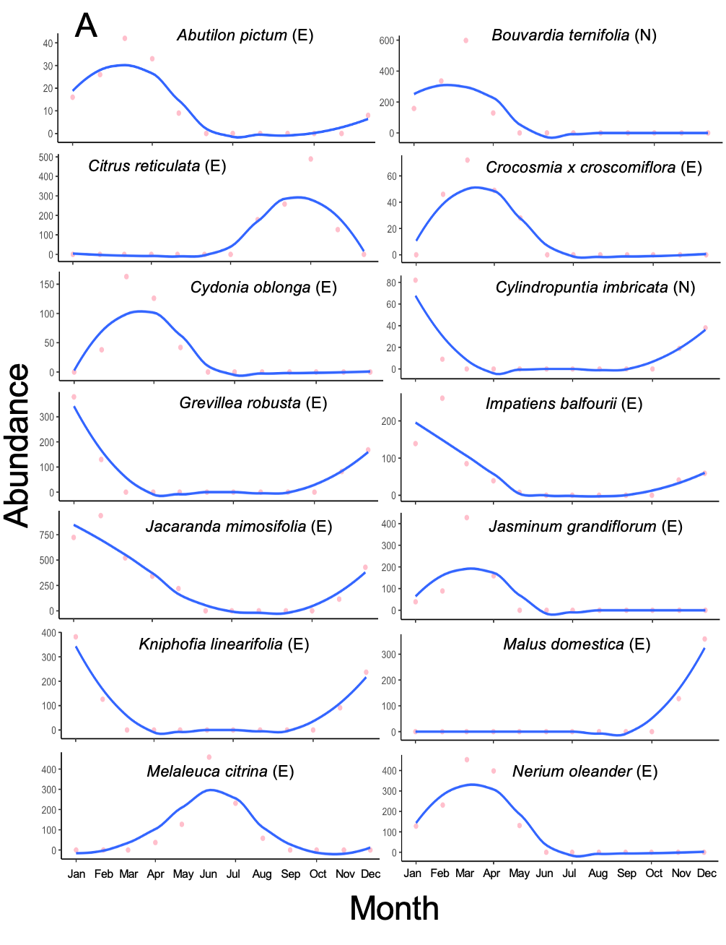

Figure 1 SB
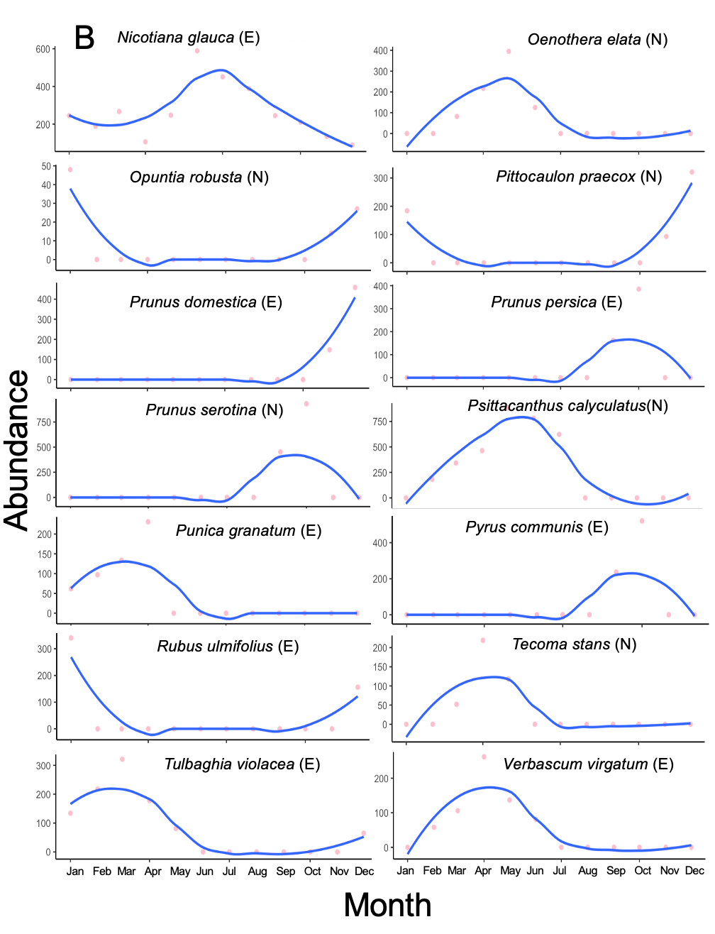

Figure 1SC

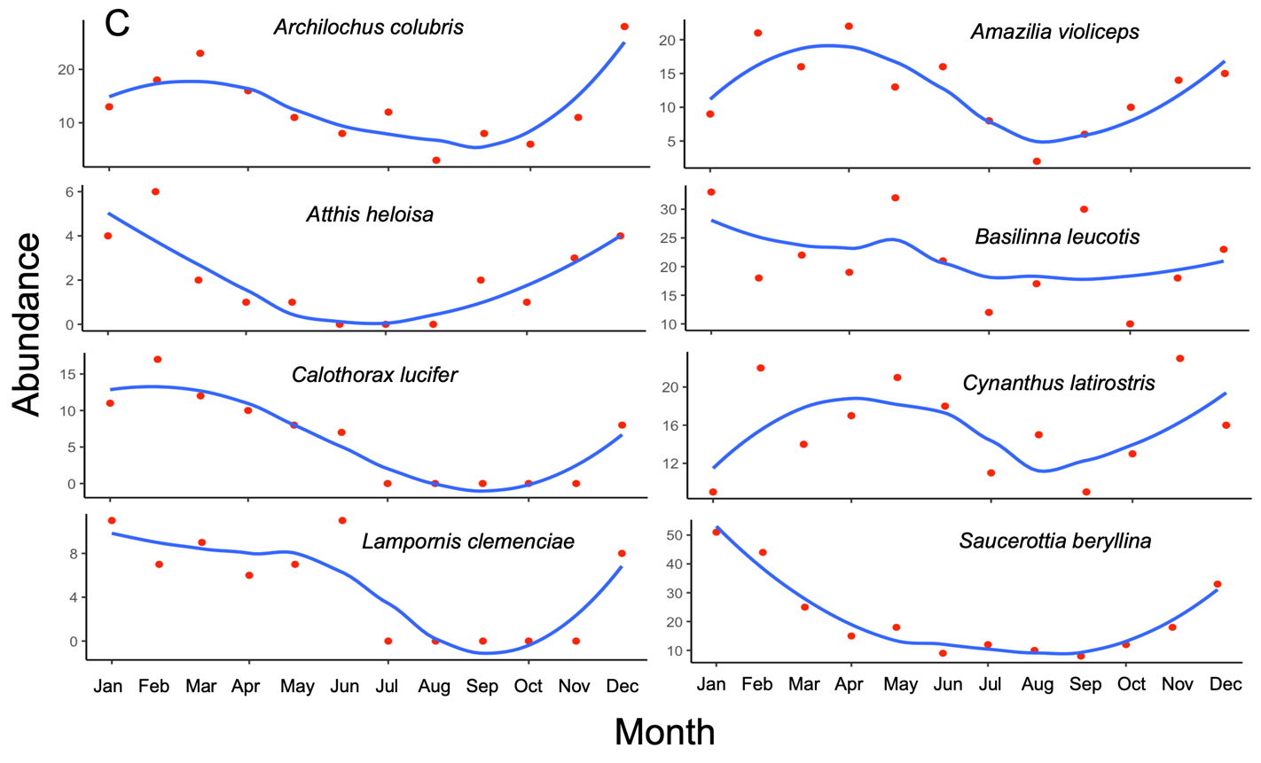

Figure S1: Monthly variations in flowers and hummingbirds recorded at the TBG (Tizatlán Botanical Garden, Tlaxcala, México). The plots illustrate the monthly fluctuations in recorded flower (A and B) and hummingbird (C) abundance observed over a year. Each data point represents the count of flowers and hummingbirds per species recorded during specific months throughout the year. The line in the plot depicts a smoothed trend, providing an overview of the trend in flower and hummingbird abundance over the entire year.

