Figure S1: Plates indicating the fungal growth in media treated with AgNPs, FeONPs , Bimetallic NPs and biochar in relation to control:
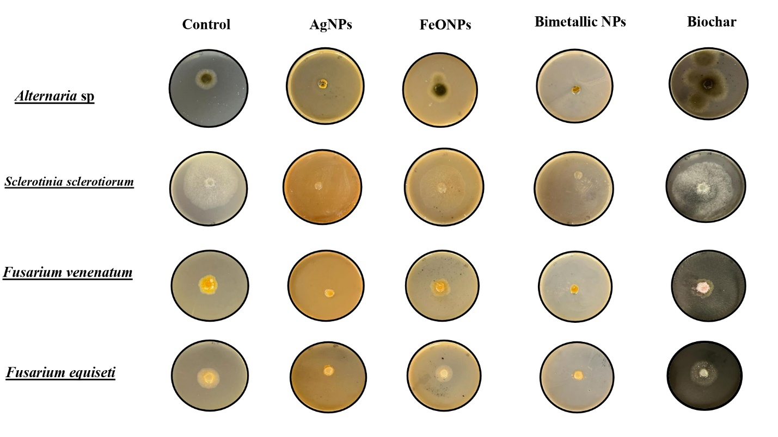

Figures S2: The FTIR spectra of A. digitata fruit shell extract, phyto-fabricated nanoparticles, and biochar.

- The FTIR spectral analysis of plant extract:

- The FTIR spectral analysis of AgNPs:

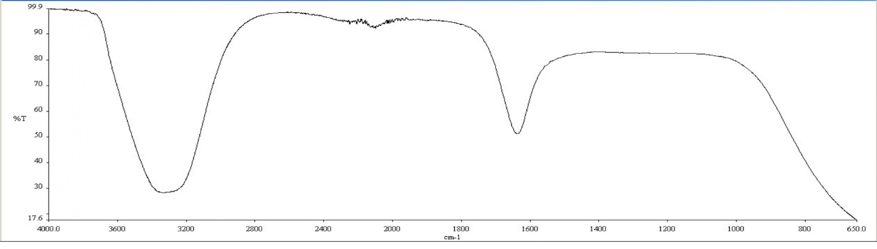
- The FTIR spectral analysis of FeONPs:

- The FTIR spectral analysis of bimetallic NPs:
- The FTIR spectral analysis of Biochar:
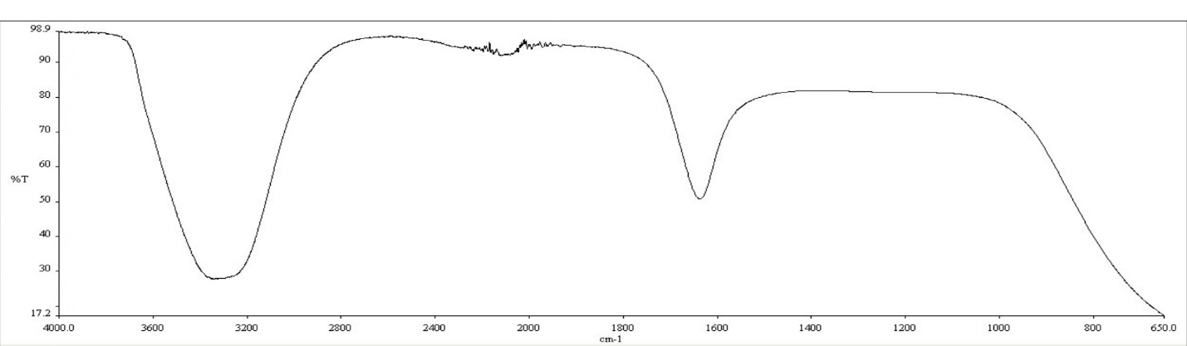

Table S1:
The major three peaks from the FTIR analysis:

Materials | Peak 1 | Peak 2 | Peak 3
Plant extract | 3336 | 2023 | 1635
AgNPs | 3337 | 2023 | 1636
FeONPs | 3337 | 2020 | 1637
Bimetallic | 3337 | 2023 | 1637
Biochar | 3341 | 2008 | 1636

