Supplementary Materials
Table of contents:
Appendix S1: Home range with respect to cumulative GPS fixes.
Figure S.1. Relationship between the home range size and number of GPS points collected.
Appendix S2: Correlation between predictor variables.
Figure S.2. Correlation matrix.
Appendix S3 Additional details about AICc model section.
Appendix S4: Additional details about 95% KDE home range size.
Table S4. Results from the top candidate GLMs predicting what intrinsic variables influenced the 95% KDE home range size.
Table S4.1. Results of the top candidate models used to predict what extrinsic factors influenced the 95% KDE home range size.
Table S4.2. Model averaged results of what extrinsic factors influenced the 95% KDE home range size.
Appendix S5: Additional details about habitat selection.
Table S5. Model results for habitat selection within a boundary of 300 m
Appendix S6: Major roads may act as barriers for cat movement.
Figure S6. A map highlighting how roads may act as barriers for cat movement.
Appendix S1: Home range with respect to cumulative GPS fixes

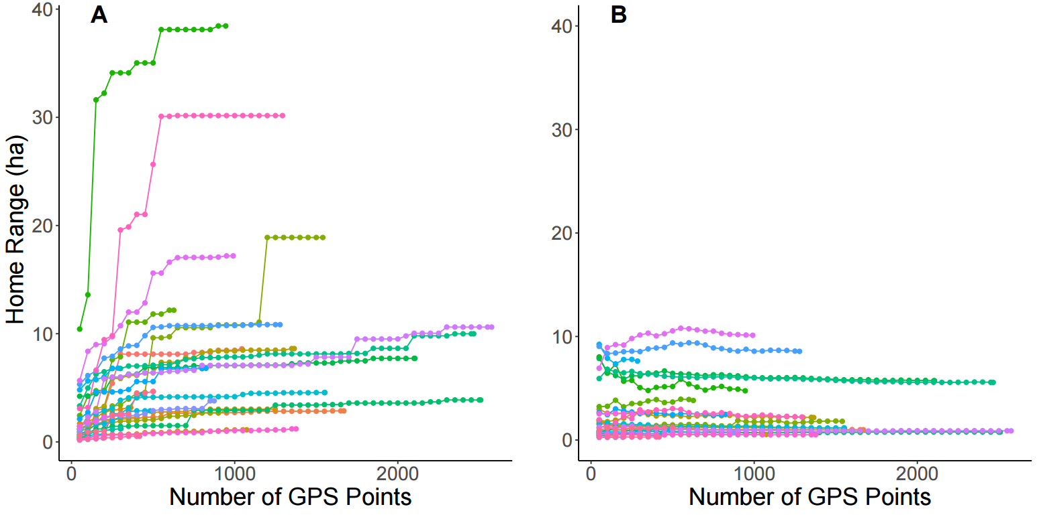

Figure S1. The cumulative number of GPS points taken from sampled cats (each line represents a different individual) with respect to the calculated A) 100% minimum convex polygon home range and B) 95% kernel density estimate home range.
Appendix 2: Correlation between predictor variables
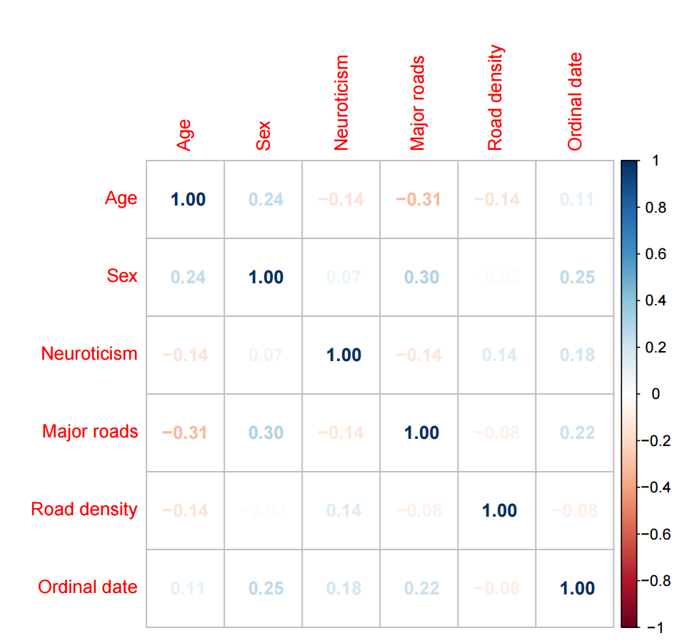
Figure S2. Visualization of the correlation matrix of predictor variables used to model home range size. The figure was generated using the R package “corrplot” (Wei & Simko, 2021).

Appendix 3: Additional details about AICc model selection
Table S3. Model selection results showing all possible combinations of intrinsic factors that could influence the cat’s 100% MCP home range size.
Model | df | AICc | ΔAICc | Weight
null | 2 | 182.7196 | 0 | 0.3625
age | 3 | 184.1567 | 1.4371 | 0.1767
sex | 3 | 184.7643 | 2.0447 | 0.1304
neuroticism | 3 | 185.1946 | 2.4750 | 0.1052
age + sex | 4 | 185.9441 | 3.2245 | 0.0723
age + neuroticism | 4 | 186.7619 | 4.0423 | 0.0480
neuroticism + sex | 4 | 187.3498 | 4.6302 | 0.0358
neuroticism + sex + neuroticism*sex | 5 | 188.3188 | 5.5992 | 0.0221
age + neuroticism + sex | 5 | 188.5881 | 5.8685 | 0.0193
age + sex + age*sex | 5 | 188.8861 | 6.1665 | 0.0166
age + neuroticism + sex + neuroticism*sex | 6 | 190.9256 | 8.2060 | 0.0060
age + neuroticism + sex + age*sex | 6 | 191.7165 | 8.9970 | 0.0040
age + neuroticism + sex + age*sex + neuroticism*sex | 7 | 194.3235 | 11.6039 | 0.0011

Table S3.1. Model selection results showing all possible combinations of extrinsic factors that could influence the cat’s 100% MCP home range size.
Model | df | AICc | ΔAICc | Weight
road density | 3 | 181.9789 | 0 | 0.2726
null | 2 | 182.7196 | 0.7407 | 0.1882
major road + road density | 4 | 182.8921 | 0.9132 | 0.1727
major road | 3 | 183.4459 | 1.4670 | 0.1309
time + road density | 4 | 184.3111 | 2.3322 | 0.0849
time + major road + road density | 5 | 185.0394 | 3.0605 | 0.0590
time | 3 | 185.1956 | 3.2167 | 0.0546
time + major road | 4 | 185.9759 | 3.9970 | 0.0370

Table S3.2. Model selection results showing all possible combinations of intrinsic factors that could influence the cat’s 95% KDE home range size.
Model | df | AICc | ΔAICc | Weight
null | 2 | 112.9432 | 0 | 0.2831
age | 3 | 113.2602 | 0.3170 | 0.2416
sex | 3 | 114.9825 | 2.0393 | 0.1021
neuroticism | 3 | 115.4390 | 2.4958 | 0.0813
neuroticism + sex + neuroticism*sex | 5 | 115.6328 | 2.6896 | 0.0738
age + neuroticism | 4 | 115.7807 | 2.8374 | 0.0685
age + sex | 4 | 115.8759 | 2.9327 | 0.0653
neuroticism + sex | 4 | 117.6798 | 4.7366 | 0.0265
age + Neuroticism + sex + neuroticism*sex | 6 | 118.3381 | 5.3949 | 0.0191
age + Neuroticism + sex | 5 | 118.6106 | 5.6673 | 0.0167
age + sex + age*sex | 5 | 118.8082 | 5.8650 | 0.0151
age + Neuroticism + sex + age*sex | 6 | 121.7071 | 8.7639 | 0.0036
age + Neuroticism + sex + age*sex + neuroticism*sex | 7 | 121.7685 | 8.8253 | 0.0034

Table S3.3. Model selection results showing all possible combinations of extrinsic factors that could influence the cat’s 95% KDE home range size.
Model | df | AICc | ΔAICc | Weight
time + road density | 4 | 101.4003 | 0 | 0.3628
time + major road + road density | 5 | 101.8162 | 0.41589 | 0.2947
road density | 3 | 102.4178 | 1.0175 | 0.2181
major road + road length | 4 | 103.6254 | 2.2251 | 0.1193
time + major road | 4 | 112.1669 | 10.7666 | 0.0017
time | 3 | 112.2965 | 10.8962 | 0.0016
null | 2 | 112.9432 | 11.5429 | 0.0011
major road | 3 | 113.6024 | 12.2021 | 0.0008

Appendix 4: Additional details about home range size
From the analysis of all 42 cats, the median 95% kernel density estimate (KDE) home range size was 1.36 ha (ranged: 0.27–11.18 ha). We did not find support for the sex hypothesis (hypothesis 1). The male and female 95% KDE home ranges showed similar variation (Brown-Forsythe test, F = 0.30, p = 0.59), with the median male 95% KDE home range being 2.01 ha (range: 0.27–10.16 ha) and females had a median home range size of 0.91 ha (range: 0.29–8.56 ha). We did not find evidence to support cats had a larger home range at night than during the day (hypothesis 2). During the day, the median home range size was 1.46 ha (range: 0.18–10.54 ha), while during the night the median home range size was 1.43 ha (range: 0.20–12.11 ha), which was not a significant difference (Wilcox signed rank test, W = 507, p = 0.50).
To explain what intrinsic variables could influence the size of a cat’s 95% KDE home range, there were two top models (ΔAICc < 2; Table S3.2). The top ranked model was the null model, and the second-ranked model (ΔAICc = 0.32) included age. The confidence intervals for age did overlap with zero (β= -0.08, 85% CI [-0.18, 0.14]; Table S4), suggesting little support that home range size was influenced by sex, age, and neuroticism (hypotheses 1, 3 and 5), and so we did not include these variables in the subsequent evaluation of extrinsic effects. To explain what extrinsic variables could influence the size of the home range, there were three candidate models within 2 ΔAICc of the top model (Table S4.1). Based on the model averaged coefficient estimate and confidence intervals not overlapping with zero, there was no support that traffic acted as a barrier for cats (hypothesis 4) as road density and time were both positively associated with home range size (Table S4.2).

Table S4. Model results of the top candidate GLM predicting intrinsic factors that influence the 95% MCP home range size of sampled cats. Age was measured in years.
Variable | Estimate | Lower 85% CI | Upper 85% CI
Intercept | 1.4384 | 0.7260 | 2.2114
Age | -0.0824 | -0.1764 | 0.0139

Table S4.1. Model selection results showing the top candidate models predicting what extrinsic factors influenced 95% KDE home range size of sampled cats. Road density was estimated by summing the road lengths, measured in meters, within a fixed boundary centred on each cat’s mean latitude and longitude coordinates. The predictor variable “major road” indicated the presence or absence of a major road near the cat’s home range (binary). Roads were labeled as “major” based on Google Maps’ classification, related to traffic rates, and through “ground-truthing”. Time was the ordinal date of the first GPS point recorded.
Model | df | AICc | ΔAICc | Weight
Time + road density | 4 | 101.4003 | 0 | 0.3628
Time + road density + major road | 5 | 101.8162 | 0.4159 | 0.2947
Road density | 3 | 102.4178 | 1.0175 | 0.2181

Table S4.2. Model-averaged results candidate GLMs predicting factors that influenced 95% KDE home range size of sampled owned cats. Road density was estimated by summing the road lengths, measured in meters, within a fixed boundary centred on each cat’s mean latitude and longitude coordinates. The variable “major road” indicated the presence or absence of a major road near the cat’s home range (binary). Roads were labeled as “major” based on Google Maps’ classification, related to traffic rates, and through “ground-truthing”.
Variable | Estimate | Lower 85% CI | Upper 85% CI
Time | 0.0063 | 0.0017 | 0.0111
Road density | 0.0073 | 0.0046 | 0.0103
Major road | -0.9524 | -1.6809 | -0.0595

Appendix 5: Additional details about habitat selection
Based on the random points generated within a 300m buffer around the houses of 41 cats, the most abundant habitat types available were impervious surfaces (60%), then roads (24%), greenspaces (11%), and the least abundant habitat type was agricultural land (5%). Within the buffers, greenspaces were comprised of recreational parks (58%), and various natural habitats (treed swamps [14%], thicket swamps [13%], deciduous forests [9%], marshlands [5%], hedge rows [0.9%], forests [0.3%], and coniferous forests [0.2%]). Results from the GLMM provided some support for our hypotheses that traffic and coyotes could act as barriers for cat movement as cats selected for impervious surfaces (73% of used locations), showed a weak avoidance for roads (22% of used locations), a strong an avoidance of greenspaces (4% of used locations), and a stronger avoidance for agricultural land (1% of used locations) in proportion to their availability (Table S5, Figure 6).

Table S5. The regression coefficient (β) from a binomial logistic regression model for cat habitat selection within a boundary of 300 m centered on their owner’s house, with impervious surfaces as a reference level. Habitat types were obtained from the Southern Ontario Land Resource Information System (SOLRIS) v.3 (Ontario Ministry of Natural Resources and Forestry, 2019).
Habitat Type | Coefficient | Lower 95% CI | Upper 95% CI | p
Impervious | 0.64 | 0.62 | 0.67 | < 0.0001
Greenspaces | -1.27 | -1.33 | -1.22 | < 0.0001
Roads | -0.15 | -0.17 | -0.12 | < 0.0001
Agricultural | -2.17 | -2.28 | -2.06 | < 0.0001

Appendix 6: Major roads may act as barriers for cat movement
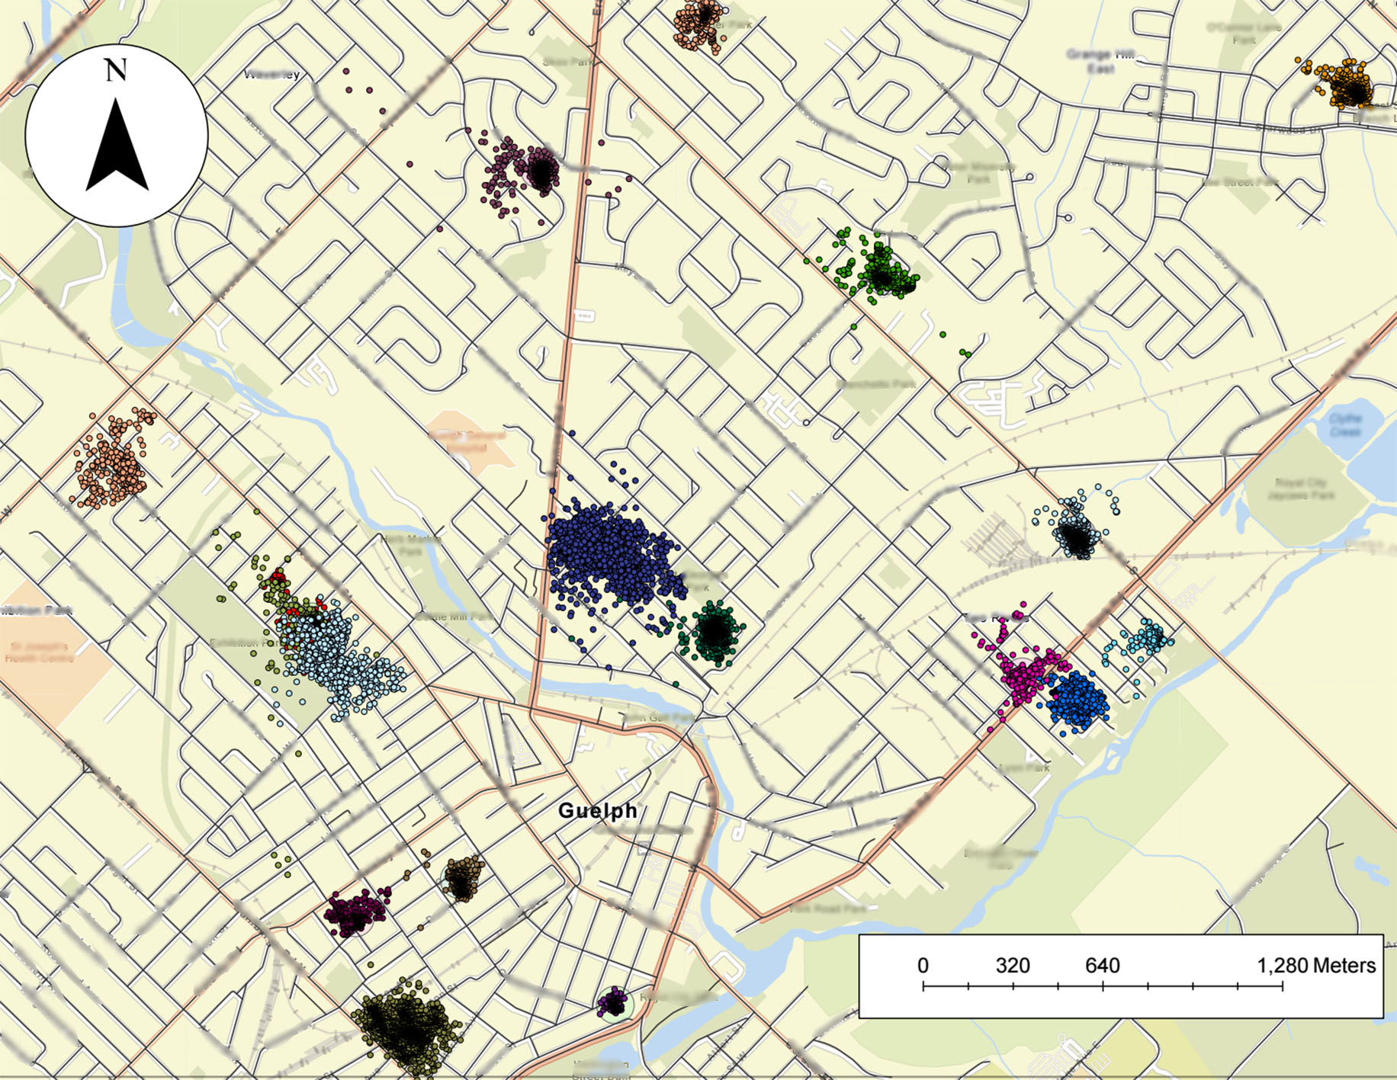
Figure S6. Map of GPS points from owned cats living in the Guelph region. This map also shows minor (black) and major (orange) roads in the city, the latter of which appeared to act as a barrier for movement.

