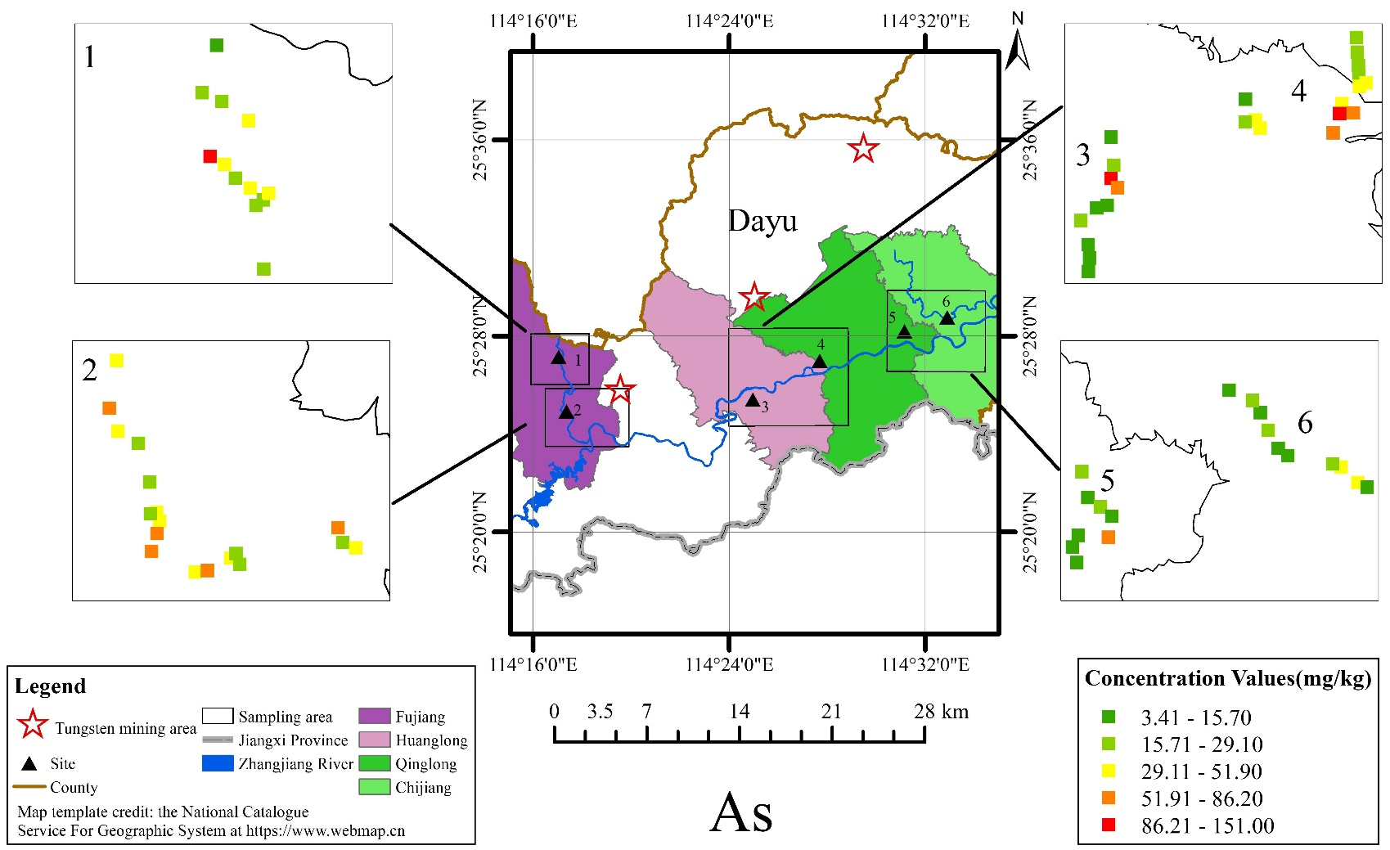

Figure 1S The GIS map on the concentration of Arsenic(As) (site1:FJ-N,site2:FJ-S,site3:HL,site4:QL,site5:CJ-W,site6:CJ-E)

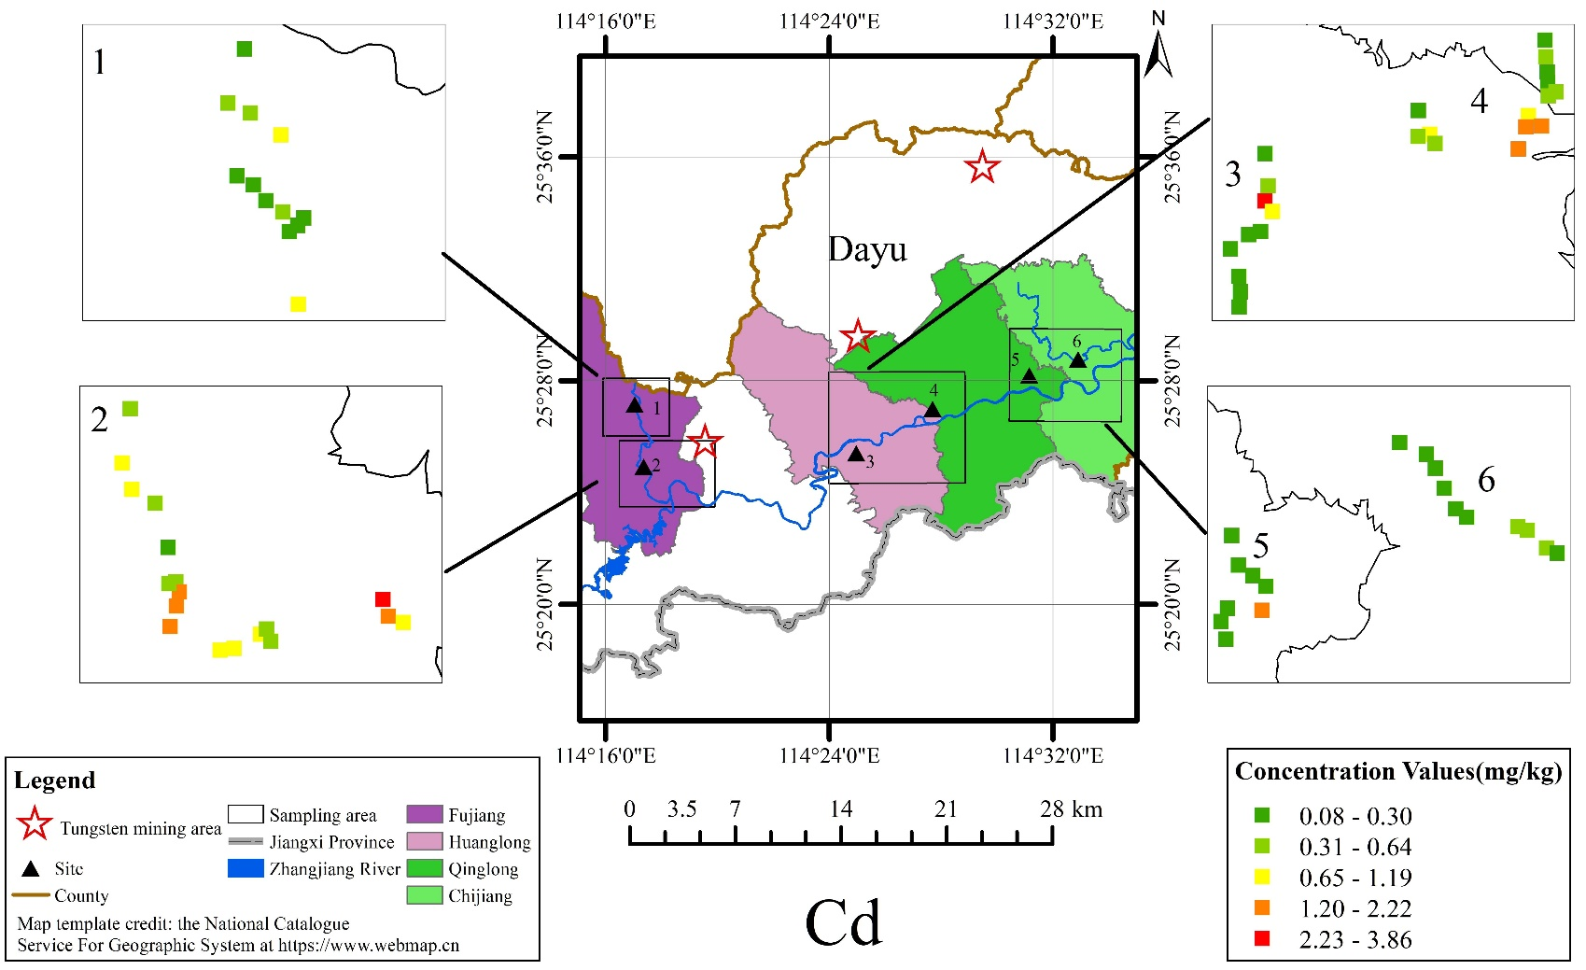

Figure 2S The GIS map on the concentration of Cadmium(Cd) (site1:FJ-N,site2:FJ-S,site3:HL,site4:QL,site5:CJ-W,site6:CJ-E)

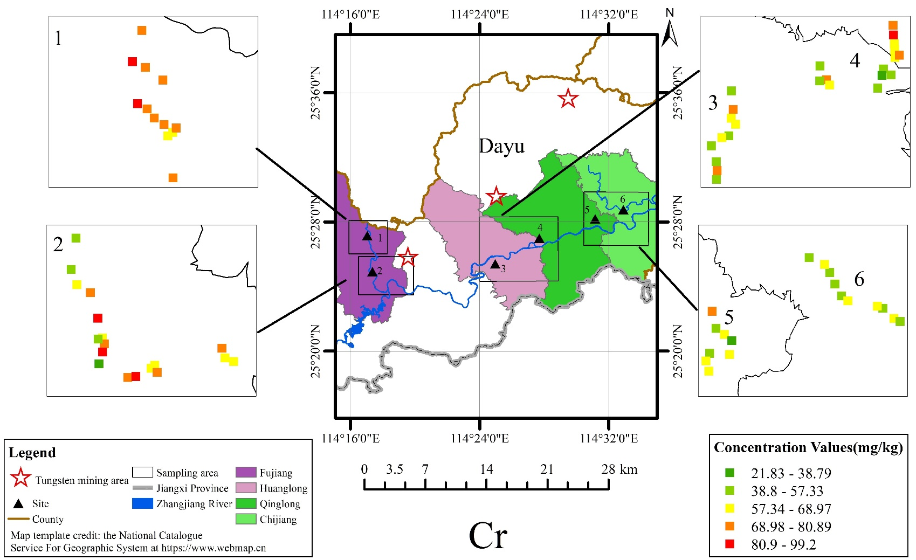

Figure 3S The GIS map on the concentration of Chromium(Cr) (site1:FJ-N,site2:FJ-S,site3:HL,site4:QL,site5:CJ-W,site6:CJ-E)

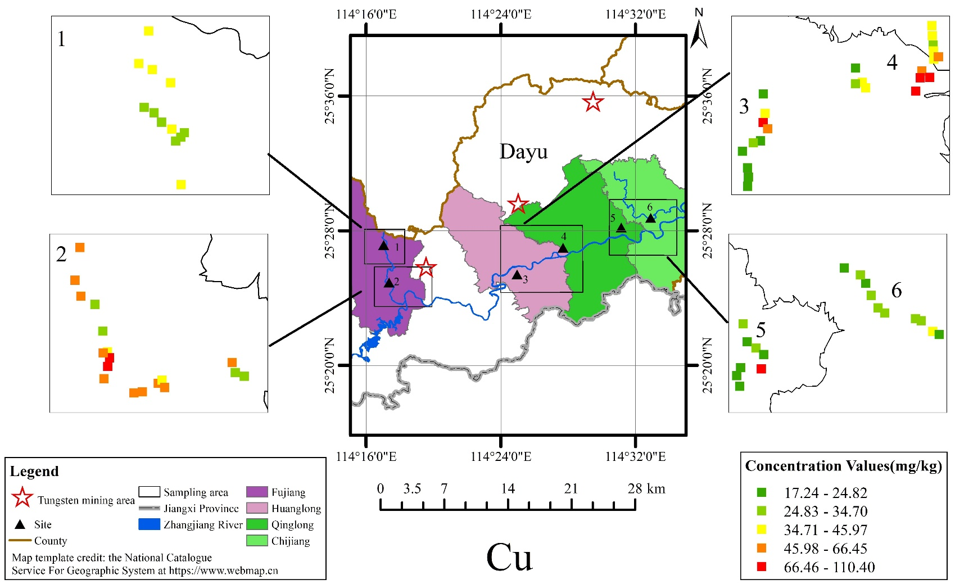

Figure 4S The GIS map on the concentration of Copper(Cu) (site1:FJ-N,site2:FJ-S,site3:HL,site4:QL,site5:CJ-W,site6:CJ-E)

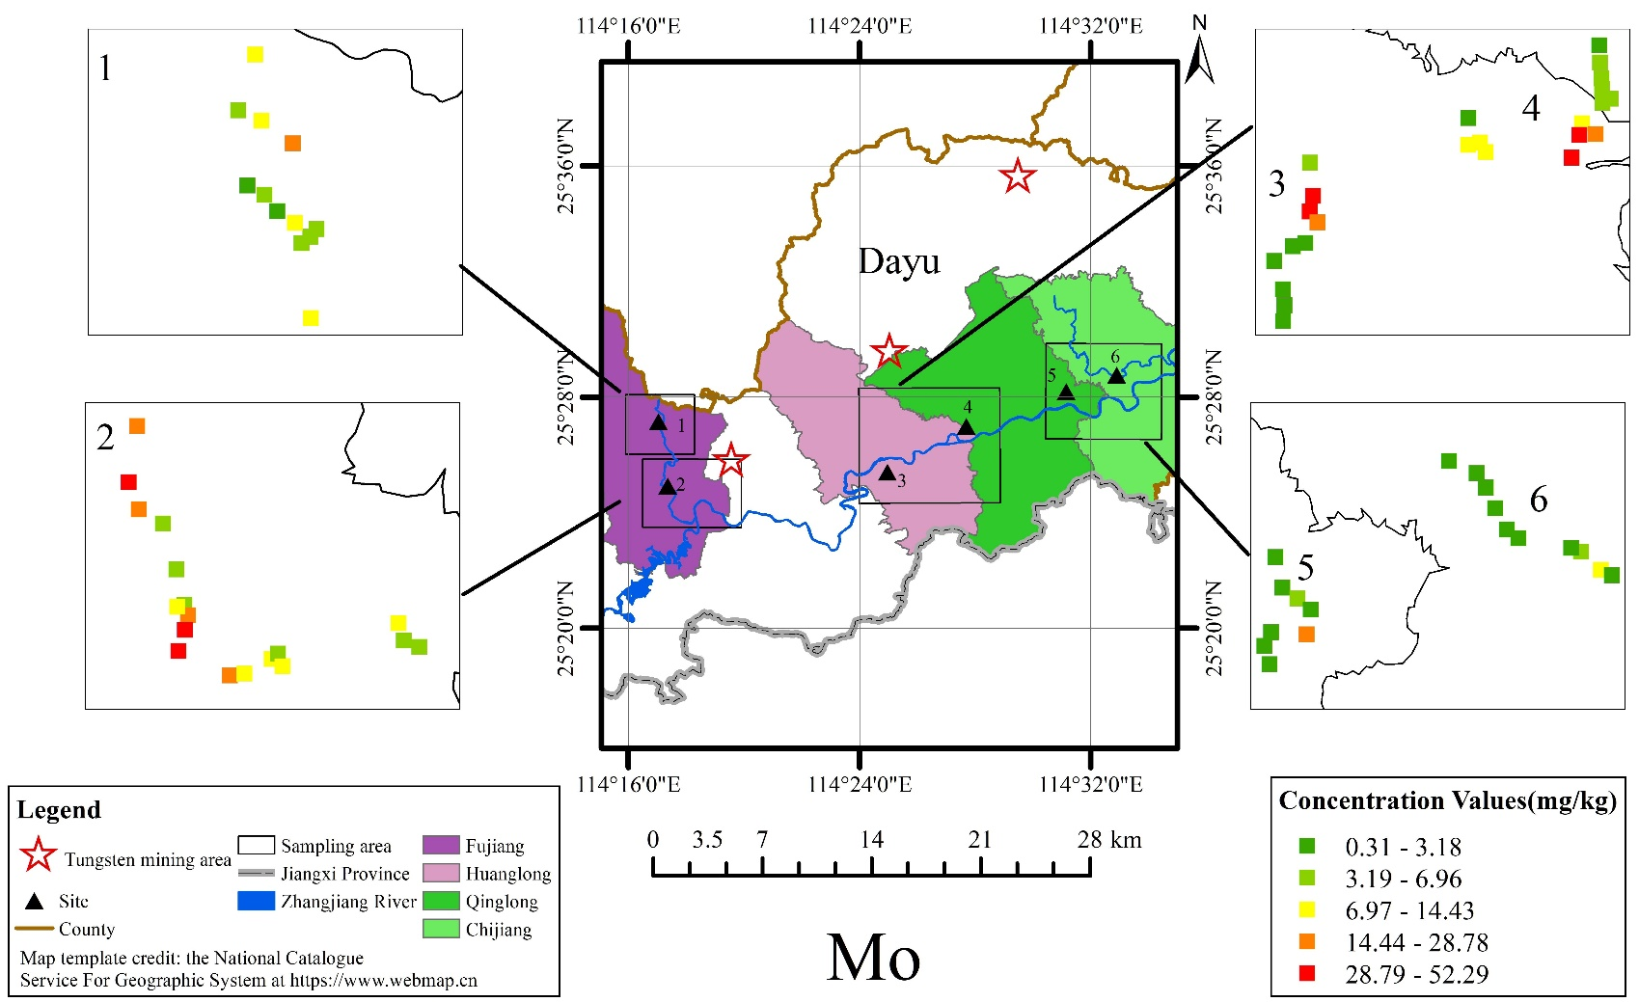

Figure 5S The GIS map on the concentration of Molybdenum(Mo) (site1:FJ-N,site2:FJ-S,site3:HL,site4:QL,site5:CJ-W,site6:CJ-E)

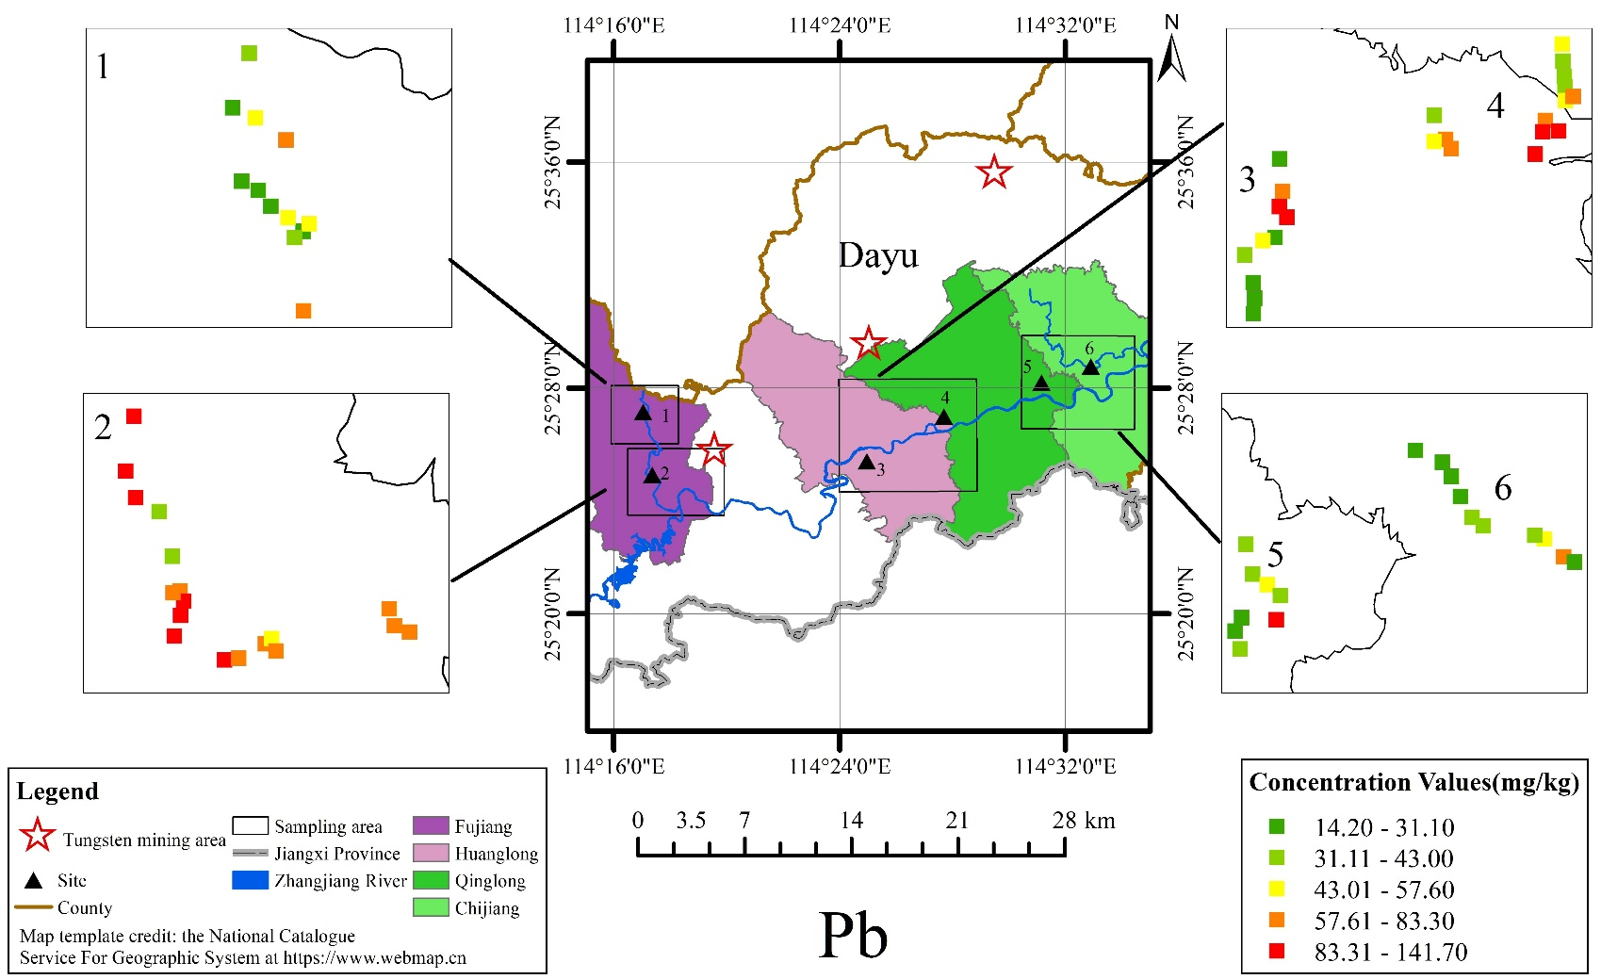

Figure 6S The GIS map on the concentration of Lead(Pb) (site1:FJ-N,site2:FJ-S,site3:HL,site4:QL,site5:CJ-W,site6:CJ-E)

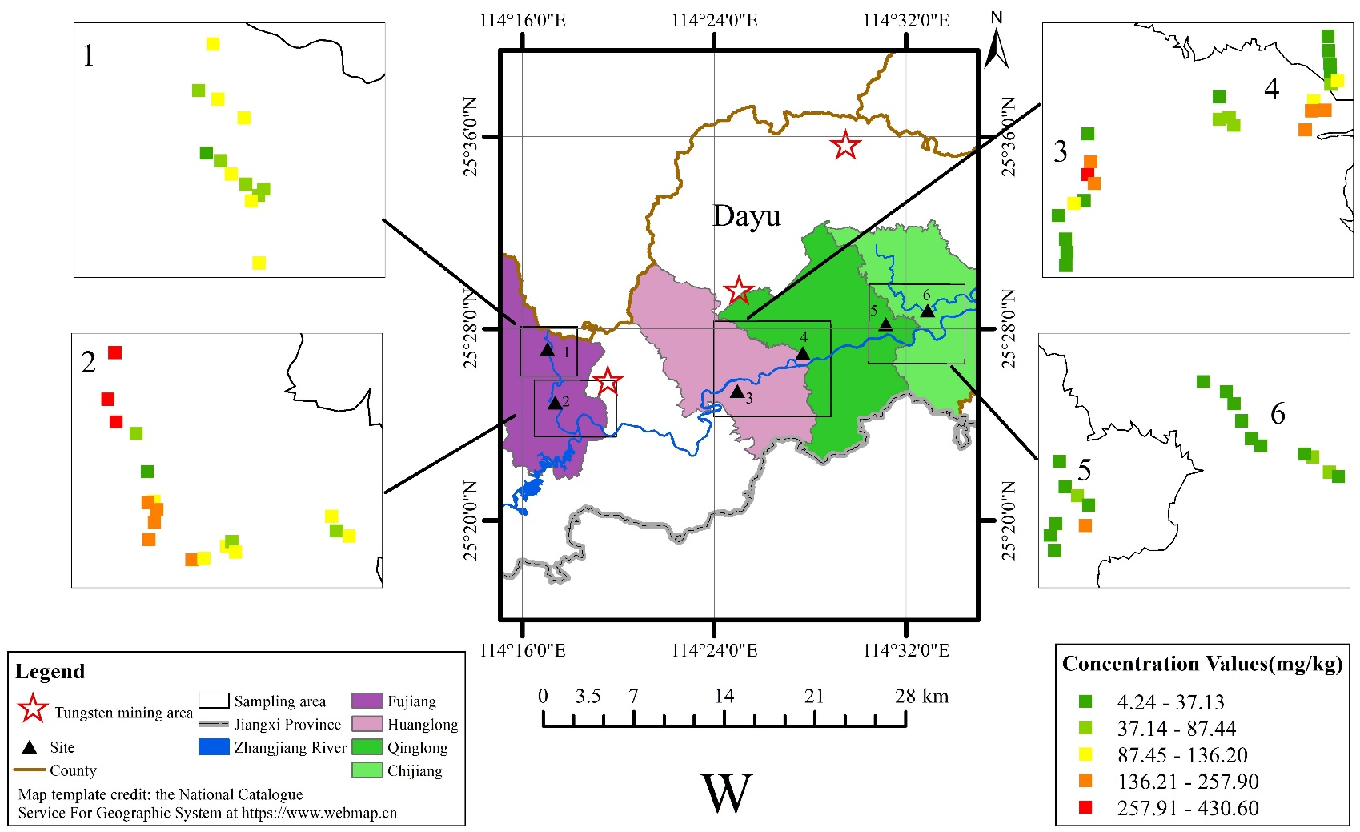

Figure 7S The GIS map on the concentration of Tungsten(W) (site1:FJ-N,site2:FJ-S,site3:HL,site4:QL,site5:CJ-W,site6:CJ-E)

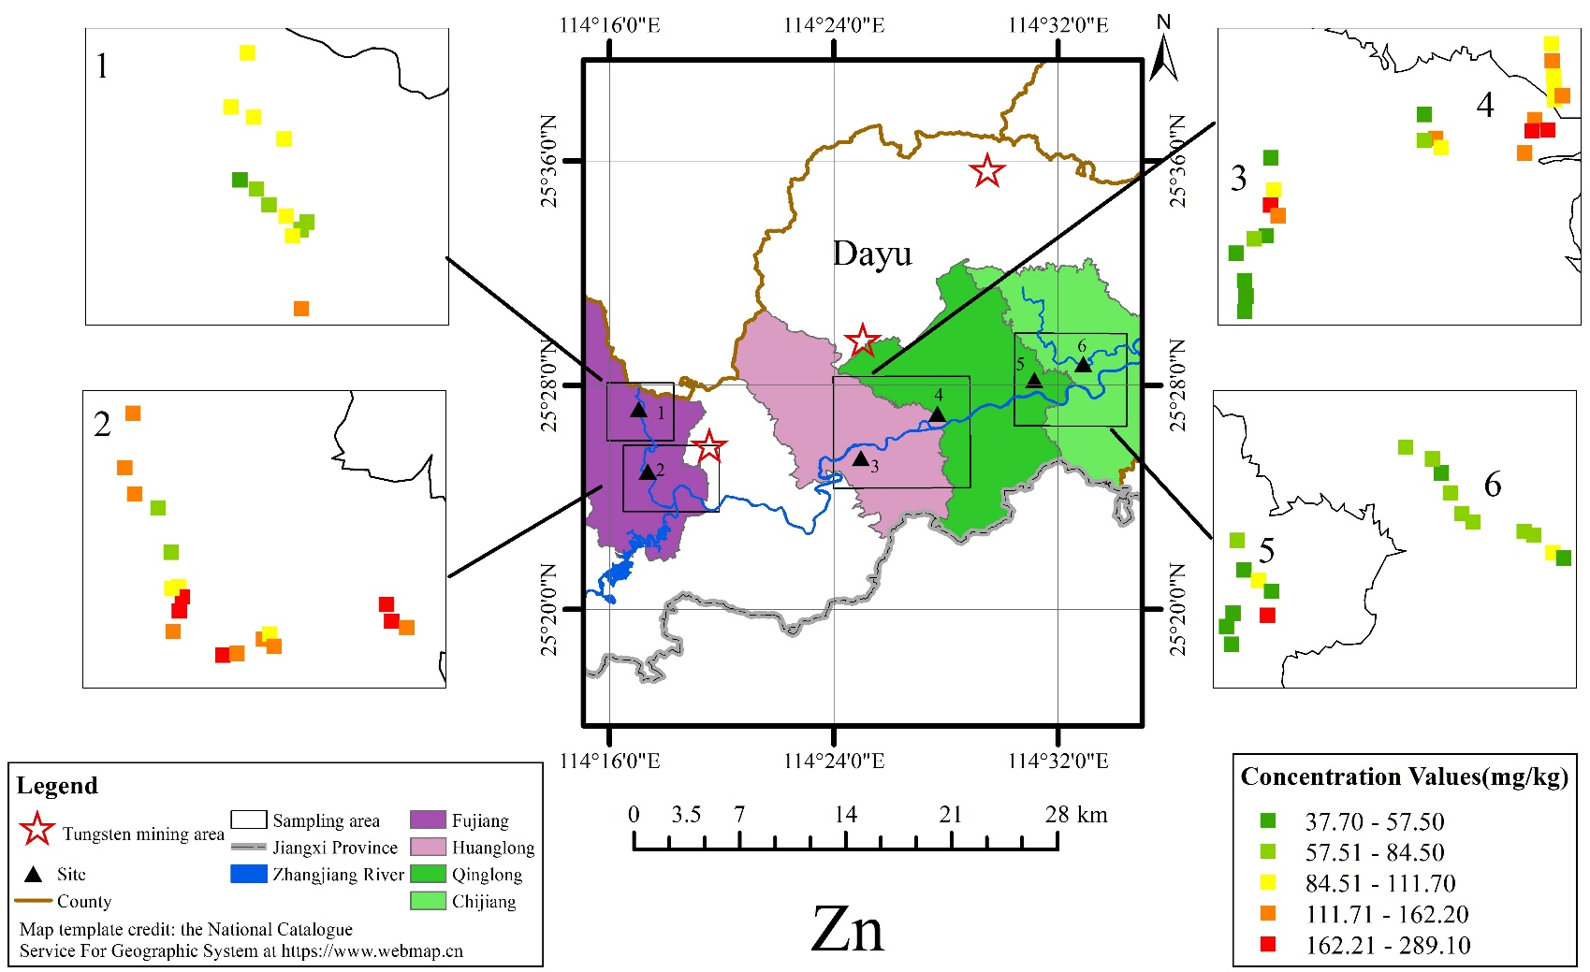

Figure 8S The GIS map on the concentration of Zinc(Zn) (site1:FJ-N,site2:FJ-S,site3:HL,site4:QL,site5:CJ-W,site6:CJ-E)