**FIGURE1：**

**WB-** **HA-Zbtb21：**

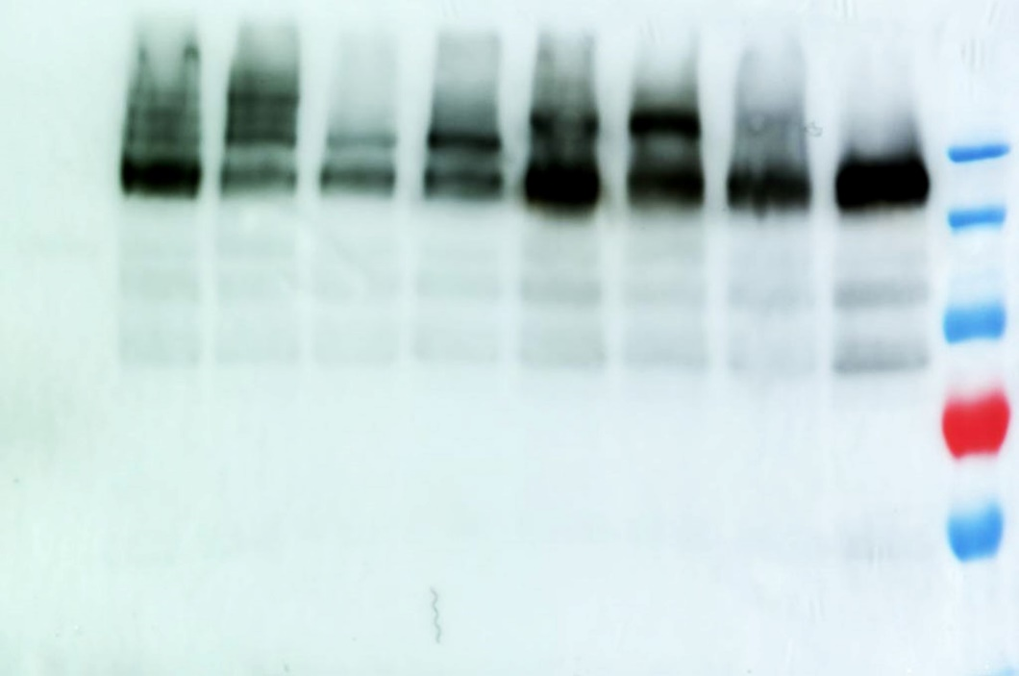

WB-TUBULIN:

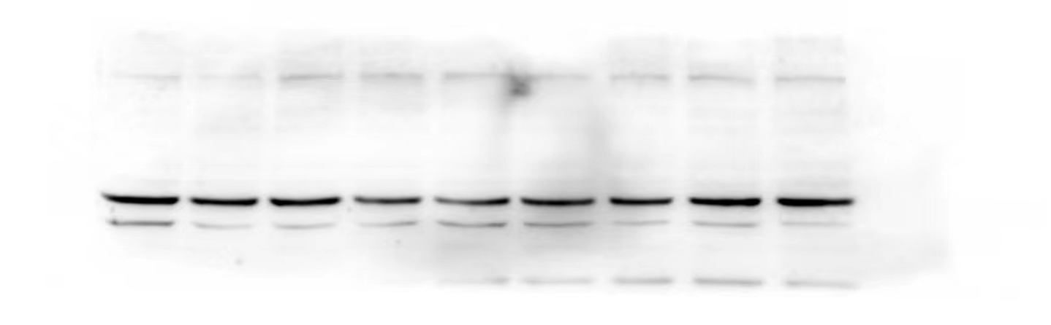

**IP：HA-Zbtb21 - SUMO1**

IP-anti-sumo1：



Input-anti-HA：



**FIGURE2：**

|  |  |  |  |  |  |  |  |  |  |  |  |  |  |  |  |
| --- | --- | --- | --- | --- | --- | --- | --- | --- | --- | --- | --- | --- | --- | --- | --- |
| zbtb14-promoter | PCS2 | | | HA-Zbtb21 | | | HA-Zbtb21K419R | | | HA-Zbtb21K845R | | | HA-Zbtb21K419+845R | | |
|  | 1 | 1 | 1 | 1.174548 | 1.165457 | 1.127235 | 1.243509504 | 1.284502 | 1.400117 | 1.296476588 | 1.293151 | 1.372978 | 1.507881317 | 1.323127 | 1.251392 |

|  |  |  |  |  |  |  |  |  |  |  |  |  |  |  |  |  |  |  |  |  |
| --- | --- | --- | --- | --- | --- | --- | --- | --- | --- | --- | --- | --- | --- | --- | --- | --- | --- | --- | --- | --- |
| CDC6-promoter | PCS2 | | | | HA-Zbtb21 | | | | HA-Zbtb21K419R | | | | HA-Zbtb21K845R | | | | HA-Zbtb21K419+845R | | | |
|  | 1 | 1 | 1 | 1 | 0.669233 | 0.723288 | 0.785301677 | 0.904241 | 0.949006 | 0.824822847 | 0.901663 | 0.749413 | 0.73787838 | 0.789528 | 0.633254 | 1.069653 | 1.059079 | 0.819347 | 0.931963 | 1.073659 |

|  |  |  |  |  |  |  |  |  |  |  |  |  |  |  |  |
| --- | --- | --- | --- | --- | --- | --- | --- | --- | --- | --- | --- | --- | --- | --- | --- |
| pu1-promoter | PCS2 | | | HA-Zbtb21 | | | HA-Zbtb21K419R | | | HA-Zbtb21K845R | | | HA-Zbtb21K419+845R | | |
|  | 1 | 1 | 1 | 0.75713628 | 0.701457293 | 0.75543886 | 0.875172652 | 0.935366347 | 1.000300075 | 0.798572744 | 1.11395223 | 1.081470368 | 0.861187845 | 1.097490217 | 1.09587397 |

WESTERN-ANTI-HA

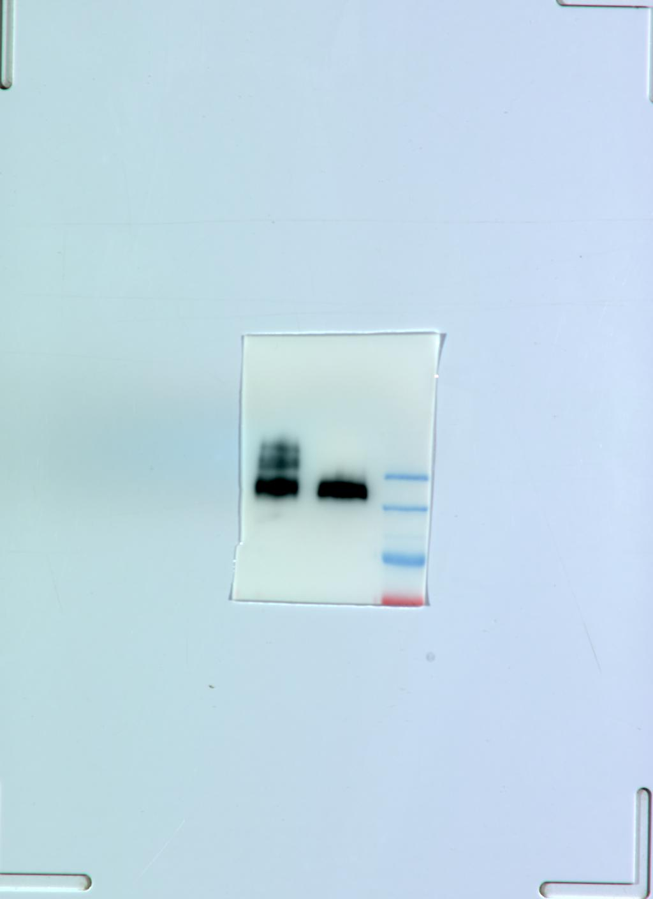

WESTERN-ANTI-TUBULIN

INPUT-ANTI-BRD4

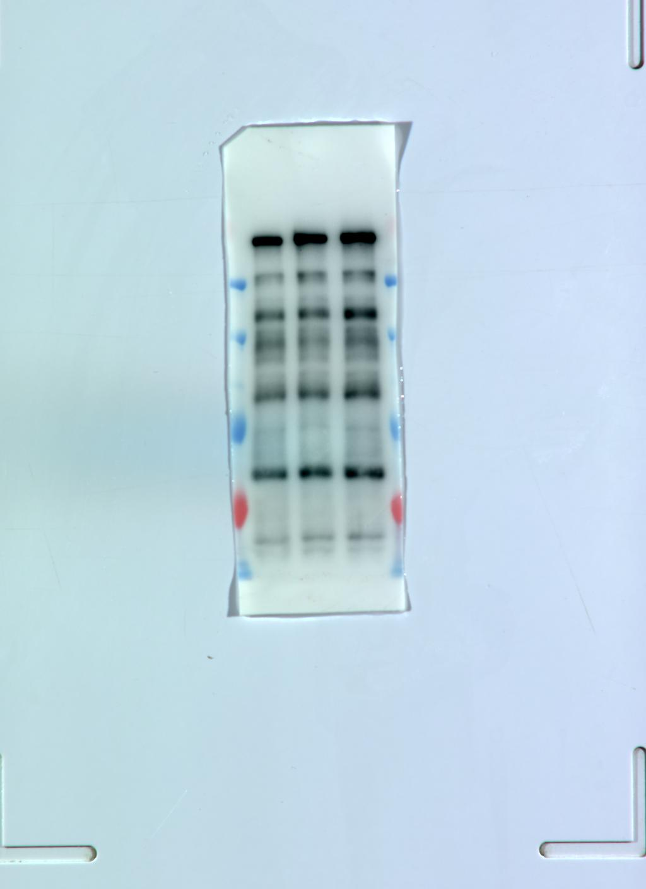

INPUT-ANTI-HDAC4

房间的摆设布局

INPUT-ANTI-HA

白板上写着字

IP-ANTI-BRD4

蓝色的门

IP-ANTI-HDAC4

蓝色的门

**FIGURE3:**

**PCS2:**

DAPI:



HA:



MERGE:



**HA-Zbtb21:**

DAPI:



HA:



MERGE:

**HA-Zbtb21K419R:**

DAPI:

黑暗里有星球

HA

MERGE

**HA-Zbtb21K845R:**

DAPI:

HA:

MERGE:



**HA-Zbtb21K419+845R:**

DAPI:

卡通人物

HA:

黑暗中的灯光

MERGE:

夜晚亮着的交通信号灯

**FIGURE4:**

**IP:** **HA-Zbtb21-Zbtb14**

IP-Anti-HA

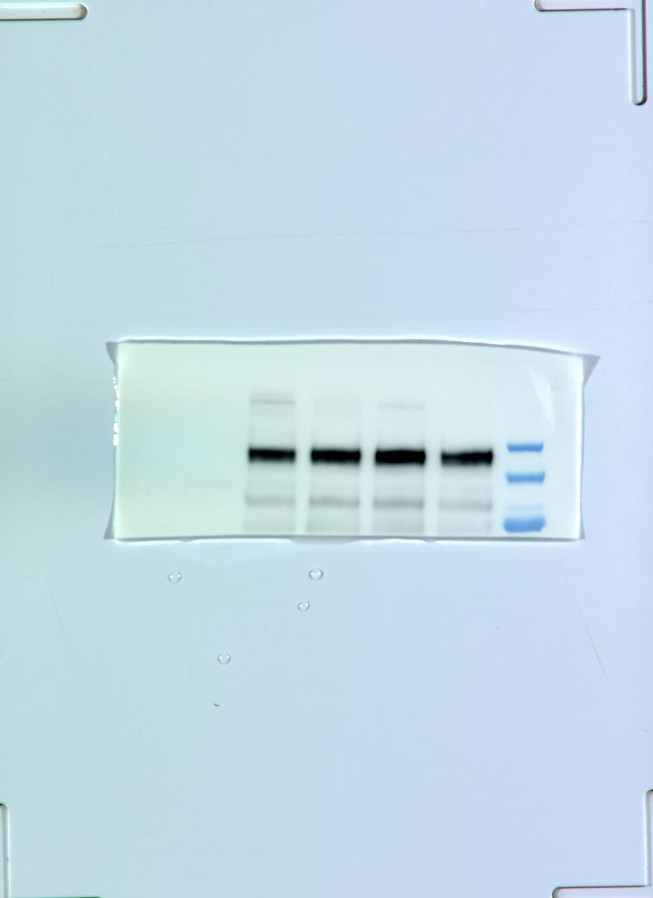

IP-Anti-FLAG

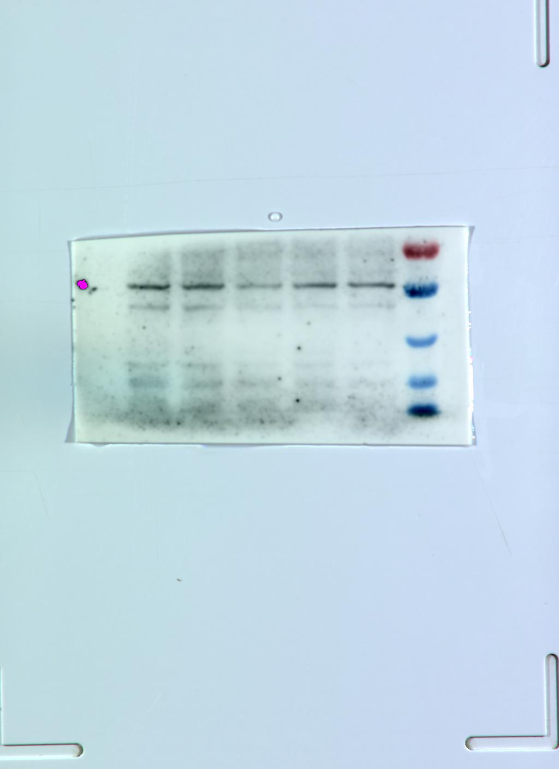

INPUT- anti-HA

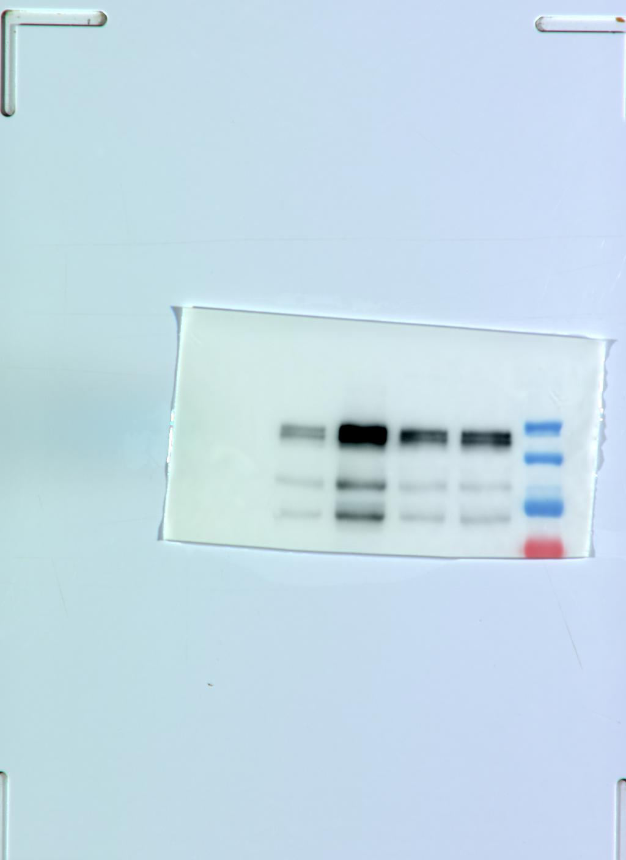

INPUT- anti-flag

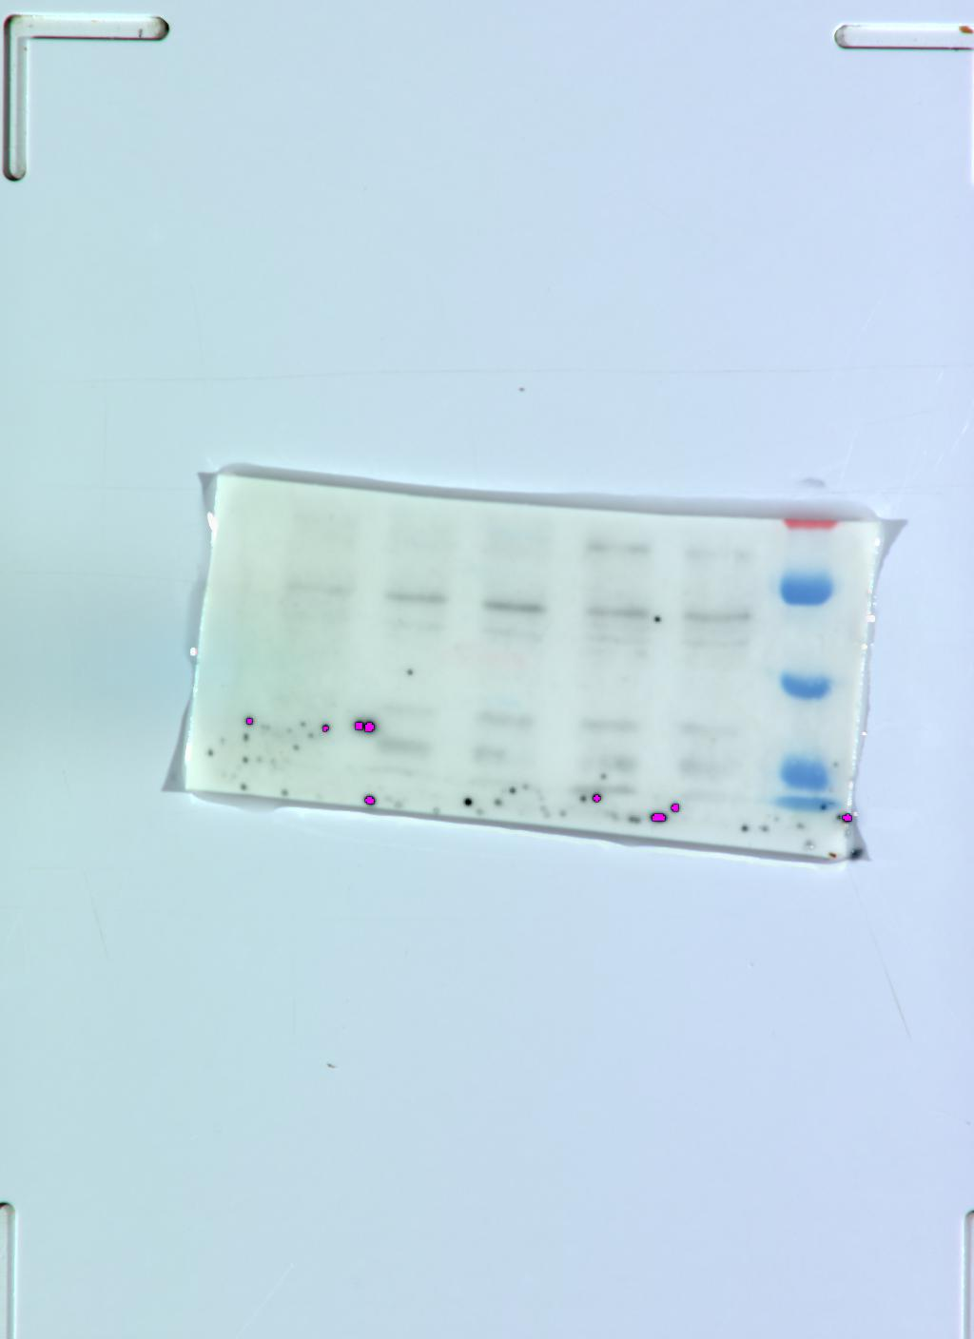

**IP: HA-Zbtb21k419+845R-FLAG-Zbtb21K419+845R**

IP-anti-HA

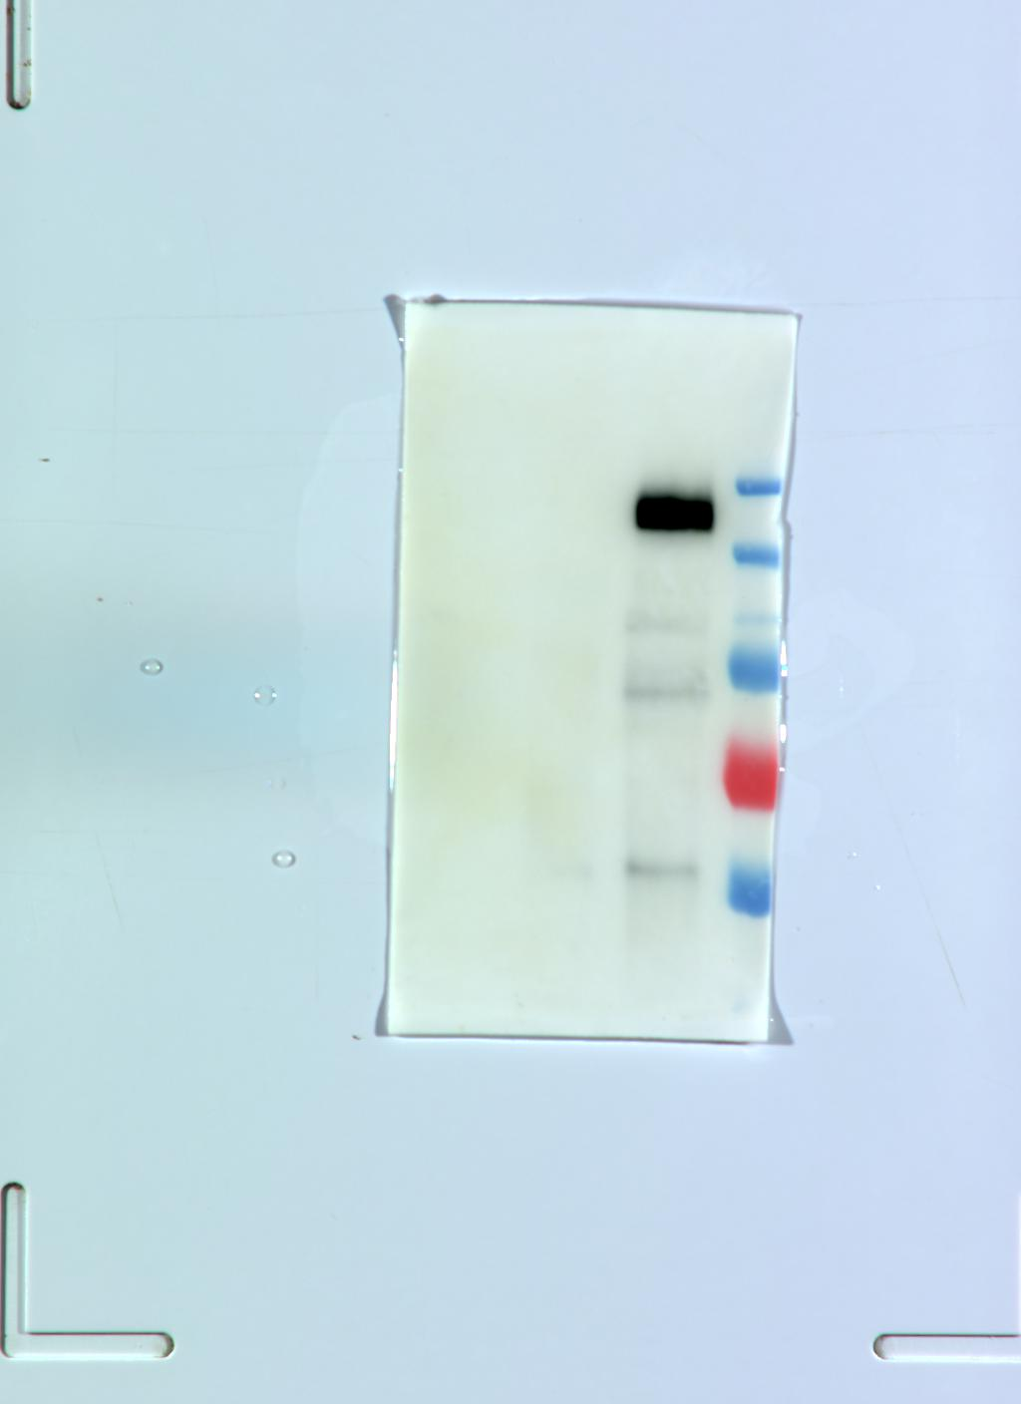

INPUT-anti-FLAG

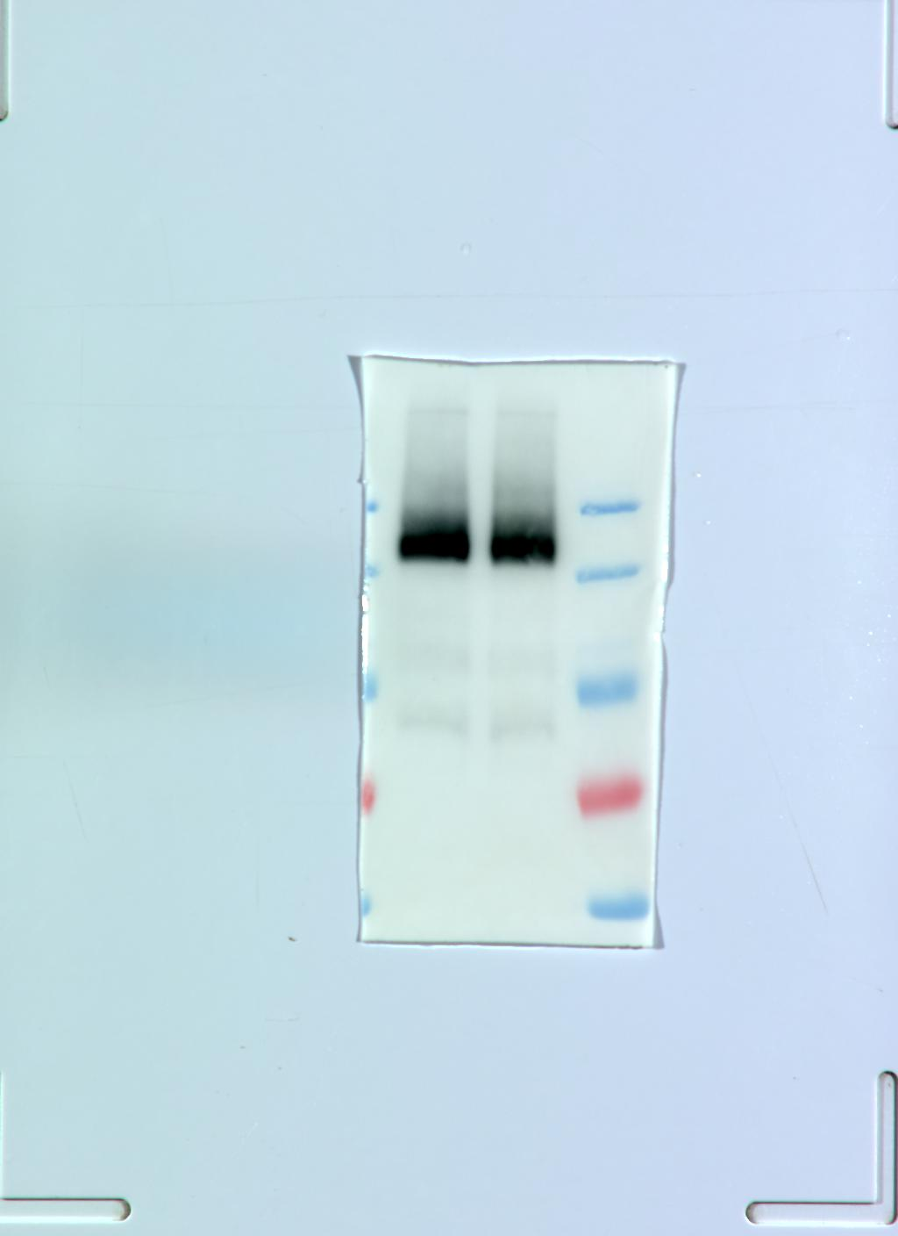

**FIGURES1:**

HU-ZBTB21-ANTI-HA

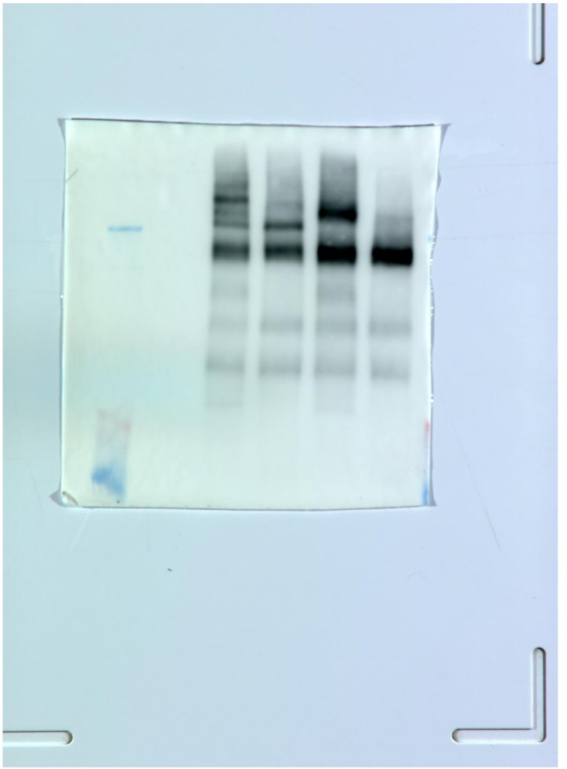

**FIGURES2:**

ANTI-HU-ZBTB21

