Supplementary Data
Microbial communities of Schisandra sphenanthera Rehd. et Wils. and the correlations between microbial community and the active secondary metabolites
Xiao Lu Qin, Han Pu, Xi Lin Fang, Qian Qian Shang, Jian Hua Li, Qiao Zhu Zhao, Xiao Rui Wang* and Wei Gu*

National Engineering Laboratory for Resource Development of Endangered Crude Drugs in Northwest China, The Key Laboratory of Medicinal Resources and Natural Pharmaceutical Chemistry, The Ministry of Education, College of Life Sciences, Shaanxi Normal University, Xi’an, Shaanxi 710119, P. R. China

* Corresponding Author:
Xiao Rui Wang, Wei Gu
620 West Chang 'an Avenue, Xi’an, Shaanxi 710119, P. R. China
Email address: xiaoruiwang@snnu.edu.cn (X.W.); weigu@snnu.edu.cn (W.G.)

Table S1. Sequencing regions and PCR primers are selected for this study.
Region | Universal primers | Direction | Primers
16S V4 | 515F | Forward | 5' GTGYCAGCMGCCGCGGTAA 3'
 | 806R | Reverse | 5' GGACTACNVGGGTWTCTAA 3'
ITS1 | ITS5-1737F | Forward | 5' GGAAGTAAAAGTCGTAACAAGG 3'
 | ITS2-2043R | Reverse | 5' GCTGCGTTCTTCATCGATGC3 '

Table S2. Factors and levels for the orthogonal test.
Level (Stem) | Factor
Level (Stem) | A (g/mL) | B (min) | C (°C) | D (W)
1 | 1：10 | 20 | 30 | 240
2 | 1：15 | 30 | 35 | 270
3 | 1：20 | 40 | 40 | 300
Level (Leaf) | Factor
Level (Leaf) | A (g/mL) | B (min) | C (°C) | D (W)
1 | 1：15 | 10 | 30 | 210
2 | 1：20 | 20 | 35 | 240
3 | 1：25 | 30 | 40 | 270
Note A: Ratio of material to solvent; B: Ultrasonic time; C: Ultrasonic temperature; D: Ultrasonic power.
Table S3. Results of L9 (3⁴) orthogonal test.
Number (Stem) | Factor |  |  |  |  | Extraction rate (%)
Number (Stem) | A (g/mL) |  | B (min) | C (°C) | D (W) | Extraction rate (%)
1 | 1 |  | 1 | 1 | 1 | 0.71±0.13
2 | 1 |  | 2 | 2 | 2 | 1.93±0.22
3 | 1 |  | 3 | 3 | 3 | 0.53±0.15
4 | 2 |  | 1 | 2 | 3 | 3.37±0.47
5 | 2 |  | 2 | 3 | 1 | 3.98±0.11
6 | 2 |  | 3 | 1 | 2 | 0.68±0.21
7 | 3 |  | 1 | 3 | 2 | 3.72±0.18
8 | 3 |  | 2 | 1 | 3 | 4.50±0.22
9 | 3 |  | 3 | 2 | 1 | 1.55±0.19
k1 | 3.17 |  | 7.80 | 5.89 | 6.24
k2 | 8.03 |  | 10.41 | 6.85 | 6.33
k3 | 9.77 |  | 2.76 | 8.23 | 8.40
K1 | 1.06 |  | 2.60 | 1.96 | 2.08
K2 | 2.68 |  | 3.47 | 2.28 | 2.11
K3 | 3.26 |  | 0.92 | 2.74 | 2.80
R | 2.20 |  | 2.55 | 0.78 | 0.72
Factor sequence | B>A>C>D
Optimal combination |  | A₃B₂C₁D₃
Number (Leaf) | Factor |  |  |  |  | Extraction rate (%)
Number (Leaf) | A (g/mL) |  | B (min) | C (°C) | D (W) | Extraction rate (%)
1 | 1 |  | 1 | 1 | 1 | 5.03±0.15
2 | 1 |  | 2 | 2 | 2 | 5.16±0.67
3 | 1 |  | 3 | 3 | 3 | 3.67±0.91
4 | 2 |  | 1 | 2 | 3 | 4.80±0.25
5 | 2 |  | 2 | 3 | 1 | 4.19±0.32
6 | 2 |  | 3 | 1 | 2 | 3.80±0.64
7 | 3 |  | 1 | 3 | 2 | 3.81±0.09
8 | 3 |  | 2 | 1 | 3 | 2.74±0.27
9 | 3 |  | 3 | 2 | 1 | 2.91±0.35
k1 | 13.86 |  | 13.64 | 11.57 | 12.13
k2 | 12.79 |  | 12.09 | 12.87 | 12.77
k3 | 9.46 |  | 10.38 | 11.67 | 11.21
K1 | 4.62 |  | 4.55 | 3.86 | 4.04
K2 | 4.26 |  | 4.03 | 4.29 | 4.26
K3 | 3.15 |  | 3.46 | 3.89 | 3.74
R | 1.47 |  | 1.09 | 0.43 | 0.52
Factor sequence | A>B>D>C
Optimal combination |  | A₁B₂C₂D₂
Note SD: standard deviation; A: Ratio of material to solvent; B: Ultrasonic time; C: Ultrasonic temperature; D: Ultrasonic power.
Table S4. Table of variance analysis of the orthogonal test.
Factor (Stem) | Sum of Squares | Degree of freedom | Mean square | F | Significance
A | 23.377 | 2 | 11.688 | 103.862 | **
B | 29.850 | 2 | 14.925 | 132.623 | **
C | 2.724 | 2 | 1.362 | 12.103 | **
D | 2.971 | 2 | 1.485 | 13.200 | **
error | 2.026 |  | 0.113
sum | 207.858
Factor (Leaf) | Sum of Squares | Degree of freedom | Mean square | F | Significance
A | 10.440 | 2 | 5.220 | 22.607 | **
B | 5.303 | 2 | 2.652 | 11.483 | **
C | 1.096 | 2 | 0.548 | 2.374
D | 1.222 | 2 | 0.611 | 2.626 | *
error | 4.156 |  | 0.231
sum | 457.012
Note A: Ratio of material to solvent; B: Ultrasonic time; C: Ultrasonic temperature; D: Ultrasonic power; *: p < 0.05; **: p < 0.01.
Table S5. Level of bacterial microorganism annotation abundances table (the level of genus).
No.* | Genus | Rhizosphere soil | Root | Stem | Leaf | Fruit
1 | Afifella | 0.059±0.022 | 0.274±0.127 | 0.000±0.000 | 0.000±0.000 | 0.000±0.000
2 | Candidatus Solibacter | 1.410±0.512 | 0.362±0.138 | 0.000±0.000 | 0.000±0.000 | 0.000±0.000
3 | Chitinophaga | 0.029±0.011 | 0.563±0.184 | 0.000±0.000 | 0.000±0.000 | 0.000±0.000
4 | Dokdonella | 0.238±0.048 | 0.168±0.038 | 0.000±0.000 | 0.000±0.000 | 0.000±0.000
5 | Inquilinus | 0.214±0.087 | 0.052±0.008 | 0.000±0.000 | 0.000±0.000 | 0.000±0.000
6 | Nitrospira | 0.178±0.074 | 0.037±0.007 | 0.000±0.000 | 0.000±0.000 | 0.000±0.000
7 | Novosphingobium | 0.006±0.001 | 0.274±0.075 | 0.000±0.000 | 0.000±0.000 | 0.000±0.000
8 | Opitutus | 0.009±0.003 | 0.206±0.086 | 0.000±0.000 | 0.000±0.000 | 0.000±0.000
9 | Paucibacter | 0.163±0.054 | 0.197±0.088 | 0.000±0.000 | 0.000±0.000 | 0.000±0.000
10 | Pedomicrobium | 0.502±0.217 | 0.173±0.094 | 0.000±0.000 | 0.000±0.000 | 0.000±0.000
11 | Rhizobium | 0.443±0.148 | 0.378±0.315 | 0.000±0.000 | 0.000±0.000 | 0.000±0.000
12 | Rhodoplanes | 2.209±1.029 | 4.280±2.127 | 0.000±0.000 | 0.000±0.000 | 0.000±0.000
13 | Bacteroides | 0.000±0.000 | 0.000±0.000 | 0.330±0.169 | 0.517±0.133 | 0.161±0.107
14 | Brevibacillus | 0.000±0.000 | 0.000±0.000 | 0.245±0.117 | 0.024±0.011 | 0.046±0.018
15 | Blastomonas | 0.000±0.000 | 0.000±0.000 | 0.265±0.099 | 0.000±0.000 | 0.053±0.019
16 | Cloacibacterium | 0.000±0.000 | 0.000±0.000 | 0.154±0.067 | 0.594±0.226 | 0.000±0.000
17 | Corynebacterium | 0.000±0.000 | 0.000±0.000 | 0.455±0.208 | 0.330±0.124 | 0.168±0.066
18 | Deinococcus | 0.000±0.000 | 0.000±0.000 | 0.266±0.135 | 0.000±0.000 | 0.136±0.062
19 | Fusobacterium | 0.000±0.000 | 0.000±0.000 | 0.079±0.033 | 0.177±0.033 | 0.037±0.021
20 | Haliscomenobacter | 0.000±0.000 | 0.000±0.000 | 0.000±0.000 | 0.223±0.182 | 0.000±0.000
21 | Hydrocarboniphaga | 0.000±0.000 | 0.000±0.000 | 0.000±0.000 | 0.000±0.000 | 0.197±0.038
22 | Jeotgalicoccus | 0.000±0.000 | 0.000±0.000 | 0.000±0.000 | 0.140±0.088 | 0.000±0.000
23 | Limnobacter | 0.000±0.000 | 0.000±0.000 | 0.167±0.088 | 0.103±0.067 | 0.213±0.101
24 | Micrococcus | 0.000±0.000 | 0.000±0.000 | 0.514±0.149 | 0.107±0.067 | 0.406±0.201
25 | Parabacteroides | 0.000±0.000 | 0.000±0.000 | 0.000±0.000 | 0.263±0.104 | 0.000±0.000
26 | Paracoccus | 0.000±0.000 | 0.000±0.000 | 0.327±0.138 | 0.000±0.000 | 0.058±0.027
27 | Pigmentiphaga | 0.000±0.000 | 0.000±0.000 | 0.264±0.113 | 0.103±0.010 | 0.000±0.000
28 | Prevotella | 0.000±0.000 | 0.000±0.000 | 0.081±0.021 | 0.317±0.163 | 0.037±0.011
29 | Anoxybacillus | 0.000±0.000 | 0.046±0.021 | 4.438±1.328 | 2.230±1.322 | 1.088±0.827
30 | Bacillus | 0.000±0.000 | 0.033±0.011 | 0.606±0.286 | 0.925±0.341 | 0.461±0.303
31 | Brevundimonas | 0.000±0.000 | 0.006±0.003 | 0.145±0.061 | 0.000±0.000 | 0.000±0.000
32 | Chryseobacterium | 0.000±0.000 | 0.023±0.011 | 0.147±0.034 | 0.111±0.009 | 0.183±0.019
33 | Curtobacterium | 0.000±0.000 | 0.012±0.005 | 0.771±0.118 | 0.385±0.113 | 0.317±0.108
34 | Friedmanniella | 0.000±0.000 | 0.017±0.007 | 0.105±0.011 | 0.178±0.018 | 0.227±0.039
35 | Kocuria | 0.000±0.000 | 0.004±0.001 | 0.298±0.102 | 0.000±0.000 | 0.002±0.001
36 | Methyloversatilis | 0.000±0.000 | 0.066±0.009 | 1.669±0.889 | 0.409±0.207 | 1.767±0.862
37 | Patulibacter | 0.000±0.000 | 0.012±0.002 | 0.000±0.000 | 0.195±0.088 | 0.053±0.027
38 | Staphylococcus | 0.000±0.000 | 0.012±0.001 | 5.901±2.357 | 0.916±0.233 | 0.526±0.208
39 | Thermus | 0.000±0.000 | 0.012±0.004 | 0.366±0.122 | 0.000±0.000 | 0.408±0.107
40 | Aeromicrobium | 0.002±0.000 | 0.000±0.000 | 0.151±0.077 | 0.000±0.000 | 0.011±0.008
41 | Agrobacterium | 0.077±0.019 | 0.875±0.237 | 0.357±0.119 | 0.000±0.000 | 0.264±0.117
42 | Caulobacter | 0.063±0.027 | 0.179±0.069 | 0.000±0.000 | 0.901±0.332 | 0.275±0.079
43 | Devosia | 0.059±0.019 | 0.253±0.113 | 0.000±0.000 | 0.000±0.000 | 0.096±0.034
44 | Frigoribacterium | 0.002±0.001 | 0.004±0.002 | 0.156±0.088 | 0.000±0.000 | 0.512±0.224
45 | Gemmata | 1.067±0.754 | 0.513±0.201 | 0.681±0.223 | 0.000±0.000 | 0.261±0.043
46 | Hymenobacter | 0.017±0.008 | 0.000±0.000 | 0.295±0.101 | 2.210±1.087 | 0.564±0.201
47 | Luteibacter | 0.203±0.057 | 0.013±0.003 | 0.000±0.000 | 0.174±0.082 | 0.000±0.000
48 | Lysobacter | 0.098±0.037 | 0.000±0.000 | 0.203±0.103 | 0.165±0.088 | 0.473±0.161
49 | Microbacterium | 0.003±0.001 | 0.015±0.007 | 0.311±0.118 | 0.000±0.000 | 0.050±0.011
50 | Paenibacillus | 0.008±0.003 | 0.000±0.000 | 0.552±0.207 | 0.428±0.201 | 0.138±0.093
51 | Pseudonocardia | 0.017±0.005 | 0.256±0.102 | 0.000±0.000 | 0.000±0.000 | 0.019±0.007
52 | Sphingobium | 0.019±0.008 | 0.320±0.132 | 0.000±0.000 | 0.000±0.000 | 0.048±0.013
53 | Spirosoma | 0.091±0.013 | 0.013±0.007 | 0.000±0.000 | 0.601±0.104 | 0.184±0.082
54 | Streptomyces | 0.014±0.007 | 0.426±0.032 | 0.253±0.023 | 0.000±0.000 | 0.000±0.000
55 | others | 6.671±1.257 | 1.629±0.731 | 0.929±0.127 | 0.419±0.224 | 0.929±0.337
* The genera counted in the table are OTUs more than 100 (at least one part of S. sphenanthera). 1-12: Bacterial microorganisms exist only in rhizosphere soil and roots. 13-28: Bacterial microorganisms are present in the above-ground part (stem, leaf, and fruit). 29-39: Bacterial microorganisms are present in the root, stem, leaf, and fruit. 40-55: The bacterial microorganism with no apparent distribution pattern.
Table S6. Level of fungal microorganism annotation abundances table (the level of genus).
No.* | Genus | Rhizosphere soil | Root | Stem | Leaf | Fruit
1 | Chaetosphaeria | 0.169±0.011 | 0.000±0.000 | 0.000±0.000 | 0.000±0.000 | 0.000±0.000
2 | Clavulinopsis | 2.101±0.776 | 0.000±0.000 | 0.000±0.000 | 0.000±0.000 | 0.000±0.000
3 | Exophiala | 0.208±0.092 | 0.000±0.000 | 0.000±0.000 | 0.000±0.000 | 0.000±0.000
4 | Hebeloma | 10.830±2.338 | 0.000±0.000 | 0.000±0.000 | 0.000±0.000 | 0.000±0.000
5 | Hymenogaster | 0.953±0.213 | 0.000±0.000 | 0.000±0.000 | 0.000±0.000 | 0.000±0.000
6 | Striaticonidium | 0.518±0.288 | 0.000±0.000 | 0.000±0.000 | 0.000±0.000 | 0.000±0.000
7 | Entoloma | 0.282±0.107 | 0.136±0.089 | 0.000±0.000 | 0.000±0.000 | 0.000±0.000
8 | Glomus | 0.025±0.010 | 0.651±0.207 | 0.000±0.000 | 0.000±0.000 | 0.000±0.000
9 | Leptonia | 0.203±0.113 | 0.197±0.008 | 0.000±0.000 | 0.000±0.000 | 0.000±0.000
10 | Trichoderma | 0.008±0.001 | 0.214±0.103 | 0.000±0.000 | 0.000±0.000 | 0.000±0.000
11 | Tuber | 1.176±0.872 | 0.678±0.324 | 0.000±0.000 | 0.000±0.000 | 0.000±0.000
12 | unclassified_  Clavariaceae | 1.887±0.934 | 0.898±0.227 | 0.000±0.000 | 0.000±0.000 | 0.000±0.000
13 | unclassified_  Glomeraceae | 0.032±0.011 | 0.439±0.115 | 0.000±0.000 | 0.000±0.000 | 0.000±0.000
14 | Auricularia | 0.000±0.000 | 0.000±0.000 | 0.031±0.017 | 0.223±0.107 | 0.000±0.000
15 | Catenulostroma | 0.000±0.000 | 0.000±0.000 | 0.000±0.000 | 0.238±0.099 | 0.000±0.000
16 | Derxomyces | 0.000±0.000 | 0.000±0.000 | 0.000±0.000 | 0.157±0.082 | 0.000±0.000
17 | Eremothecium | 0.000±0.000 | 0.000±0.000 | 0.000±0.000 | 0.000±0.000 | 1.150±0.883
18 | Glomerella | 0.000±0.000 | 0.000±0.000 | 0.000±0.000 | 0.150±0.071 | 0.000±0.000
19 | Microascus | 0.000±0.000 | 0.000±0.000 | 0.000±0.000 | 0.000±0.000 | 1.838±1.021
20 | Microcyclosporella | 0.000±0.000 | 0.000±0.000 | 0.282±0.077 | 0.866±0.233 | 0.284±0.091
21 | Paraconiothyrium | 0.000±0.000 | 0.000±0.000 | 0.000±0.000 | 0.242±0.137 | 0.021±0.008
22 | Peyronellaea | 0.000±0.000 | 0.000±0.000 | 0.221±0.101 | 0.137±0.006 | 0.133±0.007
23 | Seimatosporium | 0.000±0.000 | 0.000±0.000 | 0.092±0.011 | 0.343±0.109 | 0.000±0.000
24 | Stomiopeltis | 0.000±0.000 | 0.000±0.000 | 18.506±5.333 | 0.477±0.119 | 1.173±0.537
25 | unclassified_  Bionectriaceae | 0.000±0.000 | 0.000±0.000 | 0.245±0.100 | 0.000±0.000 | 0.000±0.000
26 | unclassified_  Thelebolaceae | 0.000±0.000 | 0.000±0.000 | 0.247±0.118 | 0.000±0.000 | 0.000±0.000
27 | Uwebraunia | 0.000±0.000 | 0.000±0.000 | 0.646±0.209 | 0.288±0.104 | 1.066±0.428
28 | Vishniacozyma | 0.000±0.000 | 0.000±0.000 | 0.000±0.000 | 0.079±0.037 | 0.388±0.107
29 | Zygophiala | 0.000±0.000 | 0.000±0.000 | 0.017±0.007 | 0.058±0.021 | 5.657±2.119
30 | Fusarium | 0.000±0.000 | 0.214±0.107 | 1.689±0.758 | 0.132±0.067 | 0.188±0.071
31 | Malassezia | 0.000±0.000 | 0.178±0.088 | 0.028±0.014 | 0.027±0.011 | 0.034±0.013
32 | Naganishia | 0.000±0.000 | 0.562±0.231 | 0.000±0.000 | 0.633±0.227 | 0.000±0.000
33 | Phlebia | 0.000±0.000 | 0.121±0.082 | 0.807±0.237 | 0.116±0.052 | 0.031±0.012
34 | Scleroramularia | 0.000±0.000 | 0.047±0.021 | 1.401±0.352 | 0.368±0.114 | 1.418±0.237
35 | Trametes | 0.000±0.000 | 0.067±0.017 | 1.430±0.371 | 0.040±0.014 | 0.065±0.021
36 | unclassified_  Eurotiales | 0.000±0.000 | 0.905±0.320 | 0.033±0.011 | 0.010±0.006 | 0.034±0.013
37 | unclassified_  Hysteriaceae | 0.000±0.000 | 0.220±0.103 | 0.011±0.002 | 0.062±0.011 | 0.065±0.023
38 | unclassified_  Peniophoraceae | 0.000±0.000 | 0.358±0.112 | 0.111±0.008 | 0.012±0.007 | 0.016±0.007
39 | Botrytis | 0.009±0.002 | 0.000±0.000 | 0.000±0.000 | 0.117±0.027 | 20.768±5.337
40 | Chaetomium | 0.016±0.008 | 0.084±0.031 | 0.236±0.073 | 0.024±0.017 | 0.000±0.000
41 | Cortinarius | 7.498±2.377 | 0.000±0.000 | 0.000±0.000 | 0.000±0.000 | 0.050±0.033
42 | Cyphellophora | 0.052±0.023 | 0.002±0.001 | 0.000±0.000 | 1.602±0.384 | 0.490±0.219
43 | Mortierella | 0.522±0.207 | 0.093±0.039 | 0.266±0.101 | 0.000±0.000 | 0.000±0.000
44 | Myrothecium | 0.020±0.010 | 0.000±0.000 | 0.244±0.116 | 0.126±0.028 | 0.047±0.021
45 | Paraphoma | 0.002±0.001 | 0.000±0.000 | 0.013±0.004 | 0.826±0.392 | 0.000±0.000
46 | Pestalotiopsis | 0.061±0.021 | 0.000±0.000 | 0.279±0.113 | 0.627±0.201 | 0.235±0.102
47 | Plectosphaerella | 0.002±0.000 | 0.000±0.000 | 0.037±0.012 | 0.200±0.034 | 0.010±0.006
48 | Ramularia | 0.009±0.002 | 0.000±0.000 | 0.142±0.068 | 3.544±1.037 | 2.815±0.769
49 | Sarocladium | 0.003±0.001 | 0.000±0.000 | 0.000±0.000 | 0.000±0.000 | 0.605±0.116
50 | unclassified_  Agaricales | 5.444±2.137 | 3.123±1.013 | 0.000±0.000 | 0.015±0.004 | 0.000±0.000
51 | unclassified_  Chaetothyriales | 0.109±0.022 | 0.002±0.000 | 0.000±0.000 | 1.374±0.201 | 0.086±0.033
52 | unclassified_  Helotiales | 0.712±0.116 | 11.790±2.377 | 0.000±0.000 | 0.156±0.049 | 0.099±0.021
53 | unclassified_  Lasiosphaeriaceae | 0.282±0.107 | 0.000±0.000 | 0.257±0.116 | 0.000±0.000 | 0.000±0.000
54 | unclassified_  Orbiliomycetes | 0.241±0.094 | 0.000±0.000 | 0.024±0.011 | 0.000±0.000 | 0.000±0.000
55 | unclassified_  Pleosporales | 0.044±0.021 | 0.017±0.008 | 0.002±0.000 | 0.665±0.131 | 0.086±0.045
56 | unclassified_  Sordariomycetes | 0.101±0.007 | 0.000±0.000 | 1.157±0.852 | 0.030±0.011 | 0.000±0.000
57 | unclassified_  Thelephoraceae | 3.758±1.055 | 0.604±0.313 | 0.000±0.000 | 0.083±0.027 | 0.000±0.000
58 | unclassified_  Xylariales | 1.511±0.331 | 0.000±0.000 | 0.000±0.000 | 0.018±0.008 | 0.005±0.001
59 | other | 50.009±5.114 | 58.710±4.332 | 6.023±1.025 | 15.804±2.009 | 13.420±3.038
* 1-6: Fungal microorganisms exist only in rhizosphere soil. 7-13: Fungal microorganisms exist only in rhizosphere soil and roots. 14-29: Fungal microorganisms are present in the above-ground part (stem, leaf, and fruit). 30-38: Fungal microorganisms are present in the root, stem, leaf, and fruit. 39-59: The fungal microorganism with no apparent distribution pattern.
Table S7. Chemical compositions identified in the essential oils of different parts of S. sphenanthera.
No. | Composition | Molecular formula | Stem (%) | Leaf (%) | Fruit (%) | RT | RI
1 | β-Methylionone | C₁₄H₂₂O | 0.739±0.19 | 1.017±0.191 | - | 18.764 | 1871
2 | Isosativene | C₁₅H₂₄ | 0.463±0.027 | - | 0.323±0.165 | 23.387 | 1417
3 | α.-Amorphene | C₁₅H₂₄ | 1.618±0.194 a | 1.564±0.217 a | 0.331±0.322 b | 24.253 | 1482
4 | Germacrene D | C₁₅H₂₄ | 0.672±0.025 b | 1.497±0.201 a | 0.411±0.022 c | 24.679 | 1515
5 | α -Bergamotene | C₁₅H₂₄ | - | - | 0.329±0.087 | 25.632 | 1433
6 | β -Santalene | C₁₅H₂₄ | 0.703±0.054 b | 1.965±0.349 a | 0.503±0.133 b | 25.695 | 1425
7 | Cuparene | C₁₅H₂₂ | - | - | 0.199±0.071 | 25.796 | 1511
8 | Cadinene | C₁₅H₂₄ | - | 0.616±0.096 | 0.409±0.078 | 26.594 | 1440
9 | Nerolidol | C₁₅H₂₆O | 0.462±0.071 | - | 0.223±0.075 | 26.701 | 1535
10 | α -Muurolene | C₁₅H₂₄ | 0.343±0.014 | - | 0.238±0.021 | 26.904 | 1497
11 | α -Bisabolene | C₁₅H₂₄ | 0.781±0.045 a | 0.401±0.055 b | 0.760±0.026 a | 27.352 | 1443
12 | trans-α-Bergamotene | C₁₅H₂₄ | 1.505±0.141 a | 2.185±0.665 a | 0.195±0.116 b | 27.922 | 1477
13 | β -Himachalene | C₁₅H₂₄ | 0.879±0.000 a | 0.531±0.011 c | 0.805±0.061 b | 28.140 | 1547
14 | Farnesyl alcohol | C₁₅H₂₆O | 1.413±0.145 a | 0.847±0.078 b | 0.892±0.259 b | 28.416 | 1713
15 | γ -Muurolene | C₁₅H₂₄ | 12.381±0.06 a | 3.182±0.881 b | 1.212±0.070 c | 28.536 | 1474
16 | δ -Cadinene | C₁₅H₂₄ | 2.419±0.904 a | 0.385±0.022 b | 0.350±0.043 b | 28.818 | 1519
17 | β-Bisabolene | C₁₅H₂₄ | 0.794±0.071 a | 0.281±0.006 b | 0.207±0.043 b | 29.078 | 1506
18 | Farnesol | C₁₅H₂₆O | 0.536±0.043 a | 0.570±0.027 a | 0.206±0.057 b | 29.604 | 1416
19 | trans-Nerolidol | C₁₅H₂₆O | 3.741±0.205 a | 2.337±0.434 b | 0.705±0.014 c | 30.201 | 1551
20 | Germacrene D-4-ol | C₁₅H₂₆O | 3.103±0.019 a | 1.077±0.119 b | 0.677±0.197 c | 30.316 | 1569
21 | α -Limonene diepoxide | C₁₀H₁₆O₂ | 4.472±0.071 a | 3.337±0.081 b | 1.299±0.111 c | 30.455 | 1294
22 | D-nerolidol | C₁₅H₂₆O | 0.682±0.010 a | 0.613±0.075 a | 0.879±0.383 a | 31.894 | 1532
23 | δ -Cadinol | C₁₅H₂₆O | 7.739±0.291 a | 0.820±0.010 b | 0.730±0.121 b | 32.169 | 1652
24 | α -Cadinol | C₁₅H₂₆O | 3.649±0.151 ab | 6.316±3.210 a | 1.450±0.013 b | 32.551 | 1650
25 | Dipentene dioxide | C₁₀H₁₆O₂ | - | 0.549±0.053 | 1.809±0.171 | 33.225 | 1129
26 | α-Bisabolol | C₁₅H₂₆O | 1.847±0.071 b | 0.547±0.211 c | 2.175±0.078 a | 33.398 | 1680
27 | Santalol | C₁₅H₂₄O | 0.821±0.014 b | 0.217±0.018 c | 1.421±0.361 a | 33.816 | 1617
28 | trans-Farnesol | C₁₅H₂₆O | 10.703±0.104 a | 2.337±0.105 b | 1.007±0.065 c | 34.572 | 1722
29 | Isospathulenol | C₁₅H₂₄O | - | 0.695±0.319 | 12.428±0.96 | 34.839 | 1582
30 | α -Santalol | C₁₅H₂₄O | - | 0.508±0.056 | 9.908±0.474 | 35.160 | 1671
31 | Aromadendrene oxide | C₁₅H₂₄O | - | 0.419±0.013 | 0.443±0.008 | 35.304 | 1662
32 | β -Elemene | C₁₅H₂₄ | - | 0.433±0.015 | 0.604±0.046 | 35.403 | 1394
33 | Cedrenol | C₁₅H₂₄O | 0.423±0.098 | - | 12.433±1.064 | 35.510 | 1604
34 | β -Chamigrene | C₁₅H₂₄ | 0.497±0.113 b | 0.397±0.165 b | 2.730±0.460 a | 35.802 | 1478
35 | Longiverbenone | C₁₅H₂₂O | - | 0.257±0.046 | 12.723±1.35 | 35.898 | 1651
36 | Isolongifolen-5-one | C₁₅H₂₂O | - | 0.282±0.061 | 2.015±1.454 | 36.385 | 1685
37 | δ -Guaiene | C₁₅H₂₄ | - | 0.306±0.053 | 1.073±0.229 | 36.477 | 1505
38 | Spathulenol | C₁₅H₂₄O | - | 0.275±0.073 | 3.275±0.267 | 36.612 | 1536
39 | Ledene oxide | C₁₅H₂₄O | 2.631±0.233 a | 0.673±0.213 b | 0.410±0.002 b | 37.199 | 2062
40 | β -Ionone | C₁₃H₂₀O | - | 0.624±0.077 | 1.644±0.233 | 37.690 | 1485
41 | Neoisolongifolene-8-ol | C₁₅H₂₄O | 1.717±0.137 b | 12.779±0.711 a | 0.656±0.297 c | 38.304 | 1578
 | Common chemical compositions |  | 65.303±1.108 | 44.857±3.131 | 20.012±0.551
 | Total |  | 67.733±1.062 | 50.838±3.137 | 80.088±4.703
The components underlined in the table are common components, and the numbers in bold indicate that the component is the dominant component of the corresponding position. Different lowercase letters (a-c) indicate significant differences (p < 0.05) of the common chemical compositions in different parts of S. sphenanthera, one-way ANOVA, and Tukey test.
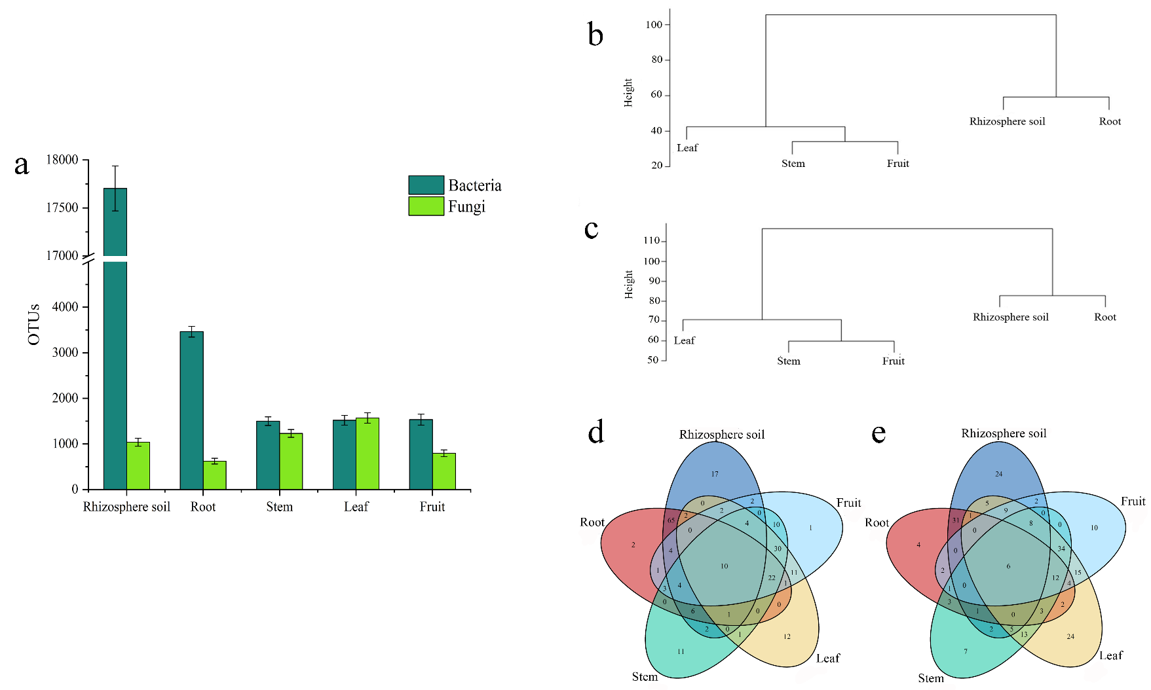
Fig. S1. OUTs statistical analysis of microorganisms in rhizosphere soil and different parts of S. sphenanthera. a: The number of OTUs, b and c: The cluster dendrogram of identified bacteria and fungi, d (Bacteria) and e (Fungi): Venn diagram analysis on OTUs.
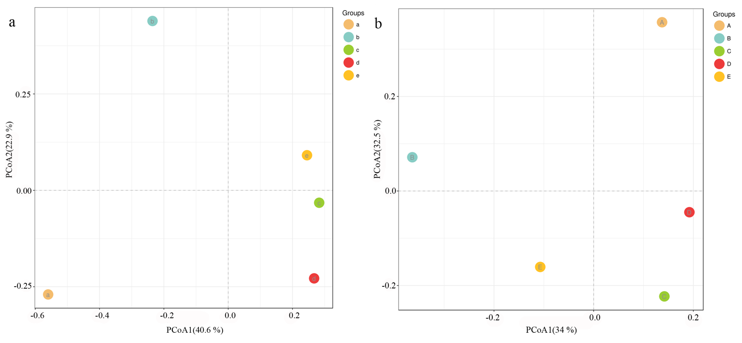
Fig. S2. The principal coordinate analysis of rhizosphere soil and different parts of S. sphenanthera. a: Bacteria. b: Fungi. a-e and A-E: Rhizosphere soil, Root, Stem, Leaf, and Fruit.
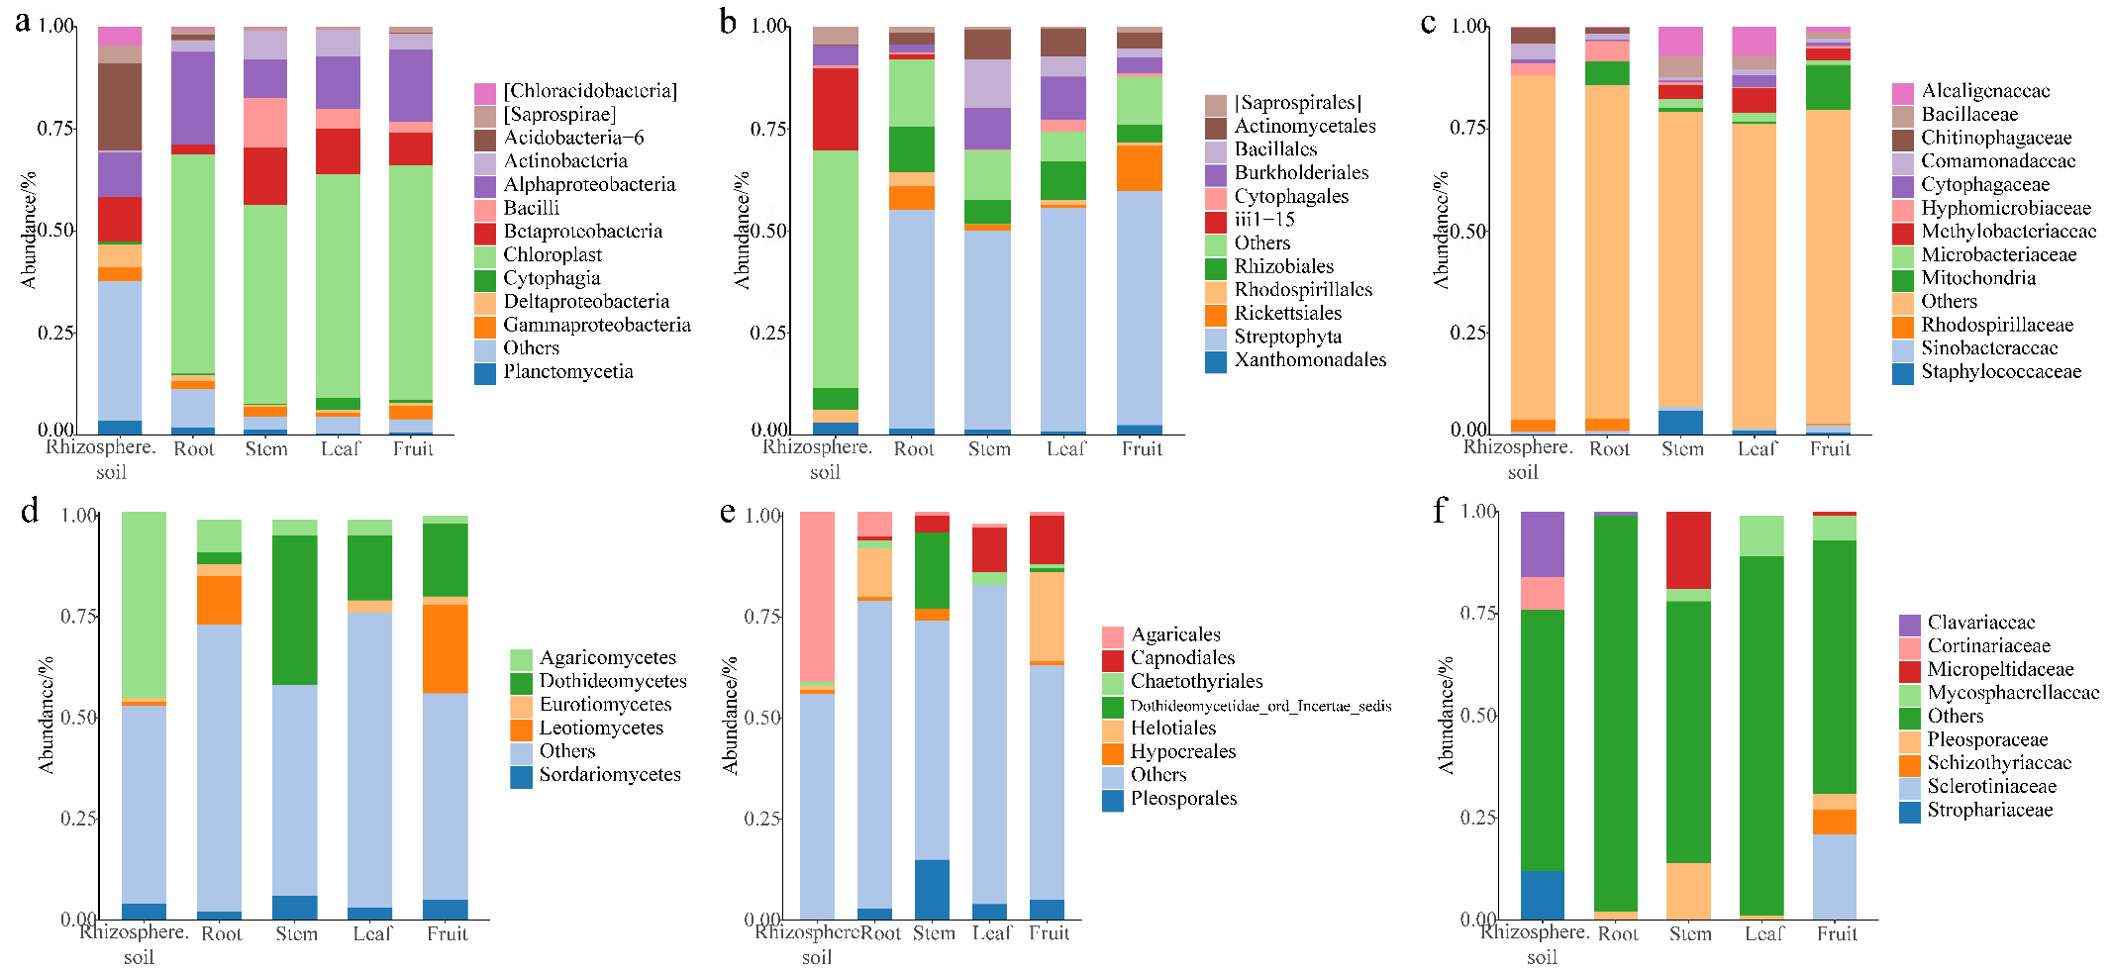
Fig. S3. Stack diagram of microorganisms in rhizosphere soil and different parts of S. sphenanthera. a-c: Class, Order, and Family of bacteria level. d-f: Class, Order, and Family of fungi level.

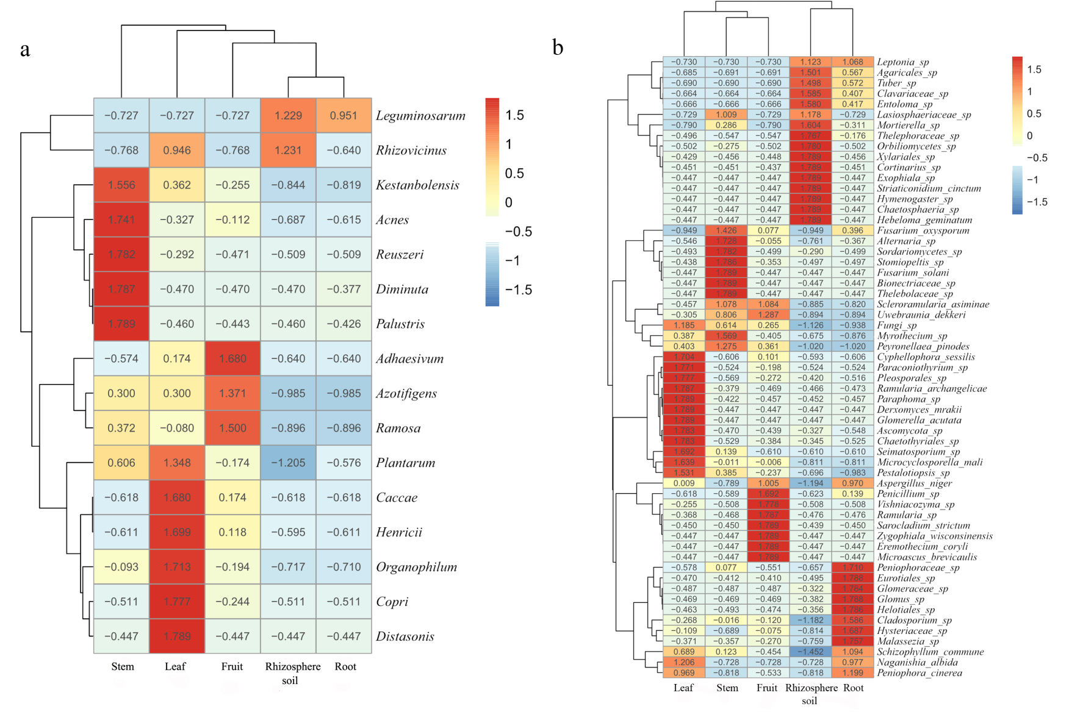
Fig. S4. Cluster heat map of relative abundance at the sample’s microbial species level. a: Bacteria. b: Fungi.
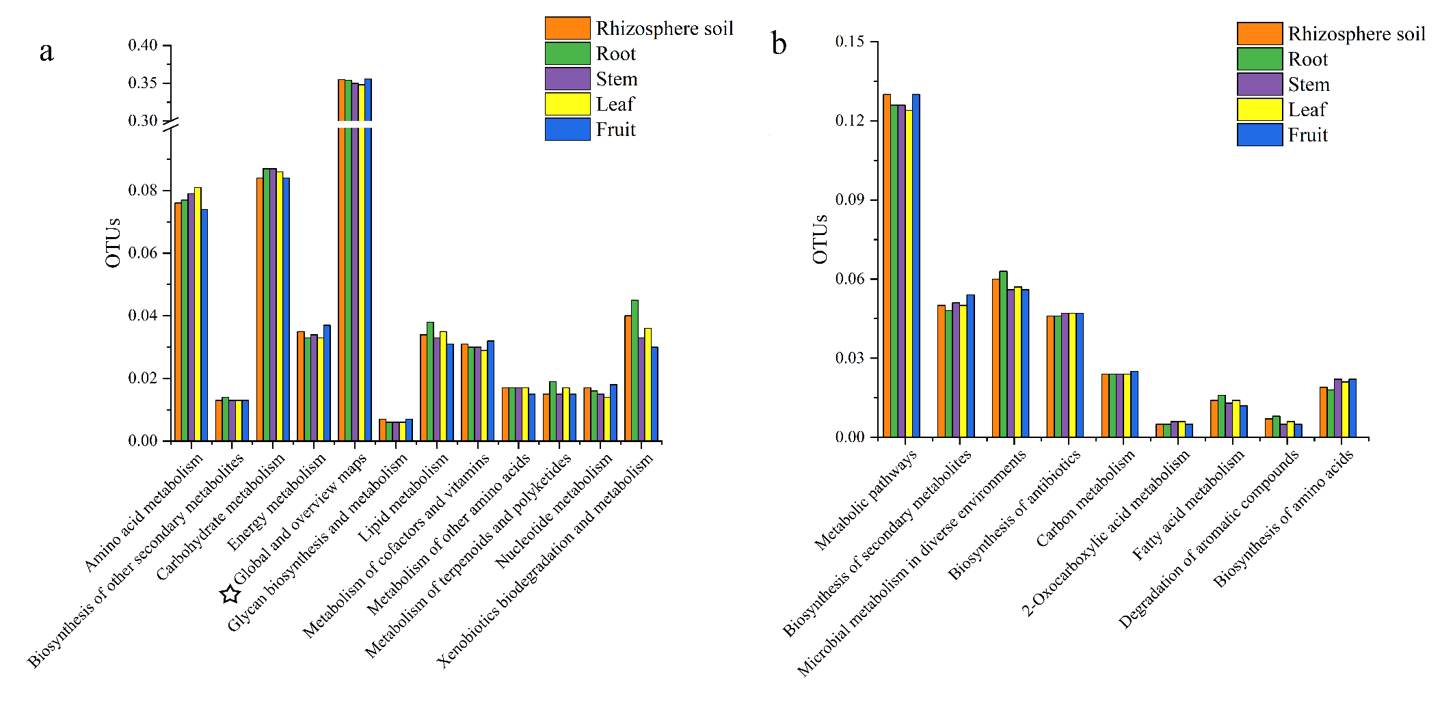
Fig. S5. Bacterial function annotation (a: metabolism, b: Global and overview maps) in rhizosphere soil and different parts of S. sphenanthera. The function marked by the five-pointed star in Figure a is the content shown in Figure b.
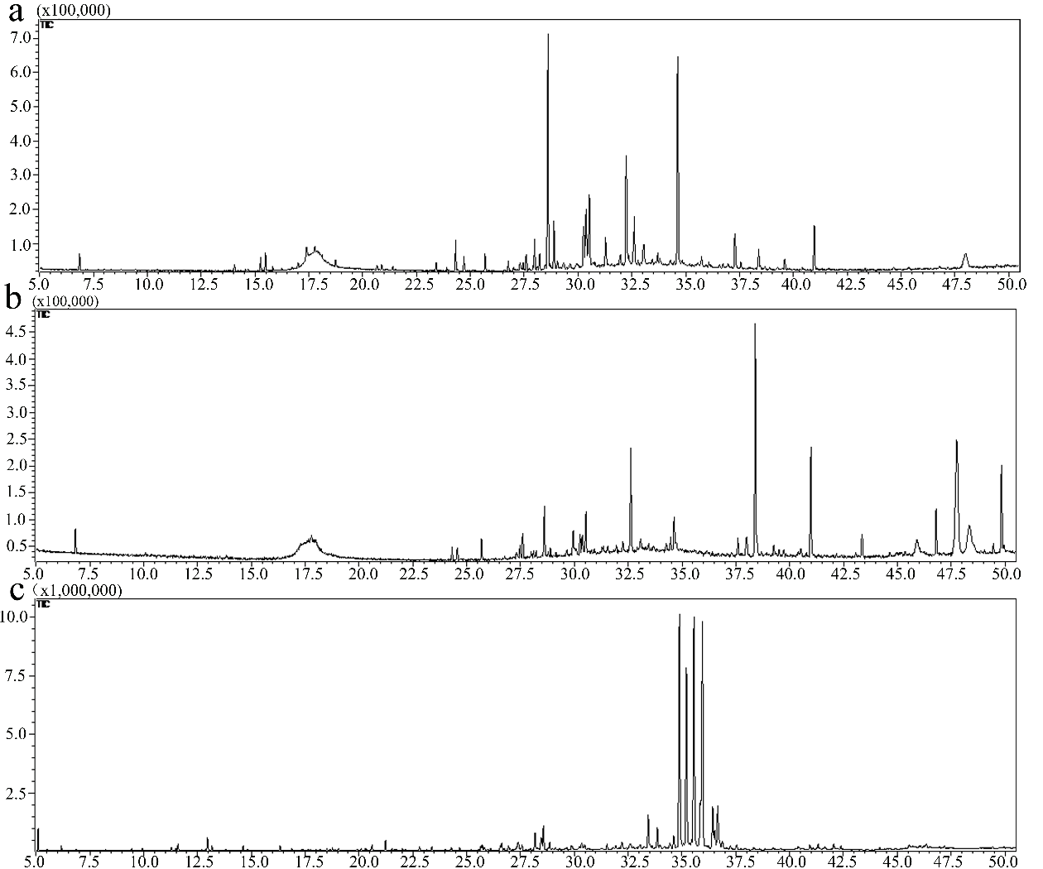
Fig. S6. The total ion chromatograms of the stem (A), leaf (B), and fruit (C) of S. sphenanthera under GC-MS.

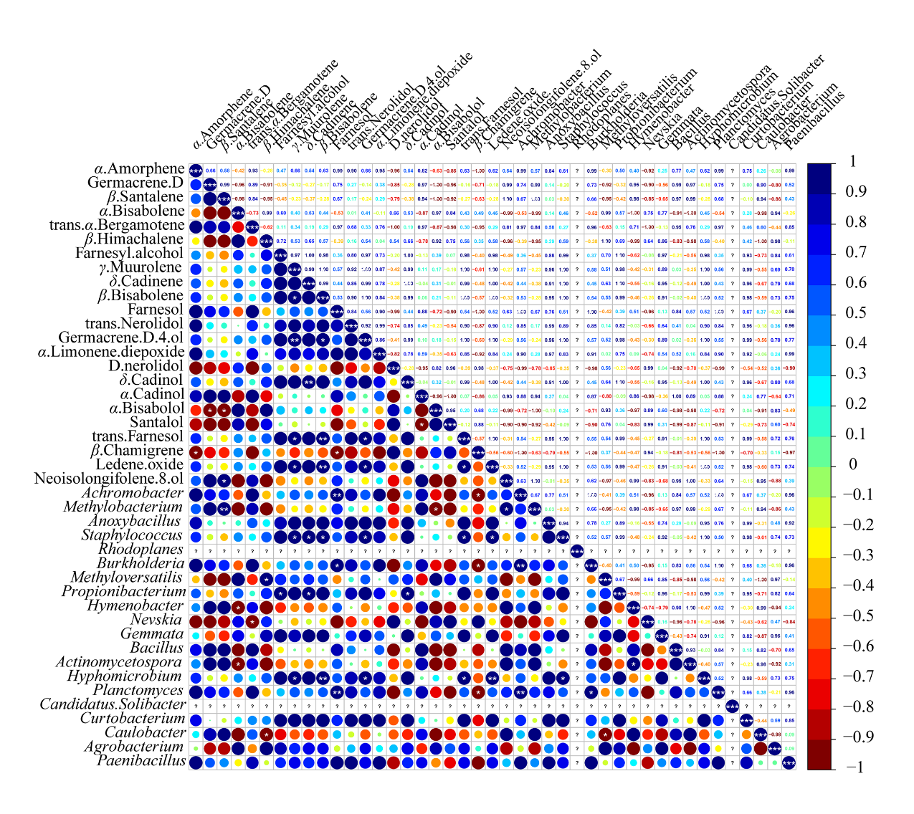
Fig. S7. Pearson correlations between the first 20 genera of bacterial and common chemical compositions of S. sphenanthera. The *, **, and *** mean significant correlation estimates at the level of 0.05, 0.01, and 0.001, respectively.
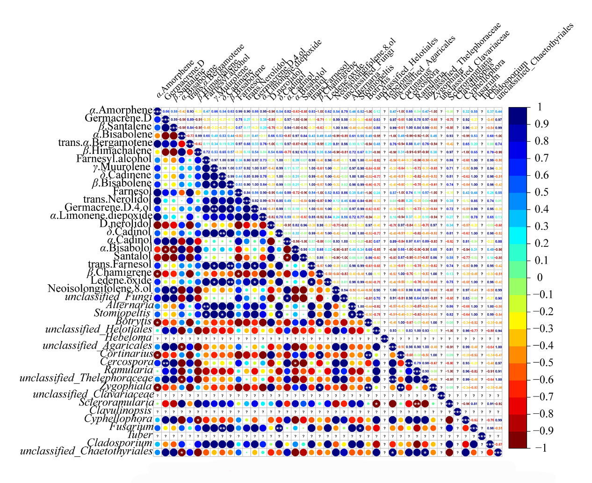
Fig. S8. Pearson correlations between the first 20 genera of fungal and common chemical compositions of S. sphenanthera. The *, **, and *** mean significant correlation estimates at the level of 0.05, 0.01, and 0.001, respectively.

