Supplementary Table 4. The conserved motifs based on the differentially expressed ERF genes.
Group IIa motifs |  | E-value
CM-1 |  | 1.6e-143
CM-2 |  | 6.2e-027
CM-3 |  | 2.2e-025
CM-4 |  | 1.2e-009
Group IIb motifs |  | E-value
CM-1 |  | 2.4e-181
CM-2 | 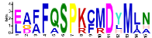 | 5.7e-022
CM-3 |  | 7.2e-019
CM-4 |  | 1.0e-013
Group IIIc motifs |  | E-value
CM-1 |  | 4.6e-207
CM-2 |  | 8.7e-080
CM-3 | 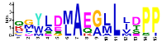 | 1.4e-024
CM-4 | 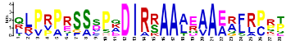 | 4.3e-032
Group IIId motifs |  | E-value
CM-1 |  | 3.5e-274
CM-2 |  | 9.3e-089
CM-3 |  | 1.3e-011
CM-4 |  | 1.8e-013
Group V motifs |  | E-value
CM-1 |  | 2.1e-105
CM-2 |  | 4.6e-007
CM-3 |  | 7.3e-007
CM-4 | 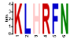 | 4.5e-001
Group VI motifs |  | E-value
CM-1 |  | 2.9e-073
CM-2 |  | 1.6e-013
CM-3 |  | 4.3e-011
CM-4 | 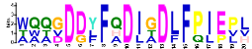 | 6.1e-010
Group VII |  | E-value
CM-1 |  | 1.1e-335
CM-2 |  | 5.3e-074
CM-3 |  | 1.1e-065
CM-4 |  | 3.1e-053
Group VIII motifs |  | E-value
CM-1 |  | 9.1e-101
CM-2 |  | 1.2e-011
CM-3 |  | 2.5e-011
CM-4 | 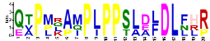 | 3.5e-006
Group IXa motifs |  | E-value
CM-1 |  | 8.5e-033
CM-2 |  | 5.7e-005
CM-3 |  | 4.3e-003
CM-4 |  | 3.8e+000
Group IXb & c motifs |  | E-value
CM-1 |  | 4.2e-296
CM-2 | 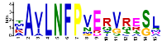 | 1.1e-042
CM-3 |  | 3.4e-042
CM-4 |  | 2.3e-027
Group X motifs |  | E-value
CM-1 |  | 1.4e-163
CM-2 | 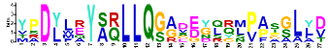 | 1.5e-018
CM-3 |  | 5.4e-014
CM-4 |  | 4.0e-011

