Supplementary Information for

Measuring multi-year changes in the Symbiodiniaceae algae in Caribbean corals on coral-depleted reefs

Ross Cunning¹, Elizabeth A. Lenz², Ruth D. Gates^{3*}, Peter J. Edmunds⁴

1 Daniel P. Haerther Center for Conservation and Research, John G. Shedd
Aquarium, 1200 South Lake Shore Drive, Chicago, IL 60605, USA
2 University of Hawaiʻi Sea Grant College Program, University of Hawai‘i at
Mānoa, 2525 Correa Rd Honolulu, HI, 96822, USA
3 Hawai’i Institute of Marine Biology, University of Hawai’i at Mānoa, 46-007
Lilipuna Rd Kāneʻohe, HI, 96744, USA
4 Department of Biology, California State University, 18111 Nordhoff Street,
Northridge, CA 91330-8303, USA
* Deceased

Supplementary Figures and Tables

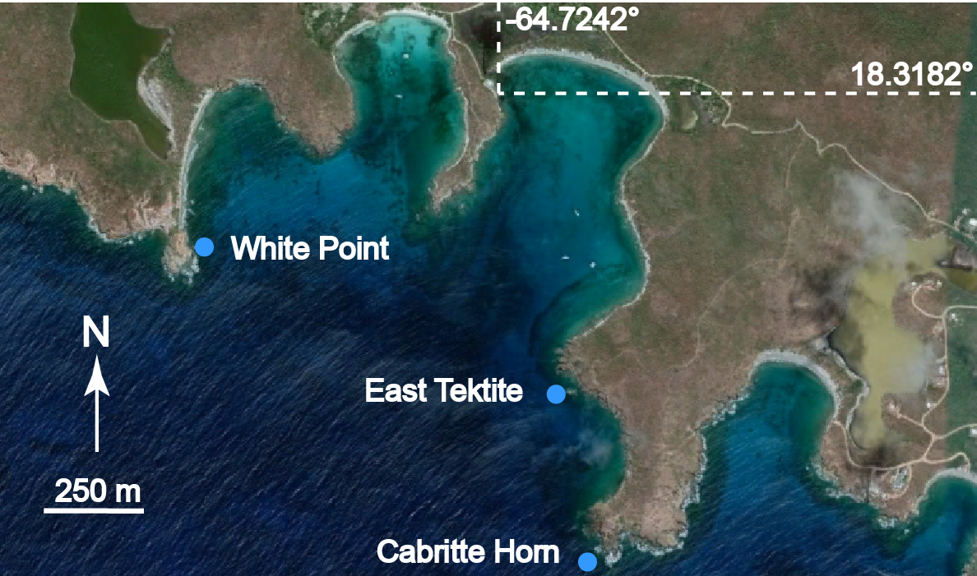
Map data ©2024 Google
Figure S1. Aerial image of the south shore of St. John showing the three study sites, White point, East Tektite, and Cabritte Horn. Dashed lines show latitude and longitude of the laboratory dock from which the fieldwork was staged. Map data ©2024 Google.

Table S1. Pairwise PERMANOVA tests for differences in composition of Breviolum sequence variants between host species. P-values were adjusted using the Benjamini-Hochberg method.

pairs | Df | SumsOfSqs | F.Model | R2 | p.value | p.adjusted | sig
franksi vs cavernosa | 1 | 0.79942217 | 2.95139717 | 0.37117969 | 0.028 | 0.042 | .
franksi vs siderea | 1 | 0.35606032 | 0.96830393 | 0.24400952 | 0.4 | 0.4
franksi vs strigosa | 1 | 0.45989451 | 2.24477147 | 0.11088154 | 0.053 | 0.07227273
franksi vs natans | 1 | 0.77125938 | 3.84385387 | 0.17596958 | 0.023 | 0.03833333 | .
franksi vs labrynthiformis | 1 | 0.75766371 | 4.64417294 | 0.17430351 | 0.003 | 0.00642857 | *
cavernosa vs siderea | 1 | 1.04683163 | 6.92700342 | 0.63393441 | 0.06666667 | 0.08333333
cavernosa vs strigosa | 1 | 2.22491103 | 13.2556755 | 0.41095638 | 0.001 | 0.0025 | *
cavernosa vs natans | 1 | 2.28688118 | 13.9578335 | 0.4235058 | 0.001 | 0.0025 | *
cavernosa vs labrynthiformis | 1 | 2.46808419 | 18.3679404 | 0.4440139 | 0.001 | 0.0025 | *
siderea vs strigosa | 1 | 0.21500379 | 1.2441047 | 0.06819215 | 0.235 | 0.27115385
siderea vs natans | 1 | 1.24926158 | 7.4209182 | 0.30387548 | 0.013 | 0.024375 | .
siderea vs labrynthiformis | 1 | 0.14720085 | 1.08871576 | 0.04928832 | 0.318 | 0.34071429
strigosa vs natans | 1 | 5.13199301 | 30.1526391 | 0.48513852 | 0.001 | 0.0025 | *
strigosa vs labrynthiformis | 1 | 1.15190092 | 7.6454951 | 0.17517261 | 0.001 | 0.0025 | *
natans vs labrynthiformis | 1 | 5.8302681 | 39.2476131 | 0.52157951 | 0.001 | 0.0025 | *
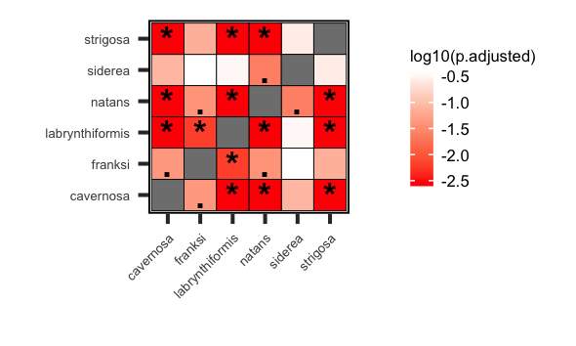
Figure S2. Heatmap showing pairwise comparisons (by PERMANOVA) in the composition of Breviolum sequences variants hosted by different coral species. Asterisks indicate adjusted p < 0.01, while periods indicate p < 0.05.
Table S2. Pairwise PERMANOVA tests for differences in composition of Cladocopium sequences between host species. P-values were adjusted by the Benjamini-Hochberg method.

pairs | Df | SumsOfSqs | F.Model | R2 | p.value | p.adjusted | sig
siderea vs faveolata | 1 | 5.92672023 | 111.698332 | 0.7827585 | 0.001 | 0.002 | *
siderea vs annularis | 1 | 5.33999542 | 75.4650298 | 0.71554552 | 0.001 | 0.002 | *
siderea vs franksi | 1 | 6.07694524 | 116.890054 | 0.79038482 | 0.001 | 0.002 | *
siderea vs cavernosa | 1 | 2.31164792 | 22.9082051 | 0.34757744 | 0.001 | 0.002 | *
siderea vs natans | 1 | 2.98742604 | 52.6742832 | 0.66112026 | 0.001 | 0.002 | *
siderea vs strigosa | 1 | 2.55418658 | 47.1185759 | 0.64441321 | 0.001 | 0.002 | *
siderea vs furcata | 1 | 2.54616633 | 31.2672399 | 0.55569173 | 0.001 | 0.002 | *
siderea vs labrynthiformis | 1 | 1.44960441 | 25.2604256 | 0.52341904 | 0.008 | 0.01107692 | .
faveolata vs annularis | 1 | 0.12498733 | 1.73426136 | 0.09257164 | 0.123 | 0.12651429
faveolata vs franksi | 1 | 0.10239761 | 2.58148565 | 0.12542757 | 0.053 | 0.06154839
faveolata vs cavernosa | 1 | 5.15598562 | 44.9461791 | 0.59971275 | 0.001 | 0.002 | *
faveolata vs natans | 1 | 3.2346539 | 71.4668459 | 0.83619379 | 0.001 | 0.002 | *
faveolata vs strigosa | 1 | 2.91788559 | 74.1239913 | 0.85078737 | 0.001 | 0.002 | *
faveolata vs furcata | 1 | 2.18935012 | 23.0831389 | 0.65795535 | 0.002 | 0.0036 | *
faveolata vs labrynthiformis | 1 | 1.47909556 | 35.030374 | 0.77792767 | 0.016 | 0.02057143 | .
annularis vs franksi | 1 | 0.16965587 | 2.41966046 | 0.12459849 | 0.072 | 0.07623529
annularis vs cavernosa | 1 | 4.66602369 | 34.5242168 | 0.54348119 | 0.001 | 0.002 | *
annularis vs natans | 1 | 3.01660007 | 35.277857 | 0.73072541 | 0.001 | 0.002 | *
annularis vs strigosa | 1 | 2.73986567 | 33.2199575 | 0.73463045 | 0.002 | 0.0036 | *
annularis vs furcata | 1 | 1.96416325 | 13.3688528 | 0.54860411 | 0.003 | 0.00469565 | *
annularis vs labrynthiformis | 1 | 1.40746282 | 14.0714045 | 0.60990671 | 0.026 | 0.03227586 | .
franksi vs cavernosa | 1 | 5.32226769 | 46.8478799 | 0.60961838 | 0.001 | 0.002 | *
franksi vs natans | 1 | 3.31599964 | 77.3171377 | 0.84668814 | 0.001 | 0.002 | *
franksi vs strigosa | 1 | 2.9932166 | 81.3157417 | 0.86216511 | 0.001 | 0.002 | *
franksi vs furcata | 1 | 2.19757974 | 23.8664391 | 0.66542539 | 0.003 | 0.00469565 | *
franksi vs labrynthiformis | 1 | 1.51369187 | 38.9108162 | 0.79554625 | 0.012 | 0.016 | .
cavernosa vs natans | 1 | 1.96410687 | 15.3451152 | 0.37114699 | 0.001 | 0.002 | *
cavernosa vs strigosa | 1 | 1.56090309 | 12.1718228 | 0.32744756 | 0.001 | 0.002 | *
cavernosa vs furcata | 1 | 2.24407663 | 14.0533372 | 0.3693063 | 0.001 | 0.002 | *
cavernosa vs labrynthiformis | 1 | 1.19463765 | 8.4332829 | 0.27710724 | 0.003 | 0.00469565 | *
natans vs strigosa | 1 | 0.01516977 | 0.342872 | 0.03669878 | 0.861 | 0.861
natans vs furcata | 1 | 1.82540253 | 14.2525961 | 0.64049139 | 0.008 | 0.01107692 | .
natans vs labrynthiformis | 1 | 1.17584219 | 22.8557396 | 0.7920691 | 0.044 | 0.0528
strigosa vs furcata | 1 | 1.72451471 | 13.3728901 | 0.65640614 | 0.005 | 0.0075 | *
strigosa vs labrynthiformis | 1 | 1.11663765 | 29.893555 | 0.85670706 | 0.057 | 0.064125
furcata vs labrynthiformis | 1 | 1.04038217 | 5.11759592 | 0.56128786 | 0.06666667 | 0.07272727

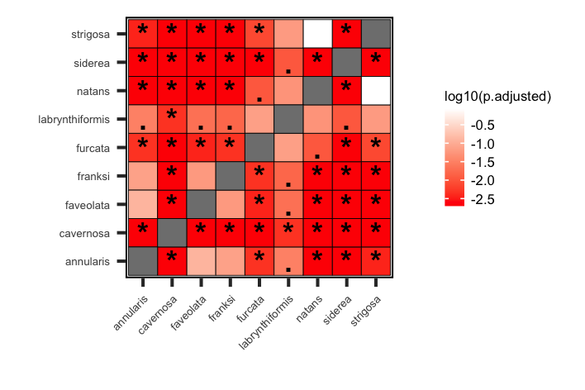
Figure S3. Heatmap showing pairwise comparisons (by PERMANOVA) in the composition of Cladocopium sequences variants hosted by different coral species. Asterisks indicate adjusted p < 0.01, while periods indicate p < 0.05.

