**Supplementary File 3**

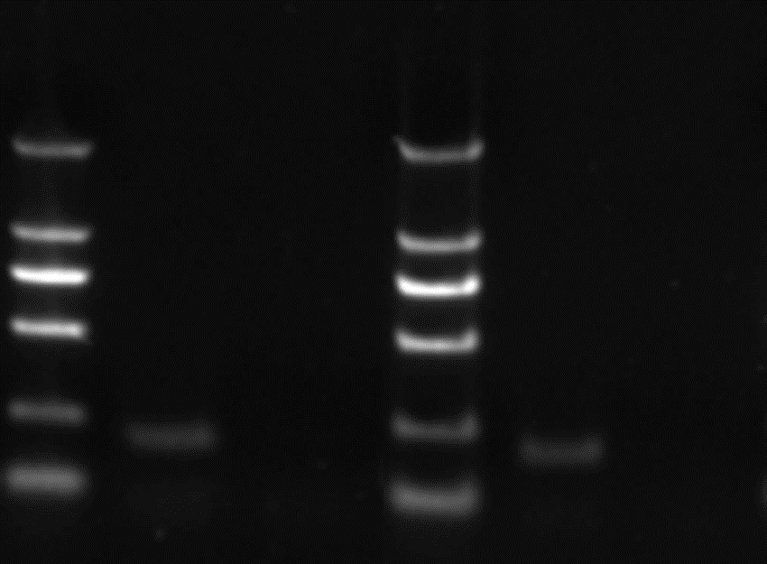

*PTPL1* methylation in DB and SU-DHL-4 cell lines detected by MSPCR.

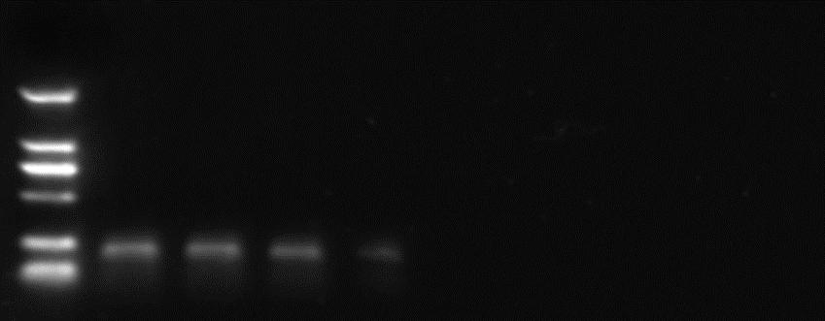

PTPL1 methylation in DB cells treated with different doses of arsenic disulfide detected by MSPCR.

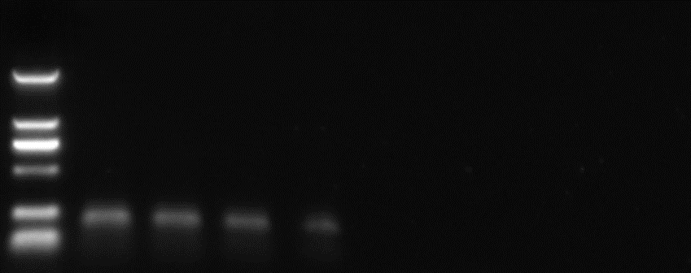

PTPL1 methylation in SU-DHL-4 cells treated with different doses of arsenic disulfide detected by MSPCR.