Supplementary materials
Current and future scenarios of suitability and expansion of cassava brown streak disease, Bemisia tabaci species complex, and cassava planting in Africa

Geofrey Sikazwe^{1,2,3}, Rosita E. E. Yocgo^{2,4}, Pietro Landi^{1,5}, David M. Richardson⁶, Cang Hui^{1,5,7}

¹Department of Mathematical Sciences, Stellenbosch University, Stellenbosch 7602, South Africa; ²African Institute for Mathematical Sciences, Kigali, Rwanda; ³Mkwawa University College of Education, P.O. Box 2513, Iringa, Tanzania. ⁴Institute for Plant Biotechnology, Stellenbosch University, Stellenbosch 7602, South Africa; ⁵National Institute for Theoretical and Computational Sciences, Stellenbosch University, Stellenbosch 7602, South Africa; ⁶Centre for Invasion Biology, Department of Botany and Zoology, Stellenbosch University, Stellenbosch 7602, South Africa; ⁷Mathematical Bioscience Unit, African Institute for Mathematical Sciences, Cape Town 7945, South Africa
Correspondence: geofrey@aims.ac.za

This supplementary document contains supporting information for model performance presented as ROC curves (Fig. A1) and uncertainty in predictive capacity of twelve SDMs (Fig. B1 & B2). It also contains information on the prediction of the current distribution for whitefly using bioclimatic variables and cassava harvested area (Fig. B3 A & B), prediction of the current distribution for cassava brown streak disease using bioclimatic variables and cassava harvested area (Fig. B3 C & D).
Moreover, the supplementary material presents information on the projection of the current and future cassava suitable habitats in Africa (Fig. C1 – C8), projection of the current and future habitats at risk of whitefly, Bemisia tabaci invasion in Africa using (Fig. D1 – D8) and projection of the current and future habitats at risk of cassava brown streak invasion in Africa (Fig. E1 – E8). The future distribution of each species was projected using seven GCMs (Table A1).

Model | Full name | Institute | Country | Reference
BCC-CSM2-MR | Beijing Climate Center Climate System  Model | Beijing Climate Center | China | (Wu et al., 2019)
CNRM-CM6-1 | National Center for Meteorological  Research Earth System Model version 6 | National Center for Meteorological Research | France | (Voldoire et al., 2019)
CNRM-ESM2-1 | National Center for Meteorological  Research Earth System Model version 2 | National Center for Meteorological Research | France | (Séférian et al., 2019)
CanESM5 | The Canadian Earth System Model version 5 | Canadian Centre for Climate Modelling | Canada | (Swart et al., 2019)
IPSL-CM6A-LR | Institut Pierre-Simon Laplace Climete Model | Institut Pierre-Simon Laplace | France | (Bonnet et al., 2021)
MIROC-ES2L | Model for Interdisciplinary Research  on Climate, Earth System version 2 | Japan Agency for Marine-Earth Science  and Technology | Japan | (Hajima et al., 2019)
MIROC6 | Model for Interdisciplinary Research  on Climate version 6 | Japan Agency for Marine-Earth Science  and Technology | Japan | (Tatebe et al., 2019)
MRI-ESM2-0 | The Meteorological Research Institute  Earth System Model Version 2 | Meteorological Research Institute | Japan | (Yukimoto et al., 2019)
Appendix A: List of Global Circulation Climate Models
Table A1: List of Global Circulation Climate Models (GCMs) used in the prediction the potential future distribution of Cassava, Whitefly (Bemisia tabaci) and Cassava brown streak disease in Africa.

Appendix B: Supplementary figures

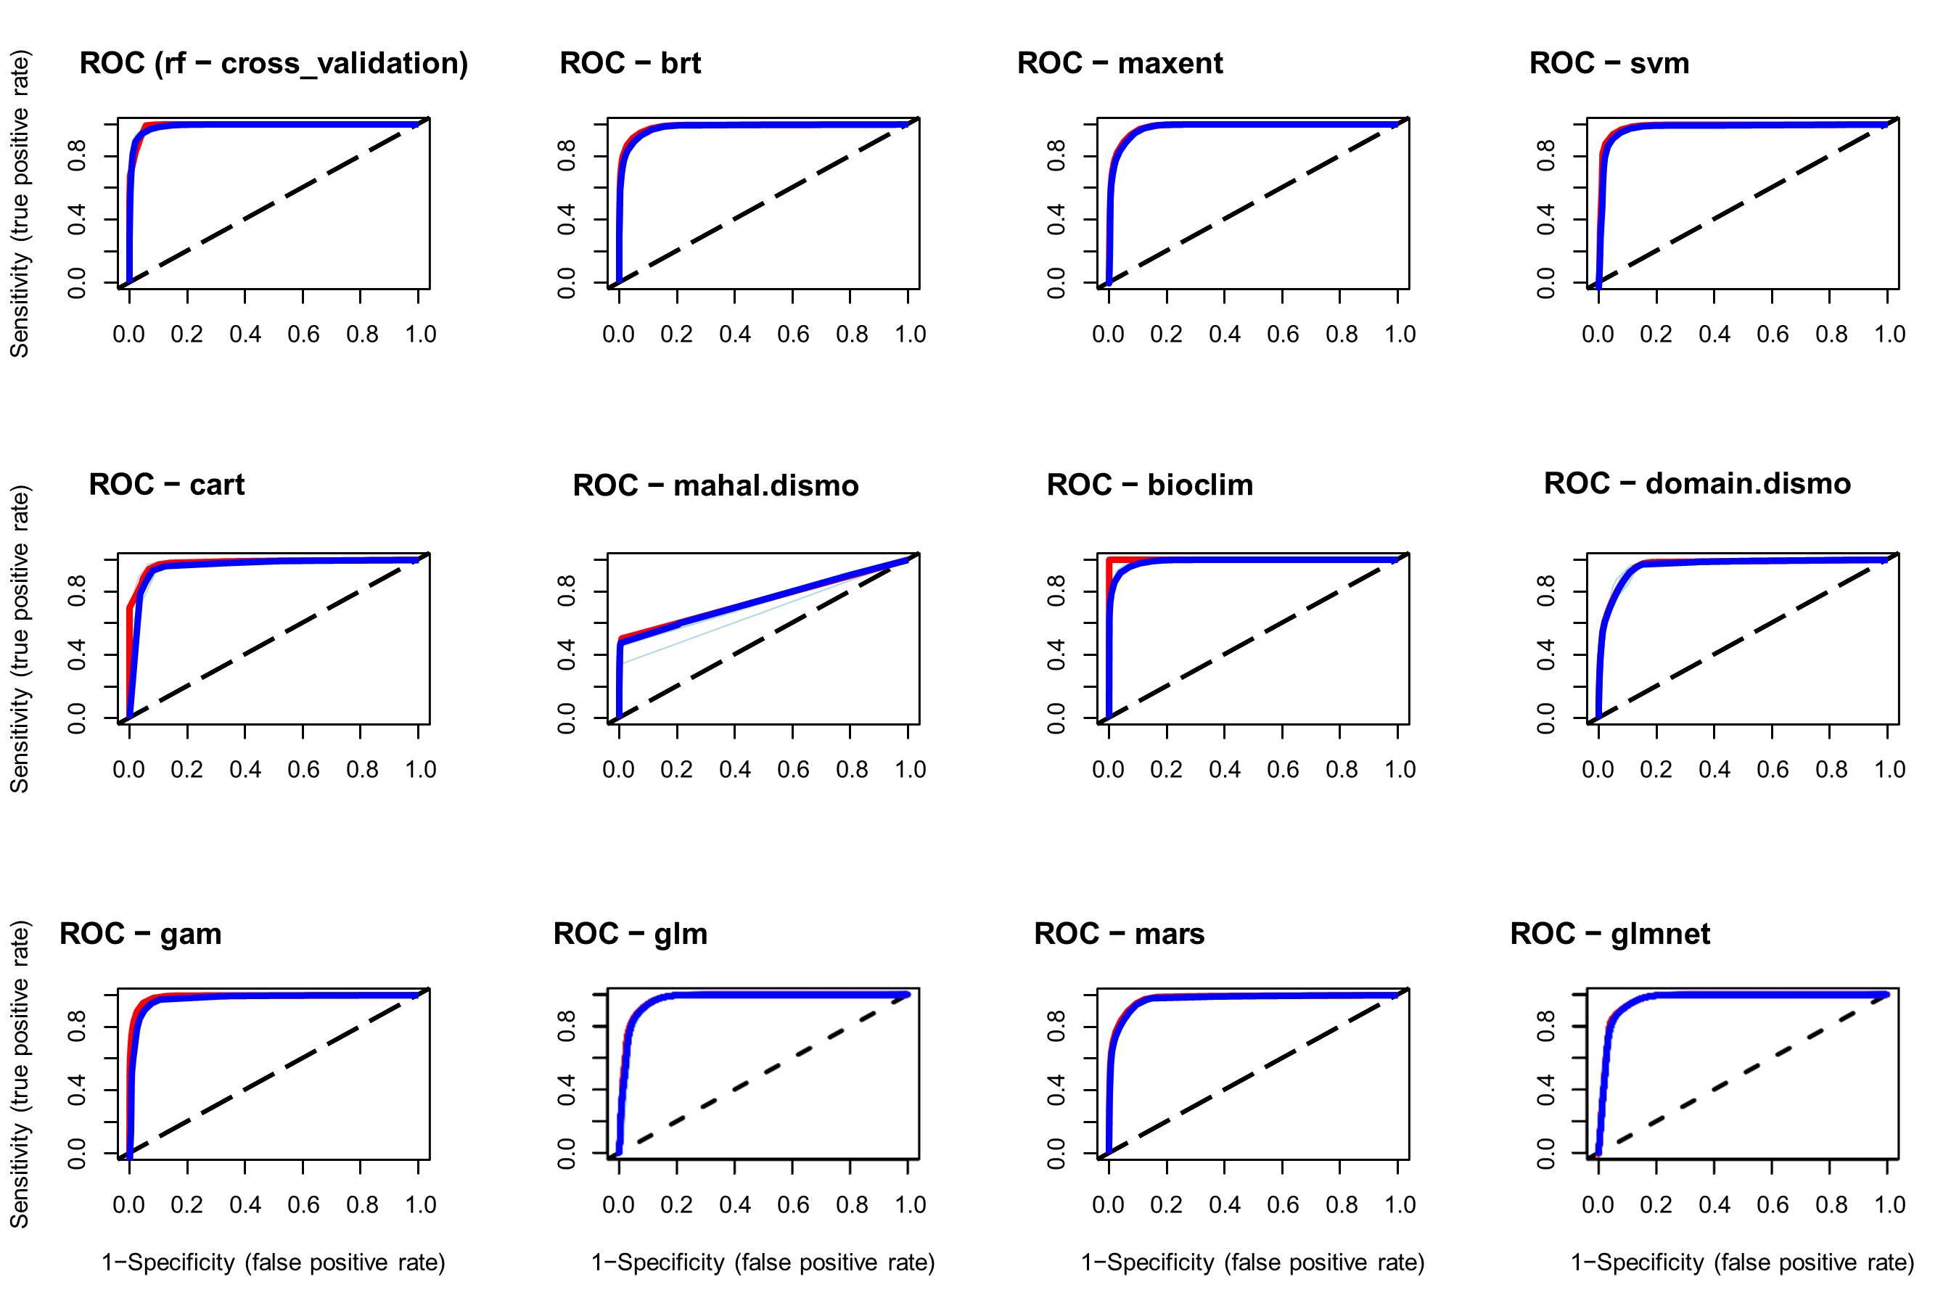
Figure B1. Receiver operating characteristic curve and AUC value under the current period (1970 - 2000) for cassava occurrence data.

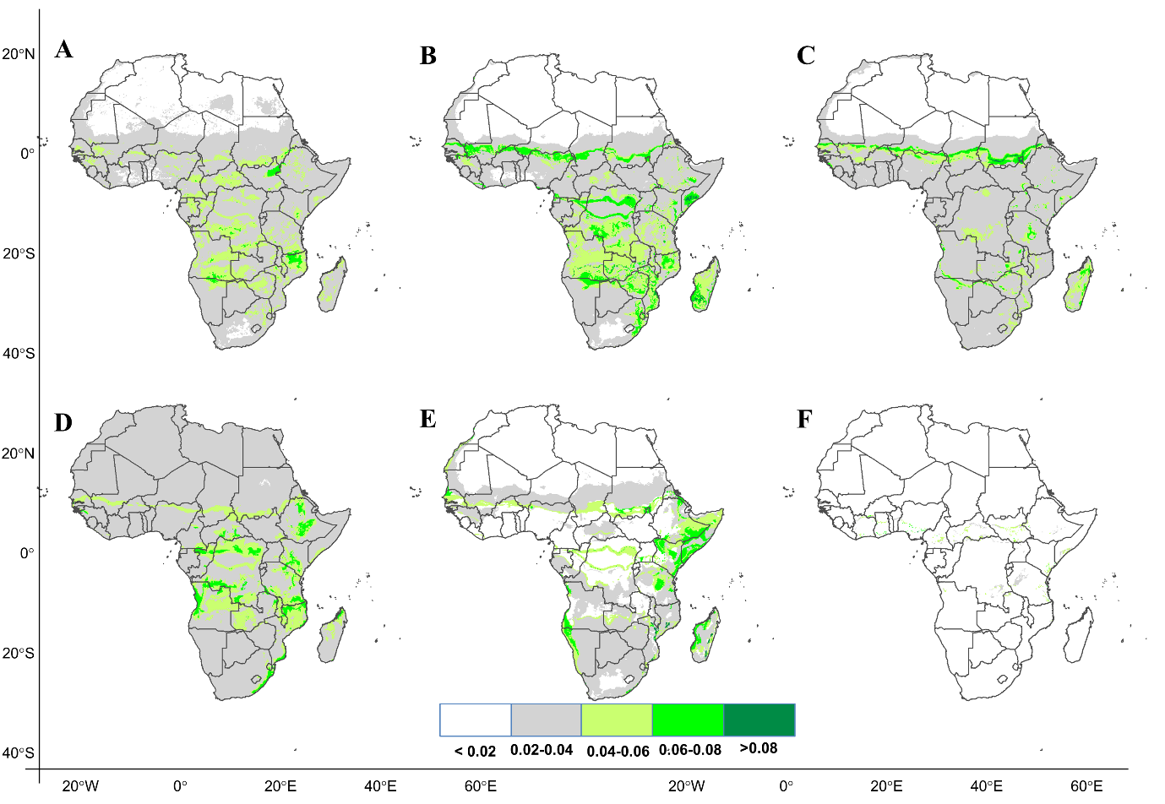
Figure B2. Comparison of predictive capacity of six models using cassava occurrence records. A) rf B) brt C) maxent D) svm E) cart and F) mahal.

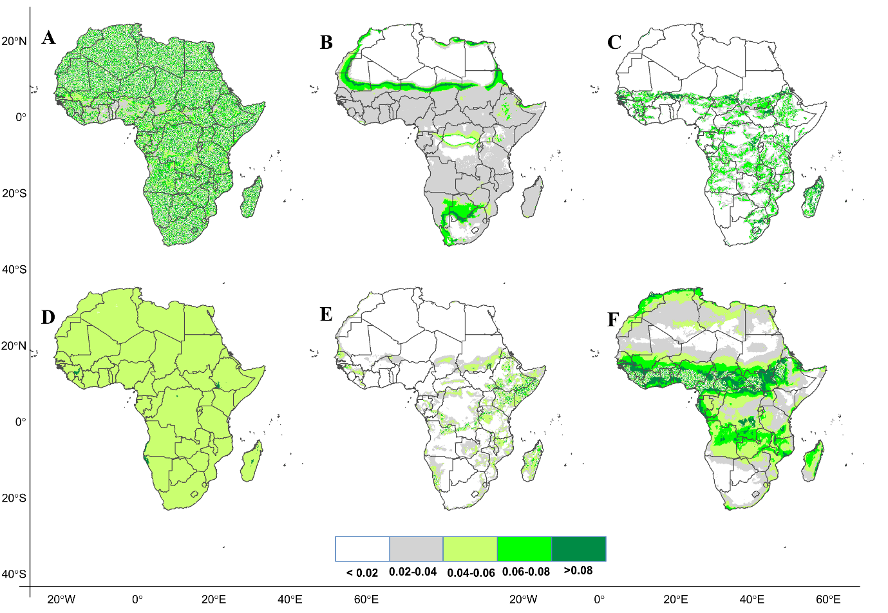
Figure B3. Comparison of predictive capacity of six models using cassava occurrence records. A) bioclim B) domain C) gam D) glm E) mars and F) glmnet.

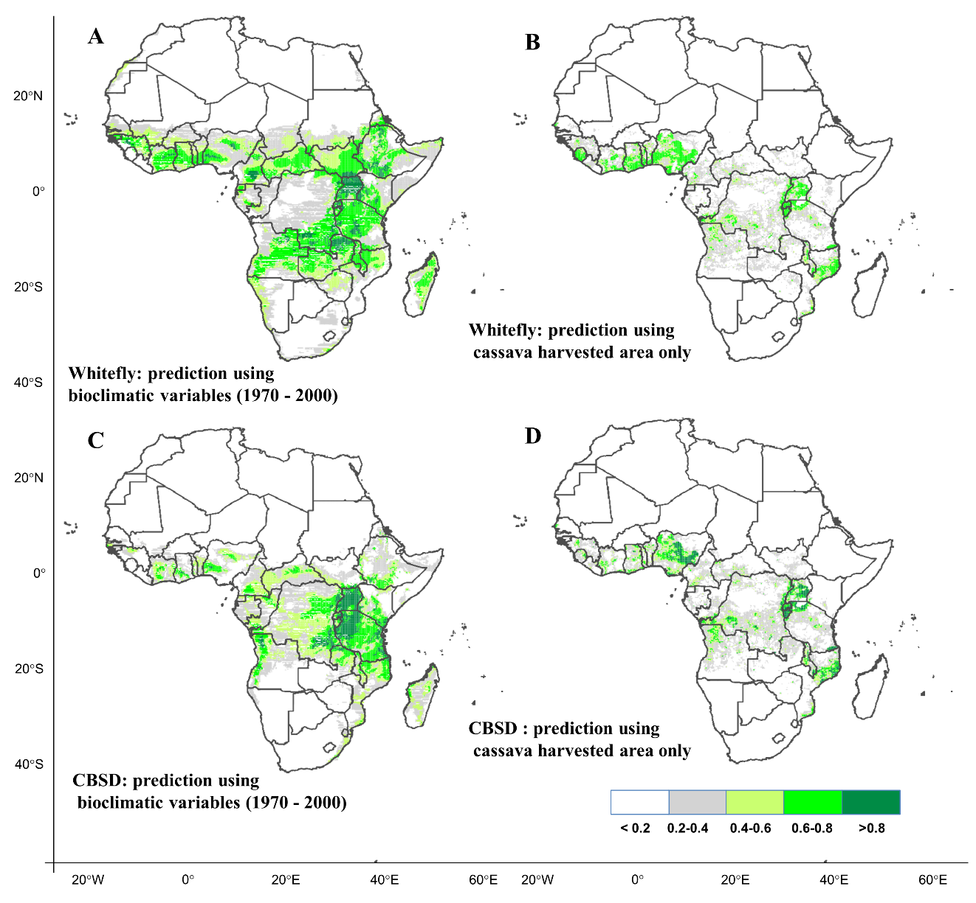
Figure B4. Predicted current distribution of whitefly, B. tabaci using A) bioclimatic variables B) using cassava harvested area. Predicted current distribution of cassava brown streak disease using C) bioclimatic variables and D) cassava harvested area and cassava suitability map.

Appendix C: Projection of the current and future cassava suitable habitats in Africa using eight GCMs.
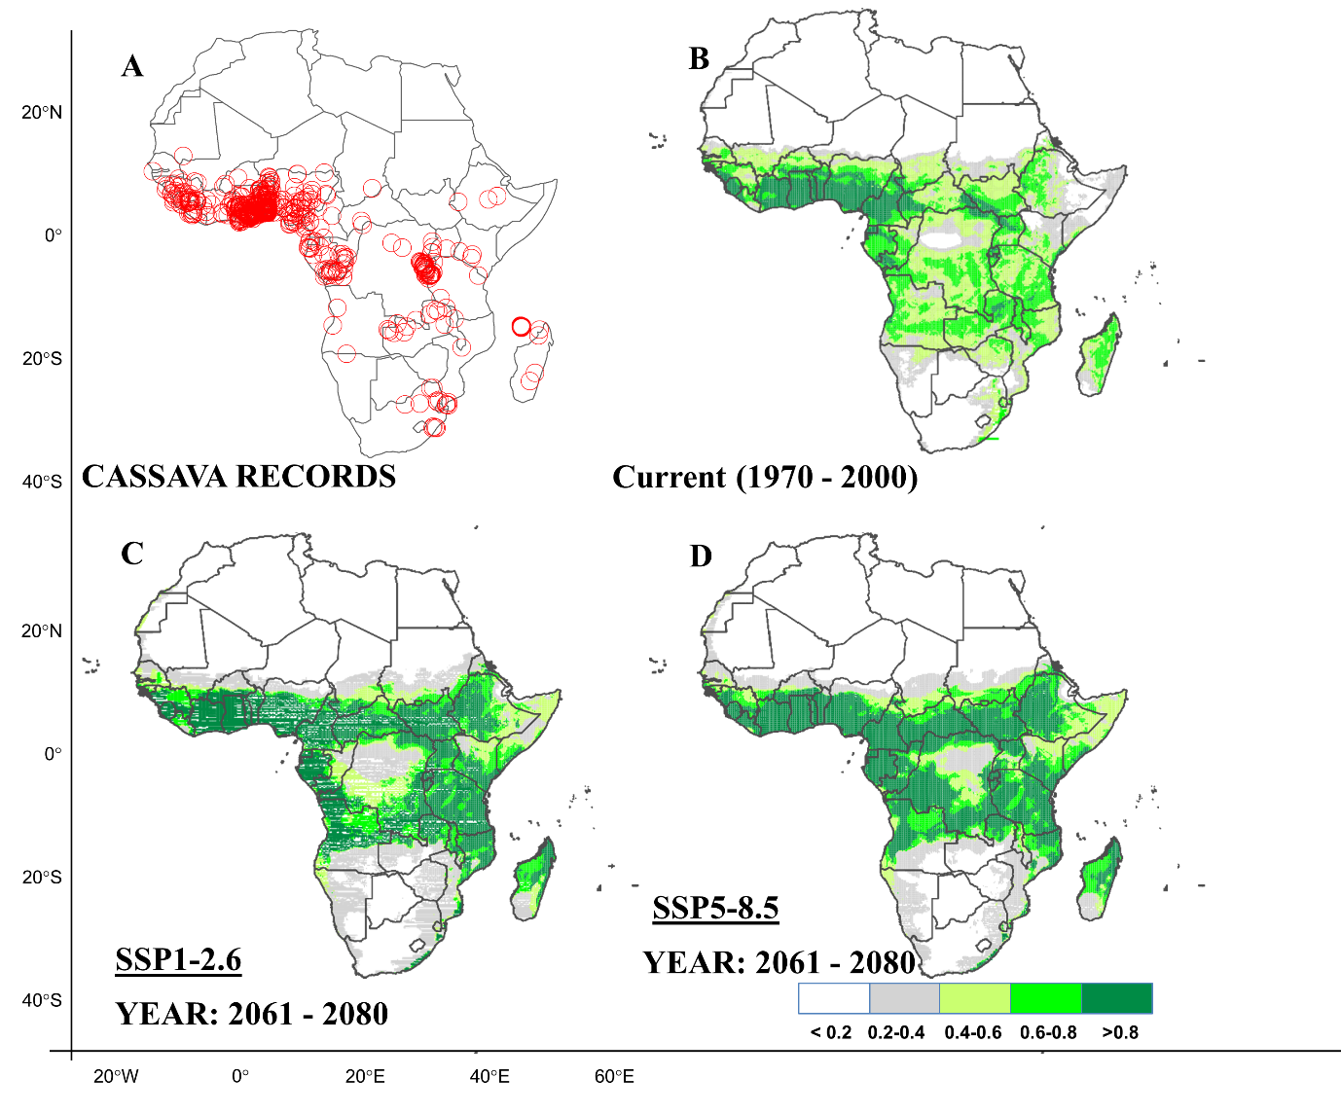
Figure C1: Current and future suitable habitats for cassava in Africa. Plots showing A) geolocations of cassava occurrence records provided by the global biodiversity information facility (GIBF; https://www.gbif.org), B) the predicted distribution for cassava under the current climate (1970-2000). Predicted future suitable habitats for cassava under C) the SSP1-2.6 scenario and D) the SSP5-8.5 scenario, using the BCC-CSM2-MR model for the year 2070s.
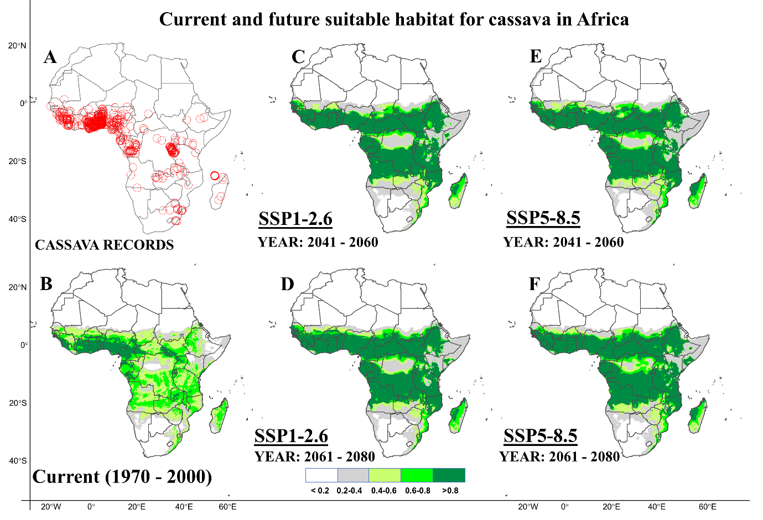
Figure C2: Current and future suitable habitats for cassava in Africa. Maps showing A) geolocations of cassava occurrence records provided by the global biodiversity information facility (GIBF; https://www.gbif.org), B) predicted spatial distribution of cassava under historical climate conditions (1970 - 2000). Future prediction of the suitable habitat under two shared social-economic pathways C) SSP1-2.6 (2050s), D) SSP1-2.6 (2070s), D) SSP5-8.5 and E) SSP5-8.5 using the MRI-ESM2-0 model.
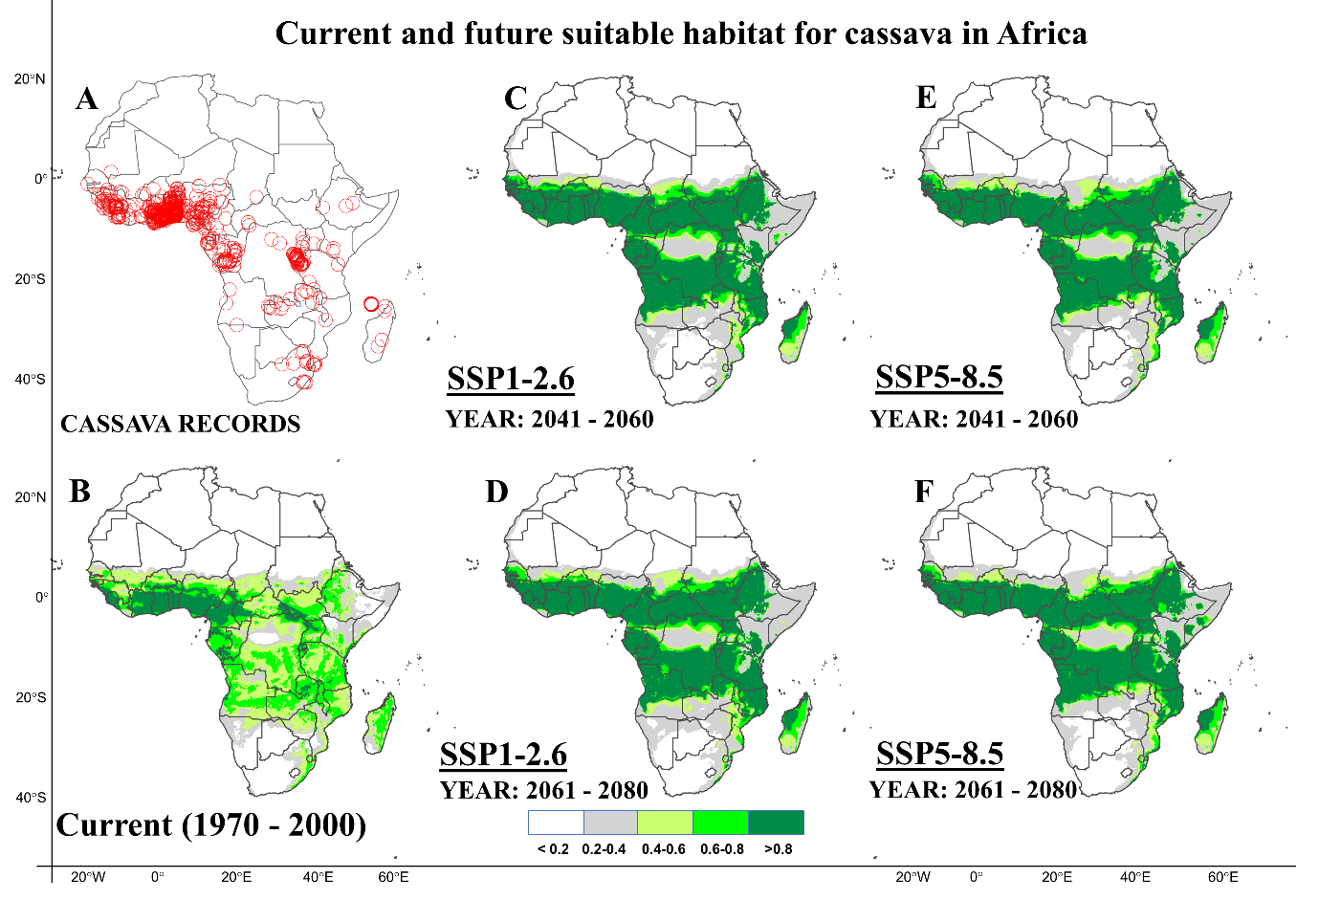
Figure C3: Current and future suitable habitats for cassava in Africa. Maps showing A) geolocations of cassava occurrence records provided by the global biodiversity information facility (GIBF; https://www.gbif.org), B) predicted spatial distribution of cassava under historical climate conditions (1970 - 2000). Future prediction of the suitable habitat under two shared social-economic pathways C) SSP1-2.6 (2050s), D) SSP1-2.6 (2070s), D) SSP5-8.5 and E) SSP5-8.5 using the MIROC-ES2L model.
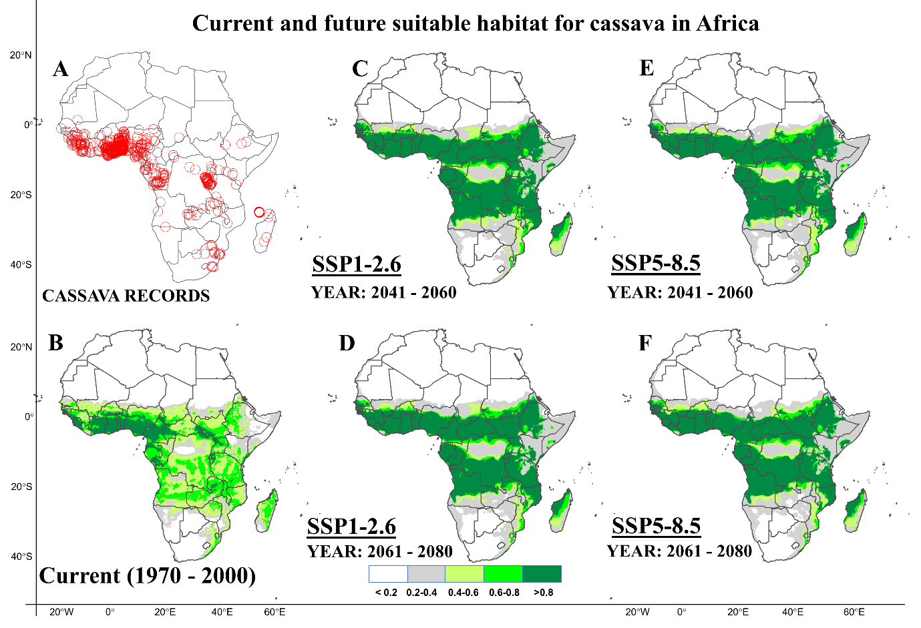
Figure C4: Current and future suitable habitats for cassava in Africa. Maps showing A) geolocations of cassava occurrence records provided by the global biodiversity information facility (GIBF; https://www.gbif.org), B) predicted spatial distribution of cassava under historical climate conditions (1970 - 2000). Future prediction of the suitable habitat under two shared social-economic pathways C) SSP1-2.6 (2050s), D) SSP1-2.6 (2070s), D) SSP5-8.5 and E) SSP5-8.5 using the MIROC6 model.
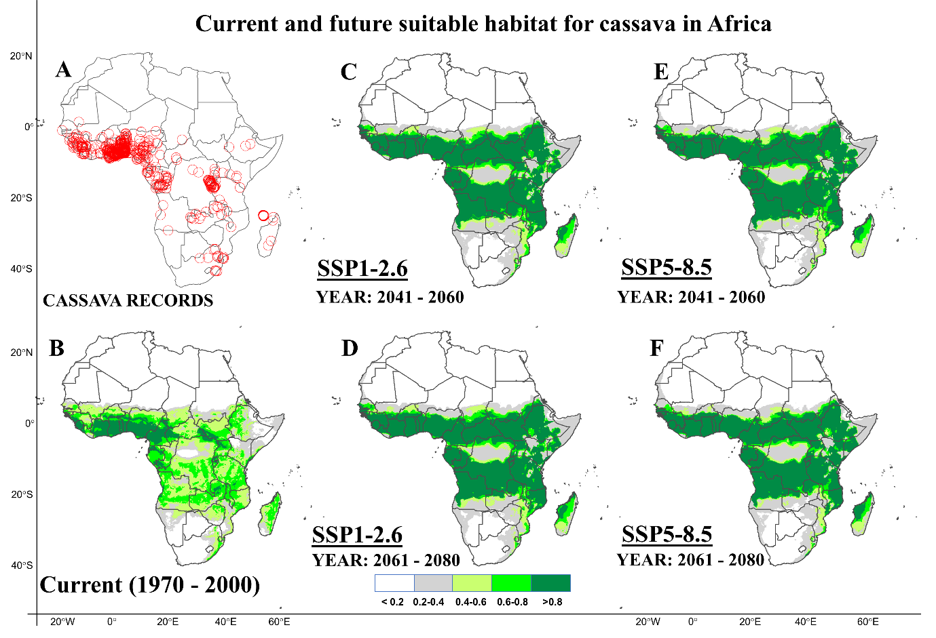
Figure C5: Current and future suitable habitats for cassava in Africa. Maps showing A) geolocations of cassava occurrence records provided by the global biodiversity information facility (GIBF; https://www.gbif.org), B) predicted spatial distribution of cassava under historical climate conditions (1970 - 2000). Future prediction of the suitable habitat under two shared social-economic pathways C) SSP1-2.6 (2050s), D) SSP1-2.6 (2070s), D) SSP5-8.5 and E) SSP5-8.5 using the IPSL-CM6A-LR model.
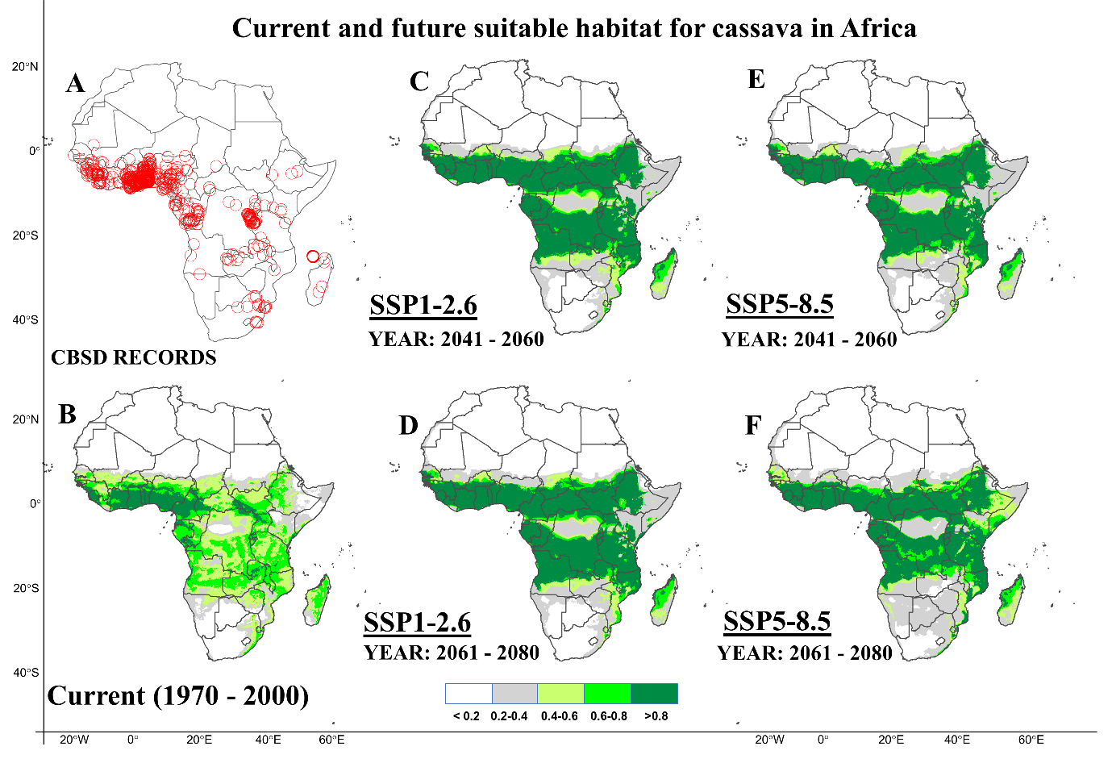
Figure C6: Current and future suitable habitats for cassava in Africa. Maps showing A) geolocations of cassava occurrence records provided by the global biodiversity information facility (GIBF; https://www.gbif.org), B) predicted spatial distribution of cassava under historical climate conditions (1970 - 2000). Future prediction of the suitable habitat under two shared social-economic pathways C) SSP1-2.6 (2050s), D) SSP1-2.6 (2070s), D) SSP5-8.5 and E) SSP5-8.5 using the CNRM-ESM2-1 model.
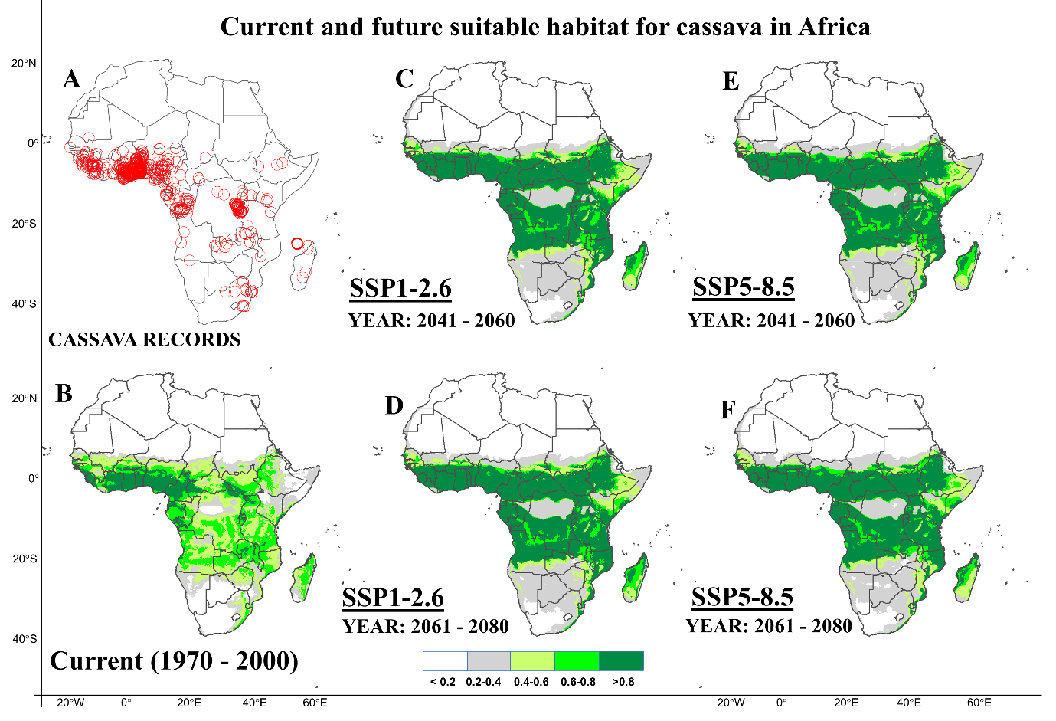
Figure C7: Current and future suitable habitats for cassava in Africa. Maps showing A) geolocations of cassava occurrence records provided by the global biodiversity information facility (GIBF; https://www.gbif.org), B) predicted spatial distribution of cassava under historical climate conditions (1970 - 2000). Future prediction of the suitable habitat under two shared social-economic pathways C) SSP1-2.6 (2050s), D) SSP1-2.6 (2070s), D) SSP5-8.5 and E) SSP5-8.5 using the CNRM-CM6-1 model.
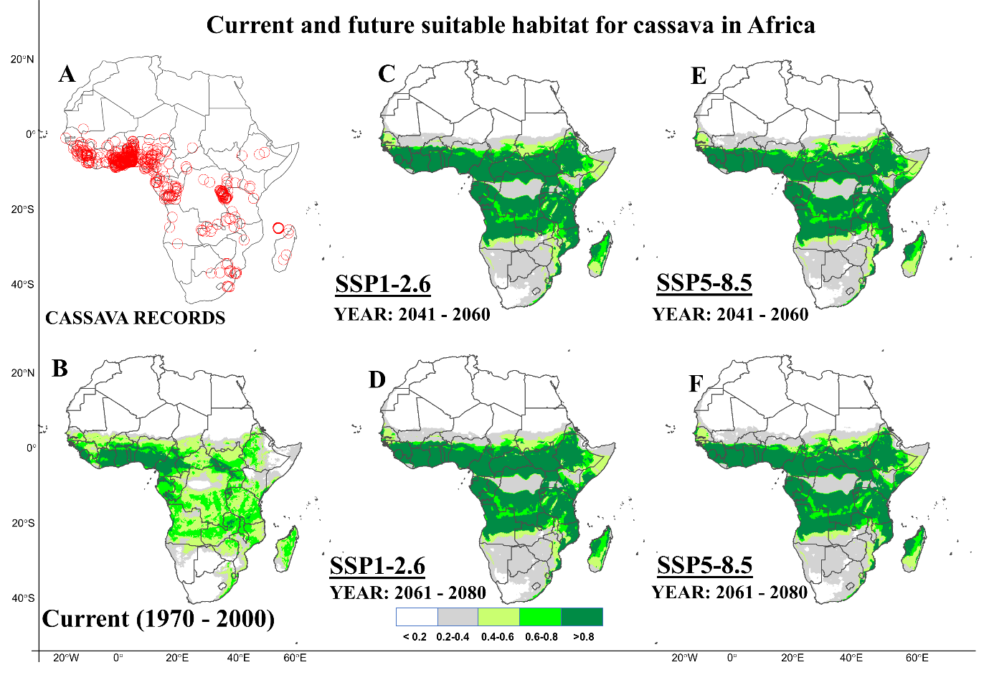
Figure C8: Current and future suitable habitats for cassava in Africa. Maps showing A) geolocations of cassava occurrence records provided by the global biodiversity information facility (GIBF; https://www.gbif.org), B) predicted spatial distribution of cassava under historical climate conditions (1970 - 2000). Future prediction of the suitable habitat under two shared social-economic pathways C) SSP1-2.6 (2050s), D) SSP1-2.6 (2070s), D) SSP5-8.5 and E) SSP5-8.5 using the CanESM5 model.

Appendix D: Projection of the current and future habitats at risk of whitefly, Bemisia tabaci invasion in Africa using eight GCM models.
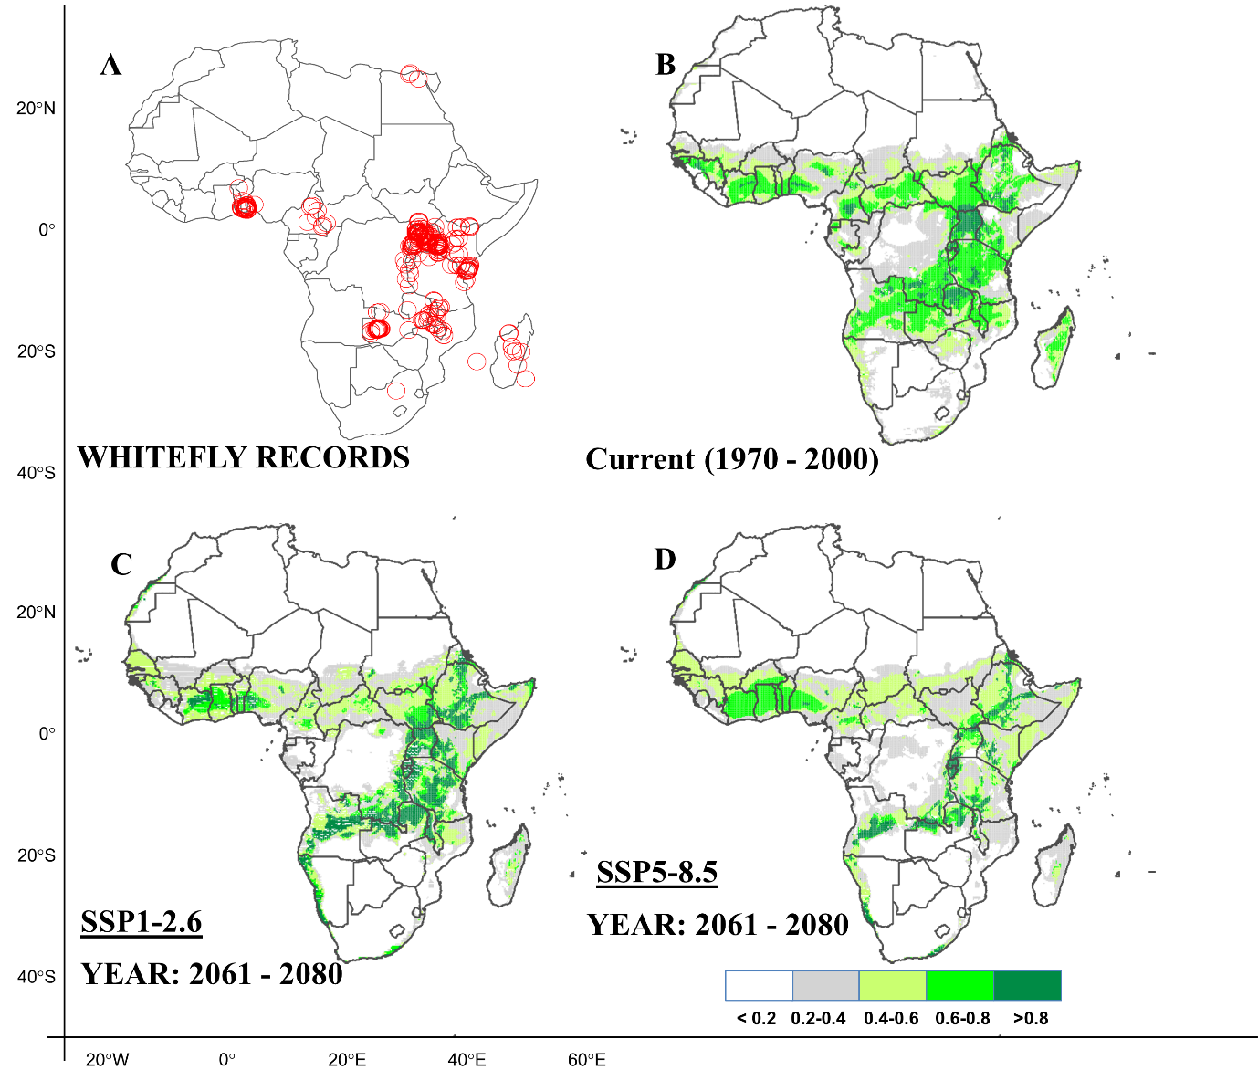
Figure D1: Current and future suitable habitats for whitefly in Africa. Plots showing A) geolocations of whitefly occurrence records provided by the global biodiversity information facility (GIBF; https://www.gbif.org) and B) the predicted distribution for whitefly under the current climate (1970-2000). Predicted future suitable habitats for whitefly under C) the SSP1-2.6 scenario and D) the SSP5-8.5 scenario, using the BCC-CSM2-MR model for the year 2070s. The figures for the SSP1-2.6 and SSP5-8.5 scenarios for the year 2050s are presented in Fig. 3 of the main text.

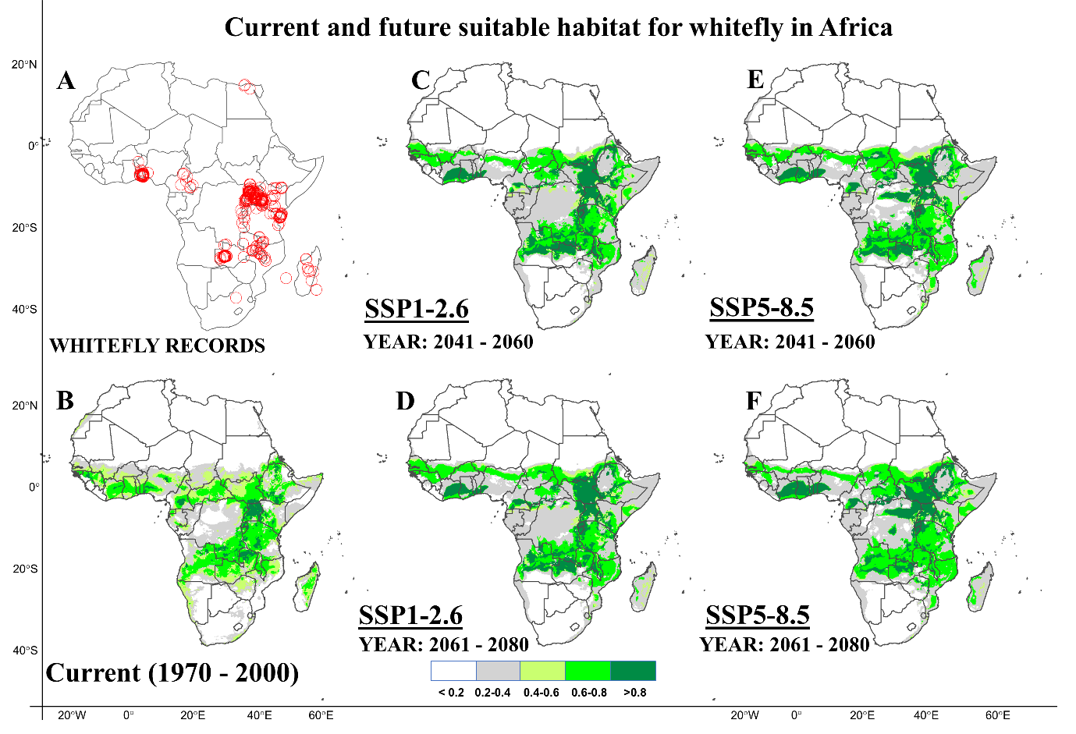
Figure D2: Current and future suitable habitats for whitefly in Africa. Maps showing A) geolocations of whitefly, B. tabaci occurrence records provided by the global biodiversity information facility (GIBF; https://www.gbif.org), B) predicted spatial distribution for whitefly under historical climate conditions. Future prediction of suitable habitats for whitefly under two shared social-economic pathways C) SSP1-2.6 (2050s), D) SSP1-2.6 (2070s), E) SSP5-8.5 (2050s) and F) SSP5-8.5 (2070s) using the MRI-ESM2-0 model.
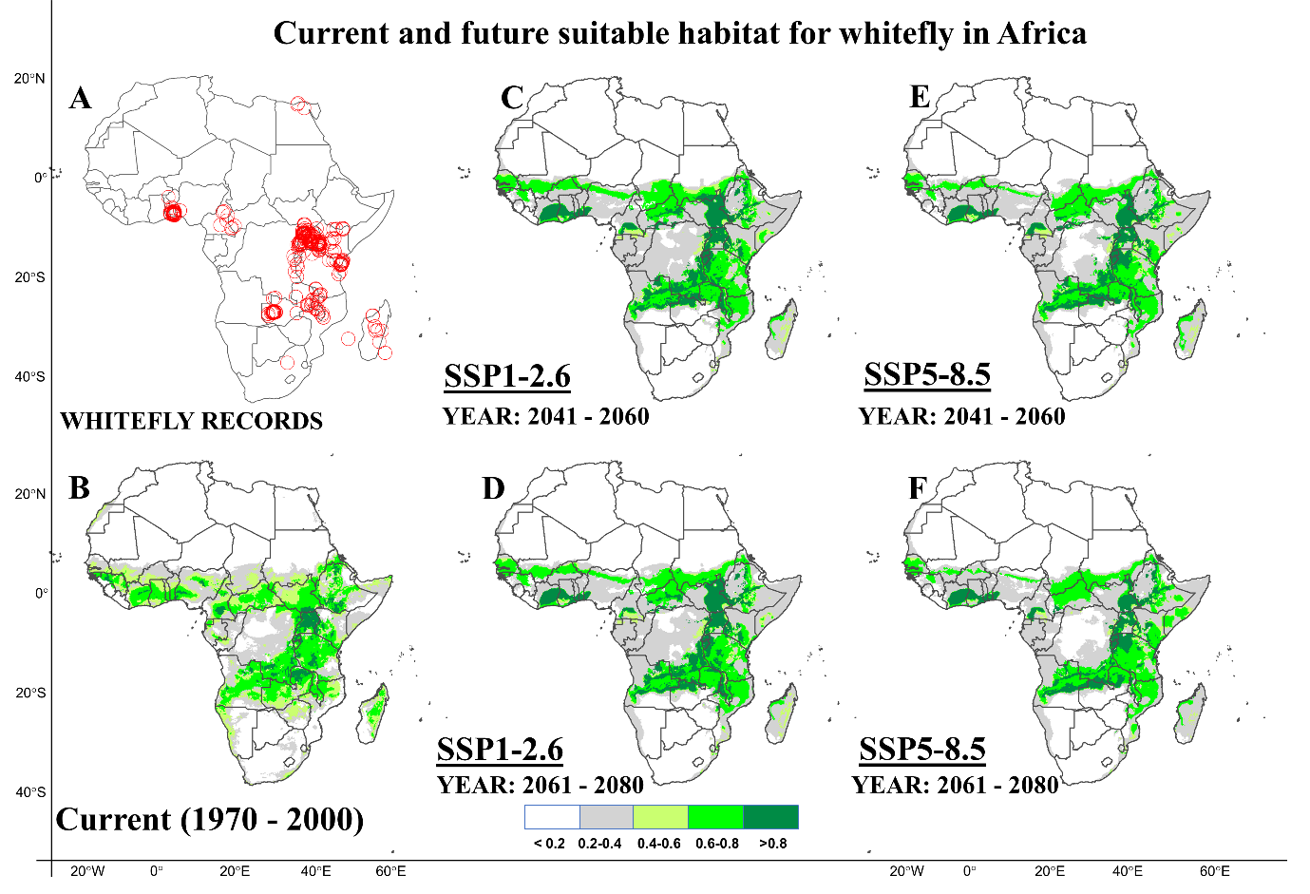
Figure D3: Current and future suitable habitats for whitefly in Africa. Maps showing A) geolocations of whitefly, B. tabaci occurrence records provided by the global biodiversity information facility (GIBF; https://www.gbif.org), B) predicted spatial distribution for whitefly under historical climate conditions. Future prediction of suitable habitats for whitefly under two shared social-economic pathways C) SSP1-2.6 (2050s), D) SSP1-2.6 (2070s), E) SSP5-8.5 (2050s) and F) SSP5-8.5 (2070s) using the MIROC-ES2L model.
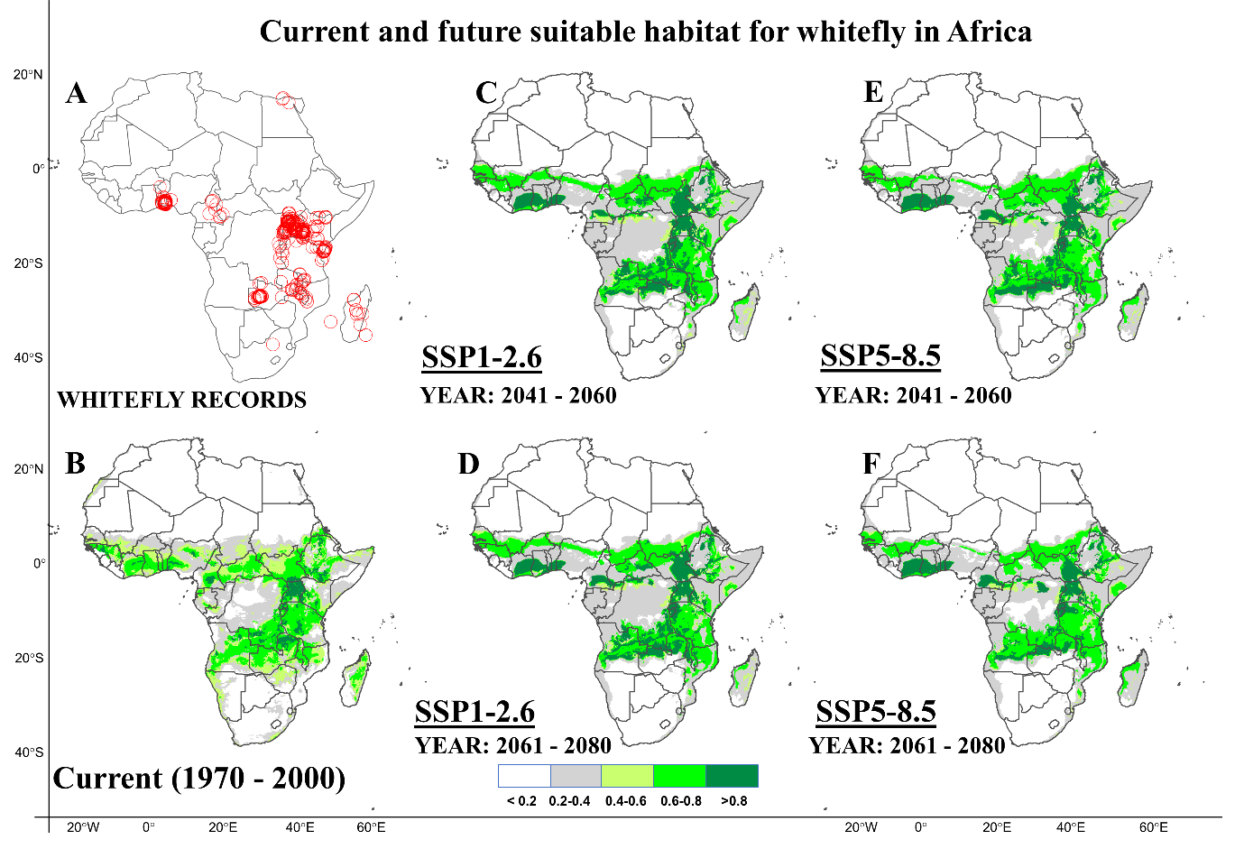
Figure D4: Current and future suitable habitats for whitefly in Africa. Maps showing A) geolocations of whitefly, B. tabaci occurrence records provided by the global biodiversity information facility (GIBF; https://www.gbif.org), B) predicted spatial distribution for whitefly under historical climate conditions. Future prediction of suitable habitats for whitefly under two shared social-economic pathways C) SSP1-2.6 (2050s), D) SSP1-2.6 (2070s), E) SSP5-8.5 (2050s) and F) SSP5-8.5 (2070s) using the MIROC6 model.
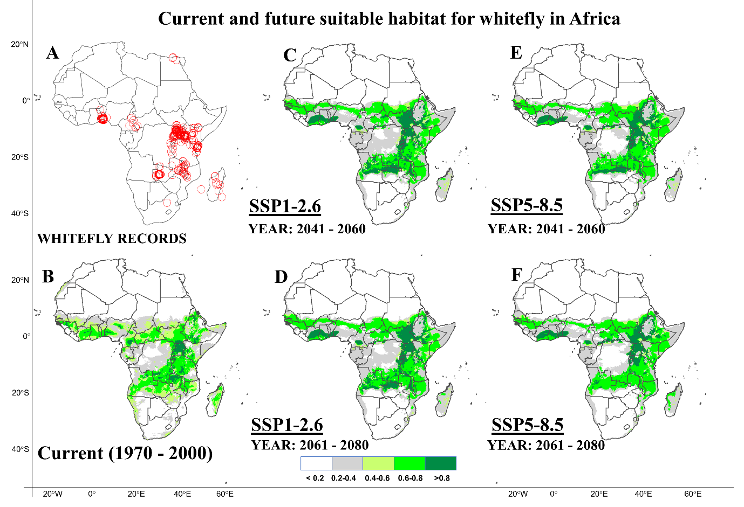
Figure D5: Current and future suitable habitats for whitefly in Africa. Maps showing A) geolocations of whitefly, B. tabaci occurrence records provided by the global biodiversity information facility (GIBF; https://www.gbif.org), B) predicted spatial distribution for whitefly under historical climate conditions. Future prediction of suitable habitats for whitefly under two shared social-economic pathways C) SSP1-2.6 (2050s), D) SSP1-2.6 (2070s), E) SSP5-8.5 (2050s) and F) SSP5-8.5 (2070s) using the IPSL-CM6A-LR model.
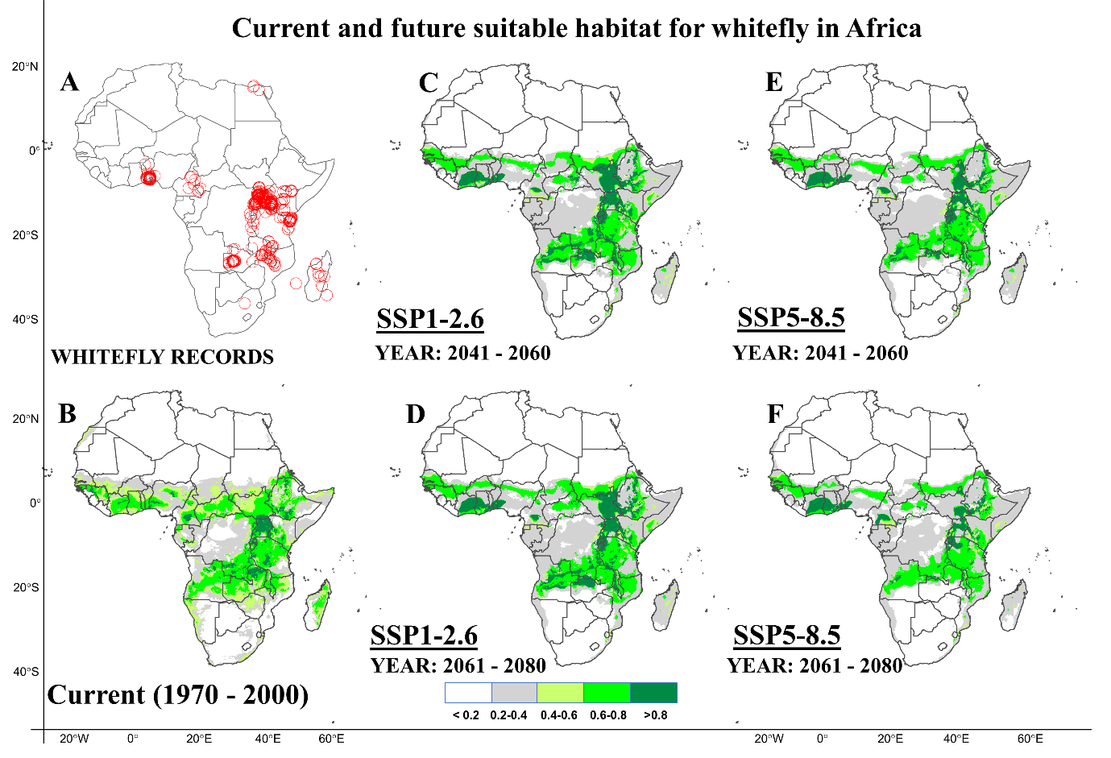
Figure D6: Current and future suitable habitats for whitefly in Africa. Maps showing A) geolocations of whitefly, B. tabaci occurrence records provided by the global biodiversity information facility (GIBF; https://www.gbif.org), B) predicted spatial distribution for whitefly under historical climate conditions. Future prediction of suitable habitats for whitefly under two shared social-economic pathways C) SSP1-2.6 (2050s), D) SSP1-2.6 (2070s), E) SSP5-8.5 (2050s) and F) SSP5-8.5 (2070s) using the CNRM-ESM2-1 model.
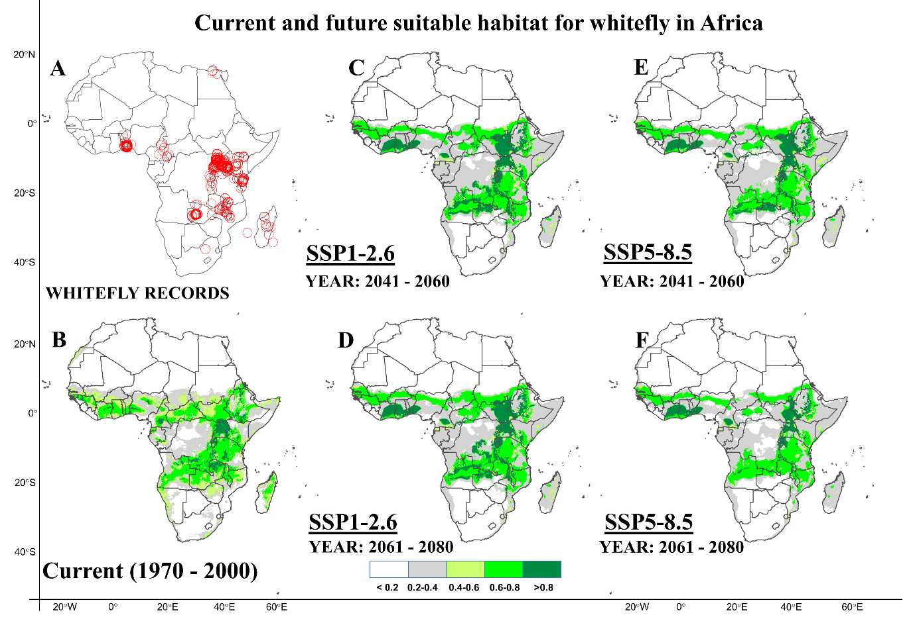
Figure D7. Current and future suitable habitats for whitefly in Africa. Maps showing A) geolocations of whitefly, B. tabaci occurrence records provided by the global biodiversity information facility (GIBF; https://www.gbif.org), B) predicted spatial distribution for whitefly under historical climate conditions. Future prediction of suitable habitats for whitefly under two shared social-economic pathways C) SSP1-2.6 (2050s), D) SSP1-2.6 (2070s), E) SSP5-8.5 (2050s) and F) SSP5-8.5 (2070s) using the CNRM-CM6-1 model.
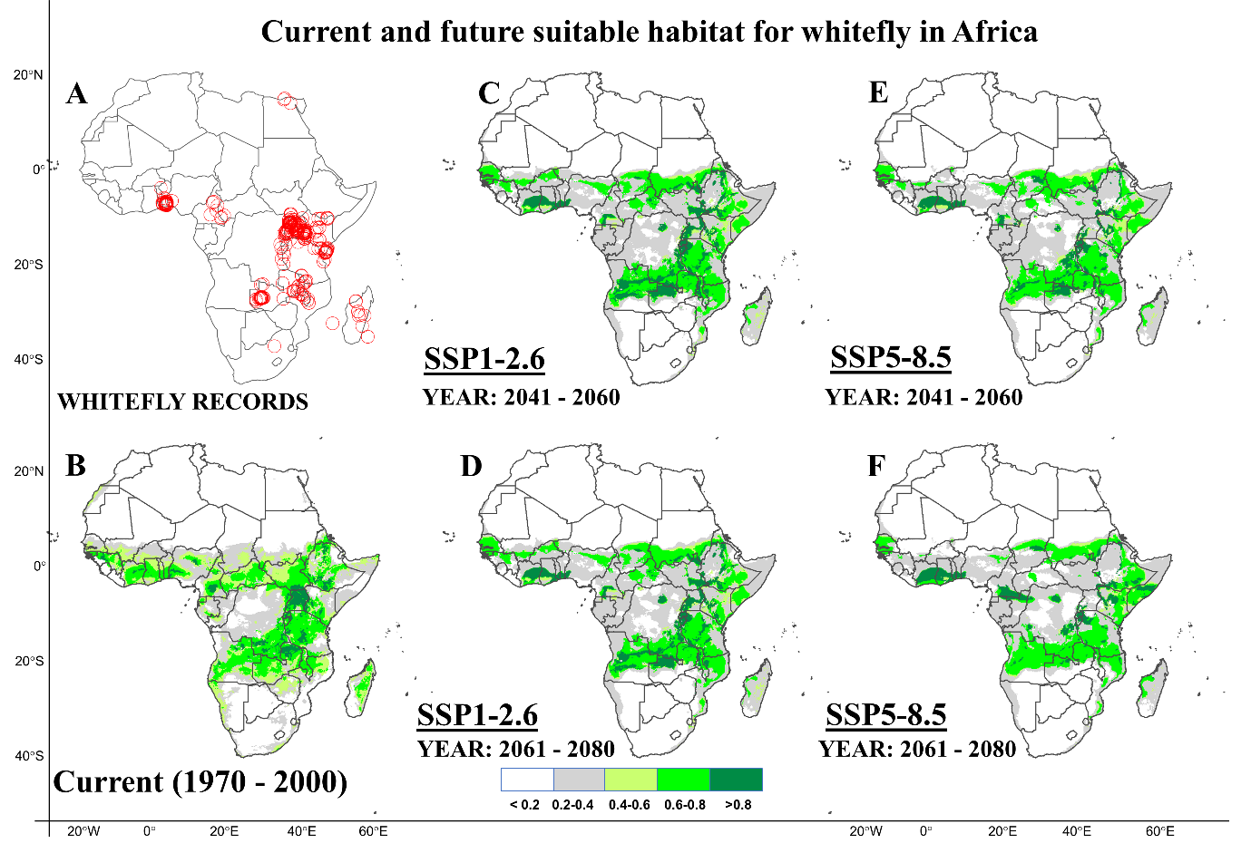
Figure D8. Current and future suitable habitats for whitefly in Africa. Maps showing A) geolocations of whitefly, B. tabaci occurrence records provided by the global biodiversity information facility (GIBF; https://www.gbif.org), B) predicted spatial distribution for whitefly under historical climate conditions. Future prediction of suitable habitats for whitefly under two shared social-economic pathways C) SSP1-2.6 (2050s), D) SSP1-2.6 (2070s), E) SSP5-8.5 (2050s) and F) SSP5-8.5 (2070s) using the CanESM5 model.

Appendix E: Projection of the current and future habitats at risk of cassava brown streak invasion in Africa using eight GCM models

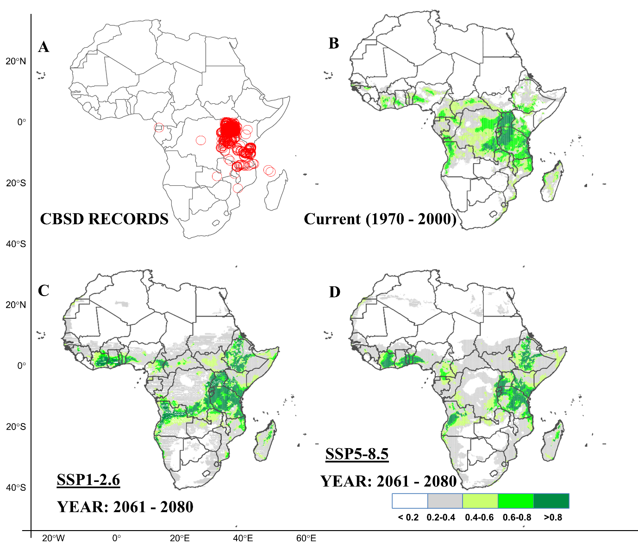
Figure E1: Current and future suitable habitats for CBSD in Africa. Plots showing A) geolocations of whitefly occurrence records provided by the global biodiversity information facility (GIBF; https://www.gbif.org) and personal correspondence with cassava diagnostic project leader in East Africa B) the predicted distribution for CBSD under the current climate (1970-2000). Predicted future suitable habitats for CBSD under C) the SSP1-2.6 scenario and D) the SSP5-8.5 scenario, using the BCC-CSM2-MR model for the year 2070s. The figures the SSP1-2.6 and SSP5-8.5 scenarios for the year 2050s are presented in Fig. 4 of the main text.

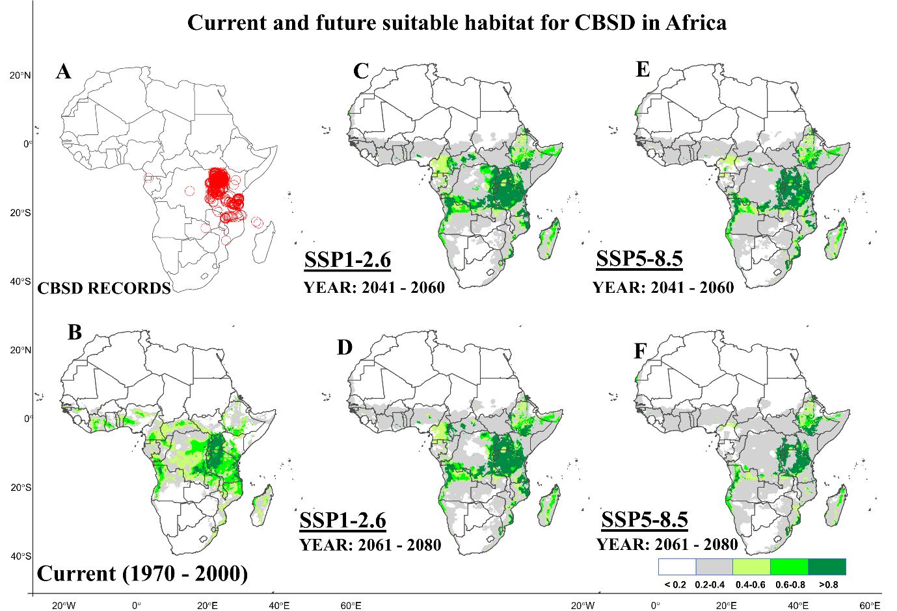
Figure E2. Current and future suitable habitats for CBSD in Africa. Plots showing A) geolocations of cassava brown streak disease (CBSD) occurrence records provided by the global biodiversity information facility (GIBF; https://www.gbif.org) and personal correspondence with cassava diagnostic project leader in East Africa B) predicted current distribution for whitefly. Future prediction of suitable habitats for whitefly under two shared social-economic pathways C) SSP1-2.6 (2050s), D) SSP1-2.6 (2070s), E) SSP5-8.5 (2050s) and F) SSP5-8.5 (2070s) using the MRI-ESM2-0 model.

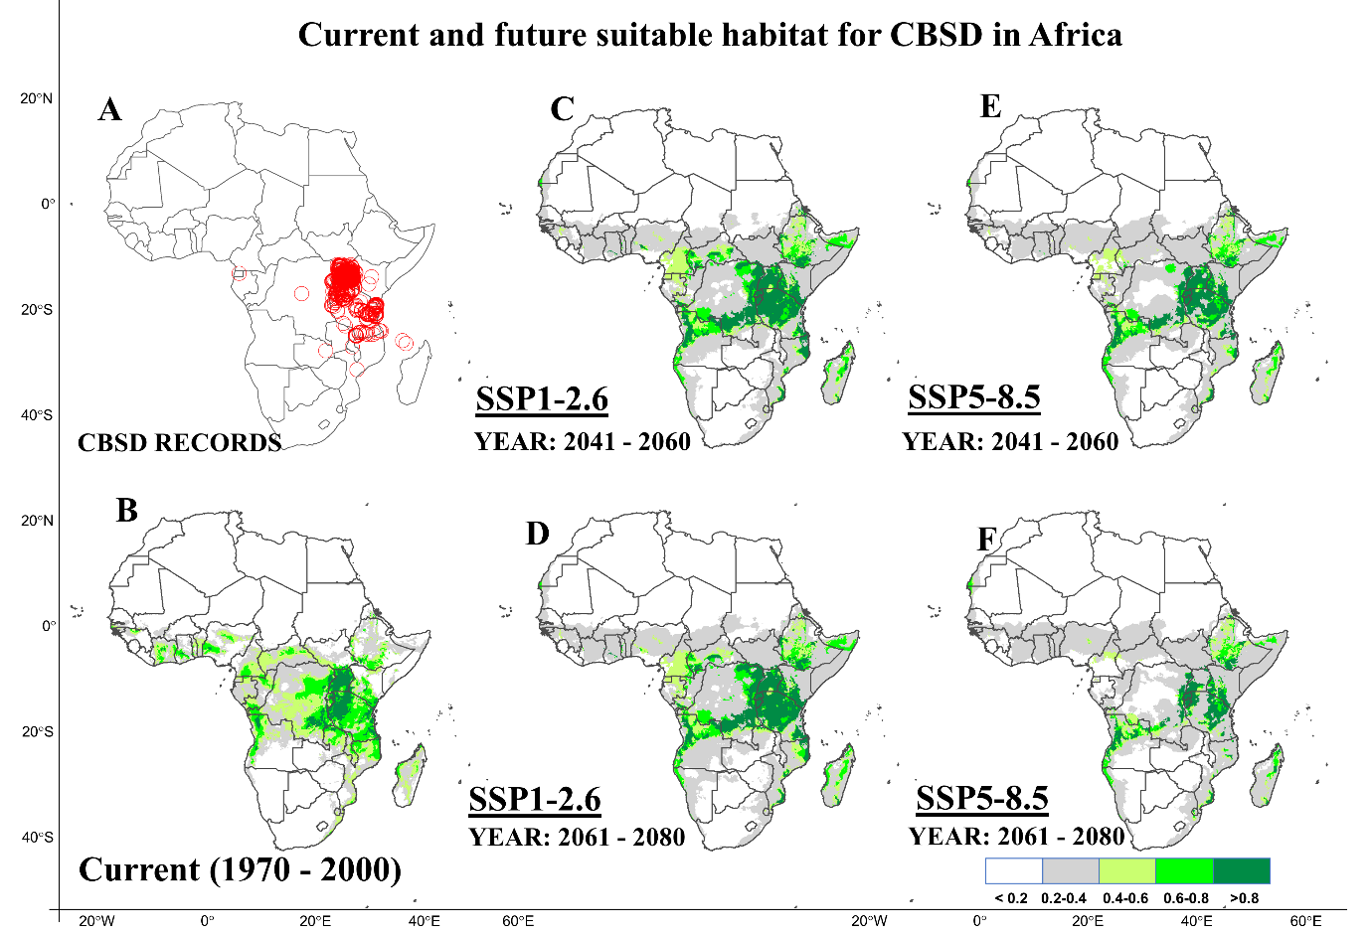
Figure E3. Current and future suitable habitats for CBSD in Africa. Plots showing A) geolocations of cassava brown streak disease occurrence records provided by the global biodiversity information facility (GIBF; https://www.gbif.org) and personal correspondence with cassava diagnostic project leader in East Africa B) predicted current distribution for whitefly. Future prediction of suitable habitats for whitefly under two shared social-economic pathways C) SSP1-2.6 (2050s), D) SSP1-2.6 (2070s), E) SSP5-8.5 (2050s) and F) SSP5-8.5 (2070s) using the MIROC-ES2L model.

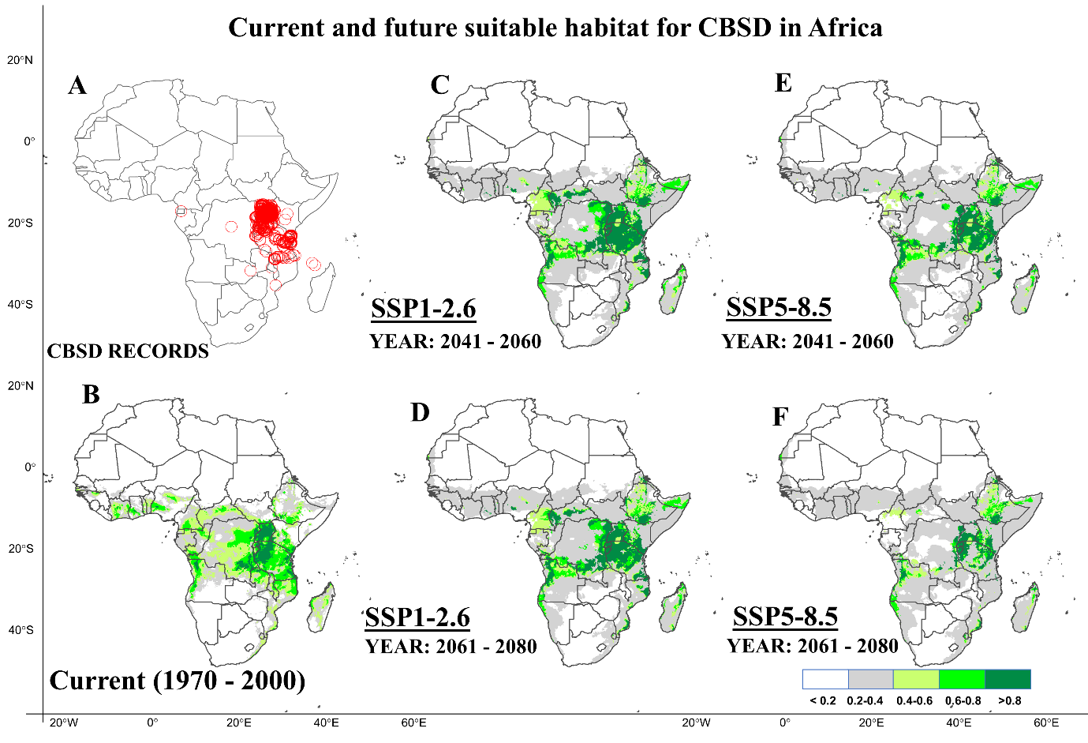
Figure E4. Current and future suitable habitats for CBSD in Africa. Plots showing A) geolocations of cassava brown streak disease occurrence records provided by the global biodiversity information facility (GIBF; https://www.gbif.org) and personal correspondence with cassava diagnostic project leader in East Africa B) predicted current distribution for whitefly. Future prediction of suitable habitats for whitefly under two shared social-economic pathways C) SSP1-2.6 (2050s), D) SSP1-2.6 (2070s), E) SSP5-8.5 (2050s) and F) SSP5-8.5 (2070s) using the MIROC6 model.

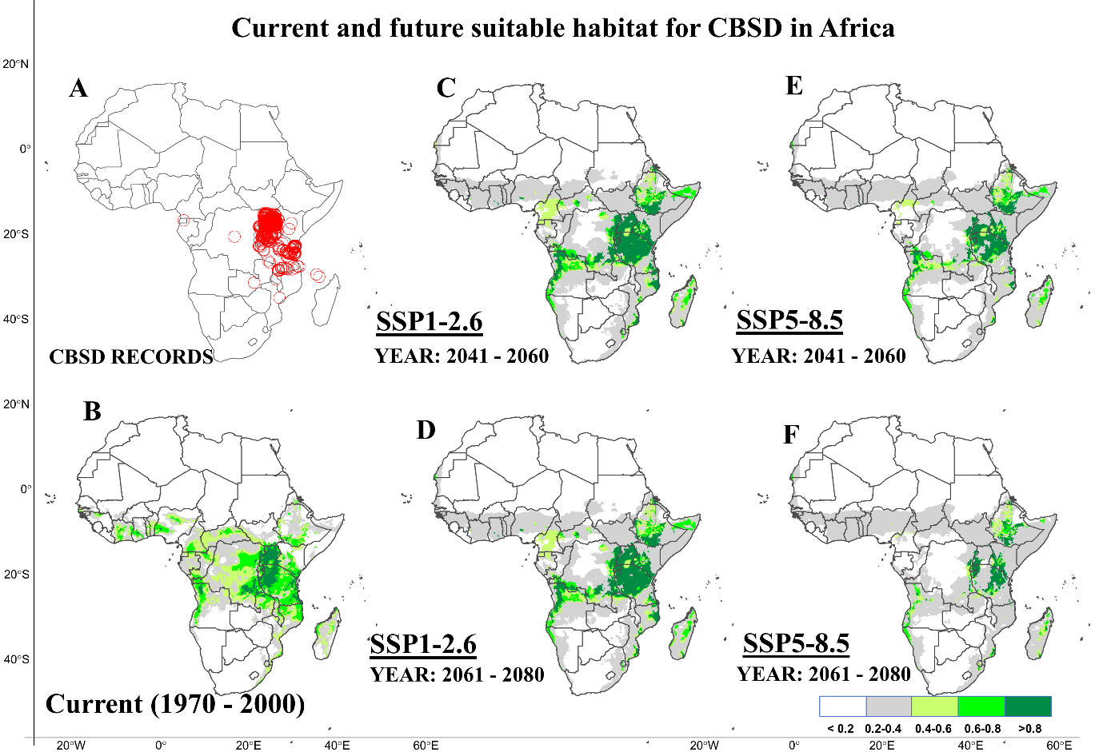
Figure E5. Current and future suitable habitats for CBSD in Africa. Plots showing A) geolocations of cassava brown streak disease occurrence records provided by the global biodiversity information facility (GIBF; https://www.gbif.org) and personal correspondence with cassava diagnostic project leader in East Africa B) predicted current distribution for whitefly. Future prediction of suitable habitats for whitefly under two shared social-economic pathways C) SSP1-2.6 (2050s), D) SSP1-2.6 (2070s), E) SSP5-8.5 (2050s) and F) SSP5-8.5 (2070s) using the IPSL-CM6A-LR model.

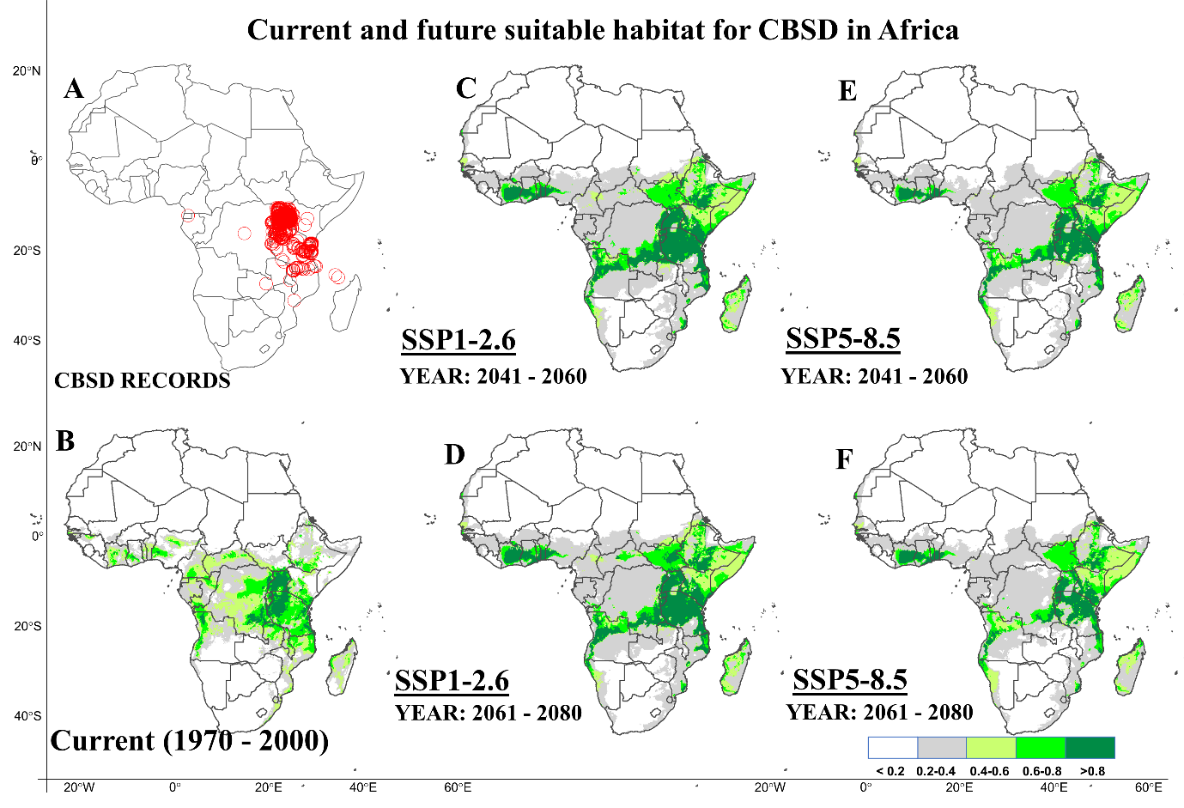
Figure E6. Current and future suitable habitats for CBSD in Africa. Plots showing A) geolocations of cassava brown streak disease occurrence records provided by the global biodiversity information facility (GIBF; https://www.gbif.org) and personal correspondence with cassava diagnostic project leader in East Africa B) predicted current distribution for whitefly. Future prediction of suitable habitats for whitefly under two shared social-economic pathways C) SSP1-2.6 (2050s), D) SSP1-2.6 (2070s), E) SSP5-8.5 (2050s) and F) SSP5-8.5 (2070s) using the CNRM-ESM2-1 model.

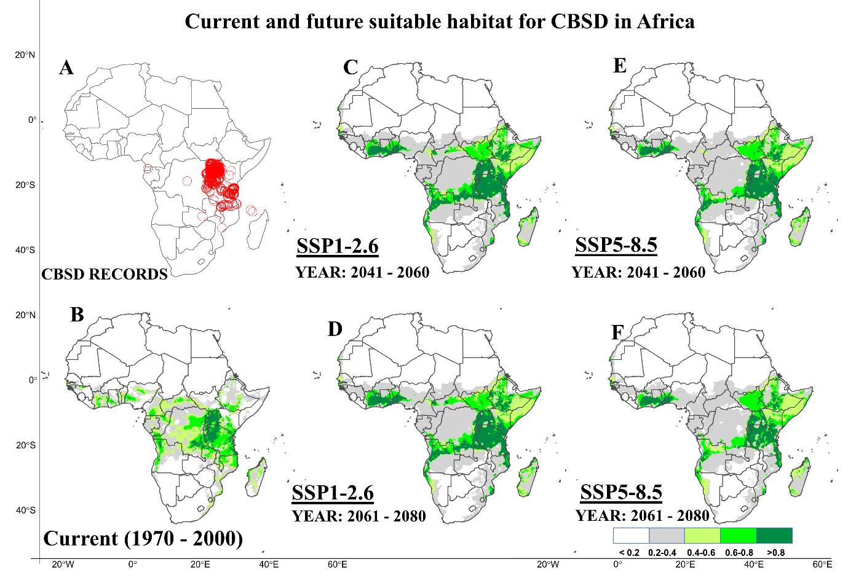
Figure E7. Current and future suitable habitats for CBSD in Africa. Plots showing A) geolocations of cassava brown streak disease occurrence records provided by the global biodiversity information facility (GIBF; https://www.gbif.org) and personal correspondence with cassava diagnostic project leader in East Africa B) predicted current distribution for whitefly. Future prediction of suitable habitats for whitefly under two shared social-economic pathways C) SSP1-2.6 (2050s), D) SSP1-2.6 (2070s), E) SSP5-8.5 (2050s) and F) SSP5-8.5 (2070s) using the CNRM-CM6-1 model.

Appendix F: Impact of species lumping in predicting the current and future distribution of Bemisia tabaci species complex in Africa
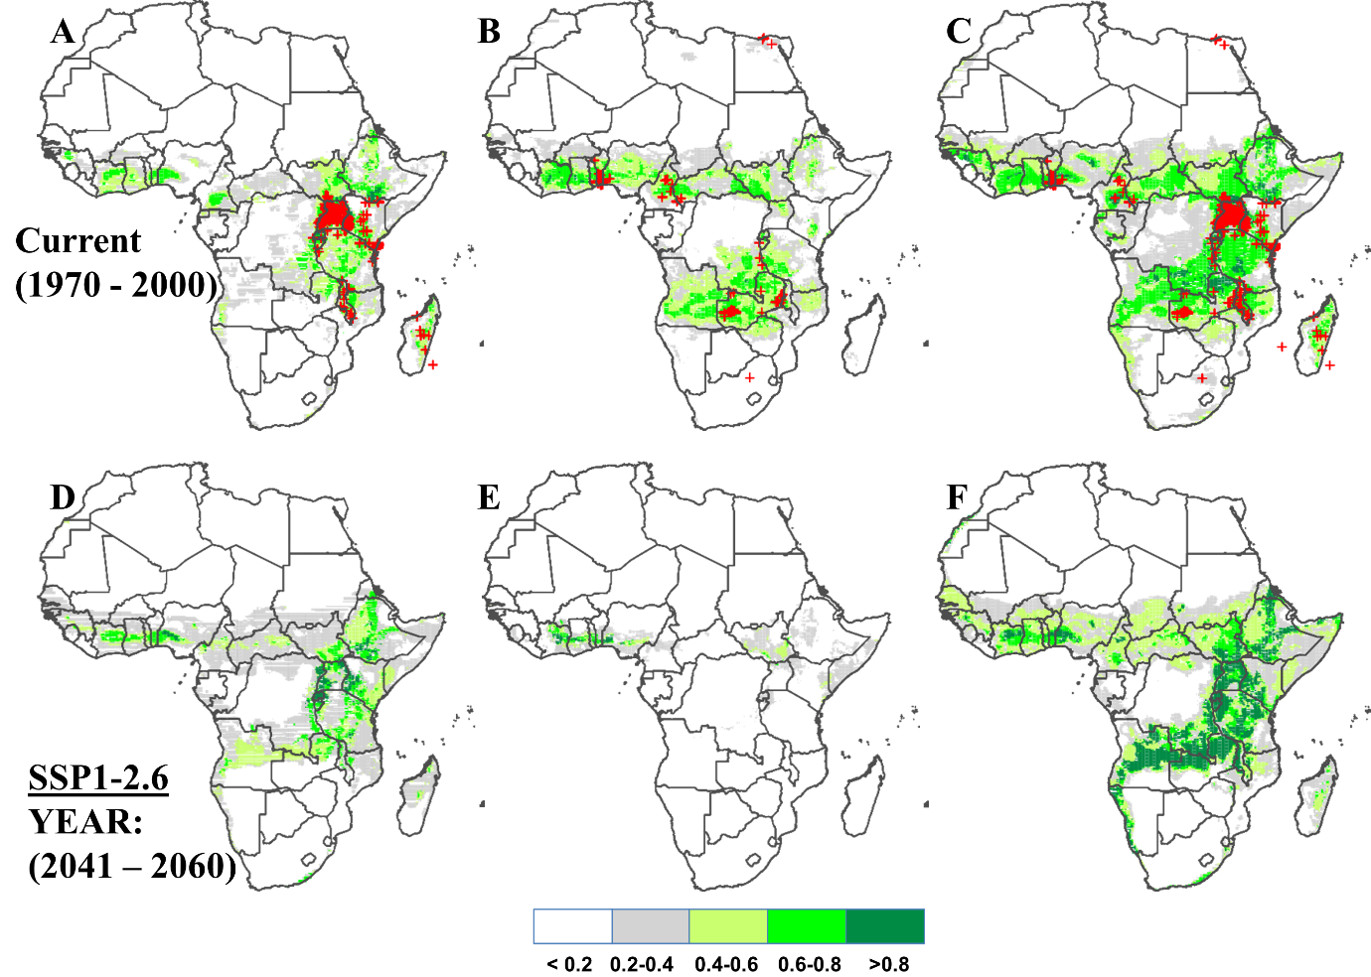
Figure F1. Current and future suitable habitats for members of Bemisia tabaci species in Africa. (A, D) Predicted current and future distribution for Bemisia tabaci species (SSA1) overlayed with geolocations from East Africa under shared social-economic pathways (SSP1-2.6) using the BCC-CSM2-MR model for the year 2050. (B, E) Predicted current and future distribution for Bemisia tabaci species (SSA2-5) overlayed with geolocations from Central and West Africa under shared social-economic pathways (SSP1-2.6) using the BCC-CSM2-MR model for the year 2050 and (C, F) Predicted current and future distribution for Bemisia tabaci species overlayed with geolocations from entire Africa under shared social-economic pathways (SSP1-2.6) using the BCC-CSM2-MR model for the year 2050.

Comparison of the performance of SDMs on two groups of Bemisia tabaci species
The ensemble of four models produced on average, an AUC of 98.7% for SSA1 records, 97.6% for SSA2-5 and 98.3% for the lumped records of species (SSA1 and SSA2-5).

Literature cited
Hajima, T., Watanabe, M., Yamamoto, A., Tatebe, H., Noguchi, M., Abe, M., … Kawamiya, M. (2019). Description of the MIROC-ES2L Earth system model and evaluation of its climate–biogeochemical processes and feedbacks. Geoscientific Model Development Discussions, 5(October), 1–73.
Swart, N. C., Cole, J. N. S., Kharin, V. V., Lazare, M., Scinocca, J. F., Gillett, N. P., … Winter, B. (2019). The Canadian Earth System Model version 5 (CanESM5.0.3). Geoscientific Model Development, 12(11), 4823–4873. https://doi.org/10.5194/gmd-12-4823-2019
Tatebe, H., Ogura, T., Nitta, T., Komuro, Y., Ogochi, K., Takemura, T., … Kimoto, M. (2019). Description and basic evaluation of simulated mean state, internal variability, and climate sensitivity in MIROC6. Geoscientific Model Development, 12(7), 2727–2765. https://doi.org/10.5194/gmd-12-2727-2019
Wu, T., Lu, Y., Fang, Y., Xin, X., Li, L., Li, W., … Liu, X. (2019). The Beijing Climate Center Climate System Model (BCC-CSM): The main progress from CMIP5 to CMIP6. Geoscientific Model Development, 12(4), 1573–1600. https://doi.org/10.5194/gmd-12-1573-2019
Yukimoto, S., Kawai, H., Koshiro, T., Oshima, N., Yoshida, K., Urakawa, S., … Ishii, M. (2019). The meteorological research institute Earth system model version 2.0, MRI-ESM2.0: Description and basic evaluation of the physical component. Journal of the Meteorological Society of Japan, 97(5), 931–965. https://doi.org/10.2151/jmsj.2019-051

