**When and Where? Day-night Alterations in Wild Boar Space Use Captured by a Generalized Additive Model.**

Bollen Martijn, Casaer Jim, Neyens Thomas and Beenaerts Natalie

Supplementary file S3: Residual plots for the GAMs presented in the main paper

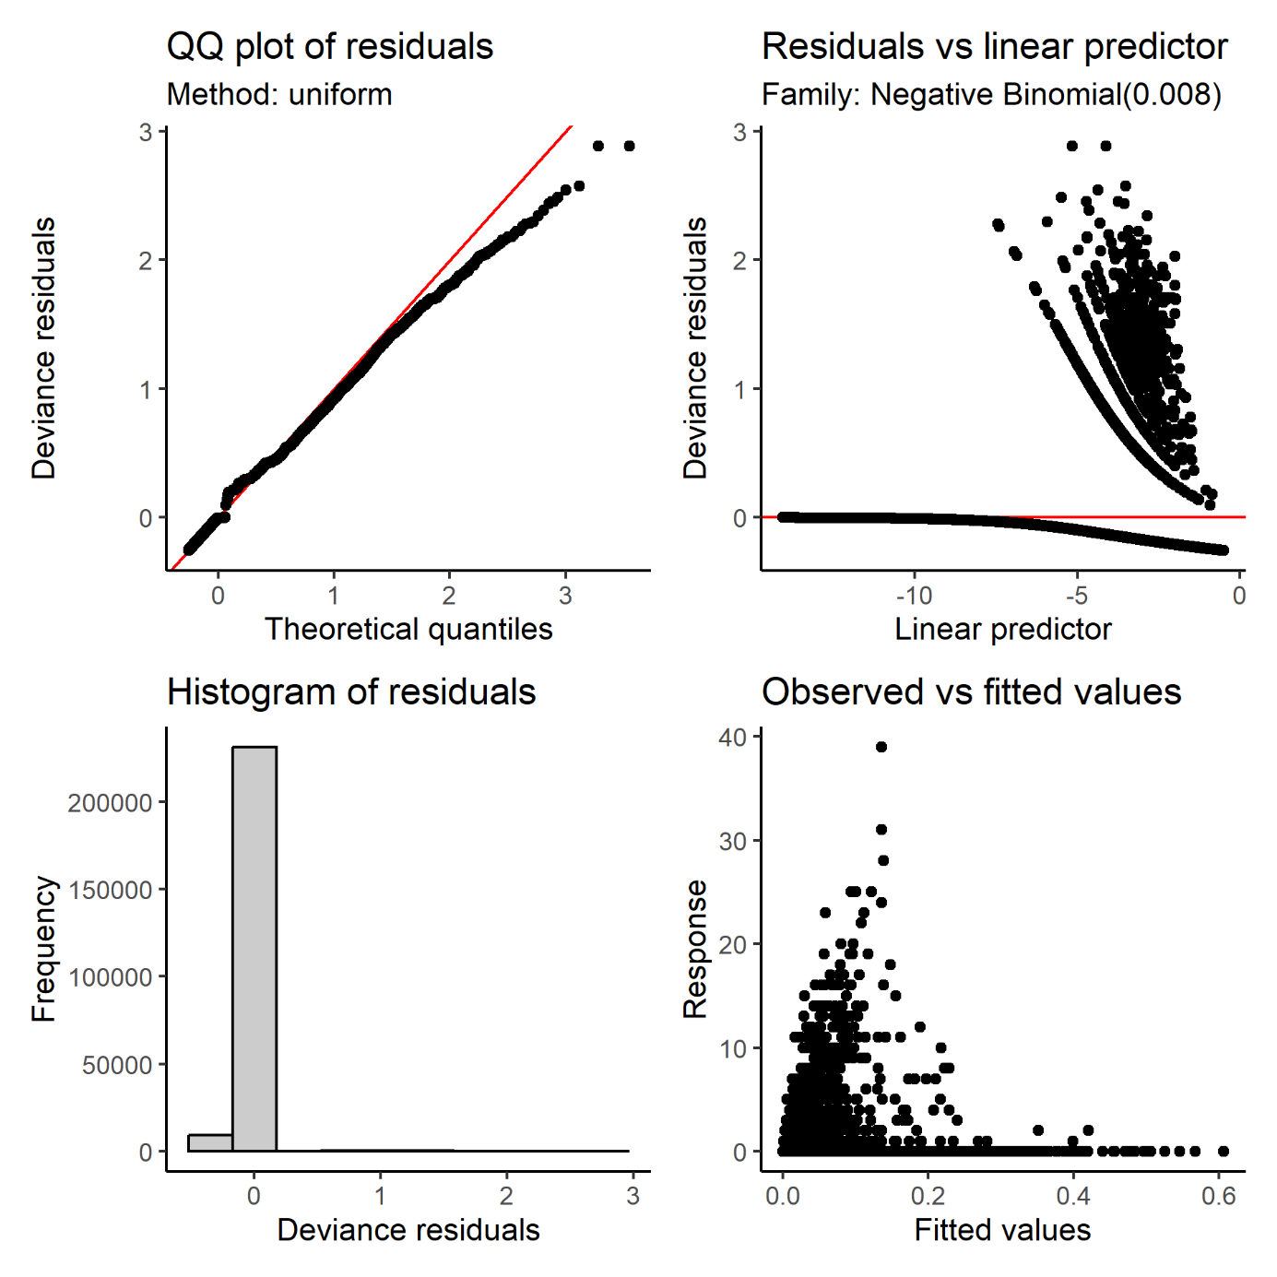

**Figure S3.1.** Residual plots for a negative binomial GAM modelling wild boar diel space use.

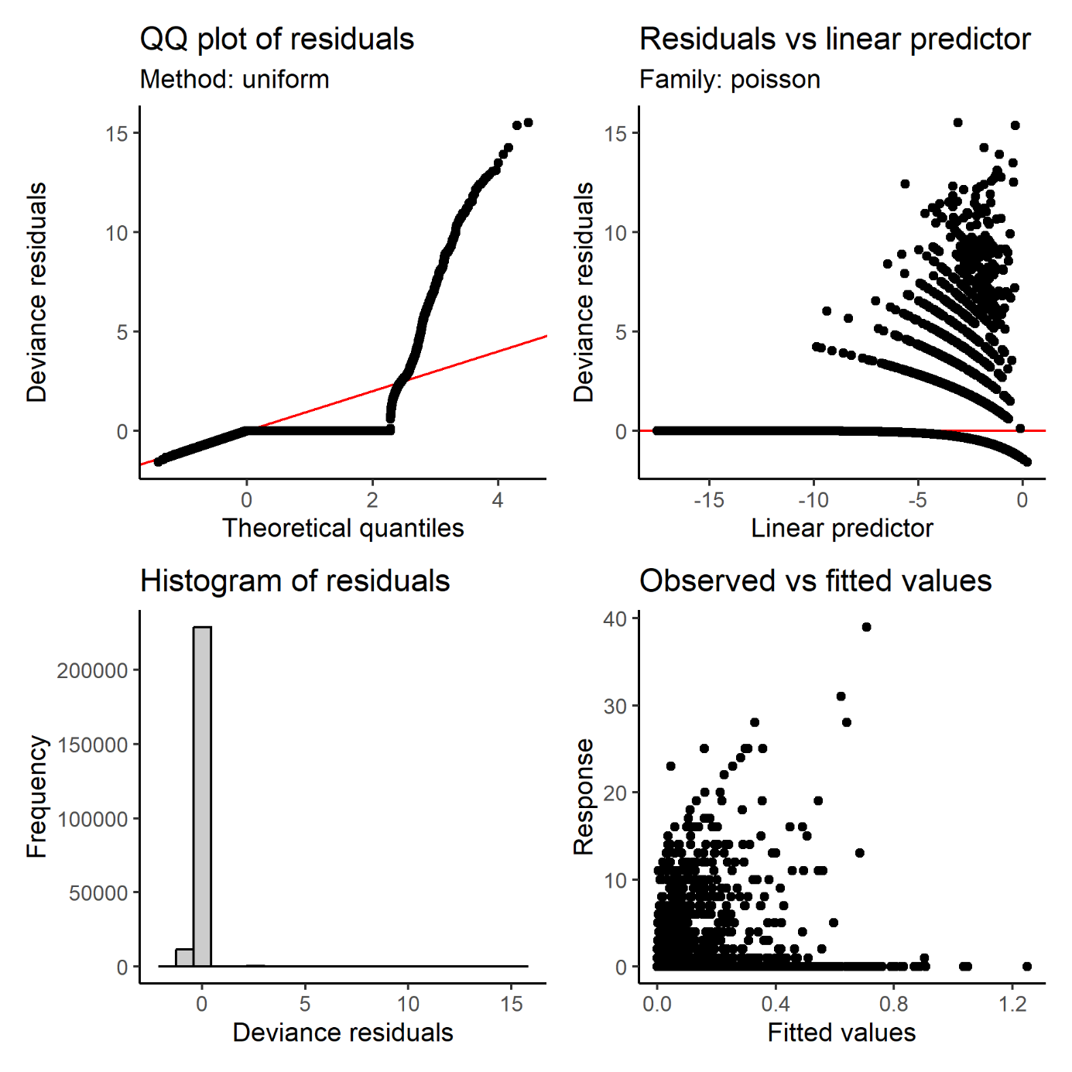

**Figure S3.2.** Residual plots for a Poisson GAM modelling hunter encounters across space and solar time bins.

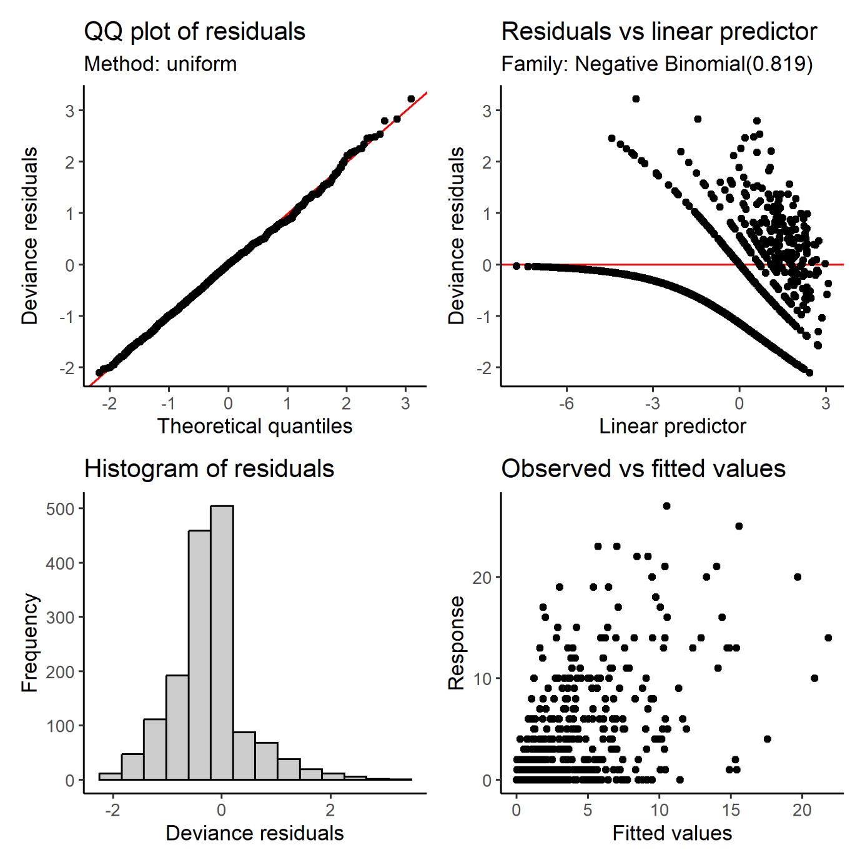

**Figure S3.3.** Residual plots for a negative binomial GAM modelling hunter encounters across space and solar time bins.

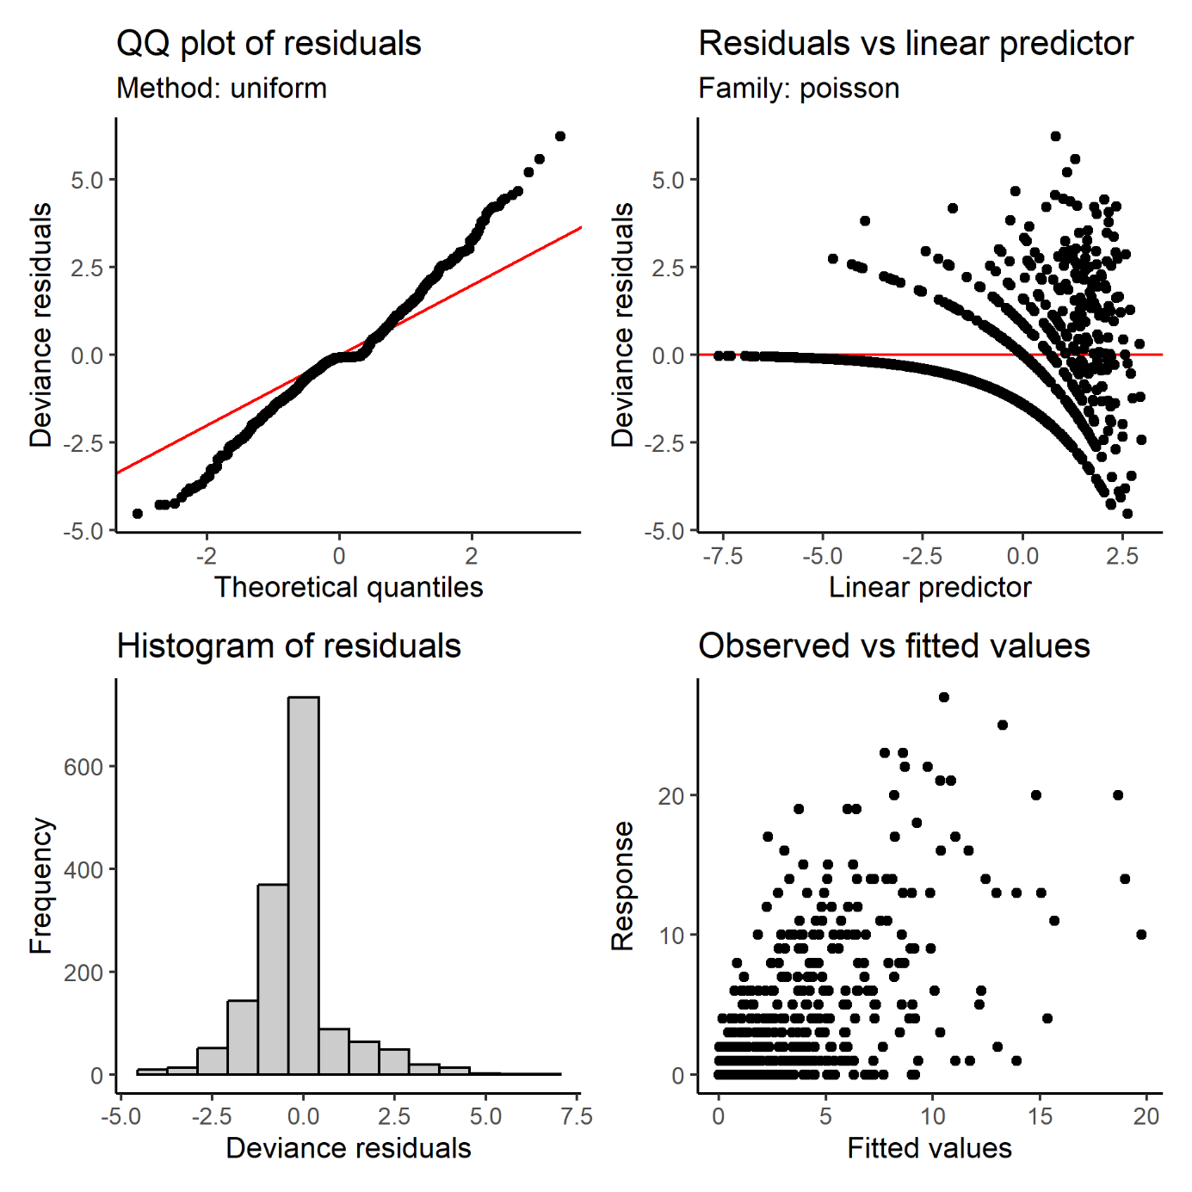

**Figure S3.4.** Residual plots for a Poisson GAM modelling wild boar encounters on days with hunting across space and solar time bins.