**A**

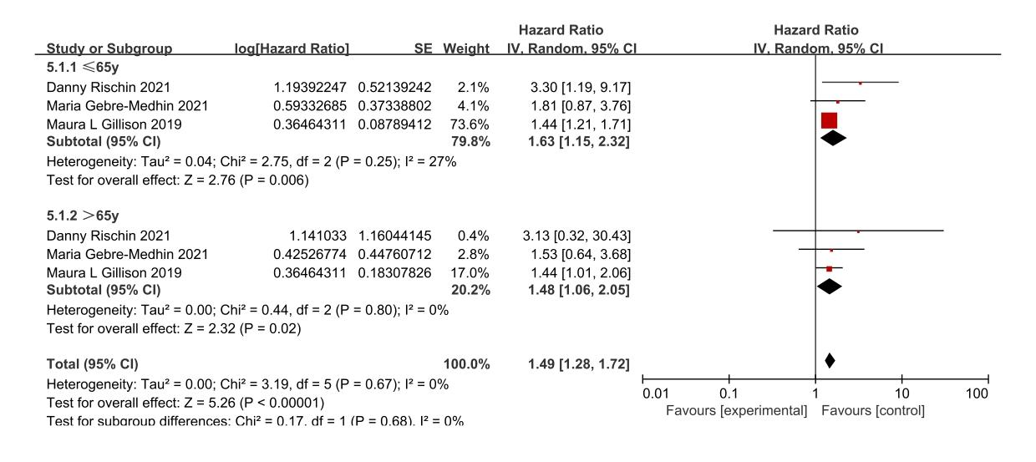

**B**

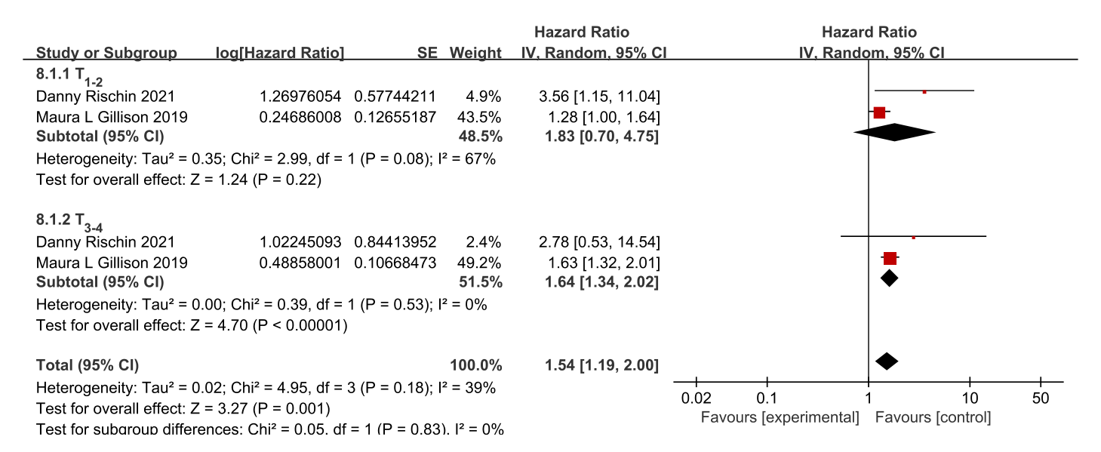

**Supplementary figure 1** (A) Forest plot of overall survival subgroup analysis based on age of patients. (B) Forest plot of overall survival subgroup analysis based on primary tumor stage T of patients.