**A**

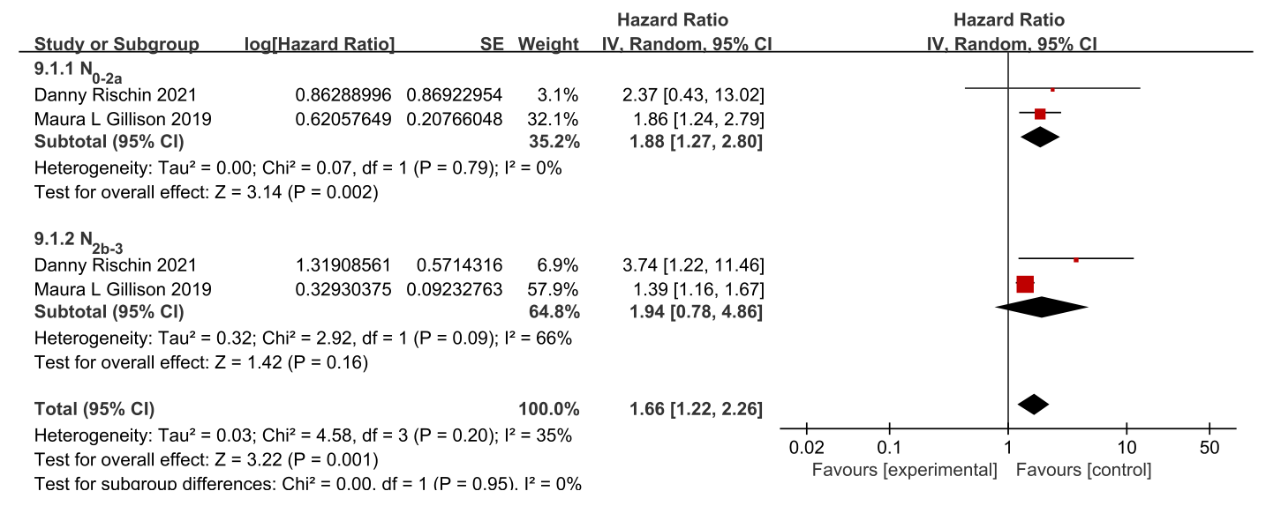

**B**

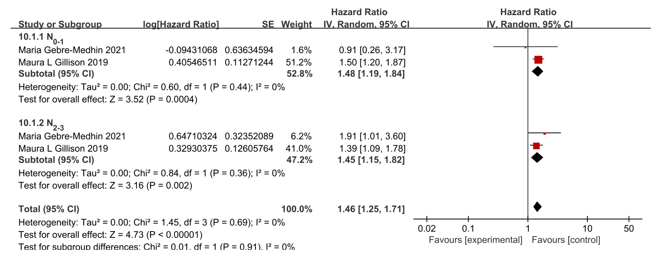

**Supplementary figure 2** (A) Forest plots for OS subgroup analysis according to the 7th UICC/AJCC definition of tumor N stage. (B) Forest plots for OS subgroup analysis according to the 8th UICC/AJCC definition of tumor N stage.