**A**

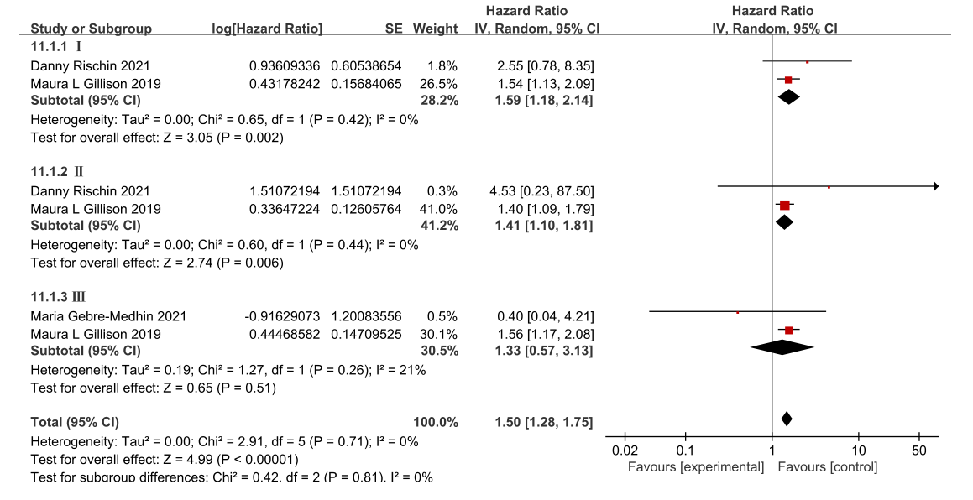

**B**

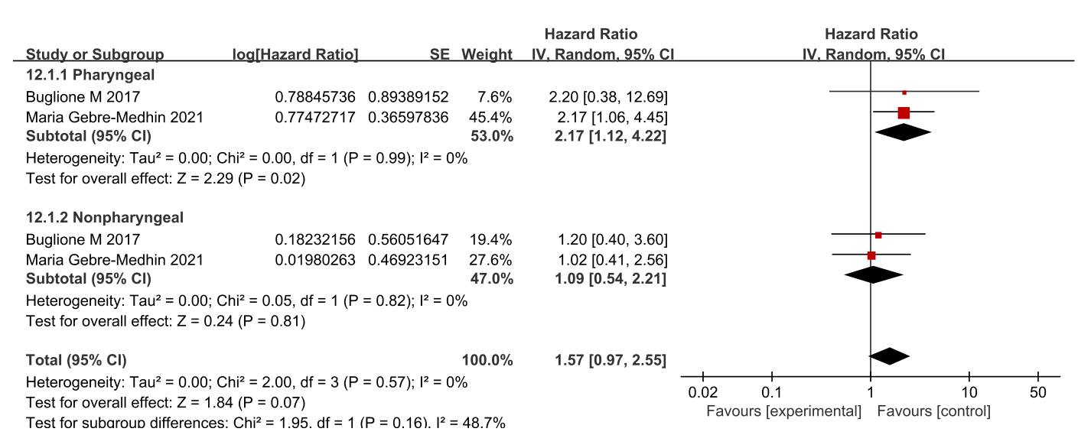

**Supplementary figure 3** (A) Forest plots for OS subgroup analysis according to the 8th edition UICC/AJCC definition of primary tumor overall stage.（B）Forest plots were analyzed for subgroups of OS according to primary tumor site.