**A**

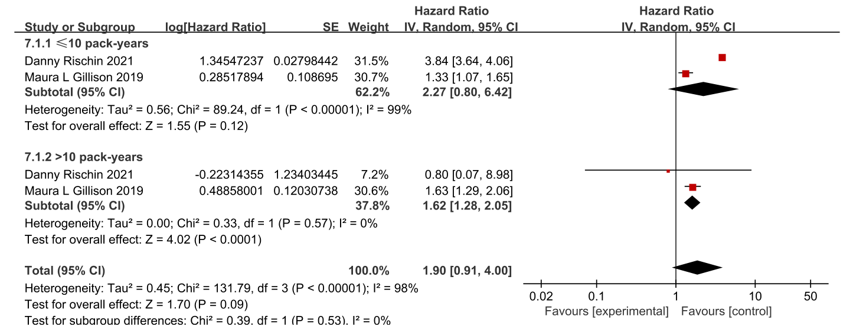

**B**

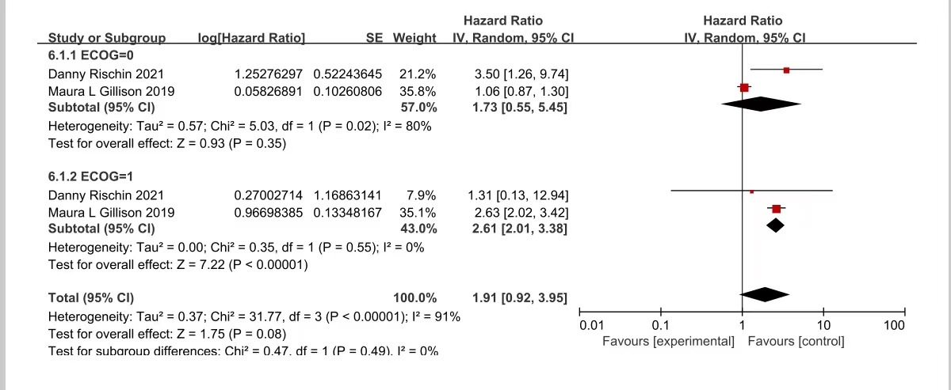

**Supplementary figure 4** (A) Forest plot of OS subgroup analysis according to the smoking history of patients. (B) Forest plot of OS subgroup analysis based on ECOG score of patients.