**A**

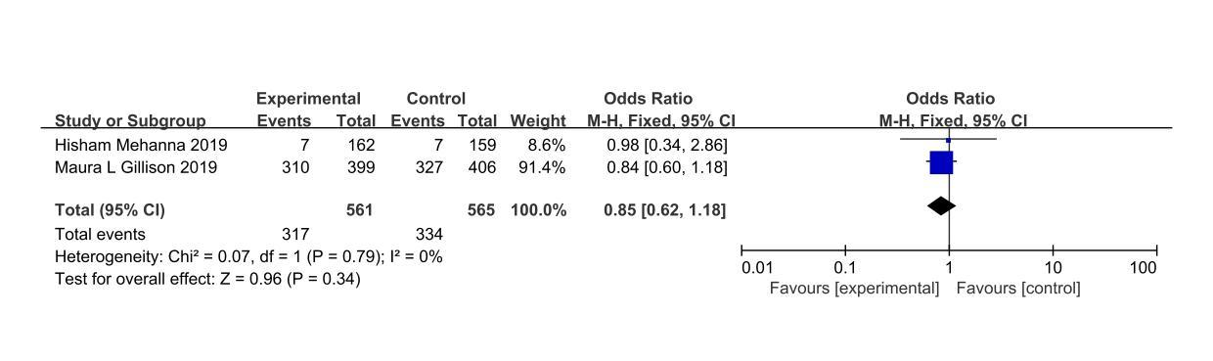

**B**

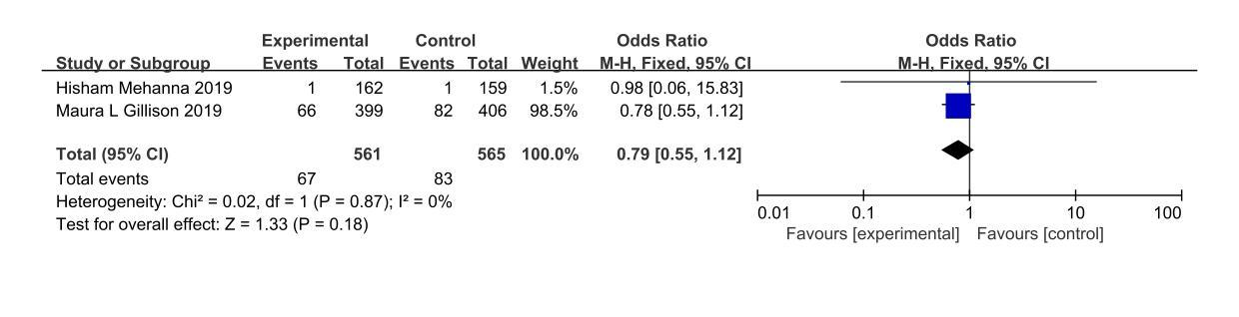

**Supplementary figure 5** (A) Forest plot of acute incidence of class III-IV AE. (B) Forest plot of incidence of late AE in class III to IV.