Thai version MIDAS Questionnaire
เอกสารแนบหมายเลข 1

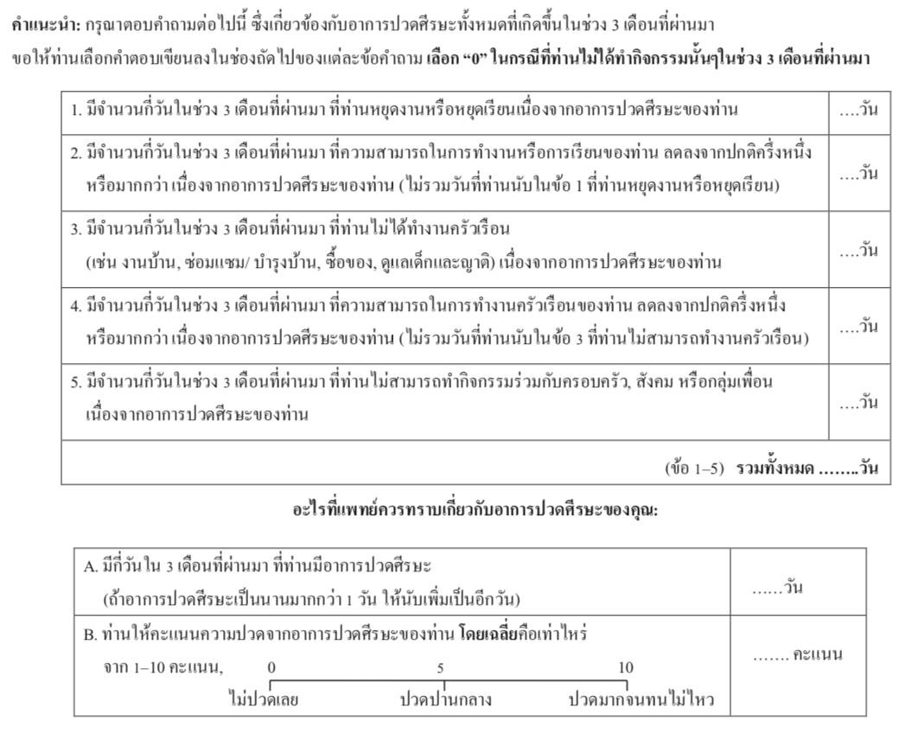

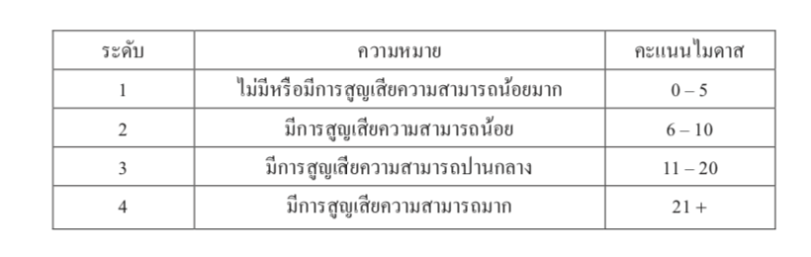
Reference: Vongvoivanich K, Youngprawat T, Jindawong N, et al. Test-Restest Reliablitiy of the Thai Migraine Disability Assessment (Thai-MIDAS) Questionanire in Thai Migraine Patients. The Bangkok Medical Journal. 2018;14 (1): 10-15.

